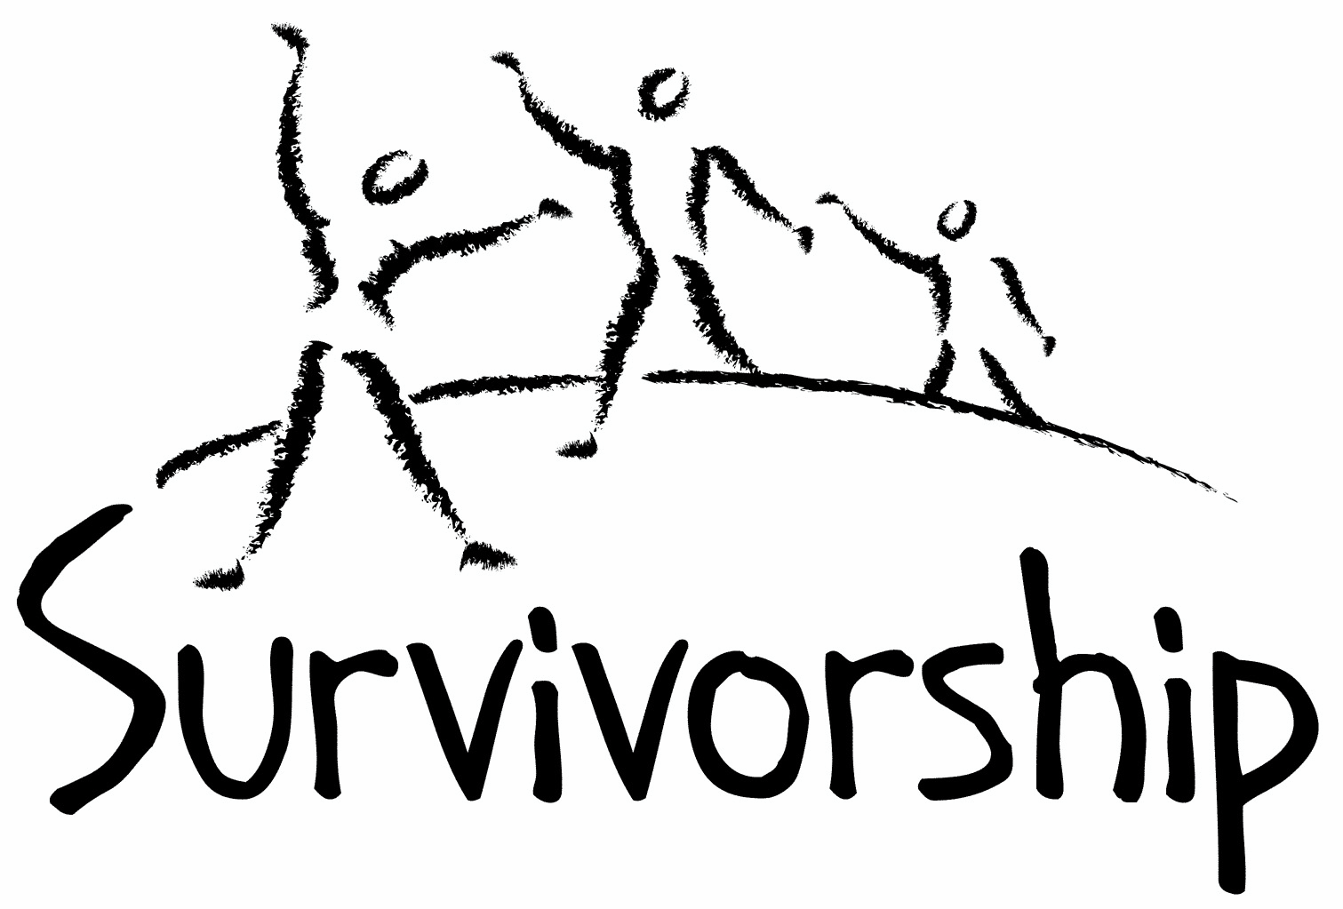

Vol. 200 No. 7 and 8 November/December 2022

The Notes, formerly called Chart Notes, ISSN 1523-275, is published bimonthly, copyright © 1999-2022 by Survivorship. All rights reserved. The entire contents of this issue are copyrighted by Survivorship and by the individual contributors. Please write Survivorship or E-mail info@survivorship.org for permission to reprint. Survivorship is a nonprofit organization.

Dear Friends,

Thank you for your support of Survivorship. Survivorship has decided on the date of its next online conference.

The Survivorship Ritual Abuse and Mind Control 2023 Online Conference
Survivor Conference - Saturday and Sunday May 20 - 21, 2023
Clinician's Conference - Friday May 19, 2023
Both conferences will be online.
https://survivorship.org/the-survivorship-ritual-abuse-and-mind-control-2023-online-conference/

Our focus will be on New Zealand and Australia. If you are from this part of the world or know someone that may be interested in speaking at the conference from this part of the world, please write us at info@survivorship.org

Survivorship Webinar 2022: Healing the Unimaginable: A Ten-Session Course with Alison Miller https://survivorship.org/survivorship-webinar-2022-healing-the-unimaginable-a-ten-session-course/ has been very popular. This webinar is for clinicians.
Please remember to renew your membership if it is due. Information is at the end of this issue of the notes or at: https://survivorship.org/how-to-renew-your-membership/
The Survivorship Board of Directors: Neil, Eileen, Randy, Elana, Laurie and Rainer

Survivorship blog https://survivorshipwp.wordpress.com
Survivorship on Twitter https://twitter.com/Survivorshiporg
Survivorship on Facebook https://www.facebook.com/SurvivorshipRitualAbusePage

Survivorship Webinar 2022:
Healing the Unimaginable: A Ten-Session Course in Treating Survivors of Organized and Extreme Abuse - Alison Miller, Ph.D., Retired Psychologist https://survivorship.org/survivorship-webinar-2022-healing-the-unimaginable-a-ten-session-course/
Alison Miller, Ph.D. is a retired clinical psychologist who practised in Victoria, B.C., Canada and worked with survivors of organized abuse, including ritual abuse and mind control from 1990 to 2017. She has twice chaired the RAMCOA (ritual abuse/mind control/organized abuse) special interest group of the International Society for the Study of Trauma and Dissociation. She is the author of Healing the Unimaginable: Treating Ritual Abuse and Mind Control (for therapists), Becoming Yourself: Overcoming Mind Control and Ritual Abuse (for survivors), and co-author with survivor Wendy Hoffman of From the Trenches: A Victim and Therapist Talk about Mind Control and Ritual Abuse. She has published several other book chapters and articles, as well as being the originator of the LIFE Seminars parent education programs. The course was only open to licensed professionals in the mental health field.
This course is based on Dr. Miller’s 2012 book Healing the Unimaginable: Treating Ritual Abuse and Mind Control. It incorporates other material from Dr. Miller’s more recent publications and those of others. Video recordings and PowerPoints of the sessions are available at https://survivorship.org/survivorship-webinar-2022-healing-the-unimaginable-a-ten-session-course/
The ten sessions are:
1. Understanding dissociative disorders and organized abuse - Thursday Feb 17th, 2022
2. The therapeutic relationship - Thursday March 10th, 2022
3. Engineered personality systems resulting from organized abuse - Thurs April 7th, 2022
4. Internal parts and their assigned functions - Thursday May 5th, 2022
5. Stabilization (internal safety) - Thursday June 2nd, 2022
6. Working with internal leaders - Thursday July 7th, 2022
7. Present-day physical safety - Thursday August 4th, 2022
8. Working through the traumatic memories - Thursday September 8th, 2022
9. Confronting the spiritual issues - Thursday October 13th, 2022
10. Healing the unimaginable - Thursday November 10, 2022

Ritual Abuse Evidence

Child Abuse Wiki - Ritual Abuse
http://childabusewiki.org/index.php?title=Ritual_Abuse
Ritual abuse exists all over the world. There have been reports, journal articles, web pages and criminal convictions of crimes against children and adults.

Proof That Ritual Abuse Exists http://ritualabuse.us/ritualabuse/

Empirical and Forensic Evidence of Ritual Abuse
by James Randall Noblitt and Pamela Perskin Noblitt (2014)
http://endritualabuse.org/empirical-and-forensic-evidence-of-ritual-abuse/

Large List of Ritual Abuse and Satanic Ritual Abuse References
http://ritualabuse.us/ritualabuse/studies/satanic-ritual-abuse-evidence-with-information-on-the-mcmartin-preschool-case/

Child Abuse Wiki – Recovered Memories
http://childabusewiki.org/index.php?title=Recovered_Memories
There is very strong scientific evidence that recovered memories exist. This has been shown in many scientific studies. The content of recovered memories have fairly high corroboration rates.

The Dark Tunnels of McMartin – Dr. Roland C. Summit http://ritualabuse.us/ritualabuse/articles/the-dark-tunnels-of-mcmartin-dr-roland-c-summit-journal-of-psychohistory/

The McMartin Preschool Case – What Really Happened and the Cover-up
http://ritualabuse.us/ritualabuse/articles/mcmartin-preschool-case-what-really-happened-and-the-coverup/

Denying Ritual Abuse of Children – Catherine Gould The Journal of Psychohistory 22 (3) 1995 http://ritualabuse.us/ritualabuse/articles/denying-ritual-abuse-of-children-catherine-gould/

Believe the children (1997). “Conviction List: Ritual Child Abuse”. http://ra-info.org/faqs/ra-convictions/

2008 Publications on Ritual Abuse and Mind Control
http://endritualabuse.org/publications-on-ritual-abuse-and-mind-control-in-2008/

Lacter, E (2008-02-11). “Brief Synopsis of the Literature on the Existence of Ritualistic Abuse”. http://endritualabuse.org/brief-synopsis-of-the-literature-on-the-existence-of-ritualistic-abuse/

Bottoms, Shaver and Goodman in their 1993 study to evaluate ritual abuse claims found that in 2,292 alleged ritual abuse cases,15% of the perpetrators in adult cases and 30% of the perpetrators in child cases confessed to the abuse. Data from Brown, Scheflin and Hammond (1998). Memory, Trauma Treatment, And the Law (W. W. Norton) ISBN 0-393-70254-5 (p.62) Bottoms, B. Shaver, P. & Goodman, G. (1993) Profile of ritual abuse and religion related abuse allegations in the United States. Updated findings provided via personal communication from B. Bottoms. Cited in K.C. Faller (1994), Ritual Abuse; A Review of the research. The American Professional Society on the Abuse of Children Advisor , 7, 1, 19-27 https://ritualabuse.us/ritualabuse/

On Page 170 (first edition), of Cult and Ritual Abuse – Noblitt and Perskin (Praeger, 1995) states “One of the best sources of evaluative research on ritual abuse is the article “Ritual Abuse: A Review of Research” by Kathleen Coulborn Faller (1994)….in a survey of 2,709 members of the American Psychological Association, it was found that 30 percent of these professionals had seen cases of ritual or religion-related abuse (Bottoms, Shaver & Goodman, 1991). Of those psychologists who have seen cases of ritual abuse, 93 percent believed that the reported harm took place and 93 percent believed that the alleged ritualism occurred. This is a remarkable finding. Mental health professionals are known to be divergent in their thinking and frequently do not agree with one another regarding questions of the diagnosis and etiology of psychiatric problems…this level of concurrence in a large national sample of psychologists…would be impressive….the similar research of Nancy Perry (1992) which further supports (the previous findings)…Perry also conducted a national survey of therapists who work with clients with dissociative disorders and she found that 88 percent of the 1,185 respondents indicated”belief in ritual abuse, involving mind control and programming” (p.3).”

Craighead, W. E.; Corsini, R.J.; Nemeroff, C. B. (2002) The Corsini Encyclopedia of Psychology and Behavioral Science Published by John Wiley and Sons ISBN 0471270830 – Sadistic Ritual Abuse (p.1435 – 1438) http://books.google.com/books?id=JQMRmyOfpJ8C&pg=PA1436&lpg=PA1436#v=onepage&q=sadistic%20ritual&f=false

Sexual Abuse in Day Care: A National Study – Executive Summary – March 1988 – Finklehor, Williams, Burns, Kalinowski “The study identified 270 “cases” of sexual abuse in day care meaning 270 facilities where substantiated abuse had occurred involving a total of 1639 victimized children….This yielded an estimate of 500 to 550 reported and substantiated cases and 2500 victims for the three-year period. Although this is a large number, it must be put in the context of 229,000 day care facilities nationwide service seven million children….allegations of ritual abuse (“the invocation of religious, magical or supernatural symbols of activities”) occurred in 13% of the cases.” The authors divided these cases into “true cult-based ritual,” pseudo-ritualism” with a primary goal of sexual gratification and ritual being used to intimidate the children from disclosing and “psychopathological ritualism” the activities being “primarily the expression of an individual’s obsessional or delusional system.” https://www.ncjrs.gov/pdffiles1/Digitization/113095NCJRS.pdf

ON-GOING MEETINGS AND TRAINING OPPORTUNITIES

Survivorship is presenting this as information only. If you choose to use one of these resources, please note that you are doing this at your own risk.

Dissociation & Trauma Clinical Discussions (DissTCD) list The Dissociation & Trauma Clinical Discussions (DissTCD) list has been created to allow for clinical discussions for all licensed mental health counselors and retired licensed mental health counselors around the world. To join: disstcd+subscribe@groups.io

ASCA (Adult Survivors of Child Abuse) On-going info@ascasupport.org www.ascasupport.org

Survivors of Incest Anonymous SIA holds 12-step meetings for incest survivors. Those designated “Nothing Too Heavy to Share” meetings are designed for ritual abuse survivors. 410-282-3400 http://www.siawso.org

Women’s Center, 46 Pleasant Street, Cambridge, MA Weekly and monthly groups for survivors of child sexual abuse, incest survivor’s interfaith quilt project, Survivors of Incest Anonymous, eating disorder support group, emotional healing group, more. info@cambridgewomenscenter.org Phone: 617-354-6394 Helpline. 617-354-8807 http://www.cambridgewomenscenter.org

The Childhelp National Child Abuse Hotline 1-800-4-A-CHILD (1-800-422-4453)
HOTLINES FAMILIAR WITH RA ISSUES
* Bay Area Women Against Rape (BAWAR): 510-845-7273
* San Francisco Women Against Rape (SFWAR): 415-647-7273
* Women’s Center, Cambridge, MA: 617-354-8807

Difficult Dates
Please use caution when reading this page. This page has words and dates that may remind survivors of their programming. This page summarizes dates that may be used by cults and various destructive groups. Abusive groups steal, pervert, and mock the holidays of legitimate religions, holidays, and cultures. This does not mean that all or even most people who observe some of these holidays are abusive.
November
11/1 All Saints' Day
11/1 Satanist High Holy Day
11/1-11/6 The Isia: six day ritual drama search for pieces of Osiris/feast of the Netherworld parting of the astral veil/resurrection of Osiris
11/2 All Souls’ Day (in honor of the dead) Santeria El Dia De Los Muertos
11/4 Kali Puja
11/4 Diwali: Hindu: Festival of Lights: The end of Lord Rama’s exile killing of a demon by Krishna’s wife
11/4 Satanic Revels (sexual)
11/5 Guy Fawkes’ Day (UK)
11/7 Hilaria/Mania (Open of Mundus Cereris) rebirth of Osiris
11/8 Full Moon
11/9 Kristallnacht
11/11 Veteran’s Day (Armistice 1918)
11/11 Remembrance Day (Canada)
11/19 Guru Nanak Birthday
11/21 Christ the King
11/24 Martyrdom of Guru Tegh Bahadur Sahib
11/24 Thanksgiving (USA)
11/25 New Moon
11/28 – 12/6 Hanukkah
11/28 - 12/24 Advent
11/30 St. Andrew’s Day

December
12/6 St. Nicholas’ Day
12/7 Full Moon
12/8 Bodhi Day
12/17-12/22 Saturnalia
12/18 Full Moon
12/18 St. Winebald’s Day (blood)
12/21 St. Thomas Day - Fire Festival, feast day, orgies
12/21 Yule/Winter Solstice
12/22 Guru Gobind Singh Birthday
12/22 Ritual of the Elements and Feast of the Times
12/23 New Moon
12/24 Christmas Eve/ Satanic Demons Revels/Da Meur/Grand High Climax rituals 5/include receiving body parts as Christmas gifts
12/25 Christmas Day
12/26 Boxing Day (UK, Canada, Australia, New Zealand)
12/26 St. Stephen’s Day
12/28 Day of the Holy Innocents
12/31 Watch Night
12/31 New Year’s Eve/Hogmanay

Books and Articles
(Please note, some of these articles may contain violence or triggering information)

Separating Fact from Fiction: An Empirical Examination of Six Myths About Dissociative Identity Disorder Bethany L. Brand, PhD, Vedat Sar, MD, Pam Stavropoulos, PhD, Christa Krüger, MB BCh, MMed (Psych), MD, Marilyn Korzekwa, MD, Alfonso Martínez-Taboas, PhD, and Warwick Middleton, MB BS, FRANZCP, MD - Harv Rev Psychiatry. 2016 Jul; 24(4): 257–270. Published online 2016 Jul 8. doi: 10.1097/HRP.0000000000000100 PMCID: PMC4959824 PMID: 27384396
Abstract: Dissociative identity disorder (DID) is a complex, posttraumatic, developmental disorder for which we now, after four decades of research, have an authoritative research base, but a number of misconceptualizations and myths about the disorder remain, compromising both patient care and research. This article examines the empirical literature pertaining to recurrently expressed beliefs regarding DID: (1) belief that DID is a fad, (2) belief that DID is primarily diagnosed in North America by DID experts who overdiagnose the disorder, (3) belief that DID is rare, (4) belief that DID is an iatrogenic, rather than trauma-based, disorder, (5) belief that DID is the same entity as borderline personality disorder, and (6) belief that DID treatment is harmful to patients. The absence of research to substantiate these beliefs, as well as the existence of a body of research that refutes them, confirms their mythical status. Clinicians who accept these myths as facts are unlikely to carefully assess for dissociation. Accurate diagnoses are critical for appropriate treatment planning. "DID is a legitimate and distinct psychiatric disorder that is recognizable worldwide and can be reliably identified in multiple settings by appropriately trained researchers and clinicians. The research shows that DID is a trauma-based disorder that generally responds well to treatment consistent with DID treatment guidelines." https://www.ncbi.nlm.nih.gov/pmc/articles/PMC4959824/

Evidence that Dissociative Identity Disorder (Multiple Personality Disorder or MPD) is caused by Childhood Trauma
Conclusive evidence that Dissociative Identity Disorder (formerly called Multiple Personality Disorder or MPD) is caused by extensive childhood trauma and not iatrogenically (resulting from the activity of physicians) or socially. Individual identities have been shown to have clear physiological differences.
https://ritualabuse.us/research/did/evidence-that-dissociative-identity-disorder-multiple-personality-disorder-or-mpd-is-caused-by-childhood-trauma/

False Memories – The Deception That Silenced Millions
Lynn Crook's long-awaited book is now available on Amazon!
Lynn Crook offers a behind-the-scenes look at how accused child molesters with a budget in the millions convinced the public that adults' accusations are false memories. Survivors, therapists, attorneys, and journalists will find this book instructive. Won Lawsuit Against Perpetrators http://lynncrook.com/index.html
Satanic forums visited by a killer uncovered The BBC has uncovered new evidence about the teenage killer of Bibaa Henry and Nicole Smallman, the two sisters murdered last summer in a Wembley park in London. Danyal Hussein was a member of a web forum, run by an American self-styled black magician, whose instructions about demonic pacts mirror steps taken by the killer. The American has encouraged murder in some of his writings, including for a violent Satanic group that’s been cited as an influence on seven young men convicted of neo-Nazi terror offences in the UK over the past two years. https://www.bbc.com/news/av/uk-58191473
London teenager who murdered sisters influenced by satanic beliefs - BBC News - Teenager Danyal Hussein murdered two sisters in a London park last year - seemingly influenced to do so by a satanic web forum that contained instructions about demonic pacts that mirror his crime. https://www.youtube.com/watch?v=LmhNfUqVX9s
Arch Med Sadowej Kryminol . 2006 Oct-Dec;56(4):271-3. [Double ritual murder by the Satanist cult members based on the casuistry of the Forensic Medicine Department in Katowice] Abstract In recent years, an increased activity of various sects, especially Satanist ones, has been observed in Poland. This is associated with an increase in the number of various crimes, including offences against life and health. The ideology of Satanism came to Poland in the early eighties of the last century, along with heavy metal music and its variants. In 1999, two cases of the murders of a 21-year-old woman and a 19-year-old man committed by Satanist cult members during their ritual mass were reported at the Forensic Medicine Department in Katowice. In the report, the authors present some issues associated with Satanism, the circumstances of these two murders and the results of medico-legal examinations of the victims. https://pubmed.ncbi.nlm.nih.gov/17249377/
Iowa Man Charged In Decapitated Woman's Murder After 'Satanic' Goat Drawing Implicates Him - On Friday, police executing a search warrant at Gilmore’s home allegedly found a whiteboard drawing of a “Satanic" goat's head in the shape of a pentagram, according to case documents https://www.yahoo.com/video/iowa-man-charged-decapitated-womans-212553888.html

How to Renew your Membership
To find out when your membership renewal is due: if you receive our literature by mail, look at the label on your Notes or Survivorship journal. You may also write info@survivorship.org and ask. If you renew before you need to, we will just add the extra months onto your membership. Please try to keep your membership up to date.

You may renew here: https://survivorship.org/how-to-renew-your-membership/
This page as a link to paying with PayPal https://survivorship.org/membership-using-paypal/

Rates
The rates for a Survivorship membership are on a sliding scale based on ability to pay beginning from $75.00 down to what you can afford. We ask that health-care professionals contribute towards gift memberships. We regret that we are not able to provide services or include members under the age of 18.

Renewing
1. Decide if you want to read the Survivorship Journal and Notes on the web site (Internet Member) or receive the Journal by regular mail (let us know if you want to also receive the Notes by regular mail) (Regular Member).

2. Then choose how much you can pay. If you are a professional, we recommend that you donate $35.00 to support gift memberships for low-income survivors. We appreciate gifts so that we may offer support to survivors who are unable to work due to the after-effects of their abuse and to survivors who are imprisoned. All donations are tax deductible. We are a 501(C) corporation.

3. Decide whether you want to pay by check, money order, or PayPal. PayPal accepts charge cards. If you want to pay using PayPal, please copy and fill out the form below, email it to info@survivorship.org, and then click https://survivorship.org/membership-using-paypal/ to make your payment.

If you want to pay by check or money order, print out the form below and send it with your payment (in U.S. funds) to: Survivorship, 881 Alma Real Drive Ste 311, Pacific Palisades, CA 90272 USA

Name ________________________________________________________

Organization (if applicable) _______________________________________

City _________________________________________________________

State __________________ (Please add street address and zip code for non-internet memberships only.)

E-mail _______________________________________________________

Regular Membership: $__________ or Internet Membership $___________

Donation $_____________

Total enclosed $______________________

You may also e-mail the information on this form to info@survivorship.org

