Volume 26, Issue 1 Winter 2022

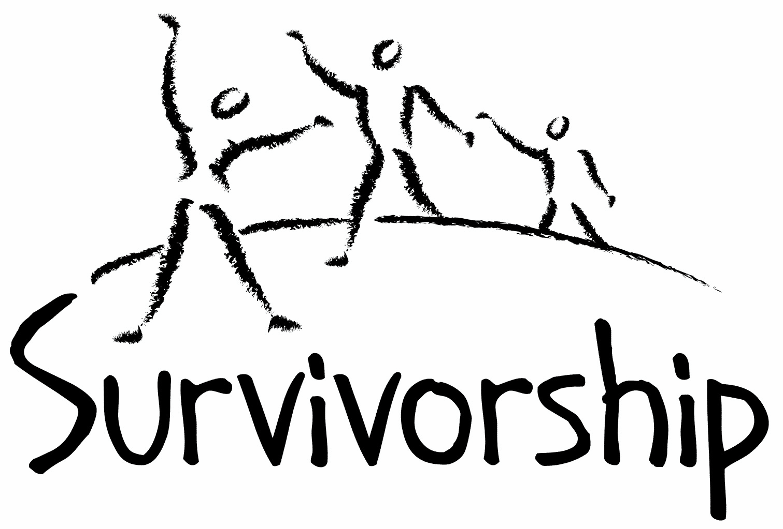
JOURNAL
For survivors of ritual abuse, mind control and torture, and pro-survivors

Copyright Information
SURVIVORSHIP JOURNAL, ISSN 046-2015, is published twice per year in Pacific Palisades, CA.

Copyright 2022 by Survivorship. All rights reserved. The entire contents of this issue are copyrighted by Survivorship and/by the individual contributors. No part of this publication may be reproduced or transmitted in any form or by any means, electronic or mechanical, including photocopying, or by any information storage and retrieval systems, without permission in writing by the copyright owners. For permission to reprint, write: Survivorship 881 Alma Real Drive Ste 311 Pacific Palisades, CA 90272 or email info@survivorship.org

Dear survivors, therapists treating surviving victims, support people and others:

In this issue we have articles by Randy Noblitt, Neil Brick and Rainer Kurz.

In February 2022 we started our webinar for clinicians, Healing the Unimaginable: A Ten-Session Course with Dr. Alison Miller, retired psychologist.
Alison Miller, Ph.D. is a retired clinical psychologist who practised in Victoria, B.C., Canada and worked with survivors of organized abuse, including ritual abuse and mind control from 1990 to 2017. She is the author of Healing the Unimaginable: Treating Ritual Abuse and Mind Control (for therapists) and Becoming Yourself: Overcoming Mind Control and Ritual Abuse (for survivors).
This course is based on Dr. Miller’s 2012 book Healing the Unimaginable: Treating Ritual Abuse and Mind Control.
Information is at: https://survivorship.org/survivorship-webinar-2022-healing-the-unimaginable-a-ten-session-course/

Table of Contents

Page Title and Author

3 Why Do People Deny Survivors’ Experiences?
Randy Noblitt

4 Boobies
Dr Rainer H. Kurz

6 A Survivor’s View of Recovery from Ritual Abuse
Neil Brick

Why do People Deny Survivors’ Abuse Experiences?
Randy Noblitt
Alliant International University

I graduated from the University of North Texas in 1978 with a PhD in Clinical Psychology. At that time there was not much professional literature about dissociation and child abuse. One of the highly regarded two-volume psychiatric texts, Kaplan and Sadock’s Comprehensive Textbook of Psychiatry provided no mention of childhood sexual abuse. Why was this important topic not given more attention? Why was it excluded from many of the published texts and journal articles? Even now, many licensed mental health professionals are unfamiliar with this topic.

Many clinicians are acquainted with what has come to be known as Sigmund Freud’s seduction theory. Although the idea was Freud’s, the terminology was proposed by Ernst Kris. Triplett (2004) described the evolution of this psychoanalytic idea that began with a recognition that sexual abuse had a role in the origins of what were then called neuroses. However, Freud was not able to prove this particular theory and he abandoned it for the alternate notion that children have sexual fantasies that might instead account for the sexual symbols and other related material that were found in the narratives of many of his patients. This became Freud’s psychosexual theory. Unfortunately for many, this theory set back the realization that child abuse is real and sadly common. Author Jeoffrey Masson described his own efforts to research documents in the Freud archives regarding this question. He published this book entitled The Assault on Truth: Freud’s Suppression of the Seduction Theory. In it, Masson argued that Freud knew about actual cases of child abuse, even instances of children who died because of their abuses. The Assault on Truth also further showed that the moment that Sigmund Freud first wrote of his disbelief in his theory that child abuse was a causal factor in various nervous conditions was while commenting about the case of Emma Eckstein with his colleague Wilhelm Fliess. Pam Noblitt and I discussed Emma Eckstein’s case as one with reported scenarios that some contemporary therapists would describe as characteristic of ritual abuse (Noblitt & Perskin; 1995, 2000; Noblitt & Noblitt; 2014). Did Freud become overly skeptical while hearing patient narratives of bizarre abuse with demonic themes? That is what has generally happened since the 1980s and 1990s when survivors began to share their stories of extreme abuse, and the media response has been generally critical of their veracity. Rather than promoting prejudiced opinions about this topic it would be more ethical for clinicians to thoroughly review the empirical literature and evaluate each case where allegations of abuse emerge on their own merits.

References
Masson, J. (1992). The assault on truth: Freud’s suppression of the seduction theory. HarperPerennial.

Noblitt, R. & Perskin, P. (1995). Cult and ritual abuse: Its history, anthropology, and recent discovery in contemporary America. Praeger.

Noblitt, R. & Perskin, P. (2000). Cult and ritual abuse: Its history, anthropology, and recent discovery in contemporary America, Revised Edition. Praeger.

Noblitt, R. & Noblitt, P. (2014). Cult and ritual abuse: Narratives, evidence, and healing
approaches (3rd ed.). Praeger.

Triplett, H. (2004). The misnomer of Freud’s “seduction theory.” Journal of the History of Ideas, 65(4), 647–665. http://www.jstor.org/stable/3654273

Boobies
Dr. Rainer Hermann Kurz
(may be triggering for survivors)

Short story by Dr. Rainer Hermann Kurz that was awarded the 1st Prize in a competition at UK site ‘Research Reform’ (https://researchingreform.net/) for describing the experience of a child in Social Services (SS) care from the child’s perspective.

My first 2 years had been great. Plenty of exciting things happening, lots of travel and the best boobies in the world. No dad around - but super mum and our two doggies. When my skin condition got bad mum took her £500 of savings and went south with me – she made it last 6 months. We got offered an air lift back to the UK from an elderly couple and stayed there for a few weeks. They seemed to know my mum but did not treat her kindly. Mum seemed scared of them – quite unusual for her as she is usually so courageous.

The old geezer turned nasty. Threw my mum out – but wanted to keep me. Within an hour we were out and at the local police station. The copper seemed to know – ‘he is dangerous’. Asked many questions and talked tosh. At last we got offered a place for the night. Soon after we went off to this wretched region where I am now – being taken hostage by bad people. I like to call it ‘Paedophilia’. They could devise a marketing slogan. ‘Do you like sex with children but feel misunderstood? Come to Paedophilia where authorities turn a blind eye as a masonic lodge is in charge.’

The first year in the region was actually good fun. Nice house. Nice friends. Nice nursery. However odd things started to happen and the old geezer turned up harassing us. My world was about to collapse.

One day I was taken out of my buggy as usual – but found myself suddenly in the hands of an old man. His breath smelled of smoke. He was saying strange things into my ear.

Suddenly I felt a pain in my backside. What the hell was that? Ants up my bum? Worms? A sausage? Perhaps a salami? The pain went on for a few minutes. Then the sausage was gone. Then it came back. The stranger’s voice said: ‘What they did to me was 17 times worse than this.’

My mum did not seem to notice what was happening. Little did I know that she did the only thing she could do in such overwhelming circumstances of extreme violence – she avoided eye-contact to reduce my trauma! She did not flee. She did not fight the stranger. She froze. Minimising the risk that he would abduct, drop, or injure me.

She knew I would be okay(’ish). That I would live. And that there was nothing she could do other than wait for the ordeal to be over. She had been there herself. Her body had – unconsciously – rapidly registered who that old man was. Her mind however was dissociating. Nature’s small mercy to survive unbearable suffering.

In the immediate aftermath she put me on boobies. Good distraction tactics I must say. Mum carried on in a ‘business as usual fashion’. Said that I was alright. Validating my trauma.

Glad she did not call the ‘professionals’ that arrived 1 month later. Ghastly people. Simply did not believe my mum. Did not believe me. I babbled and gesticulated that something went up my backside. The Health Worker said: ‘Shut up – you are getting your mum into trouble.’

Why? You see I am in the UK – a country that has strange ideas on how to protect children. The Golden Rule is that if a child got sexually attacked it is immediately removed as the mother obviously ‘failed to protect the child’. That’s the logic that the Expert Witnesses and the judge applied to ‘justify’ Forced Adoption. Sounds daft? Is daft! Rewards the abuse perpetrators as it separates the children from their loving and eagle-eyed mums, and ‘traffics’ them into the vagaries of ‘Forced Adoption’ and ‘Foster Care’.

To cut a long story short – I am now re-enacting the untreated trauma with a female toddler, and a freshly snatched baby arrived. My ‘Foster Family’ nets £60k per year tax free to ‘have us’. In my view they should be done for child neglect as my mum found in the Contact Sessions head lice on three occasions and several dermatitis spots that the foster carers missed. I suffered 5 chest infections in 15 months treated with anti-biotics. Never happened when I was with mum.

Interestingly (?) the Council’s medics ‘lost’ my blood sample. As a result I developed Blood Anaemia. In contact I just wanted boobies and then sleep. The Contact Supervisors berated my mum that this was not enough ‘stimulation’, and that this lazy approach would result in poor tick list results.

On another occasion the Social Worker allocated to me barged into the contact session demanding that mum should ‘phase out’ breast-feeding. Mum was upset about this attack, and even more so that the incident remained unrecorded.

The judge had a ‘wicked’ sense of humour. He asked my mum whether she was going to breastfeed me until I started University. I was only 3 years then, and hear that government generally promotes breast feeding. I realise now that everything is different in the SS (Social Services). Common sense and the laws of the land are replaced with a free-for-all. Oink, oink, oink.

One day I was brought to the Contact Centre but mum was not there. There were two strangers there. They took pictures of me. After a while I recognised them: These were the old couple from the place where we had stayed for a few weeks. The witch who had sent us to this forlorn part of the country, and the ‘sex magician’ who had thrown us out. Suddenly it dawned on me. The previous year after the air lift they had asked my mum to give me up for adoption but my brave mum resolutely refused. Looks like they came up with the ‘big idea’ of prompting a ‘Forced Adoption’, and getting rid of the ‘Adult Survivor’ at the same time!

The magician had used his combat expertise to orchestrate a defamation and harassment campaign that worked really well. It pulled the wool over everyone’s eyes. Police, Health Worker, Medics, Social Workers, Guardian, Psychiatrists, Clinical Psychologist, Solicitor, Senior Barrister, Judge – they all fell for the hood-winking (all-too-easily).

Just one person was not fooled by it. Mum had known this person for 10 years. She had sent a warning about the old geezer. The supporter came and eventually figured it all out - even with all the best intentions it took 100h until things ‘clicked’.

I hear that in the near future the authorities want to fast-track Forced Adoption. Down to a maximum of 26 weeks. That’s when our ‘hero’ arrived who started to turn things around – bit by bit facing down the cabal of Civil Service representatives who probably do not even know the Nolan Principles of Public Life let alone adhere to them.

I saw our supporter briefly at the end of what turned out to be my very last contact session (the judge said my mum was ‘too delusional to recognise being delusional’ – so she had to leg it). I showed him my ‘hoops’ trick.

In karmic terms there must be a reason for all this. So I need to suffer what there is to suffer, and enjoy what there is to enjoy. I am already a philosopher at my age and got ‘dissociation’ – that special gift of nature that protects me in all that nonsense. Missing the best boobies in the world though…
There are other boobies I would like to tell you about that are less pleasant. They are constructed by sick people who torture children. They ‘go off’ when the children or adults remember, and start to tell about their abuse – prompting suicide (attempts). My half-sister never got that far. She died shortly after birth (probably) at the hands of her own (grand-)father.

A Survivor’s View of Recovery from Ritual Abuse
Neil Brick

Presented at the 2019 Annual Ritual Abuse, Secretive Organizations and Mind Control Conference on August 17 – 18, 2019.

Please note: This presentation may be triggering for some survivors. None of the material on these pages or at the conference is meant as therapy, or to take the place of therapy.

Recovery from ritual abuse can take many years. Recovery may include working through memories, building functionality and developing more effective ways of interacting and integrating emotions. Every individual has different experiences that lead them through the recovery path. Neil will discuss his long journey healing from severe abuse. This will include ways he has learned more about himself, ways he has learned to develop healthier interactions with others and ways he has helped others along the recovery path.

Defining Terms:
(These are self defined. Not necessarily meant to be definitions for others.)

What is a survivor?
A person who has survived.

What did they survive?
In my case, severe trauma. An attempt to break my will and destroy my soul. Neither of which happened.

What is recovery?
Healing from an event. In my case, a lifelong battle to uncover myself from the damage done to me and the lies fed to me.

What is Ritual Abuse?

There are many definitions. Mine is severe abuse repeated in a ritualistic manner to manipulate and hurt others.
Recovery from ritual abuse can take many years.

Working through severe trauma takes a lifetime. There is always more to learn. There are always different ways to look at trauma and see how it has effected our lives.

Recovery may include working through memories.

We have to know our past to learn where we came from, how it effected us and how we can heal from the past.

Building functionality
How do we become more functional? Does this mean we become less damaged, more able to navigate the world we live in? Does this mean being able to work, to pay bills, to take care of our basic needs?

I have always been fairly good at these things. I have survived with minimal support all of my life. I have also helped others survive.

Developing more effective ways of interacting and integrating emotions.

How do we build awareness and improve our interactions? Are our interactions chaotic? Are we emotionally all over the place or blunted? Are we causing more damage in the world by our drama or are we moving toward a place of healing and peace we can present to others?

Bring all of our emotions together into one part of ourselves is very important. Having our ideas, voices and feelings in one place in our mind is crucial to healing and being aware. This development of the natural way we would have been without trauma allows us more effective ways of living with others and our world.

Every individual has different experiences that lead them through the recovery path. There are similarities in our paths, such as building an awareness of what happened, processing feelings about what happened and living a new way. There are differences, like following different recovery paths and using different techniques.

I will discuss my long journey healing from severe abuse. This will include ways I’ve learned more about myself, ways I’ve learned to develop healthier interactions with others and ways I’ve helped others along the recovery path. This journey will continue and includes the present moment. Never believe someone when they say they have fully healed. To me, Nirvana is not an end point but a process where progress has been made. The rosy picture of Nirvana is meant to attract people in the earlier stages of recovery.

Sorting out and clarifying what is in my mind has been the major part of my recovery. Being able to say that something is wrong, something needs to be fixed and things need to change is living without denial. Those that deny there is grave injustice in the world, that the United States is evil and is horribly flawed, that things are getting worse in the world are unable to see what is going on.

Those that need to join a group to think, to feel, to believe are drugging themselves. These are not healthy interactions. There is no way to really help others in these situations. One is teaching spiritual and intellectual death.

We can’t help others if we haven’t helped ourselves get better. Of course, this is a process. What is considered the 12th step in recovery programs (carrying the message to others) can be done at all levels of healing, but it is more effective with deeper healing.

One cannot truly help others if one is still programmed.

Those that have not worked through their memories and the connected parts of these can’t really help others. This applies to helping professionals as well. If one is not grounded, but is uncontrollably emotionally labile, or fear driven, they are not healed and present an unhealthy model.

What works for me?
Learning – always being willing to learn, wanting to know more, reading between the lines and not taking things as present value. Like the news we are given every day. Understanding why certain stories are given to us and others are never reported.

Understanding that programming runs from media and social control to controlling human beings by ritual abuse and mind control. We aren’t thinking for ourselves if we are copying others without analyzing our motives.

How others manipulate (unethical actions).

They control information. Important data about social injustice (poverty, hunger, lack of housing or health care) or severe child abuse is hidden from most of the public.

Bullying to silence the abused.

Name calling, insults, harassment, threats, creating false fear.

Ad hominem, off topic discreditation:
Instead of debating a person’s position, making fun of them or insult a point not related to their research to make them look bad

Attempt to destroy their professional status:
Destroy careers, licenses, ignoring the detrimental effects this may cause.
They have developed a severely distorted view of reality, the opposite of what is going on in the world.

Damage of negative philosophies and actions.

What we do and how we do it is more important than the results. (Means vs Ends)

We have built a world where disrespect is often the norm and encouraged.

This has developed due to an unmonitored Internet with almost no repercussions, the decay of family and social systems, the continued reliance on capitalistic economic systems and the increase and development of social propaganda and mind control techniques.

George Orwell:

War is peace. Freedom is slavery. Ignorance is strength.

Who controls the past controls the future. Who controls the present controls the past.

If liberty means anything at all, it means the right to tell people what they do not want to hear.

Political language. . . is designed to make lies sound truthful and murder respectable, and to give an appearance of solidity to pure wind.

Breaking free.

Recovering and growing regardless of social decay and the development and promotion of evil philosophies.
Follow your own path. Most paths are corrupted. Some that pretend to be just and fair are the opposite. Don’t get fooled by others. See things clearly.

Refuse to give in. Do what is right. Help others. Care about others. Give all you can of yourself to make things better. Things appear to be falling apart, at least here in America. More shootings, more roads falling apart, more homeless and lost people and more hate everywhere.

This does not stop personal growth. It can increase it and increase our awareness of how things are and what is right.

Do the right thing.

Neil Brick is a survivor of ritual abuse and mind control. His work continues to educate the public about child abuse, trauma and ritual abuse crimes. His child abuse and ritual abuse newsletter S.M.A.R.T. https://ritualabuse.us has been published for over 27 years. http://neilbrick.com

