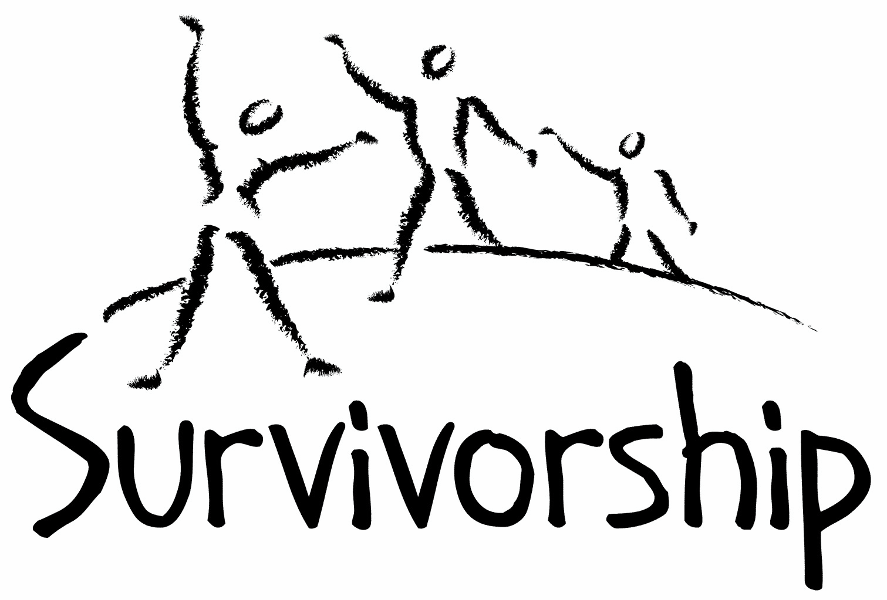

Vol. 199 No. 7 and 8 November/December 2021

The Notes, formerly called Chart Notes, ISSN 1523-275, is published bimonthly, copyright © 1999-2021 by Survivorship. All rights reserved. The entire contents of this issue are copyrighted by Survivorship and by the individual contributors. Please write Survivorship or E-mail info@survivorship.org for permission to reprint. Survivorship is a nonprofit organization.

Dear Friends,
Thank you for your continued support of Survivorship.
Survivorship would like to announce:
The Survivorship Ritual Abuse and Mind Control 2022 Online Conference - The International Evidence of Ritual Abuse Conference
Clinician's Conference - Friday May 20, 2022 - "Does Ritual Abuse Occur Internationally?" The clinical conference will present empirical evidence of ritual abuse.
Survivor Conference - Saturday and Sunday May 21 - 22, 2022 - The weekend survivor conference for survivors and their supporters will discuss breaking the global silence of ritual abuse and will provide resources and support for survivors.
More information will be posted about our conference in the upcoming months.
Conference information is at: https://survivorship.org/the-survivorship-ritual-abuse-and-mind-control-2022-conference/
Please remember to renew your membership if it is due. Information is at the end of this issue of the notes or at: https://survivorship.org/how-to-renew-your-membership/ Survivorship grows and survives with your help and support.

The Survivorship Board of Directors: Neil, Eileen, Randy, Elana and Laurie

Survivorship blog https://survivorshipwp.wordpress.com
Survivorship on Twitter https://twitter.com/Survivorshiporg
Survivorship on Facebook https://www.facebook.com/SurvivorshipRitualAbusePage
Trauma and Memory
The Science and the Silenced

Recently a new book was published about the False Memory Movement. Over the years, this movement has been extremely damaging for trauma, rape, child abuse and ritual abuse survivors and their helpers. This movement has used propaganda, bullying, harassment, disinformation and pseudoscientific research to bolster its claims. The False Memory Movement has been used to defend accused and convicted pedophiles, rapists and murderers.

Fortunately there have been many brave therapists, researchers and survivors that have spent years fighting the false memory movement’s pseudoscience, including inaccurate statements denying traumatic amnesia and denying the traumagenic origins of dissociative identity disorder.

This new book “Trauma and Memory - The Science and the Silenced” is an excellent resource for those who continue the fight against false memory disinformation. The book consolidates older historic information from Freud’s era, the 1980's and 1990's as well as newer research about more recent events.

Survivorship highly recommends this book. There is a hard copy and e-book available at the website below. “The abuse of science to silence the abused” by the false memory movement has been exposed once again. https://www.routledge.com/Trauma-and-Memory-The-Science-and-the-Silenced/Sinason-Conway/p/book/9781032044293

Trauma and Memory - The Science and the Silenced

Trauma and Memory will assist mental health experts and professionals, as well as the interested public, in understanding the scientific issues around trauma memory, and how this differs from other areas of memory.

This book provides accounts of the damage caused to psychology and survivors internationally by false memory groups and ideas. It is unequivocally passionate about the truth of trauma memory and exposing the damaging disinformation that can seep into the field. Contributors to this book include leading professionals from the field of criminology, law, psychology and psychotherapy in the UK and USA, along with survivor-professionals who understand only too well the damage such disinformation can cause.

This book is a valuable resource for mental health professionals of all disciplines including those involved with relevant law and public health policy. It will also help survivors and survivor-professionals in gaining insight into the forces resisting disclosure.

Editors - Biography
Valerie Sinason, PhD, is a widely published Writer and Psychoanalyst. She has pioneered disability and trauma-informed therapy for over 30 years, is President of the Institute of Psychotherapy and Disability, Founder and Patron of the Clinic for Dissociative Studies and on the Board of the ISSTD.
Ashley Conway, PhD, AFBPsS, is a Counselling Psychologist. He has worked in a wide range of fields of trauma, ranging through severe critical incidents to long term abuse, and has published widely in these areas. He is currently the Chair of the Clinic for Dissociative Studies in London, UK.
ISBN: 978-1-032-04432-3 (hbk) ISBN: 978-1-032-04429-3 (pbk)
ISBN: 978-1-003-19315-9 (ebk) DOI: 10.4324/9781003193159

Chapters include:
1 In conversation with Ross Cheit ASHLEY CONWAY
2 False memory syndrome movement: The origins and the promoters MARJORIE ORR
3 The rocky road to false memories: Stories the media missed LYNN CROOK
4 Re-examining the “Lost in the Mall”: study Were “false memories” created to promote a false defence? In conversation with Ruth Blizard VALERIE SINASON
5 Evaluating false memory research WINJA BUSS
6 The abuse of science to silence the abused ASHLEY CONWAY
7 False memory syndrome SUSIE ORBACH
8 Trauma, skin: memory, speech ANN SCOTT
9 Sigmund Freud's concept of repression: Historical and empirical perspectives BRETT KAHR
10 Terror in the consulting room – memory, trauma and dissociation PHIL MOLLON
11 How can we remember but be unable to recall? The complex functions of multi-modular memory MARY SUE MOORE
12 What if I should die? JENNIFER JOHNS
13 Finding a new narrative: Meaningful responses to “false memory” disinformation MICHAEL SALTER
14 “Do no harm”? KHADIJA ROUF AND DANNY TAGGART

ON-GOING MEETINGS AND TRAINING OPPORTUNITIES

Survivorship is presenting this as information only. If you choose to use one of these resources, please note that you are doing this at your own risk.

Dissociation & Trauma Clinical Discussions (DissTCD) list The Dissociation & Trauma Clinical Discussions (DissTCD) list has been created to allow for clinical discussions for all licensed mental health counselors and retired licensed mental health counselors around the world. To join: disstcd+subscribe@groups.io

ASCA (Adult Survivors of Child Abuse) On-going info@ascasupport.org www.ascasupport.org

Survivors of Incest Anonymous SIA holds 12-step meetings for incest survivors. Those designated “Nothing Too Heavy to Share” meetings are designed for ritual abuse survivors. 410-282-3400 http://www.siawso.org

Women’s Center, 46 Pleasant Street, Cambridge, MA Weekly and monthly groups for survivors of child sexual abuse, incest survivor’s interfaith quilt project, Survivors of Incest Anonymous, eating disorder support group, emotional healing group, more. info@cambridgewomenscenter.org Phone: 617-354-6394 Helpline. 617-354-8807 http://www.cambridgewomenscenter.org

The Childhelp National Child Abuse Hotline 1-800-4-A-CHILD (1-800-422-4453)
HOTLINES FAMILIAR WITH RA ISSUES
* Bay Area Women Against Rape (BAWAR): 510-845-7273
* San Francisco Women Against Rape (SFWAR): 415-647-7273
* Women’s Center, Cambridge, MA: 617-354-8807
Difficult Dates
Please use caution when reading this page. This page has words and dates that may remind survivors of their programming. This page summarizes dates that may be used by cults and various destructive groups. Abusive groups steal, pervert and mock the holidays of legitimate religions, holidays and cultures. This does not mean that all or even most people who observe some of these holidays are abusive.

November
11/1 All Saints' Day
11/1 Satanist High Holy Day
11/1-11/6 The Isia: six day ritual drama search for pieces of Osiris/feast of the Netherworld parting of the astral veil/resurrection of Osiris
11/2 All Souls’ Day (in honor of the dead) Santeria El Dia De Los Muertos
11/4 Kali Puja
11/4 New Moon
11/4 Diwali: Hindu: Festival of Lights: The end of Lord Rama’s exile killing of a demon by Krishna’s wife
11/4 Satanic Revels (sexual)
11/5 Guy Fawkes’ Day (UK)
11/7 Hilaria/Mania (Open of Mundus Cereris) rebirth of Osiris
11/9 Kristallnacht
11/11 Veteran’s Day (Armistice 1918)
11/11 Remembrance Day (Canada)
11/19 Guru Nanak Birthday
11/19 Full Moon
11/21 Christ the King
11/24 Martyrdom of Guru Tegh Bahadur Sahib
11/25 Thanksgiving (USA)
11/28 – 12/6 Hanukkah
11/28 - 12/24 Advent
11/30 St. Andrew’s Day

December
12/3 New Moon
12/6 St. Nicholas’ Day
12/8 Bodhi Day
12/14 Fast of Tevet/Holy Temple (Jewish) AM-PM
12/17-12/22 Saturnalia
12/18 Full Moon
12/18 St. Winebald’s Day (blood)
12/21 St. Thomas Day - Fire Festival, feast day, orgies
12/21 Yule/Winter Solstice
12/22 Ritual of the Elements and Feast of the Times
12/24 Christmas Eve/ Satanic Demons Revels/Da Meur/Grand High Climax rituals 5/include receiving body parts as Christmas gifts
12/25 Christmas Day
12/26 Boxing Day ( UK, Canada, Australia, New Zealand)
12/26 St. Stephen’s Day
12/28 Day of the Holy Innocents
12/31 Watch Night
12/31 New Year’s Eve/Hogmanay
News Articles
(Please note: some of these articles may contain violence or cult information)

R. Kelly Is Found Guilty of All Counts and Faces Life in Prison Sept. 27, 2021
Mr. Kelly’s conviction marked a stunning fall for a man who was once one of the biggest names in R&B music. It came after the first Me Too-era trial in which most of the victims were Black women.
The singer was convicted of federal racketeering and sex trafficking charges for a decades-long scheme to recruit women and underage girls for sex. Once one of the biggest names in popular music, he could face decades in prison.
The conviction of R. Kelly on all nine counts against him came as a significant moment in the Me Too movement for both Black women and for the music industry, ushering in a sense that, finally, justice had been served. https://www.nytimes.com/live/2021/09/27/nyregion/r-kelly-trial-news

R. Kelly made his victims write letters exonerating him. Instead, they helped convict him. Sept. 27, 2021 By Emily Palmer
Much of the evidence that prosecutors used to convict R. Kelly came from the singer himself.
He obsessively collected message slips and letters written by the women he interacted with — some of them underage — according to Ryan Chabot, the lead federal investigator in the case. Mr. Chabot said he sifted through the evidence recovered from several searches of the singer’s Chicago apartment and storage facility.
https://www.nytimes.com/live/2021/09/27/nyregion/r-kelly-trial-news
Grey Faction, Satanic Temple and Lucien Greaves Fact Sheet https://ritualabuse.us/ritualabuse/grey-faction-satanic-temple-and-lucien-greaves-fact-sheet/
Satanic Temple – Grey Faction Pseudoscience
Pseudoscience: Denial that memories can be repressed.
Pseudoscience: Denial that DID (Dissociative Identity Disorder) is caused by trauma.
https://ritualabuse.us/ritualabuse/satanic-temple-grey-faction-pseudoscience/

Doug Mesner (Lucien Greaves, Satanic Temple, Grey Faction) Anti-Semitic Statements, Eugenics Policy, Interview with former KKK member and neo-Nazi group founder
https://ritualabuse.us/ritualabuse/doug-mesner-lucien-greaves-satanic-temple-grey-faction-anti-semitic-statements-eugenics-policy-interview-with-former-kkk-member-and-neo-nazi-group-founder/

How to Renew your Membership
To find out when your membership renewal is due: if you receive our literature by mail, look at the label on your Notes or Survivorship journal. You may also write info@survivorship.org and ask. If you renew before you need to, we will just add the extra months onto your membership. Please try to keep your membership up to date.

You may renew here: https://survivorship.org/how-to-renew-your-membership/
This page as a link to paying with PayPal https://survivorship.org/membership-using-paypal/

Rates
The rates for a Survivorship membership are on a sliding scale based on ability to pay beginning from $75.00 down to what you can afford. We ask that health-care professionals contribute towards gift memberships. We regret that we are not able to provide services or include members under the age of 18.

Renewing
1. Decide if you want to read the Survivorship Journal and Notes on the web site (Internet Member) or receive the Journal by regular mail (let us know if you want to also receive the Notes by regular mail) (Regular Member).

2. Then choose how much you are able to pay. If you are a professional, we recommend that you donate $35.00 to support gift memberships for low-income survivors. We appreciate gifts so that we may offer support to survivors who are unable to work due to the after-effects of their abuse and to survivors who are imprisoned. All donations are tax deductible. We are a 501(C) corporation.

3. Decide whether you want to pay by check, money order, or PayPal. PayPal accepts charge cards. If you want to pay using PayPal, please copy and fill out the form below, email it to info@survivorship.org, and then click https://survivorship.org/membership-using-paypal/ to make your payment.

If you want to pay by check or money order, print out the form below and send it with your payment (in U.S. funds) to: Survivorship, 881 Alma Real Drive Ste 311, Pacific Palisades, CA 90272 USA

Name ________________________________________________________

Organization (if applicable) _______________________________________

City _________________________________________________________

State __________________ (Please add street address and zip code for non-internet memberships only.)

E-mail _______________________________________________________

Regular Membership: $__________ or Internet Membership $___________

Donation $_____________

Total enclosed $______________________

You may also e-mail the information on this form to info@survivorship.org

