Volume 25, Issue 12 Summer 2021

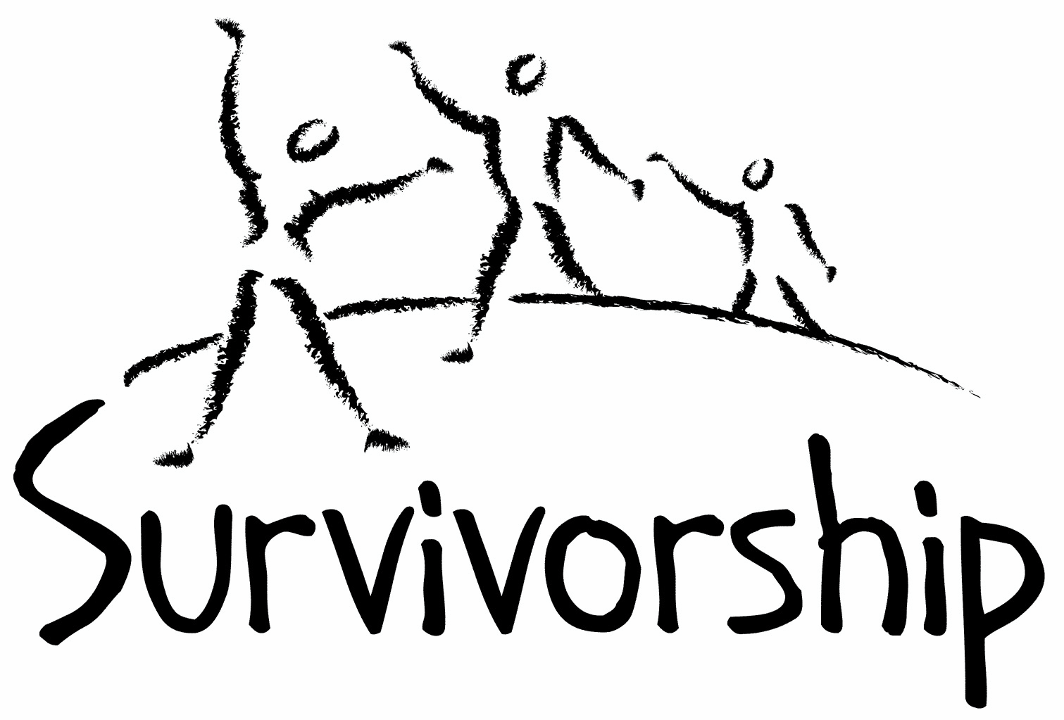
JOURNAL
For survivors of ritual abuse, mind control and torture, and pro-survivors

Copyright Information
SURVIVORSHIP JOURNAL, ISSN 046-2015, is published twice per year in Pacific Palisades, CA.

Copyright 2021 by Survivorship. All rights reserved. The entire contents of this issue are copyrighted by Survivorship and/by the individual contributors. No part of this publication may be reproduced or transmitted in any form or by any means, electronic or mechanical, including photocopying, or by any information storage and retrieval systems, without permission in writing by the copyright owners. For permission to reprint, write: Survivorship 881 Alma Real Drive Ste 311 Pacific Palisades, CA 90272 or email info@survivorship.org

Dear survivors, therapists treating surviving victims, support people and others:

In this issue we have articles by Randy Noblitt, Rainer Kurz and Neil Brick.

In May 2021 we had our second online Survivorship Ritual Abuse and Mind Control 2021 Conference which included a regular conference and a clinician's conference. Presentations are at: https://survivorship.org/the-survivorship-ritual-abuse-and-mind-control-2021-conference-presentations/
Speakers Included:

One Hundred Children: A Parable for Healing from Dissociation-savvy Mind Control - Ellen Lacter, Ph.D.
Dissociation of Identity and Trained Trauma-Mediated Behaviors - Randy Noblitt
Production of Sadistic Child abuse Materials: Psychology of the Victims and Perpetrators - Ellen Lacter, Ph.D.
Self-Esteem - Wendy Hoffman
Deliberate Disinformation in the Orkney ritual child abuse case - Sarah Nelson
Mind Control and How to Stop it - Neil Brick

Table of Contents

Page Title and Author

3 What is Evidence-Based Practice?
Randy Noblitt

4 Ritual Abuse Presentations at ESTD Conferences
Dr Rainer H. Kurz

7 Always Getting Stronger: Giving Survivors a Voice in the World
Neil Brick

What is Evidence-Based Practice?
Randy Noblitt
Alliant International University

The healthcare professions generally promote evidence-based practice (EBP). The reasons for this policy may seem obvious. There is a common expectation that treatment decisions should be guided by good science. Providing effective healthcare that is based on evidence may sound like a simple task; but in many ways, it is confusing and unclear.

On the other hand, there are varying degrees of confidence in the reliability of research, and numerous problems in interpretating these studies. A serious problem is that published research results are often incorrect (Ioannidis, 2005). Biases of the researchers, e. g., confirmatory or allegiance bias (Coyne & Kok, 2014; Munder et al. 2011) as well as publication bias (Wagner, 2021) are common and potentially invalidating. Researchers who advocate for a particular theory are more likely to get research results that favor that theory as compared to researchers with a different point-of-view. Scholarly journals are more likely to publish research with statistically significant results while rejecting studies with statistically non-significant outcomes. Further, research conclusions are not always consistent with one another. According to Frank Hillary and John Medaglia “study reproducibility in psychology hovers at 40%” (2020, p. 3). This is what some authors and clinicians are calling a “replication crisis” (Shrout and Rodgers, 2018). When research results cannot be repeated it may be inferred that they are unreliable or invalid.

The American Psychological Association (APA) has defined evidence-based practice in as “the integration of the best available research with clinical expertise in the context of patient characteristics, culture, and preferences” (APA Presidential Task Force on Evidence-Based Practice, 2006, p. 273). The APA also distinguished evidence-based practice from empirically supported treatments (ESTs) that “are specific psychological treatments that have been shown to be efficacious in controlled clinical trials” (2006, p. 273). Many clinicians as well as members of the public confuse evidence-based practice and empirically supported treatment; and assume that any treatment with good research support qualifies it as evidence-based (Laska et al., 2014). As previously stated, this is not the case; research outcomes must be integrated with the clinician’s expertise and the client’s individual characteristics, culture, and preferences. In accommodating to clients’ unique characteristics, culture, and preferences, evidence-based-practice requires some degree of developing a “new therapy for each client in collaboration with that client” (Norcross and Cooper, 2021, p. 6).

Despite the controversies associated with psychological research and theories, most clients generally improve while in psychotherapy (American Psychological /Association, 2013). The specific psychotherapy categories or brand names (e.g., psychodynamic, cognitive-behavior therapy, etc.) seem to have less to do with the clients’ success in therapy (American Psychological Association, 2013) than some of the common factors associated with most psychological treatment approaches, especially the therapeutic alliance.

References
American Psychological Association. (2013). Recognition of psychotherapy effectiveness. Psychotherapy, 50(1), 102–109. https://doi.org/10.1037/a0030276
APA Presidential Task Force on Evidence-Based Practice. (2006). Evidence-based practice in psychology. American Psychologist, 61(4), 271–285. https://doi.org/10.1037/0003-066X.61.4.271
Coyne, J. C., & Kok, R. N. (2014). Salvaging psychotherapy research: A manifesto. Journal of Evidence-Based Psychotherapies, 14(2), 105–124.
Hillary, F. G., & Medaglia, J. D. (2020). What the replication crisis means for intervention science. International Journal of Psychophysiology, 154, 3–5. https://doi.org/10.1016/j.ijpsycho.2019.05.006
Ioannidis, J. (2005). Why most published research findings are false. PLOS Medicine, 2(8), Article e124. https://doi.org/10.1371/journal.pmed.0020124
Kinsler, P. J. (2014). Relationships redux: Evidence-based relationships. Journal of Trauma & Dissociation, 15, 1–5, https://doi.org/10.1080/15299732.2013.852420
Laska, K. M., Gurman, A. S., & Wampold, B. E. (2014). Expanding the lens of evidence-based practice in psychotherapy: A common factors perspective. Psychotherapy, 51(4), 467–481. https://doi.org/10.1037/a0034332
Munder, T., Gerger, H., Trelle, S., & Barth, J. (2011). Testing the allegiance bias hypothesis: A meta-analysis. Psychotherapy Research, 21(6), 670–684. https://doi.org/10.1080/10503307.2011.602752
Norcross, J. C., & Cooper, M. (2021). A new psychotherapy for each patient. In J. C. Norcross & M. Cooper, Personalizing psychotherapy: Assessing and accommodating patient preferences (pp. 3–19). American Psychological Association. https://doi.org/10.1037/0000221-001
Open Science Collaboration. (2015, Aug 28). Estimating the reproducibility of psychological science. Science, 349(6251), 1–8. http//dx.doi.org/10.1126/science.aac4716
Shean, G. D. (2015). Some methodological and epistemic limitations of evidence-based therapies. Psychoanalytic Psychology, 32(3), 500–516. https://doi.org/10.1037/a0035518
Shrout, P. E., & Rodgers, J. L. (2018). Psychology, science, and knowledge construction: Broadening perspectives from the replication crisis. Annual Review of Psychology, 69, 487–510. https://doi.org/10.1146/annurev-psych-122216-011845
Wagner, J.A. (2021). The influence of unpublished studies on results of recent meta-analyses: publication bias, the file drawer problem, and implications for the replication crisis, International Journal of Social Research Methodology. https://doi.org/10.1080/13645579.2021.1922805

Ritual Abuse Presentations at ESTD Conferences
Dr Rainer H. Kurz
C. Psychologist
London

Buoyed by attending the Survivorship conference for three evening a few weeks ago I decided to write a short article about conferences of the European Society for Trauma and Dissociation (ESTD) that I attended and share various presentations by including the ResearchGate download link.

In my day job I am an Industrial & Organizational Psychologist based in London who develops personality, ability and competency assessment tools that are deployed by major employers and consultancies in the context of Human Resources activities such as recruitment, selection, and development.

In June 2012 I stumbled across an unusual case where a mother reported a sexual assault on her toddler. The mother disclosed that she was also raped as a toddler by her father. Authority paperwork documented that it was medically proven that her toddler’s half-cousin was raped by a stranger when playing at the bottom of the garden a few years earlier. In October 2010, the toddler’s half-aunt succumbed to a sudden death – ostensibly due to alcoholism. A few months later the toddler’s nursery teacher’s friend was found dead in a village river on December 28, and a row of cottages overlooking that location went up in flames four weeks later, on 29 January 2011:
https://www.walesonline.co.uk/news/local-news/police-find-womans-body-river-1882719
https://www.bbc.co.uk/news/uk-wales-12314741

In between on 17th January 2011 the toddler’s godmother was found dead in the hallway of her burnt out house!
Nevertheless, authority representatives disbelieved her account of the toddler assault. Tame psychiatrists and psychologists claimed that she was delusional about this incident. I volunteered to talk to the mother before sitting in on a ‘final’ assessment session with a clinical psychologist. The mother eloquently described her upbringing with harsh and punitive parents. When asked about sexual abuse she relayed an incident she started to remember in her early 20s where her father locked her out of the flat at about 4 years of age and the downstairs neighbour took advantage. She briefly described feeling something on her back which I recognized as ‘being humped’. The clinical psychologist claimed that her account was ‘confused’ and simply wrote down her disclosure that she was abused by her father “from birth to age 20” without asking any follow up questions.
In a follow up support call the mother dropped the ‘bombshell news’ that she had a baby as a young teenager and that the baby disappeared. I had to research what disappearing babies are about and thus started to encounter Satanist Ritual Abuse (SRA) literature.

ESTD Conference Copenhagen 2014
At my first trauma conference I felt very comfortable in the presence of like-minded people. I was particularly impressed by the three sessions run by Ellert Nijenhuis - co-author of ‘The Haunted Self: Structural Dissociation and the Treatment of Chronic Traumatization’.

I presented on my activities as a volunteer ‘case manager’. I used 20+ years of personality assessment experience to counter the ‘delusional’ claims and used the incredibly helpful Lacter & Lehmann (2008) guidelines for differentiating complex trauma from schizophrenia. Colin Ross, the leading US specialist on dissociation, who presented in the same session nodded approvingly. Good.
https://www.researchgate.net/publication/279975389_True_Traumas_-_Top_Ten_Tips_for_Case_Management

ESTD Conference Bern 2017
The next ESTD presentation I attended was 2017 in Bern. Imagine my surprise (and horror) when I picked up my locally printed poster next to the “Kinderfresser Brunnen” (‘Children-Eater Fountain’) which I then depicted on one of my papers there:
https://www.researchgate.net/publication/321138144_An_Organised_Ritualised_Crime_Abuse_Network_ORCAN_in_the_British_Isles

I had successfully convened a symposium, but two survivor/activist presenters pulled out due to risks (financial and otherwise). I managed to cajole another work personality expert, who specialises in the assessment of personality over-extensions and had encountered abuse situations, to join me and thus rescue my symposium.
In the first paper I outlined four cases I investigated where UK Family Court experts in inexplicable ways claimed that mothers had a mental illness and thus removed their custody rights of their children. Prof Jane Ireland (2012) found that 2/3 of psychological assessment reports trawled from UK Family Courts were “poor” or “very poor.”
https://www.researchgate.net/publication/321138059_Challenging_Inadequate_Assessments_and_the_'Discourse_of_Disbelief'

In the last paper of the symposium (see ORCAN URL above) I relayed further details of the original case I encountered in 2012 and shared pictures I took in December 2013 at the burnt out house of the toddler’s godmother. Through a fluke coincidence I had been able to work out from an email list her website and obtain from family members many official documents. Why was she found with broken legs and broken arm in the house entrance hall ‘on top of rooftiles’? Why was someone in a ‘little blue car’ giving a witness a lift ‘back up to the burning house’? On site I found a grey indicator shell that belonged to a SEAT Arosa Mark 1. I found a drugs bottle in the windowsill. I found drinks and other containers. I found a strange object with transformer, metal and plastic bits – an incendiary device? How could half a dozen police officials ‘overlook’ these items? Why do police representatives at local, regional, and national level continue to ignore the evidence?
The poster I presented depicted an incident the mother disclosed at age 8 where she was forced to have sex with another girl on a stage somewhere in Ireland. I also showed excerpts of medical records that the absence of medical general practitioner entries made the claim of a pregnancy at age 13 followed by “home schooling” and “home birth” at 14 credible.
https://www.researchgate.net/publication/321137852_COMPLEX_TRAUMA_SOMATOFORM_DISSOCIATIONS_PSYCHOMETRIC_ASSESSMENT

Finally, I presented a paper on shenanigans at the British Psychological Society (BPS) where senior officials routinely promote views of the False Memory lobby:
https://www.researchgate.net/publication/321138130_Lost_Memories_False_Prophets_BPS_Guidelines

ESTD Conference Rome 2019
“All roads lead to Rome” is an old saying. And indeed, trauma thought leaders came from all over Europe to the EURO quarter which Mussolini had built for an EXPO that never happened due to WW2. I was as usual very impressed with Ellert Nijenhuis who shared very touching anecdotes about his son and about a female patient who was exclaiming “all is red.”

In Rome I had convened a symposium where I was joined by Survivor-Activist Declan Howard, who presented his first ever conference paper, and Ellen Lacter.
For my paper that kicked off the symposium I had transcribed a 10 minute C-PTSD assessment session with a suitable qualified trauma psychologist where the mother was asked to list all traumas she remembers at headline level in roughly chronological order. She rattled of 67 incidents about 2/3 of which I was already aware of through disclosure in private. I finished the presentation with further details on how authority representatives decline to investigate the death of the toddler’s godmother who was found dead in her burnt out house – which was not properly secured and preserved as a crime scene in spite of obvious indication for a hit-drug-arson murder. https://www.researchgate.net/publication/337001751_The_Legacy_of_Satanist_Ritual_Abuse_SRA_Trauma_Mind_Control_A_C-PTSD_Assessment_Case_Study

Declan presented ‘Seeing Invisible Wounds – A Bioenergetic Understanding of Systematic Trauma:
https://www.researchgate.net/publication/337012604_Seeing_Invisible_Wounds_-_A_Bio-Energetic_Understanding_of_Systematic_Trauma

Ellen Lacter kindly provided a video recorded presentation on one of the hardest topics in the grim world of extreme abuse – Forced Perpetration. http://endritualabuse.org/coerced-under-torture/

In the Q&A session that followed Valerie Sinason endorsed our work and our presentations.
Declan presented another paper on criminality as the cause of mental health problems:
https://www.researchgate.net/publication/337012704_Criminality_As_A_Cause_Of_Mental_Health_Problems_-_Informing_The_Aetiology_Of_Mental_Illness_With_Survivors'_Accounts

I presented a paper on False Memories co-authored by Ashley Conway where we previewed selected content of a chapter in a book that he is editing with Valerie Sinason about issues with the False Memory lobby. It revisits a chapter on the topic he wrote some 20 years ago.
https://www.researchgate.net/publication/337000312_Kurz_Conway_2019_ESTD_Paper_Recovered_Memories_Revisited

Ruth Blizzard presented a powerful paper deconstructing the vastly over-rated ‘lost in the mall’ study of Elizabeth Loftus.
ESTD-UK Conference Norwich 2017 & York 2019
I was pleased to attend the ESTD-UK 2017 conference as a delegate where three papers centred on Ritual Abuse.
At the ESTD-UK 2019 conference I presented a poster mapping out the approximate location of:
A, the violent deaths of six adults
B, disappearance of two new-born babies
C, three toddler rapes
https://www.researchgate.net/publication/332719777_COMPLEX_TRAUMA_SOMATOFORM_DISSOCIATIONS_RE-VICTIMISATION_A_UK_FAMILY_COURT_CASE_STUDY

Several people commented positively including a survivor-activist of the First Person Plural team.
I hope that this brief overview of inputs at various ESTD conferences is of some use. I would be pleased to hear from others who are supporting Ritual Abuse survivors and from survivors.

Always Getting Stronger: Giving Survivors a Voice in the World
Neil Brick
This is a transcript from a speech at the 2011 Ritual Abuse Conference.
The Child Abuse Survivor Movement has been under strong attack for the last twenty years. At the same times, it has grown stronger and developed a strong research base. Survivors that have healed are now able to help other survivors that are beginning to heal from ritual abuse. Many survivors now have blogs and web pages telling their stories and presenting the research that backs up their stories.
Many of the child abuse crimes of the past that were either ignored, seen as acceptable or covered up, are now given coverage in the media, seen as detrimental to children and society and the cover ups are now being exposed.
Child abuse is seen by most media outlets and researchers as being clearly traumatic. Most understand that the traumatic effects of child abuse cause clear symptoms that are detrimental to child abuse survivors. Those that misrepresent the fact that child abuse trauma symptoms are some sort of myth have been rebutted and answered.
Those attacking the child abuse survivor field and child abuse research have picked and chosen the less believable aspects of the field to attack, like ritual abuse and dissociation, especially dissociative identity disorder (formerly called multiple personality disorder.)
They have misrepresented the research, literature and criminal cases in both areas, ignoring the large research base showing that both ritual abuse and dissociative identity disorder are realities. They claim that those that believe in dissociation, hurt the child abuse research field, yet most that claim this actually do little or nothing to try and stop child abuse crimes.
Some of those skeptical of certain child abuse crimes insult and harass those working in the child abuse field in an attempt to silence them. There are several documented occurrences of this on the Internet and in the literature. This harassment is meant to silence those that attempt to expose different child abuse crimes, including those in the fields of ritual abuse, dissociation and trauma.
Other skeptics have done whatever they can to make sure that accurate research on child abuse and ritual abuse crimes does not make it into the public arena. It has been difficult at times to get accurate information into the media and mainstream websites.
The problem of survivors getting a voice to speak out with all of this going on is problematic.
How do we as researchers and survivors organize and demand if necessary in large enough numbers that:
1) The media needs to cover the issue of ritual abuse and dissociation more thoroughly and fairly.
2) The misinformation about certain ritual abuse crimes and dissociative identity disorder is accurately rebutted with our own scientific research.
3) Those that insult and harass researchers in our field are accurately exposed and that the techniques they use to unfairly manipulate public opinion are also exposed.
How do we develop a common voice strong enough to withstand the attacks on our movement?
1) Organize
a) Develop a group solely dedication to research and advocacy.
One that will develop a research base that will cover all of the child abuse cases and books of the last thirty years and then make this public to rebut all of the misinformation that has been made public about these cases.
2) Speak out
a) Make sure that everyone hears our side of the story.
Everyone gets a blog and/or a web page. They put their story on it and list all of the research in our field that backs their story.
3) Debate when necessary and when prudent.
Our voices are not heard in the public arena. Repeated attacks on the realities of the crimes committed against us are not answered. We need to answer every attack, with letters to the editor, our own articles, our own comments, our own web pages.
We have a choice. We can be silent, or we can all organize. I propose we organize. I propose we start a group today, right now, that will work on developing a research base to answer every skeptics’ response to the crimes committed against us. I propose that every one of us create their own website and conference in their own area to educate the public about ritual abuse crimes. I propose that we have regional groups across the country linked together working to expose these crimes.
I propose that each and every one of us commit 30 minutes a day to doing this. We can organize by e-mail and develop advocacy groups. We all need to decide what kind of world we want to see in twenty years. One where children are abused and not believed, or one where children aren’t abused and those that abuse them are held accountable.
No one will fight our battles for us. We need to fight them ourselves. Let’s start now. We can change the world and our voices will be heard. We will no longer be silenced. Those that attack us and spread misinformation about the crimes committed against us will be answered.

