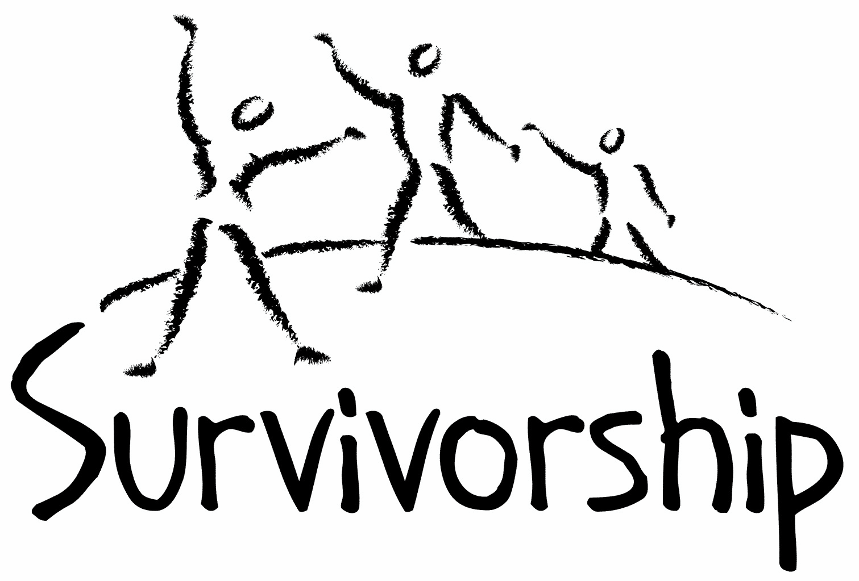

Vol. 199 No.1 and 2 May/June 2021

The Notes, formerly called Chart Notes, ISSN 1523-275, is published bimonthly, copyright © 1999-2021 by Survivorship. All rights reserved. The entire contents of this issue are copyrighted by Survivorship and by the individual contributors. Please write Survivorship or E-mail info@survivorship.org for permission to reprint. Survivorship is a nonprofit organization.

Dear Friends,
We will be having an online conference in May 21-23, 2021. The conference topic is: “Being a survivor or clinician in a changing world.” The world is changing very quickly with the COVID, climate change and economic stresses. Presentations will focus on ways survivors and clinician can survive and function better in this changing world. https://survivorship.org/the-survivorship-ritual-abuse-and-mind-control-2021-conference/
SMART will have its 2021 Online Annual Ritual Abuse, Secretive Organizations and Mind Control Conference on August 14 – 15, 2021 - Internet conference information:
http://ritualabuse.us/smart-conference/
Please remember to renew your membership if it is due. Information is at the end of this issue of the notes.
Information is at: https://survivorship.org/how-to-renew-your-membership/
Survivorship grows and survives with your help and support.

The Survivorship Board of Directors: Neil, Eileen, Randy, Elana and Laurie

Survivorship blog https://survivorshipwp.wordpress.com
Survivorship on Twitter https://twitter.com/Survivorshiporg
Survivorship on Facebook https://www.facebook.com/SurvivorshipRitualAbusePage

Survivorship announces new speakers for its
2021 Ritual Abuse and Mind Control Online Conference.

This year's presenters: Neil Brick, Wendy Hoffman, Ellen Lacter, Randy Noblitt, Sarah Nelson, Elana Christensen, Eileen Aveni and Annika Lundin

Conference Website:
https://survivorship.org/the-survivorship-ritual-abuse-and-mind-control-2021-conference/
Conference will be May 21 - 23, 2021.

Neil Brick will speak about Mind Control and How to Stop it. This presentation will explain how mind control and different suggestive techniques work in a variety of settings.

Neil Brick is a survivor of ritual abuse and mind control. https://ritualabuse.us
http://neilbrick.com

Wendy Hoffman will speak about Self Esteem and Programming.

Wendy Hoffman endured various forms of high level secret mind control, and consequently had amnesia for most of her life. https://ritualabuse.us/smart/wendy-hoffman

Dr. Ellen Lacter will speak about One Hundred Children: A Parable for Healing from Dissociation-savvy Mind Control and Production of Sadistic Child abuse Materials: Psychology of the Victims and Perpetrators.

Ellen Lacter is a licensed Clinical Psychologist in private practice. She has been publishing and presenting on ritual abuse for 20 years.
https://endritualabuse.org https://ritualabuse.us/smart/ellen-lacter/

Dr. Randy Noblitt will present Institutional Child Abuse: A Panel Presentation and General Discussion. This Panel presentation discusses a topic depicted in popular media, institutional child abuse and Dissociation of Identity and Trained Trauma-Mediated Behaviors.

Randy Noblitt is a clinical psychologist and professor of clinical psychology. https://ritualabuse.us/smart/randy-noblitt/

Sarah Nelson will speak about Deliberate Disinformation in the Orkney ritual child abuse case

The Orkney child abuse case, was a highly publicised case in the UK from 1991 - 1992, had the 30th anniversary in February this year of nine children being removed into care in "dawn raids" by police and social workers.

Dr. Sarah Nelson OBE has written and presented widely for decades on sexual abuse issues.

How to Find A Therapist - An Interactive Discussion Group
Elana Christiansen is a psychotherapist in private practice in California seeing clients experiencing trauma symptoms and dissociation.

Olivia will speak about You're Not Who They Said You Are: My Battles For Freedom and Justice Through Perseverance and Exposing the Truth
She will be giving a broad overview of surviving 40 plus years of satanic ritual abuse and mind control

Olivia is a survivor of satanic ritual abuse and mind control at the government level.

Other panelists and moderators include:
Annika Lundin, a doctoral student pursuing her degree in clinical psychology and Eileen Aveni LMSW, LCSW, ACSW, BCD a psychotherapist

https://survivorship.org/

ON-GOING MEETINGS AND TRAINING OPPORTUNITIES

More information is available at https://survivorship.org/community-calendar-of-events/

Survivorship is presenting this as information only. If you choose to use one of these resources, please note that you are doing this at your own risk.

Dissociation & Trauma Clinical Discussions (DissTCD) list
The Dissociation & Trauma Clinical Discussions (DissTCD) list has been created to allow for clinical discussions for all licensed mental health counselors and retired licensed mental health counselors around the world. To join: disstcd+subscribe@groups.io
Organized and Extreme Abuse SIG The Organized and Extreme Abuse Special Interest Group (OEA SIG) of the International Society for the Study of Trauma and Dissociation (ISSTD) was approved by ISSTD’s Executive Council in 2008. The Mission of the OEA SIG is to further dialogue, knowledge, research, and training on the etiology, evaluation, and effective treatment of trauma and dissociation in clients reporting histories of ritual abuse or mind control. https://www.isst-d.org/join-isstd/special-interest-groups/ramcoa-sig/
ASCA (Adult Survivors of Child Abuse) On-going info@ascasupport.org www.ascasupport.org

Survivors of Incest Anonymous SIA holds 12-step meetings for incest survivors. Those designated “Nothing Too Heavy to Share” meetings are designed for ritual abuse survivors. 410-282-3400 http://www.siawso.org

Women’s Center, 46 Pleasant Street, Cambridge, MA Weekly and monthly groups for survivors of child sexual abuse, incest survivor’s interfaith quilt project, Survivors of Incest Anonymous, eating disorder support group, emotional healing group, more. info@cambridgewomenscenter.org Phone: 617-354-6394 Helpline. 617-354-8807 http://www.cambridgewomenscenter.org

The Childhelp National Child Abuse Hotline 1-800-4-A-CHILD (1-800-422-4453)
HOTLINES FAMILIAR WITH RA ISSUES
* Bay Area Women Against Rape (BAWAR): 510-845-7273
* San Francisco Women Against Rape (SFWAR): 415-647-7273
* Women’s Center, Cambridge, MA: 617-354-8807

Difficult Dates
Please use caution when reading this page. This page has words and dates that may remind survivors of their programming. This page summarizes dates that may be used by cults and various destructive groups. Abusive groups steal, pervert and mock the holidays of legitimate religions, holidays and cultures. This does not mean that all or even most people who observe some of these holidays are abusive.

May
5/1 May Day (Ireland)
5/1 is the Illuminati’s second most sacred holiday and may include human sacrifice
5/5 Cinco de Mayo
5/8 V-E Day
5/9, 5/11, 5/13 Lemuria (three days Roman All Souls)
5/9 Laylat al Qadr
5/9 Mother's Day
5/11 New Moon
5/12 - 5/13 Eid-al-Fitr (End of Ramadan)
5/13 Ascension Day, Ascension of Jesus
5/15 Armed Forces Day
5/16 - 5/18 Shavout
5/16 - 5/18 Shavuot
5/23 Pentecost
5/24 Victoria Day
5/26 Full Moon
5/26 Vesak - Buddha Day
5/29 - 5/30 Lag BaOmer
5/30 Memory day dedicated to Joan of Arc
5/30 Trinity Sunday
5/31 Memorial Day

June
6/3 Corpus Christi – feast to mock the body & blood of Christ in Christian ritual
6/6 D Day (invasion of France in WW2)
6/7 Queen Elizabeth’s birthday (New Zealand)
6/10 Savitri Pooja
6/10 New Moon
6/12 Queen Elizabeth’s birthday (Australia except Queensland & West Australia)
6/14 Queen Elizabeth’s birthday (West Australia)
6/15 Saint Vladimir
6/16 Martyrdom of Guru Arjan Dev Sahib
6/20 Summer Solstice (orgies blood)
6/20 Father's Day
6/21 Rituals of the Elements and Feast of the Times
6/21 First Nations Day - Canada
6/23 St. John’s Eve Fire Festival
6/24 Full Moon
6/24 Midsummer’s Eve
6/29 Saints Peter and Paul
News Articles
(Please note: some of these articles may contain violence or cult information)

Elizabeth Loftus
– A Brief History of the False Memory Research of Elizabeth Loftus
– Ethics Complaints Filed Against FMSF Board Member Elizabeth Loftus
– “Lost in a Shopping Mall” A Breach of Professional Ethics
– Quotes: Elizabeth Loftus, Ph.D.
– The Alleged Ethical Violations of Elizabeth Loftus in the Case of Jane Doe
https://ritualabuse.us/smart/elizabeth-loftus/

Michelle Remembers
Verification of the accuracy of the book “Michelle Remembers”
by Michelle Smith and Lawrence Pazder, MD
https://ritualabuse.us/ritualabuse/articles/michelle-remembers/

Sex offenders sue state after being denied leftovers from their Satanic feast
Clark Kauffman Iowa Capital Dispatch March 5, 2021
A group of convicted sex offenders is suing the state of Iowa, claiming their right to worship Lucifer with a weeklong feast of fried chicken, doughnuts and ice cream is being violated.
https://www.desmoinesregister.com/story/news/2021/03/05/sex-offenders-sue-state-after-being-denied-leftovers-their-satanic-feast-jail-prison-meals/4600133001/

Man who said he killed his girlfriend on behalf of ‘Satan’ takes plea deal
October 16, 2020 Kayla Crandall” https://wpta21.com/2020/10/16/man-who-said-he-killed-his-girlfriend-on-behalf-of-satan-takes-plea-deal/

Former Boarding School Owners Facing 102 Charges In 'Horrific' Child Abuse Case
“[It’s] one of the most widespread cases of sexual, physical and mental abuse patterns against young girls and women in Missouri history” By Dorian Geiger March 12, 2021
https://www.oxygen.com/crime-news/boyd-and-stephanie-householder-facing-102-child-abuse-charges

Facebook apps used in more than half of online child sex crimes
By Jonathan Wilson Friday, March 26, 2021 More than half of the online child sex crimes in one year took place on Facebook-owned apps, according to data from the NSPCC, as the charity called for more to be done to tackle abuse in private messaging.
https://eandt.theiet.org/content/articles/2021/03/facebook-apps-used-in-more-than-half-of-online-child-sex-crimes-says-nspcc/

How to Renew your Membership

To find out when your membership renewal is due: if you receive our literature by mail, look at the label on your Notes or Survivorship journal. You may also write info@survivorship.org and ask. If you renew before you need to, we will just add the extra months onto your membership. Please try to keep your membership up to date.

You may renew here: https://survivorship.org/how-to-renew-your-membership/
This page as a link to paying with PayPal https://survivorship.org/membership-using-paypal/

Rates
The rates for a Survivorship membership are on a sliding scale based on ability to pay beginning from $75.00 down to what you can afford. We ask that health-care professionals contribute towards gift memberships. We regret that we are not able to provide services or include members under the age of 18.

Renewing
1. Decide if you want to read the Survivorship Journal and Notes on the web site (Internet Member) or receive the Journal by regular mail (let us know if you want to also receive the Notes by regular mail) (Regular Member).

2. Then choose how much you are able to pay. If you are a professional, we recommend that you donate $35.00 to support gift memberships for low-income survivors. We appreciate gifts so that we may offer support to survivors who are unable to work due to the after-effects of their abuse and to survivors who are imprisoned. All donations are tax deductible. We are a 501(C) corporation.

3. Decide whether you want to pay by check, money order, or PayPal. PayPal accepts charge cards. If you want to pay using PayPal, please copy and fill out the form below, email it to info@survivorship.org, and then click https://survivorship.org/membership-using-paypal/ to make your payment.

If you want to pay by check or money order, print out the form below and send it with your payment (in U.S. funds) to: Survivorship, 881 Alma Real Drive Ste 311, Pacific Palisades, CA 90272 USA

Name ________________________________________________________

Organization (if applicable) _______________________________________

City _________________________________________________________

State __________________ (Please add street address and zip code for non-internet memberships only.)

E-mail _______________________________________________________

Regular Membership: $__________ or Internet Membership $___________

Donation $_____________

Total enclosed $______________________

You may also e-mail the information on this form to info@survivorship.org

