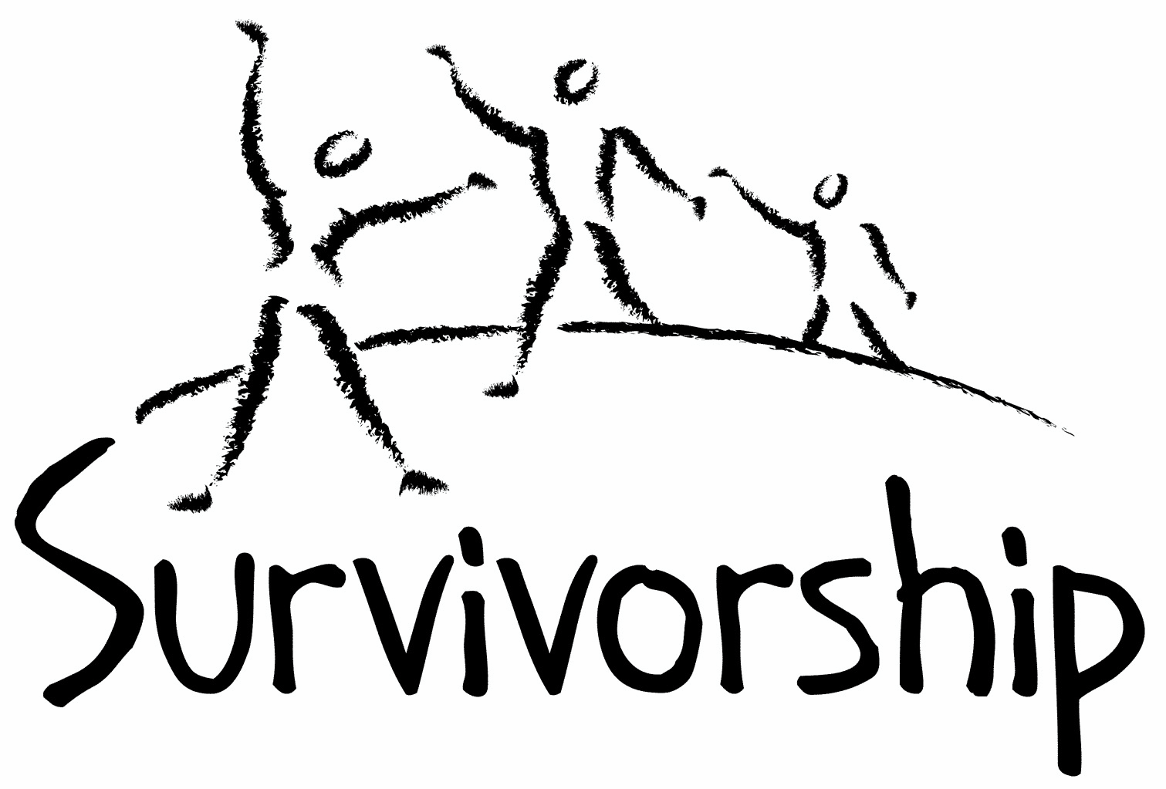

Vol. 198 No.11 and 12 March/April 2021

The Notes, formerly called Chart Notes, ISSN 1523-275, is published bimonthly, copyright © 1999-2021 by Survivorship. All rights reserved. The entire contents of this issue are copyrighted by Survivorship and by the individual contributors. Please write Survivorship or E-mail [info@survivorship.org](mailto:info@survivorship.org) for permission to reprint. Survivorship is a nonprofit organization.

Dear Friends,

We will be having an online conference in May 2021. The conference topic is: “Being a survivor or clinician in a changing world.” The world is changing very quickly with the COVID, climate change and economic stresses. Presentations will focus on ways survivors and clinician can survive and function better in this changing world. <https://survivorship.org/the-survivorship-ritual-abuse-and-mind-control-2021-conference/>

**SMART will have its 2021 Online Annual Ritual Abuse, Secretive Organizations and Mind Control Conference on** August 14 – 15, 2021 - **Internet conference information:**  
<http://ritualabuse.us/smart-conference/>

**Please remember to renew your membership if it is due**. Information is at the end of this issue of the notes.

Information is at: <https://survivorship.org/how-to-renew-your-membership/>

Survivorship grows and survives with your help and support.

The Survivorship Board of Directors: Neil, Eileen, Randy, Elana and Laurie

**Survivorship blog**  [https://survivorshipwp.wordpress.com](https://survivorshipwp.wordpress.com/)

**Survivorship**onTwitter <https://twitter.com/Survivorshiporg>

**Survivorship**on **Facebook** <https://www.facebook.com/SurvivorshipRitualAbusePage>

### 

**The 2021 Online Annual Ritual Abuse, Secretive Organizations and Mind Control Conference**  
August 14 – 15, 2021. For safety reasons due to the Corona virus we have decided to change the conference to an online conference. **Internet conference information:** <http://ritualabuse.us/smart-conference/>

**Speakers will include Wendy Hoffman, Ellen Lacter and Nel Brick**

**Proof That Ritual Abuse Exists** <https://ritualabuse.us/ritualabuse/>

**Large List of Ritual Abuse and Child Abuse References** <https://ritualabuse.us/ritualabuse/studies/satanic-ritual-abuse-evidence-with-information-on-the-mcmartin-preschool-case/>

**Research and Information on Dissociative Identity Disorder (formerly called Multiple Personality Disorder)** <https://ritualabuse.us/research/did/>

Judith Herman: “In order to escape accountability for his crimes, the perpetrator does everything in his power to promote forgetting. If secrecy fails, the perpetrator attacks the credibility of his victim. If he cannot silence her absolutely, he tries to make sure no one listens.” Trauma and Recovery: The Aftermath of Violence – From Domestic Abuse to Political Terror

***Call for submissions:*** For Survivorship's next journal, please send your essays, articles, poetry and art work for consideration for publication. We accept entries from survivors and specialists in the field. Please mail to: [info@survivorship.org](mailto:info@survivorship.org) All entries must be in electronic form and sent by e-mail or e-mail attachment.

**ON-GOING MEETINGS AND TRAINING OPPORTUNITIES**

**More information is available at** <https://survivorship.org/community-calendar-of-events/>

**Survivorship is presenting this as information only. If you choose to use one of these resources, please note that you are doing this at your own risk.**

**Dissociation & Trauma Clinical Discussions (DissTCD) list**

The Dissociation & Trauma Clinical Discussions (DissTCD) list has been created to allow for clinical discussions for all licensed mental health counselors and retired licensed mental health counselors around the world. To join: disstcd+subscribe@groups.io

**Organized and Extreme Abuse SIG** The Organized and Extreme Abuse Special Interest Group (OEA SIG) of the International Society for the Study of Trauma and Dissociation (ISSTD) was approved by ISSTD’s Executive Council in 2008. The Mission of the OEA SIG is to further dialogue, knowledge, research, and training on the etiology, evaluation, and effective treatment of trauma and dissociation in clients reporting histories of ritual abuse or mind control. <https://www.isst-d.org/join-isstd/special-interest-groups/ramcoa-sig/>

**ASCA (Adult Survivors of Child Abuse)** On-going [info@ascasupport.org](mailto:info@ascasupport.org) [www.ascasupport.org](http://www.ascasupport.org)

**Survivors of Incest Anonymous** SIA holds 12-step meetings for incest survivors. Those designated “Nothing Too Heavy to Share” meetings are designed for ritual abuse survivors. 410-282-3400 <http://www.siawso.org>

Women’s Center, 46 Pleasant Street, Cambridge, MA Weekly and monthly groups for survivors of child sexual abuse, incest survivor’s interfaith quilt project, Survivors of Incest Anonymous, eating disorder support group, emotional healing group, more. [info@cambridgewomenscenter.org](mailto:info@cambridgewomenscenter.org) Phone: 617-354-6394 Helpline. 617-354-8807 <http://www.cambridgewomenscenter.org>

**The Childhelp National Child Abuse Hotline** 1-800-4-A-CHILD (1-800-422-4453)

HOTLINES FAMILIAR WITH RA ISSUES

* Bay Area Women Against Rape (BAWAR): 510-845-7273

* San Francisco Women Against Rape (SFWAR): 415-647-7273

* Women’s Center, Cambridge, MA: 617-354-8807

**Difficult Dates**

**Please use caution when reading this page.** This page has words and dates that may remind survivors of their programming. This page summarizes dates that may be used by cults and various destructive groups. Abusive groups steal, pervert and mock the holidays of legitimate religions, holidays and cultures. This does not mean that all or even most people who observe some of these holidays are abusive.

**March**

3/1 St David’s Day

3/13 New Moon

3/15-3/17 Ides of March: Rites of Cybele and Attis (begins twelve day death and resurrection ritual)

3/16 Montsegur Day, persecution of the Cathars

3/17 St. Patrick Day

3/18 Jacques de Molay Day (Knights Templar)

3/20 Feast of the Supreme Ritual, the invocation of Hours: the beginning of the new year (orgies)

3/20 Feast for the Equinox of the Gods: commemorates the founding of Thelema in 1904

3/20-3/22 Pelusia, Invocation of Isis. Tubulustrum Roman purification/Shab-i-barat, Homage to the God of death

3/20 Spring Equinox. Children dedicated to Satan or Tiamet

3/19 Goddess Ostara (Ishtar, Eaostre) for whom Easter is named.

3/21 is one of the Illuminati’s Human Sacrifice Nights.

3/26 Full Moon

3/27 - 4/4 Passover

3/28 Palm Sunday (Palm Sunday to Easter Sunday - All of Holy Week).

3/29 Holi: Hindu: Festival of colors, spring festival

**April**

4/1April Fool’s Day 13 weeks from New Year’s Day

4/1 - Maundy Thursday, Last Supper of Jesus and Apostles

4/2 - Good Friday (blood) – human sacrifice

4/3 End of Lent - Holy Saturday

4/4 - Easter

4/4 Hitler’s Birthday (alternate)

4/4 Death of Martin Luther King

4/11 New Moon

4/8-4/10 The Feast for three days of the writing of the Book of the Law

4/7 Yom Hashoah Holocaust Remembrance Day

4/12 - 5/12 Ramadan

4/13 Vaisakhi

4/14 Israel Independence Day (Yom Haatzmaut)

4/9 Theravada New Year

4/21 Rama navami: Hindu Birth of Lord Rama

4/23 St. George's Day

4/18 Birthday of Guru Angad Dev

4/24 St Mark’s Eve (divining and herb gathering)

4/23 St George’s day/national day in the UK

4/22-4/29 Preparation for sacrifice

4/21-5/1 Grand Climax/Da Meur/ preparation for Beltane

4/21 Queen Elizabeth’s birthday

4/20 Hitler’s birthday

4/26 Full Moon

4/27 4/8 Hanuman Jayanti: Hindu: Birth of Hanuman

4/26-5/1 Corpus de Baal/Grand Climax

4/19-5/1 First day of the 13-day Satanic fire ritual Baal Nimrod major human child sacrifice Fire sacrifice is required on 4/19.

4/30-5/1 Walpurgisnacht (May eve) major festival day/Roodmas Day. Beltane (May Day) Fire festival/Celtic festival Greatest Witches

4/27 Queen’s Day ( Netherlands)

4/30-5/5 Grand Climax/Da Meur/ Beltane (blood)

4/30 Anniversary of Hitler’s death

**News Articles**

(Please note: some of these articles may contain violence or cult information)

**Report to reveal scale of abuse at Ireland's mother and baby homes**

**Results of investigation expected to tell how 9,000 children died in 18 institutions between 1922 and 1998**

https://www.theguardian.com/world/2021/jan/12/report-scale-abuse-ireland-mother-baby-homes

**The Memory War Jennifer Freyd accused her father of sexual abuse. Her parents’ attempt to discredit her created a defense for countless sex offenders.**

By Katie Heaney https://www.thecut.com/amp/article/false-memory-syndrome-controversy.html

**Marilyn Manson: His satanic majesty**

https://www.independent.co.uk/arts-entertainment/music/features/marilyn-manson-his-satanic-majesty-116023.html

**Ashley Walters Accuses Marilyn Manson Of Using Mind Control And Torture Tactics To Control Her**

Https://celebrityinsider.org/ashley-walters-accuses-marilyn-manson-of-using-mind-control-and-torture-tactics-to-control-her-473565/

**Artist Gabriella Says Marilyn Manson Sliced Their Hands To Make A Blood Pact, Tied Her Up, And Raped Her**

https://celebrityinsider.org/artist-gabriella-says-marilyn-manson-sliced-their-hands-to-make-a-blood-pact-tied-her-up-and-raped-her-473619/

**Model Sarah McNeilly Says Marilyn Manson Love Bombed Her Then Tortured And Terrorized Her**

https://celebrityinsider.org/model-sarah-mcneilly-says-marilyn-manson-love-bombed-her-then-tortured-and-terrorized-her-473609/

**Model Ashley Lindsay Morgan Says Marilyn Manson Would Cut And Burn Her, Was Obsessed With Nazi Memorabilia**

https://celebrityinsider.org/model-ashley-lindsay-morgan-says-marilyn-manson-would-cut-and-burn-her-was-obsessed-with-nazi-memorabilia-473592/

**Evan Rachel Wood describing the abuse she suffered when she was in a relationship with Marilyn Manson**

https://twitter.com/i/status/1270709342032072704

**Evan Rachel Wood accuses Marilyn Manson of abuse**

https://www.bbc.com/news/entertainment-arts-55889002

**The False Memory Syndrome at 30: How Flawed Science Turned into Conventional Wisdom** The false memory syndrome stands in direct scientific opposition to the wealth of evidence supporting dissociative amnesia—a psychological defense mechanism which, according to trauma therapists, enables people to split off painful events from conscious awareness for years.

https://www.madinamerica.com/2021/02/false-memory-syndrome/

**Michael Salter - Organized Abuse**

https://ritualabuse.us/smart/michael-salter/

Michael Salter

Organised abuse has been reported by child victims, adult survivors and a range of professionals for over thirty years. However, organised abuse remains poorly understood.

This website has been developed by criminologist Scientia Associate Professor Michael Salter who specialises in the study of organised abuse and complex trauma. The aim of the website is to disseminate reliable information about organised abuse to professionals, victims and survivors.

https://www.organisedabuse.com/

**Scientia Associate Professor Michael Salter**

I am the Scientia Associate Professor in Criminology at the University of New South Wales, Australia. I specialise in the study of organised sexual abuse. In addition to my work on complex trauma, I have researched and published widely on violence against women and children.

I sit on the Scientific Advisory Committee and the Board of Directors of the International Society for the Study of Trauma and Dissociation. I am an Associate Editor of Child Abuse Review, the peer-reviewed journal of the British Association for the Study and Prevention of Child Abuse and Neglect, and I sit on the editorial board of the Journal of Trauma and Dissociation. Ihttps://www.organisedabuse.com/michael-salter

**Bennett G. Braun’s research**

(with information about the Burgus v. Braun legal case)

https://ritualabuse.us/smart/bennett-braun/

Bennett Braun was a famous doctor that worked in the field of dissociation and trauma in the 1980’s and early 1990’s. He created the BASK Model of Dissociation, a model for understanding and healing dissociation that is still used by some today.

**The BASK Model of Dissociation Bennett G. Braun, M.D.**

ABSTRACT The BASK model conceptualizes the complex phenomenology of dissociation along with dimensions of Behavior, Affect, Sensation, and Knowledge. The process of dissociation itself, hypnosis, and the clinical mental disorders that constitute the dissociative disorders are described in terms of this model, and illustrated.

https://scholarsbank.uoregon.edu/xmlui/bitstream/handle/1794/1276/Diss_1_1_2_OCR_rev.pdf

**Remembering our Childhood: How Memory Betrays Us**

Karl Sabbagh

Print publication date: 2011 Print ISBN-13: 9780199218417 Published to Oxford Scholarship Online: March 2015

Freyds and Feuds Karl Sabbagh

This chapter describes the British False Memory Society (BFMS) and its American equivalent, the False Memory Syndrome Foundation (FMSF). These organizations are made up of parents who had been accused of abuse — they would say falsely — by one of their children.

https://oxford.universitypressscholarship.com/view/10.1093/acprof:osobl/9780199218417.001.0001/acprof-9780199218417-chapter-11

**Paedophile Karl Sabbagh, author and film maker, jailed for grooming child**

A RENOWNED author and filmmaker was secretly a depraved paedophile who preyed on a 'vulnerable' child before grooming her.

Predator Karl Sabbagh began talking to his 14-year-old victim about films and literature but the conversation soon moved on to him sending videos of himself performing sex acts.

https://www.oxfordmail.co.uk/news/17933474.paedophile-karl-sabbagh-author-film-maker-jailed-grooming-child

**How to Renew your Membership**

To find out when your membership renewal is due: if you receive our literature by mail, look at the label on your Notes or Survivorship journal. You may also write info@survivorship.org and ask. If you renew before you need to, we will just add the extra months onto your membership. Please try to keep your membership up to date.

You may renew here: <https://survivorship.org/how-to-renew-your-membership/>

This page as a link to paying with PayPal <https://survivorship.org/membership-using-paypal/>

**Rates**

The rates for a Survivorship membership are on a sliding scale based on ability to pay beginning from $75.00 down to what you can afford. We ask that health-care professionals contribute towards gift memberships. We regret that we are not able to provide services or include members under the age of 18.

**Renewing**

1. Decide if you want to read the Survivorship Journal and Notes on the web site (Internet Member) or receive the Journal by regular mail (let us know if you want to also receive the Notes by regular mail) (Regular Member).

2. Then choose how much you are able to pay. If you are a professional, we recommend that you donate $35.00 to support gift memberships for low-income survivors. We appreciate gifts so that we may offer support to survivors who are unable to work due to the after-effects of their abuse and to survivors who are imprisoned. All donations are tax deductible. We are a 501(C) corporation.

3. Decide whether you want to pay by check, money order, or PayPal. PayPal accepts charge cards. If you want to pay using PayPal, please copy and fill out the form below, email it to info@survivorship.org, and then click <https://survivorship.org/membership-using-paypal/> to make your payment.

If you want to pay by check or money order, print out the form below and send it with your payment (in U.S. funds) to: Survivorship, 881 Alma Real Drive Ste 311, Pacific Palisades, CA 90272 USA

Name ________________________________________________________

Organization (if applicable) _______________________________________

City _________________________________________________________

State __________________ (Please add street address and zip code for non-internet memberships only.)

E-mail _______________________________________________________

Regular Membership: $__________ or Internet Membership $___________

Donation $_____________

Total enclosed $______________________

You may also e-mail the information on this form to [info@survivorship.org](mailto:info@survivorship.org)