Volume 25, Issue 11 Winter 2021

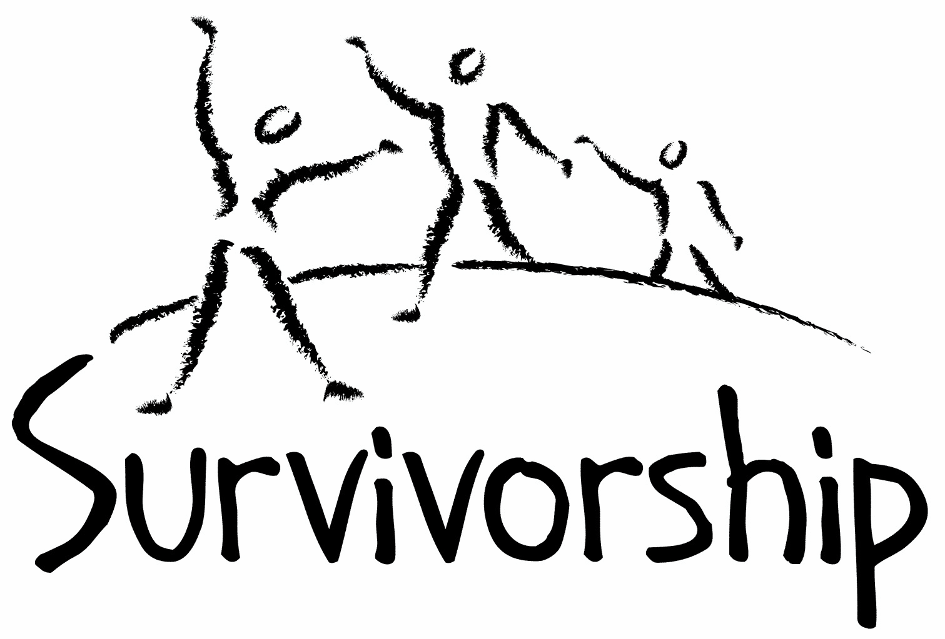
JOURNAL
For survivors of ritual abuse, mind control and torture, and pro-survivors

Copyright Information
SURVIVORSHIP JOURNAL, ISSN 046-2015, is published twice per year in Pacific Palisades, CA.

Copyright 2021 by Survivorship. All rights reserved. The entire contents of this issue are copyrighted by Survivorship and/by the individual contributors. No part of this publication may be reproduced or transmitted in any form or by any means, electronic or mechanical, including photocopying, or by any information storage and retrieval systems, without permission in writing by the copyright owners. For permission to reprint, write: Survivorship 881 Alma Real Drive Ste 311 Pacific Palisades, CA 90272 or email info@survivorship.org

Dear survivors, therapists treating surviving victims, support people and others:

In this issue we have articles and poetry by Randy Noblitt, Wendy Hoffman and Victoria Skye.

This May 2021 we will be having our second online Survivorship Ritual Abuse and Mind Control 2021 Conference which includes a regular conference and a clinician's conference.
Information is at: https://survivorship.org/the-survivorship-ritual-abuse-and-mind-control-2021-conference

Speakers Include:

One Hundred Children: A Parable for Healing from Dissociation-savvy Mind Control
Presenter: Ellen Lacter, Ph.D.

Production of Sadistic Child abuse Materials: Psychology of the Victims and Perpetrators Presenter: Ellen Lacter, Ph.D.

Self-Esteem Presenter: Wendy Hoffman

Mind Control and How to Stop it. Presenter: Neil Brick

Table of Contents

Page Title and Author

3 Institutional Child Abuse
Annika Lundin and Randy Noblitt

4 Boulspo, 2016
Wendy Hoffman

5 My Personal Experience
Victoria Skye

9 Whitman’s Samplers on the dining room table - Forest Hills, 1940s
Wendy Hoffman

10 Now and Then
Victoria Skye

Institutional Child Abuse
Annika Lundin and Randy Noblitt
Alliant International University

We all have a responsibility to protect vulnerable people from abuse. The widespread occurrence of familial and intergenerational child abuse is disturbing and inconceivable to many of us, until we learn that this is sadly commonplace. Tamara Blakemore and her colleagues (2017) found that institutional abuse was more often severe and involved multiple perpetrators. Additionally, perpetrators who commit child sexual assault within these institutional settings are found to commonly have multiple victims (Sullivan et al, 2011). Perpetrators will use rewards, isolation, show favoritism, and will secure their victims' silence through the normalization of the abuse activities (McNeish & Scott, 2018). With multiple sources revealing the adverse impact on the emotional and physical health of survivors, as well as the impact on economic and educational outcomes later in life, the practice of institutional abuse has become the focus for many health care professionals in varying countries. According to UNICEF, child sexual abuse in particular, is a “global problem,” (p. 5), and there are “institutional and organisation practices that do little to challenge or even reinforce” (p. 9) these crimes.

These institutional settings provide structure and policies that not only provide perpetrators access to these children, but additionally support exploitation of power, and offers opportunities to repeat the abuse time and time again (Blakemore et al, 2017). Such institutions include “religious organizations, childcare and educational settings, out-of-home care, health settings and sporting and community organizations,” with training schools and foster homes receiving report rates six times greater than the others (Blakemore et al., 2017, p. 36). A recent study revealed that 57.7% of the participants exposed to the foster care system reported varying experiences with institutional abuse and neglect. Furthermore, this study found that these participants also showed a significantly higher prevalence in experience with depression, anxiety, somatization, dissociation, and posttraumatic stress disorder (Lueger-Schuster et al., 2018). With such disturbing reports and statistics, the question of why these atrocities go unnoticed for so many years has motivated much research by health care professionals and child advocacy groups.

Although research remains underdeveloped in the area of reporting behaviors, there are a few known reasons that can come into play: Children and adolescents may not have the necessary understanding in order to recognize their experience as abuse; Certain stigmas, shame and fear of consequences will maintain the victims’ silence; health professionals may miss the signs and identifying behaviors due to underdeveloped research or inexperience; miscommunication or lack of communication entirely between different sectors such as education, health, and justice; systemic laws and policies conflict with the protection of these children (i.e. age definitions in laws of consent); and surveys indicate that only a small percentage of these children have access to professional help/advice (UNICEF, 2020). Additionally, many institutions fail to take accountability through denial, secrecy, and self-preservation (McNeish & Scott, 2018). Because of this, most cases of child sexual abuse go undisclosed for many years. Instead, institutions should focus on factors such as maintaining a high staff-to-child ratio, safe physical environment, population mix, staff training and support collaboration with outside agencies, and fostering an open culture where the children and staff feel safe and supported in coming forward about suspected abuse.

Additionally, since research has shown that perpetrators have a tendency to seek out professions and opportunities where there is an ease of access to their victims, some institutions have begun to implement a rigorous recruitment and selection process; however, while this approach holds value, potential offenders are mostly difficult to identify as most do not hold previous offences on their record (McNeish & Scott, 2018). Without doubt, “institutional abuse demands an institutional response” (“Caring for Survivors of Institutional Abuse,” 2020). They must support a culture where the safety of the children is everyone’s first priority through education, prevention, and rehabilitation for the survivor, family, community, and also the perpetrator.

References
Blakemore, T., Herbert, J.L., Arney, F., & Parkinson, S. (2017). The impacts of institutional child sexual abuse: A rapid review of the evidence. Child Abuse & Neglect, 74, 35–48. https://doi.org/10.1016/j.chiabu.2017.08.006.
Caring for survivors of institutional child abuse (2020). The Lancet, 394(10200), 710. https://doi.org/10.1016/S0140-6736(19)31999-3
Hawthorn, M. (2020). Learning from positive historical child care practice. Scottish Journal of Residential Child Care. 19(1), 1–18. https://doi.org/10.1177/0306624X09359194
McNeish, D., & Scott, S. (2018). Key messages from research on institutional child sexual abuse. Centre of Expertise on Child Sexual Abuse. https://www.csacentre.org.uk/resources/key-messages/institutional-csa/
Sullivan, J., Beech, A., Craig, L., & Gannon, T. (2011). Comparing intra-familial and extra-familial child sexual abusers with professional who have sexually abused children with whom they work. International Journal of Offender Therapy and Comparative Criminology, 55(1), 56–74. https://doi.org/10.1177/0306624X09359194
UNICEF (2020). Action to end child sexual abuse and exploitation. https://www.unicef.org/media/89206/file/CSAE-Brief-v3.pdf

Boulspo, 2016
Wendy Hoffman

Note: This article has graphic descriptions of violence and abuse.

Author’s note: The following is an excerpt from Wendy Hoffman’s memoir A Brain of My Own, published 2020 by Aeon Books and reprinted with permission of the author. The character Liz is a torturer who offered and perhaps is offering surviving victims ‘safe housing’ in her home. Hank is a fixer-programmer, one who travels around ‘fixing’ programming that went wrong. The city’s name is changed but is in Washington State.

Liz found it inconvenient to travel to torture me for she needed more time to shop and go to the hair dressers. Instead, she summoned me to a town near her. She was late as usual. I waited in a pet store that held an animal rescue. Two dogs had bonded. One was adopted. The other, heartbroken, forsaken, barked endlessly. When Liz finally arrived, we shopped and she bought for herself. I had no memories or realizations of her true identity at the time. A few hours later, I was ready to go home but she wanted to have dinner. What I hadn’t remembered before was a gun suddenly in my side—one of her pink miniature girly guns. She has many. I couldn’t understand why I went to that restaurant until I associated that she walked a part of me to a restaurant with the gun in my left ribs. Perpetrators walk you somewhere with focused purpose, urgently, like a rat in a maze. We ate as she kicked my shins under the table, another trigger. I’m supposed to always pay for her meals. Some of me must have been more healed then, because for the first time I didn’t pay. Her face became blank, then troubled, then exasperated. Using hand signals, she walked me behind a building cluttered with rubbish bins. Hank appeared. No one else was there but this town is cult territory. He probably had guards watching in alleys. He showed me playing card triggers, punched me in the stomach, strangled me, kicked me in the groin. “Put the gun away, Liz. We don’t need it now.” The other piece of this memory that had been slow reaching the surface is that Liz complained about my not buying her dinner. Hank emptied my purse and gave my money to Liz, who put it in her bra.
When I couldn’t breathe at all, Hank said “Kneel over.” He put a larger gun from his holster into my right temple. “I want to talk to Queen Iphigenia. I should kill you now. Maybe I’ll take you to the warehouse first and skin you. I’ll make a deal with you. You drive back to Prim now, stay there for the rest of your life and never return to Victoria or see Alison again and I’ll leave you alone. Will you do that?”
Lightning, I became lightning striking them dead. “Yes,” I said.
“One little sock to the ear” [with the gun handle], “one little sock to the jaw for old time’s sake.” Hank put his gun away, snapped his fingers and did hand gestures in front of my face before he dismissed me.
Of course, I returned to Victoria. Beating up clients who are in therapy is satanic cults’ methodology. I wonder how many therapists don’t see what is happening to their clients. I wonder how many clients right now aren’t seeing or consciously feeling what is happening to them. They may feel the just administered pain but attribute it to something else like an illness or old injury acting up. Or the tortured parts may go deep inside and the more forward parts don’t feel the pain. And I wonder if any external witness saw but is too afraid to tell. Terror wipes out other feelings.
It confuses me that I followed their commands to move to Prim and be in association with the ‘friends’ but not to follow the fine points of their commands or be silenced. If I were rebellious, why not completely rebellious? Even when most of the brain is captured in a net and squeezed hard, slivers escape and act like their unhampered selves. Satanic professionals can’t kill all of the mind.

My Personal Experience
Victoria Skye

Cults have been recognized
By some for centuries
Others are skeptical and refuse
To acknowledge their existence

I know cults are real
And sadly, I’m aware that
Cult abuse has touched
Millions of people
Too many of those people,
Including myself,
Had no choice about their cult involvement
They were born into a cult

Or raised in one
And as an adult, some
Were coerced or seduced
Yet had no idea what
The outcome of their decision could bring
They didn’t know

They were possibly being led
into situations they would regret
for the rest of their lives

For those who were able
To escape
I wrote the following:
Do ‘they’ want you back?
Do ‘they’ call to you?
Do the phrases ‘they’ repeated and
The chants ‘they’ uttered
Thrash around in your brain

As you silently scream,“no!”
In an attempt to squelch them?
Do you have flashbacks triggered by
A sound, a smell, a touch,
Or
That much too familiar feeling
of impending terror?
Do you remember how you felt
When someone looked at you
With those eyes?
The ones that made you cower in fear and
Beg all that is holy to save you?

Do ‘they’ want you back?
Please, don’t go

I’m sharing a bit of
what happened to me when
I escaped one cult and
Unknowingly stepped into another
And another until I could
Finally get Free

Note: This article has graphic descriptions of violence and abuse.
As a child, I was used and abused by a sadistic ritualistic cult. In my teens, I ran away and was able to escape that, but I ran directly into the arms of a religious cult. I went from what I consider to be, the most heinous, horrible, reprehensible group of “monsters” to...some of the most manipulative, controlling, dogmatic, often predatory people in my world at the time. Each group performed rituals, often while dressed in their special garb.

Each group worshiped idols and statues consistent with their beliefs. And, both groups ultimately wanted power and control over their subjects.

I had no choice regarding the cult I was abused by as a child. I had no voice in that. I have to confess though that I willingly joined the religious cult. I was seeking something that was real, something that was right, people I could believe and trust. I was vulnerable, I was young, i was a seeker, and I went blindly into their camp.

Were you born into a cult, raised in a cult, or perhaps “seduced” into a cult? Maybe someone told you that you would find family and friends and perhaps most importantly; you would be loved, if you just followed them. Maybe, for some reason you felt you had no choice. I’m not entirely sure the “how” is important.

What I am sure of is, “if you want a chance to live your own life, you have to get out”. “If you want a chance at undoing the brainwashing you’ve endured, you have to stay out.”

You may have to plan your escape and trust at least one person to help you. The best time for you to get away may be when the sun is high or under the cover of darkness. Only you can judge that. If, for some reason, you can’t plan, you may have to abandon everything and run the moment you have the opportunity. I had to run, every time I had to run!

In the satanic cult, ‘they’ tried to make us believe that what we saw never happened. I don’t remember how we were taken into the woods where the sacrifices were performed; I just remember some of the statues standing and weapons hanging. I remember a hard table and babies crying and sounds and smells and snakes and fire! As children, we were made to do unspeakable acts to other children. Those acts still haunt me many decades later.

The following is a short synopsis of what allowed me to look at the abuse and begin to recognize how it impacted the rest of my life. With that knowledge and years of therapy with a trauma informed therapist, I have been able to heal from those years I spent in hell. After years of talk therapy with that same therapist, I am considered to be a peer expert who continues to help other survivors.

The first time I met with my therapist, I took a picture I had drawn of the scenes that lingered in my head. I didn’t consciously know what they meant, but I knew I needed someone to help me figure it out. I needed someone to talk to about the nightmares and flashbacks that continued to disturb my sleep when I was able to sleep. I needed help with the anxiety and depression taking over my life. I had to find a way to alleviate the ever present suicidal ideations and attempts or I was going to die.

My therapist wasn’t shocked as I thought she would be when I handed her my disturbing art work. She assured me other patients had drawn pictures very similar to mine. She told me those patients were from different parts of the country, they were people I had never met, in fact we had no knowledge of one another: nevertheless, we all drew similar pictures depicting the same kind of abuse, and we all suffered psychiatric diagnoses including severe PTSD.

We, as children, suffered mental/emotional abuse, physical abuse, sexual abuse, and, the worst for me was spiritual abuse. It has been one of the most if not the most disturbing, debilitating, disabling details of my life.

I don’t know about you, but my trauma informed therapist helped me work through my mental/emotional abuse. Don’t get me wrong, that did not happen overnight. There were many sessions where unlearning and relearning took place and then a lot of positive self-talk on my own.

Scars from the physical abuse have faded over the years. They didn’t disappear by any means, but somehow the fact that I can see them and touch them helps me. I can comfort that part of me as I look at the scars and remind myself that they do not define me.

As for the sexual abuse, that took years to even begin talking about and then more years of learning how to be patient with myself. And without patience from my partner, I don’t believe I could have attained any kind of ok-ness with that aspect of my healing.

Talking about the spiritual abuse: one major point is that spirituality in my opinion is a very personal, private walk. The fact that abuse in the cult when i was a child focused on darkness and terror and death while being performed in the name of their god, affected the very core of my existence. Until decades later, I thought they had stolen my soul.

I was 17 when I joined my first religious cult. I was taught that Jesus was the light. It was preached repeatedly that the only way to make it into heaven was to obey what those people taught. They taught that the ultimate goal was to live an exemplary life based on every word written in their bible and if I could do that I would be granted a place in heaven for eternity. I was also taught that all of the other “churches” didn’t quite have the salvation thing right, so I had to stay in the original camp and not venture out of their circle.

Yes, talk therapy helped me and sharing my heart thoughts helped me: but, in the quiet, when spiritual questions arise, it is a sacred moment for me, a moment that is mine alone often with fear attached. The only help with my thoughts and feelings in that moment has to come from a spiritual source, which all too often brings questions of who, what, and where is that source? How do I know it’s there? How do I access it? Often times it is all too confusing. Yet somehow, there in the midst of my questioning, if I listen, I can hear a still, small voice inside that brings me calm. Perhaps that is my connection.

Going back to the fragmented scenes in those flashbacks. I tried to ignore them. I did not want to know those atrocities could have ever happened to anyone. I wanted to think I was just making it all up and the right psychiatrist with the right medication could erase all of it. I didn't want to believe anyone could carry out such abhorrent deeds, but...'they' did.

The 'they' I'm talking about were monsters as they declared, “you’re coming with us, because you’re special”.
‘They’ were liars when they mocked, “you will like this”.
‘They’ were haters and 'they' proved it when 'they' involved innocent children in their sick, disgusting ceremonies.
‘They’ were “would be” destroyers of children’s minds by what they made them do, by what they made me do.
‘They’ were murderers as 'they' sacrificed the most precious, perfect, loving, souls.
'They' sacrificed newborns: little-tiny-babies
'They' were more than savages when they raped young children, when they cut out body parts and ate them, and fed them to others; and when ‘they’ made little children drink the blood of their sacrifices.

You may be a skeptic and question, "who and where are the ‘they’ of which you speak?” You may scoff and doubt ‘their’ existence, but I’ve known them and I can tell you who some of them are.

'They' walk among us: you and me, every day 'they' walk. I dare say, "you may know some of ‘them,’ but know not of their ritualistic ways. You may have had dinner with some of ‘them’. You have possibly rubbed elbows with them at the gym. 'They' may have bagged your groceries, 'they' speak in your pulpits, 'they' listen to your confessions, many of them are upstanding pillars of the community, and some of them--some of them treat your children when they are ill.

'They' look like regular folk. 'They' dress appropriately during the day and perform their jobs: then, in the dark of night 'they' meet 'out there'.
Anyone ever exposed to one of their ceremonies knows exactly where ‘out there’ is. 'Out there' may not be the same woods, or the identical barn, nor the exact tent, or sanctuary, but ‘out there’ feels the same regardless of where it is.

As the evil hovers, ‘they’ shed their suits of the day and don the dress of their fellows. ‘They’ perform their rituals, their jobs which have to be done in the dark of night. This is when ‘they’ do, their sickening, disgusting jobs (of which no one is allowed to speak), their ‘monster’ jobs, if you will.

'They' call them their ceremonial procedures. They were the most heinous crimes performed in the most repulsive way any one would dare speak. And all done in the name of their god.

Whitman’s Samplers
on the dining room table
Forest Hills, 1940s
Wendy Hoffman

When we had company, my father passed around boxes of Whitman’s candy. Some chocolates were solid, some filled with flavored goo.
Men descended their long fingers, picked them out and left the little paper cups which sighed as the Samplers circulated.

He passed me around.
When I looked into the silent empty paper in the box that preceded me,
I thought that’s what life is.

How to fill the cups? Walking, swimming, eating better chocolate.
Sunshine, shade.

I had been passed from lap to bulging lap. Wives’ giggles echoed from the other room, the kitchen, as they gulped caramel, fudge, cherry and nut filled pieces. My mother preferred caramel, my aunt cherry, and my grandmother—almond coated chocolates.

Diminutive paper cups rattled with nothingness.
An old woman now, I still prefer the solid.

Now and Then
Victoria Skye

I remind myself it’s “now,”
it’s today, and I am here
But when darkness falls

And I’m alone,

My “then” creeps in

When something in the “now”

Reminds me of my past,

My thoughts get crazy scary

When my “then” creeps in

I think I have myself collected
and everyone right here
But it’s hard to stay
in the “now”
When my “then”creeps in

“Then” I didn’t matter
But today I know I count
as my “now” speaks louder
When my “then” creeps in

Some of the hills
I have to climb
Seem more like mountains
When I trust in the “now”
I know I’m ok
Even if my “then” creeps in

