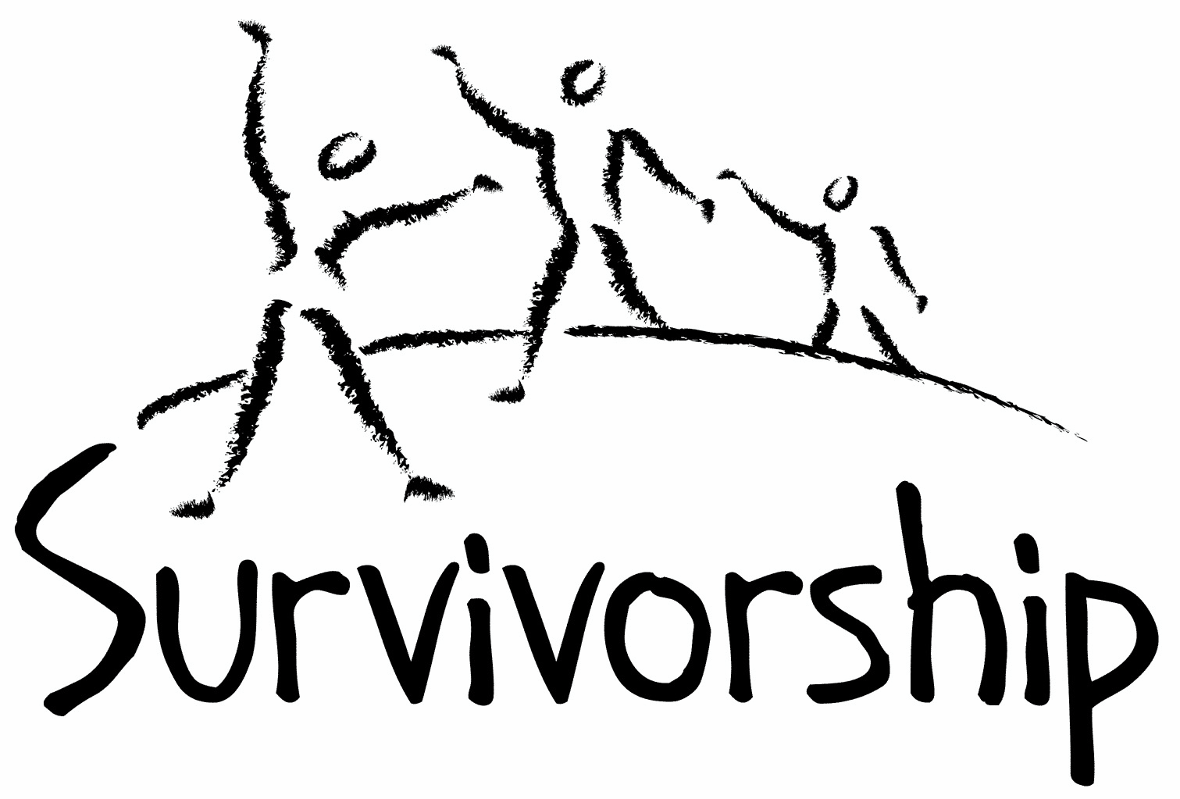

Vol. 198 No. 9 and 10 Jan/Feb 2021

The Notes, formerly called Chart Notes, ISSN 1523-275, is published bimonthly, copyright © 1999-2021 by Survivorship. All rights reserved. The entire contents of this issue are copyrighted by Survivorship and by the individual contributors. Please write Survivorship or E-mail info@survivorship.org for permission to reprint. Survivorship is a nonprofit organization.

Dear Friends,
We will be having an online conference in May 2021. We are looking for both clinicians and survivors to speak at the conference. The conference topic is: “Being a survivor/clinician in a changing world.” The world is changing very quickly with the COVID, climate change and economic stresses. Presentations will focus on ways survivors and clinician can survive and function better in this changing world. https://survivorship.org/the-survivorship-ritual-abuse-and-mind-control-2021-conference/
We would like to welcome Laurie Matthews to the Survivorship board. Laurie has many years of experience in the ritual abuse field. Information about Laurie can be found at:
Journal Articles on Child and Ritual Abuse – Laurie Matthew
https://ritualabuse.us/ritualabuse/studies/journal-articles-on-child-and-ritual-abuse-laurie-matthew/
Ritual Abuse Network Scotland (RANS) https://www.rans.org.uk/
RANS provides information and a safe place to talk for survivors of ritual abuse.
Please remember to renew your membership if it is due. Information is on Page 7 of this issue of the notes.
Information is at: https://survivorship.org/how-to-renew-your-membership/
Survivorship grows and survives with your help and support.

The Survivorship Board of Directors: Neil, Eileen, Randy, Elana and Laurie

Survivorship blog https://survivorshipwp.wordpress.com
Survivorship on Twitter https://twitter.com/Survivorshiporg
Survivorship on Facebook https://www.facebook.com/SurvivorshipRitualAbusePage

A BRAIN OF MY OWN A memoir about dissociation dissolved by Wendy Hoffman https://www.aeonbooks.co.uk/product/a-brain-of-my-own-a-memoir-about-dissociation-dissolved/94611/ https://www.aeonbooks.co.uk/Preview/9781912807925_PDF.pdf At aeonbooks.co.uk Paperback. RRP: £16.99 / US $24.95
A Brain of My Own is about slavery, about brains stolen in childhood and before; brains that have been intruded upon, stopped, shrunk, paralyzed. We know about the history of people whose bodies were enslaved; but we know barely anything about the victims who appear free but whose brains are invisibly chained. Nor do we know about the international collusion, silence, and apathy that surround this kind of slavery. In A Brain of My Own, Wendy Hoffman describes her final years of attempting escape from the criminal mind control cult into which she had the misfortune of being born. This is her third memoir, and chronicles the final years of reclaiming her brain, including the ongoing abuse and torture during her recovery process. Hoffman describes the ways in which perpetrators manipulate the brain to create amnesiac barriers, methods held secret for generations. She exposes the duplicity of perpetrators functioning as normal people in the ordinary world and what is under their masks. She gives advice about how to spot seemingly helpful people who are actually out to destroy victims of mind control. The book includes an Afterword by Dr. Alison Miller. This kind of dissociation is difficult to overcome, but the path back to full humanity is possible and happening.
Wendy Hoffman is a survivor of organized criminal abuse and has been a psychotherapist for over two decades working in general practice and the field of recovering dissociated memories and trauma. Now that she has brought together the separated parts of her mind, taken her life back, and achieved freedom, she wants to help other survivors also become free of mind control. Wendy recorded her struggle to free herself from imposed dissociation in her memoirs Enslaved Queen (2014), White Witch in a Black Robe (2015) and now A Brain of My Own (2020).
The 2021 Online Annual Ritual Abuse, Secretive Organizations and Mind Control Conference
August 14 – 15, 2021. For safety reasons due to the Corona virus we have decided to change the conference to an online conference. Internet conference information: http://ritualabuse.us/smart-conference/ Proof That Ritual Abuse Exists https://ritualabuse.us/ritualabuse/
Large List of Ritual Abuse and Child Abuse References https://ritualabuse.us/ritualabuse/studies/satanic-ritual-abuse-evidence-with-information-on-the-mcmartin-preschool-case/
Grey Faction, Satanic Temple and Lucien Greaves Fact Sheet https://ritualabuse.us/ritualabuse/grey-faction-satanic-temple-and-lucien-greaves-fact-sheet/
Research and Information on Dissociative Identity Disorder (formerly called Multiple Personality Disorder) https://ritualabuse.us/research/did/
Judith Herman: “In order to escape accountability for his crimes, the perpetrator does everything in his power to promote forgetting. If secrecy fails, the perpetrator attacks the credibility of his victim. If he cannot silence her absolutely, he tries to make sure no one listens.” Trauma and Recovery: The Aftermath of Violence – From Domestic Abuse to Political Terror
Call for submissions: For Survivorship's next journal, please send your essays, articles, poetry and art work for consideration for publication. We accept entries from survivors and specialists in the field. Please mail to: info@survivorship.org All entries must be in electronic form and sent by e-mail or e-mail attachment.

ON-GOING MEETINGS AND TRAINING OPPORTUNITIES

More information is available at https://survivorship.org/community-calendar-of-events/

Survivorship is presenting this as information only. If you choose to use one of these resources, please note that you are doing this at your own risk.

Dissociation & Trauma Clinical Discussions (DissTCD) list
The Dissociation & Trauma Clinical Discussions (DissTCD) list has been created to allow for clinical discussions for all licensed mental health counselors and retired licensed mental health counselors around the world. To join: disstcd+subscribe@groups.io

ASCA (Adult Survivors of Child Abuse) On-going info@ascasupport.org www.ascasupport.org

Survivors of Incest Anonymous SIA holds 12-step meetings for incest survivors. Those designated “Nothing Too Heavy to Share” meetings are designed for ritual abuse survivors. 410-282-3400 http://www.siawso.org

Women’s Center, 46 Pleasant Street, Cambridge, MA Weekly and monthly groups for survivors of child sexual abuse, incest survivor’s interfaith quilt project, Survivors of Incest Anonymous, eating disorder support group, emotional healing group, more. info@cambridgewomenscenter.org Phone: 617-354-6394 Helpline. 617-354-8807 http://www.cambridgewomenscenter.org

The Childhelp National Child Abuse Hotline 1-800-4-A-CHILD (1-800-422-4453)
HOTLINES FAMILIAR WITH RA ISSUES
* Bay Area Women Against Rape (BAWAR): 510-845-7273
* San Francisco Women Against Rape (SFWAR): 415-647-7273
* Women’s Center, Cambridge, MA: 617-354-8807

Difficult Dates
Please use caution when reading this page. This page has words and dates that may remind survivors of their programming. This page summarizes dates that may be used by cults and various destructive groups. Abusive groups steal, pervert and mock the holidays of legitimate religions, holidays and cultures. This does not mean that all or even most people who observe some of these holidays are abusive.

January
1/1 New Year’s Days. A druid (spirit) feast day (light fires on hill tops)
1/5 or 1/6 Twelfth Night
1/13 New Moon
1/6 Epiphany referring to celebrations over the manifestation of the divinity of Jesus
1/6 Dionysian Revels
1/6 Epiphany
1/7 Eastern Orthodox Christmas
1/12 Birth of both Rosenberg and Goering Nazi Leaders in WWII
1/13 Satanic New Year
1/14 Maghi - Lohri
1/14 Makar Sankranti: Hindu: Harvest Festival
1/19 Old Epiphany
1/17 Feast of fools(Old Twelfth Night) Satanic and Demon Revels (sex)
1/21 M L King Day
1/20 Guru Gobind Singh Birthday
1/20-1/27 Grand climax (blood rituals) in Satanic calendar: conjuration of Talal a warrior demon
1/21 t. Agnes Eve patron saint of virgins
1/18 Old Epiphany
1/17 Feast of fools(Old Twelfth Night)Satanic and Demon Revels (sex)
1/20 St Agnes Eve (casting of spells)
1/26 Australia Day
1/25 Robert Burns Night (Burns night)
1/28 Full Moon
1/28 Mahayana New Year
1/28 Tu BiShvat
1/30 Hitler named Chancellor of Germany

February
2/1-2/3 Mysteries of Persephone Groundhog/Imbolg day. A night requiring human sacrifice
2/2 Candlemas (Imbolc/Imbolg) Brigid’s Day/mother goddess (bride) (blood) animal or human sacrifice
2/11 New Moon
2/12 Lincoln’s Birthday
2/12 Chinese New Year
2/14 Valentine Day encourages physical lust 13 days after Imbolc
2/15 Nirvana Day
2/14 St. Valentine's Day
2/15 Flag Day
2/15 Lupercalia (she-wolf mother Romulus and Remus: honoring of Pan)
2/16 Shrove Tuesday (Mardi Gras)
2/16 Vasant Panchami: Hindu: Worship of Saraswati goddess of knowledge ancestor worship
2/17 Family Day (AB BC SK ON)
2/17 Presidents' Day
2/21 2/22 Feralia/Terminalia (Roman All Souls)
2/26 Purim
2/27 Full Moon
News Articles
(Please note: some of these articles may contain violence or cult information)

Largest anti-human trafficking sting in Ohio history leads U.S. marshals to 45 missing children, more than 100 survivors
https://abc17news.com/news/national-world/2020/10/28/largest-anti-human-trafficking-sting-in-ohio-history-leads-u-s-marshals-to-45-missing-children-more-than-100-survivors/

Ritual Abuse, Mind Control and Organised Abuse: Examining our History and Looking
https://news.isst-d.org/ritual-abuse-mind-control-and-organized-abuse-examining-our-history-and-looking-forward/

Psychiatric Impact of Organized and Ritual Child Sexual Abuse: Cross-Sectional Findings from Individuals Who Report Being Victimized
https://www.ncbi.nlm.nih.gov/pmc/articles/PMC6266763/

Demystifying ritual abuse - insights by self-identified victims and health care professionals
https://pubmed.ncbi.nlm.nih.gov/32043938/

Alleged groomer of teen victims in La Luz del Mundo sex abuse case says she was victim too
https://www.latimes.com/california/story/2020-11-03/alleged-groomer-teen-victims-la-luz-del-mundo-sex-abuse-case-says-she-was-victim-too

James Randi's Alleged Sex Tape
James Randi, a magician known as "The Amazing Randi," had been involved in a lawsuit in which his opponent introduced a tape of sexually explicit telephone conversations Randi had with teenage boys. https://ritualabuse.us/ritualabuse/articles/james-randis-alleged-sex-tape/

Boy Scouts deluged with 92,700 sexual abuse claims, dwarfing U.S. Catholic Church’s numbers
https://www-latimes-com.cdn.ampproject.org/c/s/www.latimes.com/california/story/2020-11-16/boy-scouts-sexual-abuse-claims-top-88000-bankruptcy

Expert Compares Trump's Politics to FascismYale philosophy professor Jason Stanley explains why he claims President Donald Trump's politics are akin to fascism, a political movement based around a leader. https://www.youtube.com/watch?v=c4MTns3MyxQ
Jason Stanley: How Fascism Works https://www.youtube.com/watch?v=agX5v7h4_1g
How Fascism Works - The Politics of Us and Them By Jason Stanley https://www.penguinrandomhouse.com/books/586030/how-fascism-works-by-jason-stanley/

The Frontman: Douglas Misicko, better known as Lucien Greaves and Doug Mesner https://danielkbuntovnik.wordpress.com/2019/04/20/the-frontman-douglas-misicko-better-known-as-lucien-greaves-and-doug-mesner/
"Although The Satanic Temple attempts to present itself along politically progressive lines, Douglas Misicko(aka Doug Mesner, aka Lucien Greaves) as collaborated with a significant number of individuals holding prominent positions in white supremacist and neo-Nazi movements.“

Teenage Satanist and far-right extremist sentenced for terrorism offences
Schoolboy avoids jail after admitting terrorism and child abuse image offences
https://www.theguardian.com/uk-news/2020/nov/02/teenage-satanist-and-far-right-extremist-sentenced-for-terrorism-offences

Man charged in stabbing death of mosque caretaker followed hate group online Guilherme
https://www.cbc.ca/news/canada/toronto/mosque-stabbing-suspect-1.5732078

Relatives mourn sisters killed in vicious machete attack by suspect once considered 'kind' But Urias’ Facebook pages show a fascination with disturbing imagery. They are filled with gory and violent drawings and pictures, including skulls, Satanic symbols and demons. https://www.nola.com/news/crime_police/article_1e2c87cc-1893-11eb-aee8-53f54aa07eb5.html

Satanic worship, church burnings and murder: The true story behind ‘Lords of Chaos’
The terrible dawn of Norwegian black metal came during the summer of 1984, during an adolescent season of inspiration in a small village outside Oslo.
https://www.latimes.com/entertainment/movies/la-ca-mn-jonas-akerlund-lords-of-chaos-20190212-story.html

The NXIVM cult: How long are the leaders of going to jail for?
https://filmdaily.co/news/nxivm-cult-jail/

21 members of a South Korean religious cult were arrested in Singapore.
https://sea.mashable.com/culture/13201/21-members-of-a-south-korean-religious-cult-were-arrested-in-singapore-heres-what-we-know

Manson cult killer has parole release blocked
At the age of 19, she was among a trio of Manson followers who broke into the home of Leo and Rosemary LaBianca. Leslie Van Houten stabbed the latter 16 times.
https://www.rte.ie/news/world/2020/1130/1181542-manson-follower-parole/

Alleged devil worshipper out on bond for 2016 Houston murder has killed again, police say
Edward O’Neal Jr. was out on a $25,000 bond for the stabbing death of a Houston teen and now he's charged with another murder four years later.
https://www.khou.com/article/news/crime/alleged-devil-worshipper-charged-houston-murder/285-e266ffe5-c919-42d2-aadd-67f74504315a

Fashion Mogul Peter Nygard Indicted on Sex-Trafficking Charges
Https://www.nytimes.com/2020/12/15/world/canada/peter-nygard-sex-trafficking-charges.html

How to Renew your Membership

To find out when your membership renewal is due: if you receive our literature by mail, look at the label on your Notes or Survivorship journal. You may also write info@survivorship.org and ask. If you renew before you need to, we will just add the extra months onto your membership. Please try to keep your membership up to date.

You may renew here: https://survivorship.org/how-to-renew-your-membership/
This page as a link to paying with PayPal https://survivorship.org/membership-using-paypal/

Rates
The rates for a Survivorship membership are on a sliding scale based on ability to pay beginning from $75.00 down to what you can afford. We ask that health-care professionals contribute towards gift memberships. We regret that we are not able to provide services or include members under the age of 18.

Renewing
1. Decide if you want to read the Survivorship Journal and Notes on the web site (Internet Member) or receive the Journal by regular mail (let us know if you want to also receive the Notes by regular mail) (Regular Member).

2. Then choose how much you are able to pay. If you are a professional, we recommend that you donate $35.00 to support gift memberships for low-income survivors. We appreciate gifts so that we may offer support to survivors who are unable to work due to the after-effects of their abuse and to survivors who are imprisoned. All donations are tax deductible. We are a 501(C) corporation.

3. Decide whether you want to pay by check, money order, or PayPal. PayPal accepts charge cards. If you want to pay using PayPal, please copy and fill out the form below, email it to info@survivorship.org, and then click https://survivorship.org/membership-using-paypal/ to make your payment.

If you want to pay by check or money order, print out the form below and send it with your payment (in U.S. funds) to: Survivorship, 881 Alma Real Drive Ste 311, Pacific Palisades, CA 90272 USA

Name ________________________________________________________

Organization (if applicable) _______________________________________

City _________________________________________________________

State __________________ (Please add street address and zip code for non-internet memberships only.)

E-mail _______________________________________________________

Regular Membership: $__________ or Internet Membership $___________ Donation $_____________

Total enclosed $______________________
You may also e-mail the information on this form to info@survivorship.org

