Volume 24, Issue 10 Summer 2020

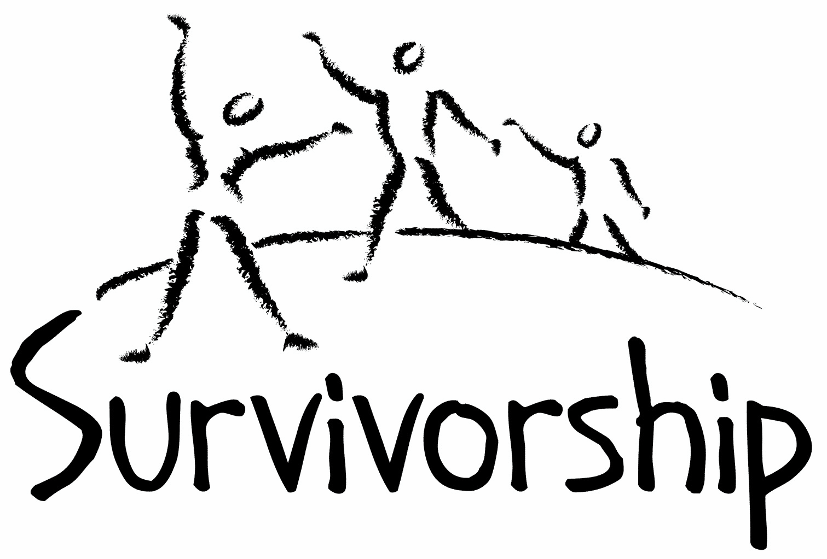
JOURNAL
For survivors of ritual abuse, mind control and torture, and pro-survivors

Copyright Information
SURVIVORSHIP JOURNAL, ISSN 046-2015, is published twice per year in Pacific Palisades, CA.
Copyright 2020 by Survivorship. All rights reserved. The entire contents of this issue are copyrighted by Survivorship and/by the individual contributors. No part of this publication may be reproduced or transmitted in any form or by any means, electronic or mechanical, including photocopying, or by any information storage and retrieval systems, without permission in writing by the copyright owners. For permission to reprint, write: Survivorship 881 Alma Real Drive Ste 311 Pacific Palisades, CA 90272 or email info@survivorship.org

Dear survivors, therapists treating surviving victims, support people and others:

In this issue we have articles by Randy Noblitt and Neil Brick and poetry by Wendy Hoffman and Jay J Pennington.

Last month we had our first online
Survivorship Ritual Abuse and Mind Control 2020 Conference which included a regular conference and a clinician's conference.

Online Presentations are at:
https://survivorship.org/the-survivorship-ritual-abuse-and-mind-control-2020-conference-presentations/

Speakers Included: Dr. Randy Noblitt and Pamela Perskin Noblitt, Dr. Karol Darsa, Neil Brick and Cristina Mardirossian, LMFT

5 Common Mistakes in Trauma Treatment - Dr. Karol Darsa
Identifying the Personality Systems of Mind Control Survivors and Trauma Treatment - Cristina Mardirossian, LMFT
Extreme Abuse Survivors, Social Security Benefits, and Ethical Practice - Dr. Randy Noblitt and Pamela Perskin Noblitt
Misinformation Campaigns Against Survivors - Neil Brick
Organicity and the Inorganic: a Sensorimotor Approach to Healing with RAMCOA Survivors - Will Randle
Eating Disorders and Dissociative Identity Disorder - Sherry Fleming, MFT

Table of Contents

Page Title and Author

3 What Happens When Psychotherapists Suspend Their Preconceived Ideas?
Randy Noblitt

5 Doing the right thing and getting stronger at the same time, a survivor’s path to recovery and helping others
Neil Brick

8 Amnesia
Wendy Hoffman

8 The Beginning
Jay J Pennington

What Happens When Psychotherapists Suspend Their Preconceived Ideas?
Randy Noblitt

Survivors of extreme abuse often experience intermittent and sometimes lifelong distress. Many seek psychological therapy or counseling.

Does psychotherapy help? The short answer is yes, generally speaking, but not always for the expected reasons. Some people presume that effective psychotherapy consists of well-researched treatments delivered by highly trained therapists. In the real world, successful psychotherapy is less related to what therapists do, and is more associated with the clients’ unique characteristics including their strengths and vulnerabilities. Some psychotherapists do get better results than others, but most of the work of psychotherapy is done by clients (Bohart & Tallman, 1999; 2010). However, therapists who work with extreme abuse survivors should have experience with severe trauma and dissociation, have a respectful validating attitude, and be able to facilitate clients’ progress when they feel psychologically blocked, or trapped in painful or unproductive repetitive cycles of thinking, feeling, or acting.

The psychotherapy process can be especially confusing because of the many different psychotherapy theories.

Which approach is most helpful?

I will cut to the chase. There is no universally accepted best theory or approach for everyone (American Psychological Association, 2013). Many therapists think that psychotherapy should match the survivor’s own unique needs. Why rely on theories or other preconceived ideas when you can attend to what your clients are telling you? One of the common psychotherapist failings is when we allow our preconceived ideas to derail us from what is actually needed in psychotherapy sessions. What is important? Listen to your client. Therapists are not the best experts on the experiences of survivors, they are. If true, then what do therapists contribute to the process? Ideally, we have humility. We are aware that we don’t know everything. We are empathic listeners, and we are creative. We know that most of the work of therapy is done by our clients, and we are careful not to obstruct their self-informed direction, or sidetrack them with our preconceived ideas.

Psychotherapists who narrowly focus on particular theories may miss important details in their clients’ stories when those narratives do not align well with preferred theories. Theories can guide people, but they can also misdirect us. Although he was not a psychotherapist the philosopher Edmund Husserl came up with an approach to understanding subjective experience that he called epoché, to “bracket” or suspend judgment while listening to another person describe his or her experience. This philosophical concept has also been adapted by psychotherapists as a way of understanding clients in psychotherapy without imposing the therapist’s thinking (e.g., Loewenthal, 2019).

References

American Psychological Association. (2013). Recognition of psychotherapy effectiveness. Psychotherapy, 50,102–109. http://dx.doi.org/10.1037/a0030276
Bohart, A. C., & Tallman, K. (1999). How clients make therapy work: The process of active self-healing. American Psychological Association. https://doi.org/10.1037/10323-000
Bohart, A. C., & Tallman, K. (2010). Clients: The neglected common factor in psychotherapy. In B. L. Duncan, S. D. Miller, B. E. Wampold, & M. A. Hubble (Eds.), The heart and soul of change: Delivering what works in therapy (p. 83–111). American Psychological Association. https://doi.org/10.1037/12075-003
Loewenthal, D. (2019). Phenomenology, personal therapy and the training of psychological therapists, European Journal of Psychotherapy & Counselling, 21(1), 1-4, https://doi.org/10.1080/13642537.2019.1565667

Doing the right thing and getting stronger at the same time, a survivor’s path to recovery and helping others
Neil Brick
This is a transcript from a speech at the 2014 Ritual Abuse Conference
Today’s topic could be equally applied to any spiritual path or social endeavor where one wants to make personal and social progress.
I will describe how one can do the right thing and also get stronger in their lives. Without doing the right things and persevering to do the right things, one cannot grow and change, nor can one help others or the world. The right thing is determined by one’s personal goals and personal instincts.
I will break each idea down into two sections: what works and what doesn’t.
1) Social advocacy
Social advocacy entails speaking out.
For years, survivors have been silenced, first by harassment and threats. In the last ten years, the harassment and threats have moved more toward Internet bullying and Internet trolling. The Internet has allowed two phenomena to grow. One is the phenomena of Internet attacks. Two is the phenomena of inaccurate information used against child abuse survivors combined with insults. These phenomena and their power are increased by the anonymity of the Internet and by the shelter of Section 230 of the Communication Decency Act. This act in essence protects providers from being responsible from much of what is on their web pages. This has allowed attacks and misinformation to expand exponentially against survivors and anti-child abuse advocates. The harassment spreads misinformation and works to scare off and silence anti-child abuse advocates. The antidote is to speak up and counter the misinformation, insults, bullying and name calling by those fighting anti-child abuse advocates.
For years, I have been explaining the importance of speaking up and defending our work. When misinformation is published in any forum about our work, it must be countered and rebutted. Otherwise, only the misinformation stands in the public forum and public minds. And we lose.
What has happened over the last twenty years is the reluctance and at times mistaken ideology that if these attacks are ignored, they won’t be noticed. This is not true. The Internet and search engines make all attacks public and accessible to all. This has caused our point of view and research to disappear from the public view. All that is left is the insults and misinformation.
The misinformation is that we are “crazy” and that there was some sort of “panic” when child abuse crimes were exposed twenty years ago. Calling someone crazy is a cheap and well known tactic used to discredit someone instead of rebutting their actual research. Repeating untrue and disproved theories, like “panic” is another false tactic used to discredit our work.
The antidote is to speak up. If we don’t speak up, survivors suffer and children suffer.
What works is to speak up. What doesn’t work is silence.
2) Misalignment with non-growth philosophies
Another mistake survivors make is to align themselves with either religious or negative political philosophies. To try to grow and help the world change, without thinking through and developing one’s own philosophy and using it, doesn’t work. Religions and religious books may be helpful to get information from, but not to follow or join. They may be helpful as a temporary step for some when leaving a cult, but in the long run, they become a trap.
Many religions discourage original thought and personal action. Members do not realize this. Religions use different techniques to get people to follow them and not think for themselves. They encourage rote learning and repetition to instill ideas in people’s mind. Some are even used to re-access ritual abuse survivors and control them. Socialization in general involves levels of programming, though these may be more mundane and less nefarious than mind control programming. Religion uses a variety of techniques to make a person feel good, but most are not truly one’s own, but are contrived and manufactured by the religion itself.
Many of us escaped groups that controlled us. Now we are free. Let’s use that freedom to develop our own lives and our own ideas.
What works is thinking for oneself. What doesn’t is following another’s ideas without clear analysis.
Another mistake child abuse survivors make is following negative political philosophies. Many of us as cult survivors were used to make a profit for the cult. The society turned its back on us because money was made and power was increased. Some survivors follow right wing jingoistic philosophies that in reality are philosophies of hate. These philosophies back the hatred of immigrants or the promotion of war and bombing other countries. Others in the US believe they may be following more progressive philosophies, but in reality many of these philosophies also promote hatred, injustice and violence.
The reality is that as long as there is an imbalance in the social power dynamic, the encouragement of profit over morality and right action and the control of information via the mass media, it will be impossible to have any sort of justice in our country or the world. The only way to help survivors grow and to help the world around us grow is to embrace philosophies that do not foster hate, power imbalances or violence. This means believing in political systems that promote economic and social equality and justice. It will be impossible to stop child abuse and help survivors fully until we live in a world where equality is promoted, violence is stopped and ethics triumph profit motives.
What works is equality, nonviolence and ethics. What doesn’t work is inequity, war and violence (in words or actions) and monetary profit motives above all other goals.
3) Right action equals personal and social growth
If one is really thinking for oneself and really trying hard not to hurt others, then one can begin to make a large difference in the world. Following through on right action can be difficult without the development of personal courage and personal integrity. One needs to leave the ego behind. Many survivors get caught up in their health issues, personal struggles and personal relationships to the point where they lose focus on what needs to be done in the survivor movement. In long term recovery, eventually one needs to move on to doing service work.
There is no way one can grow and get stronger without helping others. It is impossible. Helping others builds connections with others. It breaks down the symptoms of attachment disorders, it helps build bonds of trusts between others and it increases the overall connections between people. Doing service also helps people build insights into their own actions and psychological condition.
Right action builds social growth. When one helps others, one helps the people around them and our society. Stopping child abuse by telling our stories, helping others get their stories out and making sure there are adequate resources for child abuse survivors, including adults and children, helps our society grow.
Child abuse robs people and our society as a whole in many ways. From addictions, to health issues, to psychological problems, to long term disabilities, child abuse destroys our society. Exposing child abuse and exposing those that cover up child abuse crimes due to their own denial and self interest helps build a world where someday child abuse will no longer exist. A world where trauma crimes can no longer be hidden. When they can no longer be hidden, covered up or denied, child abuse will no longer be allowed to exist.
What works is right action and helping others. What doesn’t work is being caught up in one’s own personal struggles.
4) Getting Stronger
One cannot get stronger by pulling others down. Their strength is a facade. Their actions damage the world, but most of all themselves. Insults, name calling and personal attacks are never part of any growth philosophy and only weaken the proponent of these actions. Standing up to and exposing these tactics is crucial. Running from any false philosophy or believe systems being promoted by others only strengthens the hold these beliefs have on society. Lack of action exponentially damages the individuals involved and our society. All participants are hurt, those watching are hurt and those that do not get help or correct information due to the damage done also get hurt.
Strength entails addressing problems compassionately and intelligently. The ends are the means. Our actions govern the final result. By addressing a problem with strength and caring for those involved, we can build end results that help everyone and others later. History is written by those that act. It is decided by those that are strong enough to speak up and tell the truth. The only way to grow is to work one’s way to the truth through hard work, courage and right action. This makes all of us strong.
What works is working hard and persevering to get stronger. What doesn’t work is hurting others and running from challenges.
Conclusion
If you do the right thing, you will get stronger. Your recovery as a survivor will get stronger by helping others. And others will get stronger also.
What works is to speak up.
What works is thinking for oneself.
What works is equality, nonviolence and ethics.
What works is right action and helping others.
What works is working hard and persevering to get stronger.
We are at a turning point in the survivor movement. Whether the movement continues or gets lost like last century is up to everyone. A lot of people and children depend on us to do the right thing. We can stop child abuse and trauma crimes and change the future.
This article is at: https://ritualabuse.us/smart-conference/2014-conference/doing-the-right-thing-and-getting-stronger-at-the-same-time-a-survivors-path-to-recovery-and-helping-others/

Amnesia

Wendy Hoffman

My clothes went to work, washed the dishes, changed the litter,
married, birthed. I was nowhere around.

Slowly over decades, I came back, filling a sleeve first, a sock,
finally my trousers.

Now I live with what I know and wear my clothes. I fill my space
with pride, disgust

and surprise that knowledge didn’t burst my empty shell.

My socks match my ironed shirts, and my brain remains seamless.
I iron my skirt and floral dress, put on matching socks and fasten my seamless brain.

The Beginning
Jay J Pennington
(may be triggering)

How many years can it have been

ever since the original horrible sin?

For, against my childhood will, and might,

I was kidnapped from my bed one night.

A rag was forced upon my face.

It was damp, it stunk when it was placed

over my mouth, my nose - I couldn’t breathe!

I fought for air, my chest heaved.

I awoke in the back seat of a car

with a headache seeing only black, and stars.

Blindfolded so I wouldn’t know

the way we were about to go.

My hands were tied behind my back.

Someone packed their cigarettes.

My legs were tied together too.

It was a sudden terror, and all so new.

The secrets of the dark

from the journey just embarked –

the twisted games of the knife,

would for most of my life

confound, haunt, confuse me,

like a veil of fog on a nocturnal sea.

I suffered my fear quietly.

I endured my shock silently.

When we got to where we went,

my imagination spent,

I was carried up the stairs inside.

There was no escape, no place to hide.

I was locked inside a narrow closet.

I heard someone nearby run a faucet.

Hours passed, or so it seemed.

My voice was too afraid to scream,

and I, too paralyzed to move,

my stomach growling, absent food –

I, too young to fight the hour,

wept, and rocked myself to sleep.

This, despite strange noises which would keep

most anyone, most anywhere awake,

but I was just a boy, and it was late.

