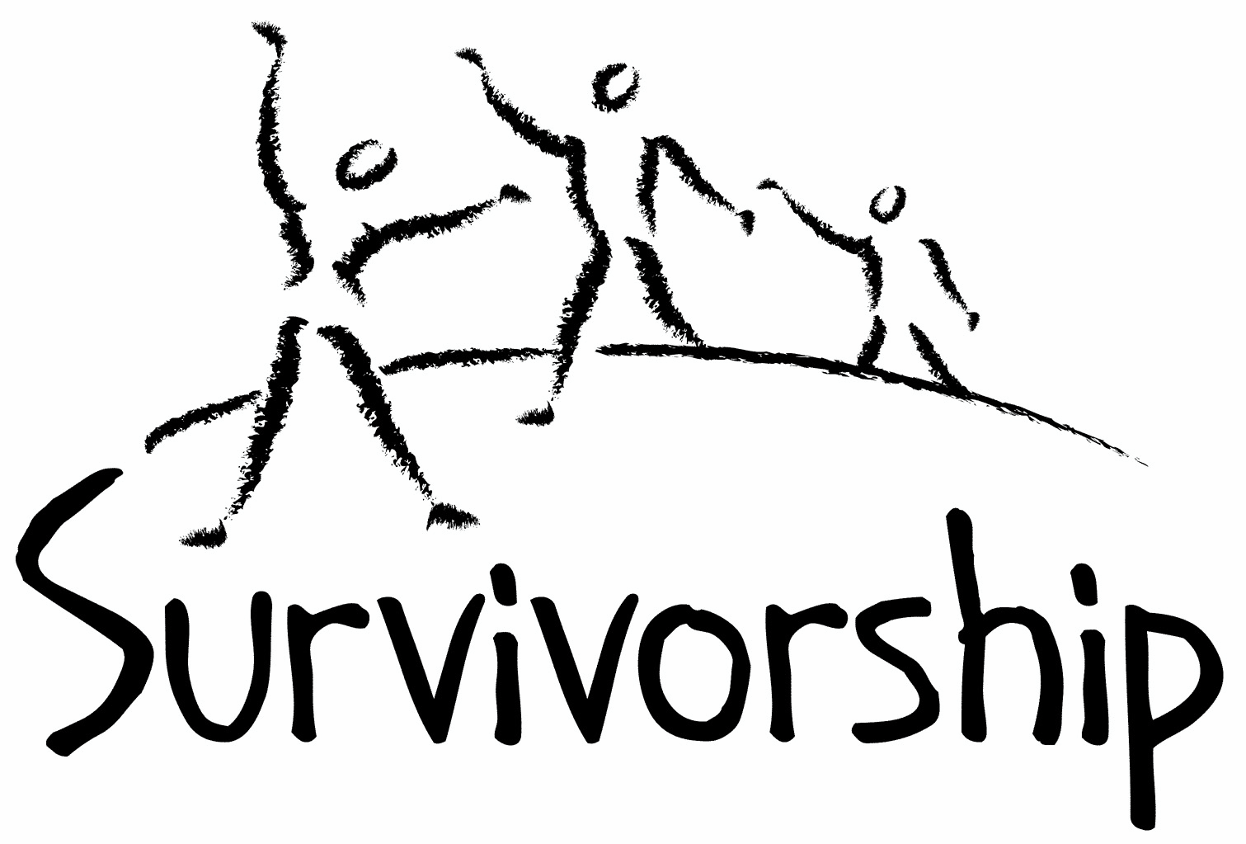

Vol. 198 No. 1 and 2
May/June 2020

The Notes, formerly called Chart Notes, ISSN 1523-275, is published bimonthly, copyright © 1999-2020 by Survivorship. All rights reserved. The entire contents of this issue are copyrighted by Survivorship and by the individual contributors. Please write Survivorship or E-mail info@survivorship.org for permission to reprint. Survivorship is a nonprofit organization.

Dear Friends,

The Survivorship Ritual Abuse and Mind Control 2020 Conference
For safety reasons due to the Novel Corona virus, we have decided to change the conference to an online conference. We strongly recommend that people follow the public health guidelines around the Covid-19 virus. We will be providing an online conference for survivors and their helpers on the same dates. Information is at: https://survivorship.org/ritual-abuse-and-mind-control-2020-conference/

When:
Regular Conference - Saturday and Sunday May 16 - 17, 2020
Clinician's Conference - Friday May 15, 2020

Speakers Include: Dr. Randy Noblitt and Pamela Perskin Noblitt,
Dr. Karol Darsa, Neil Brick, Cristina Mardirossian, LMFT and Sherry Fleming, MFT.

Due to this change, we will be holding our reduced prices another week until May 10th.
Conference prices are low as $50.
Fri: $125 - clinician’s conference Sat: $75 - $50 low income survivors
Sun: $75 - $50 low income survivors

Please remember to renew your membership if it is due.
Information is at: https://survivorship.org/how-to-renew-your-membership/
Survivorship grows and survives with your help and support.

The Survivorship Board of Directors: Neil, Eileen, Karol, Randy, Elana
Survivorship blog https://survivorshipwp.wordpress.com
Survivorship on Twitter https://twitter.com/Survivorshiporg
Survivorship on Facebook https://www.facebook.com/SurvivorshipRitualAbusePage

The Survivorship Ritual Abuse and Mind Control 2020 Conference Speakers:
https://www.prnewswire.com/news-releases/due-to-the-novel-coronavirus-covid-19-the-survivorship-ritual-abuse-conference--may-15-17-2020-has-been-changed-to-an-online-conference-301041696.html

Dr. Randy Noblitt and Pamela Perskin Noblitt will speak about Extreme Abuse Survivors, Social Security Benefits, and Ethical Practice - This workshop provides an introduction to SSA requirements for healthcare providers and survivors. Pamela Perskin Noblitt is a non-attorney claimants representative for individuals applying for SSDI and SSI benefits. Randy Noblitt is a clinical psychologist and professor of clinical psychology at the California School of Professional Psychology (CSPP) at Alliant International University, Los Angeles. https://ritualabuse.us/smart/randy-noblitt/
Dr. Karol Darsa will speak about the 5 Common Mistakes in Trauma Treatment - She will discuss how trauma treatment is becoming one of the top areas to specialize in and how it is important to have proper training to work with unprocessed trauma to achieve good outcomes for clients. Dr. Karol Darsa is a licensed psychologist, founder and executive director of Reconnect Integrative Trauma Treatment Center. She has about 20 years of clinical and administrative experience in trauma and mental health disorders.
Neil Brick will speak about Misinformation Campaigns Against Survivors - He will discuss how child and ritual abuse survivors and their advocates have been attacked by misinformation campaigns the last several years. Neil Brick is a survivor of ritual abuse and mind control. His child and ritual abuse newsletter S.M.A.R.T. https://ritualabuse.us has been published for over 25 years. http://neilbrick.com
Cristina Mardirossian, LMFT will speak about Identifying the Personality Systems of Mind Control Survivors and Trauma Treatment - She will explain how therapists are increasingly starting to see that many of their clients have histories of complex and chronic abuse. Cristina Mardirossian is the owner and director of Pasadena Trauma Therapy, Inc. and is a Licensed Marriage and Family Therapist in Pasadena, CA.
Will Randle will speak about Organicity and the Inorganic: a Sensorimotor Approach to Healing with RAMCOA Survivors - This presentation will explore the therapist's development of the internal qualities and practices foundational to Sensorimotor Psychotherapy. Will Randle is part of Columbus Counseling Group in Columbus, OH, a private practice focusing on the phase oriented treatment of complex PTSD and structural dissociation.
Sherry Fleming, MFT will speak about Eating Disorders and Dissociative Identity Disorder -
This talk presents some key similarities and differences between Eating Disorders and Dissociative Identity Disorder. Sherry Fleming has served as the Clinical Director at both The Eating Disorder Center of California and Reconnect’s residential program, both the first of their kind. In 2012, Sherry began working with clients diagnosed with DID (Dissociative Identity Disorder). She received the majority of her training in DID while working for Dr. Karol Darsa. Presently, Sherry shares her time between her private practice in Woodland Hills and her work at Serenity Trauma Treatment Center in Malibu.

Upcoming ritual abuse conference in 2020:

The 2020 Annual Ritual Abuse, Secretive Organizations and Mind Control Conference August 8 – 9, 2020 DoubleTree near Bradley International Airport Windsor Locks, CT Internet conference information: http://ritualabuse.us/smart-conference/

News Articles
Some of these articles may describe violence and/or abuse.

The Amish Keep to Themselves. And They’re Hiding a Horrifying Secret
A year of reporting by Cosmo and Type Investigations reveals a culture of incest, rape, and abuse.
https://www.cosmopolitan.com/lifestyle/a30284631/amish-sexual-abuse-incest-me-too/

Jeffrey Epstein used database to keep track of his ‘numerous’ victims
Pedophile Jeffrey Epstein kept a harem of abused and trafficked girls as young as 11
https://nypost.com/2020/01/15/jeffrey-epstein-used-database-to-keep-track-of-his-numerous-victims/

Jeffrey Epstein’s ‘first victim’ was introduced to Donald Trump when she was 14: suit
https://www.nydailynews.com/resizer/aExJIo_NqJGL6o7-9-_RLNlIsag=/800x600/top/arc-anglerfish-arc2-prod-tronc.s3.amazonaws.com/public/W7YU7SAAG5DPXI7AY6RUHSNXSA.jpg
https://www.nydailynews.com/new-york/ny-epstein-trump-victim-suit-20200118-m6sqsa2h7venpf5uewjrkvigo4-story.html

Jeffrey Epstein ran a 'trafficking pyramid scheme' from his private island until 2018, a new lawsuit alleges. Here are all the famous people he was connected to.
https://www.businessinsider.com/famous-people-jeffery-epstein-money-manager-sexual-trafficking-connected-2019-7

U.S. Virgin Islands Officials: Epstein Trafficked Girls On Private Island Until 2018
Authorities claim Epstein's sexual predation on the hideaway islands occurred as recently as 2018 and involved children as young as 11 years old. The suit alleges the activity was covered up by Epstein's associates through a complex web of corporations.
https://www.wbur.org/npr/797011139/u-s-virgin-islands-officials-epstein-trafficked-girls-on-private-island-until-20

Survivor recounts confused, chaotic cult rite that killed 7
https://wcti12.com/news/nation-world/survivor-recounts-confused-chaotic-cult-rite-that-killed-7

Nxivm ‘Sex Cult’ Was Also a Huge Pyramid Scheme, Lawsuit Says
Eighty people contended that they were bilked out of millions of dollars through a “coercive” scheme by the self-help group.
https://www.nytimes.com/2020/01/29/nyregion/nxivm-lawsuit-keith-raniere.html

Man dubbed 'largest facilitator' of child abuse images pleads guilty Eric Eoin Marques, citizen of US and Ireland, faces up to 30 years in prison over web hosting service https://www.theguardian.com/us-news/2020/feb/06/child-abuse-images-case-us-ireland-eric-eoin-marques

Police uncovering 'epidemic of child abuse' in 1970s and 80s https://www.theguardian.com/uk-news/2020/feb/05/police-uncovering-epidemic-of-child-abuse-in-1970s-and-80s

Mutilating Southeast Asia’s girls On 6 February, the world celebrated International Day of Zero Tolerance for Female Genital Mutilation (FGM) which aims to raise awareness and to eradicate the practice. According to the United Nations Population Fund (UNFPA), in 2020 alone, 4.1 million girls around the world are at risk of undergoing FGM. https://theaseanpost.com/article/mutilating-southeast-asias-girls

Church cult controlled sex lives ... even on wedding nights
New book documents story of Word of Faith Fellowship, a bizarre Pentecostal spinoff in N.C. foothills
https://www.gastongazette.com/entertainment/20200215/church-cult-controlled-sex-lives--even-on-wedding-nights

Former La Luz Del Mundo Member Alleges The Church Ran Child Sex Slavery Ring
https://laist.com/2020/02/13/la-luz-del-mundo-child-abuse-allegations-holy-supper.php

Six former wrestlers say Rep. Jim Jordan knew about abusive OSU doctor https://www.cnn.com/2020/03/06/politics/jordan-osu-wrestlers-strauss-invs/index.html

Child sex abuse victim says Anglican Church fobbed her off, then offered payout in exchange for silence https://www.abc.net.au/news/2020-03-10/abuse-survivor-beth-heinrich-anglican-church-qld/12039190

Pastor and wife jailed after he raped children in bogus religious ceremony over 20 years https://news.yahoo.com/pastor-birmingham-rape-jailed-160535296.html

How Father Flanagan spoke out about Irish abuse of children in 1946 In his new book, A New Ireland, Niall O’Dowd traces the first-ever revelation about the savage treatment of children by church and state in Ireland during the 1940s.
https://www.irishcentral.com/roots/history/new-ireland-niall-odowd-father-flanagan

Weinstein gets 23 years in sentence hailed by accusers https://apnews.com/310554f06f644d41e1c0513600099ce1

Call for submissions: For Survivorship's next journal, please send your essays, articles, poetry and art work for consideration for publication. We accept entries from survivors and specialists in the field. Please mail to: info@survivorship.org All entries must be in electronic form and sent by e-mail or e-mail attachment.

ON-GOING MEETINGS AND TRAINING OPPORTUNITIES

More information is available at https://survivorship.org/community-calendar-of-events/

Survivorship is presenting this as information only. If you choose to use one of these resources, please note that you are doing this at your own risk.

PODS - POSITIVE OUTCOMES FOR DISSOCIATIVE SURVIVORS (PODS) info@pods-online.org.uk http://www.pods-online.org.uk/events.html

ASCA (Adult Survivors of Child Abuse) On-going meetings in CA, FL, IL, NE, NJ, NY, NC, RI, and South Africa info@ascasupport.org www.ascasupport.org

Survivors of Incest Anonymous
SIA holds 12-step meetings for incest survivors. Those designated “Nothing Too Heavy to Share” meetings are designed for ritual abuse survivors. 410-282-3400 http://www.siawso.org

Trauma Center at JRI Free lecture each Thursday of the month, 12-1 p.m., Brookline, MA
moreinfo@traumacenter.org 617- 232-1303 www.traumacenter.org/training/workshops.php

Women’s Center, 46 Pleasant Street, Cambridge, MA Weekly and monthly groups for survivors of child sexual abuse, incest survivor’s interfaith quilt project, Survivors of Incest Anonymous, eating disorder support group, emotional healing group, more. info@cambridgewomenscenter.org Phone: 617-354-6394 Helpline. 617-354-8807 http://www.cambridgewomenscenter.org

Dissociation & Trauma Clinical Discussions
The Dissociation & Trauma Clinical Discussions (DissTCD) list has been created to allow for clinical discussions for all licensed mental health counselors and retired licensed mental health counselors around the world to discuss ritual abuse, mind control and other topics. If you have a related license or degree, please write for more information at DissTCD-owner@yahoogroups.com http://groups.yahoo.com/group/DissTCD

Ritual-Abuse/Mind-Control Special Interest Group
The Ritual Abuse and Mind Control Special Interest Group (RA/MC SIG) of the International Society for the Study of Trauma and Dissociation (ISSTD) was approved by ISSTD’s Executive Council in 2008. The Mission of the RA/MC SIG is to further dialogue, knowledge, research and training on the etiology, evaluation, and effective treatment of trauma and dissociation in clients reporting histories of ritual abuse or mind control. Membership in the RA/MC SIG is free to all ISSTD members as an ISSTD membership benefit. https://www.isst-d.org/join-isstd/special-interest-groups/ramcoa-sig/

The Childhelp National Child Abuse Hotline 1-800-4-A-CHILD (1-800-422-4453)
HOTLINES FAMILIAR WITH RA ISSUES
* Bay Area Women Against Rape (BAWAR): 510-845-7273
* San Francisco Women Against Rape (SFWAR): 415-647-7273
* Women’s Center, Cambridge, MA: 617-354-8807

Difficult Dates
Please use caution when reading this page. This page has words and dates that may remind survivors of their programming. This page summarizes dates that may be used by cults and various destructive groups. Abusive groups steal, pervert and mock the holidays of legitimate religions, holidays and cultures. This does not mean that all or even most people who observe some of these holidays are abusive.
May
5/2 May Day (Ireland)
5/1 is the Illuminati’s second most sacred holiday and may include human sacrifice.
5/22 New Moon
5/5 Cinco de Mayo
5/8 V-E Day
5/9, 5/11, 5/13 Lemuria (three days Roman All Souls)
5/12 Mother's Day
5/28 - 5/30 Shavout
5/16 Armed Forces Day
5/31 Pentecost
5/12 Lag BaOmer
5/7 Full Moon
5/19 Laylat al Qadr
5/22 Savitri Pooja
5/23 Eid-al-Fitr (End of Ramadan)
5/25 Memorial Day
5/7 Vesak - Buddha Day
5/21 Ascension Day, Ascension of Jesus
5/18 Victoria Day
5/29 5/30 Memory day dedicated to Joan of Arc
5/28 - 5/30 Shavuot
June
6/5 Queen Elizabeth’s birthday (New Zealand)
6/6 D Day (invasion of France in WW2)
6/9 Pentecost
6/11 Corpus Christi – feast to mock the body & blood of Christ in Christian ritual
6/7 Trinity Sunday
6/15 Saint Vladimir
6/16 Father's Day
6/16 Martyrdom of Guru Arjan Dev Sahib
6/12 Queen Elizabeth’s birthday (Australia except Queensland & West Australia)
6/21 Father’s Day
6/5 Full Moon
6/21 First Nation’s Day - Canada
6/21 New Moon
6/21 Summer Solstice (orgies blood)
6/21 Rituals of the Elements and Feast of the Times
6/24 Midsummer’s Eve
6/23 St. John’s Eve Fire Festival
6/19 Saints Peter and Paul

How to Renew your Membership

To find out when your membership renewal is due: if you receive our literature by mail, look at the label on your Notes or Survivorship journal. You may also write info@survivorship.org and ask. If you renew before you need to, we will just add the extra months onto your membership. Please try to keep your membership up to date.

You may renew here: https://survivorship.org/how-to-renew-your-membership/
This page as a link to paying with PayPal https://survivorship.org/membership-using-paypal/

Rates
The rates for a Survivorship membership are on a sliding scale based on ability to pay beginning from $75.00 down to what you can afford. We ask that health-care professionals contribute towards gift memberships. We regret that we are not able to provide services or include members under the age of 18.

Renewing
1. Decide if you want to read the Survivorship Journal and Notes on the web site (Internet Member) or receive the Journal by regular mail (let us know if you want to also receive the Notes by regular mail) (Regular Member).

2. Then choose how much you are able to pay. If you are a professional, we recommend that you donate $35.00 to support gift memberships for low-income survivors. We appreciate gifts so that we may offer support to survivors who are unable to work due to the after-effects of their abuse and to survivors who are imprisoned. All donations are tax deductible. We are a 501(C) corporation.

3. Decide whether you want to pay by check, money order, or PayPal. PayPal accepts charge cards. If you want to pay using PayPal, please copy and fill out the form below, email it to info@survivorship.org, and then click https://survivorship.org/membership-using-paypal/ to make your payment.

If you want to pay by check or money order, print out the form below and send it with your payment (in U.S. funds) to: Survivorship, 881 Alma Real Drive Ste 311, Pacific Palisades, CA 90272 USA

Name ________________________________________________________

Organization (if applicable) _______________________________________

City _________________________________________________________

State __________________ (Please add street address and zip code for non-internet memberships only.)

E-mail _______________________________________________________

Regular Membership: $__________ or Internet Membership $___________ Donation $_____________

Total enclosed $______________________
You may also e-mail the information on this form to info@survivorship.org

