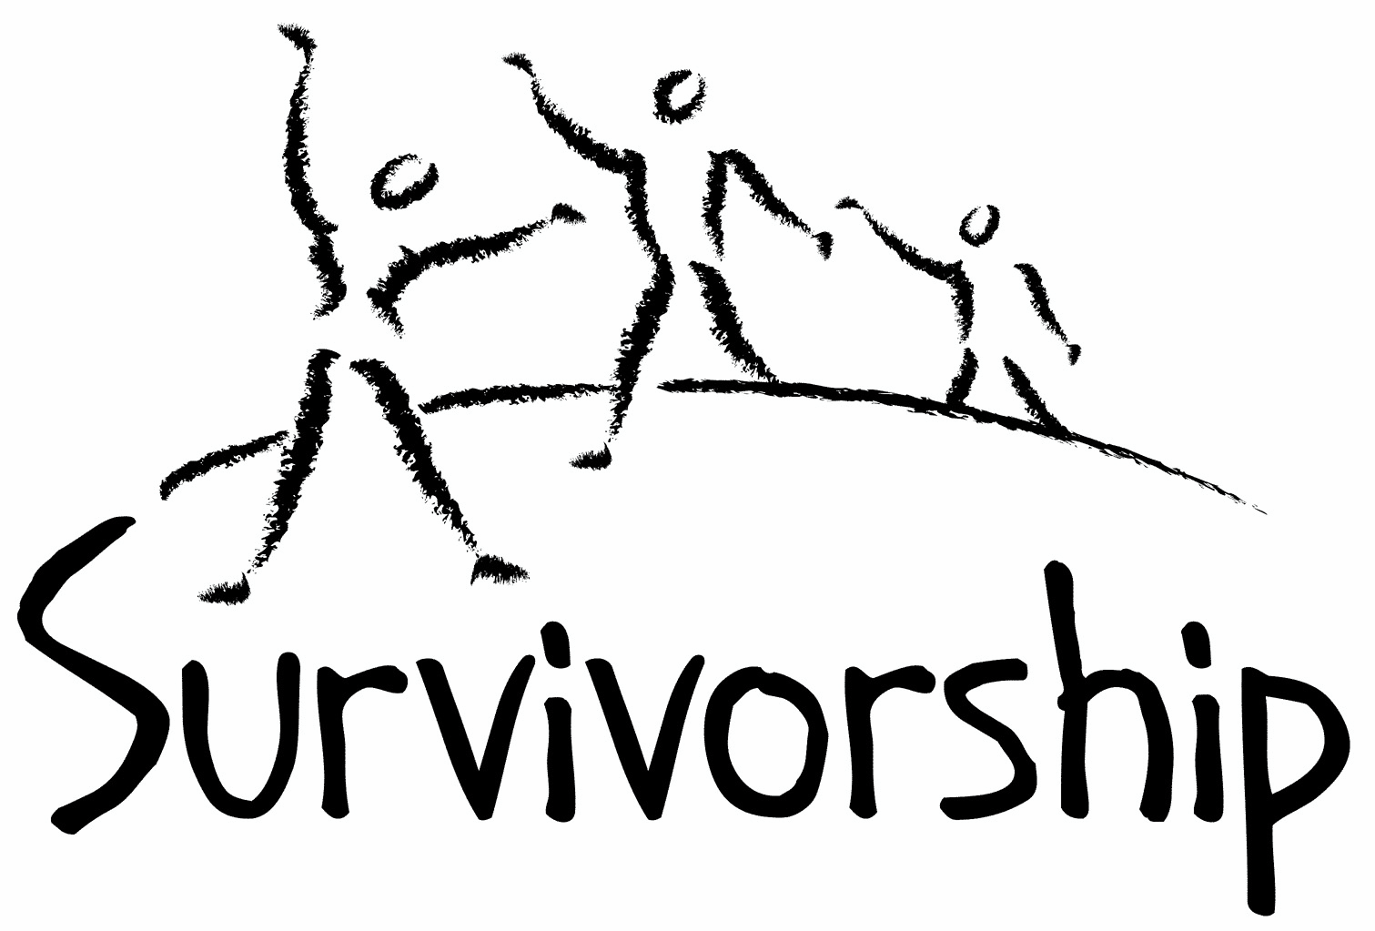

Vol. 196 No. 7 and 8
September/October 2019

The Notes, formerly called Chart Notes, ISSN 1523-275, is published bimonthly, copyright © 1999-2019 by Survivorship. All rights reserved. The entire contents of this issue are copyrighted by Survivorship and by the individual contributors. Please write Survivorship or E-mail info@survivorship.org for permission to reprint. Survivorship is a nonprofit organization.

Dear Friends,
We co-sponsored the East Coast conference organized by S.M.A.R.T. (Stop Mind Control and Ritual Abuse) The 2019 Annual Ritual Abuse, Secretive Organizations and Mind Control Conference
https://ritualabuse.us/smart-conference/ Speakers included Dr. Alison Miller, Neil Brick and movie maker Daniel Roemer.
Online Conference Presentations:
Deception by Organized Abuser Groups: Helping Your Front People and Your Insiders Recognize the Lies and Tricks Which Keep You Enslaved by Alison Miller https://ritualabuse.us/smart-conference/2019-conference/deception-by-organized-abuser-groups-helping-your-front-people-and-your-insiders-recognize-the-lies-and-tricks-which-keep-you-enslaved-by-alison-miller/
Possible Hate Groups – How Do They Effect Survivors and Their Resources by Neil Brick
This presentation discussed groups that attack survivors and their helpers due to their diagnosis of dissociation and dissociative identity disorder and work recovering from trauma. https://ritualabuse.us/smart-conference/2019-conference/possible-hate-groups-how-do-they-effect-survivors-and-their-resources/
A Survivor’s View of Recovery from Ritual Abuse by Neil Brick https://ritualabuse.us/smart-conference/2019-conference/a-survivors-view-of-recovery-from-ritual-abuse-by-neil-brick/
Please remember to renew your membership if it is due. Information is at: https://survivorship.org/how-to-renew-your-membership/ Survivorship grows and survives with your help and support.

The Survivorship Board of Directors: Neil, Eileen, Karol and Randy
Survivorship blog https://survivorshipwp.wordpress.com
Survivorship on Twitter https://twitter.com/Survivorshiporg
Survivorship on Facebook https://www.facebook.com/SurvivorshipRitualAbusePage

PowerPoints from the Survivorship Conference are now available at:
https://survivorship.org/ritual-abuse-and-mind-control-2019-conference/

Deception by Organized Abuser Groups: Helping Yourself and Your Clients Think Through the Issues by Alison Miller
The Use of Music and other Auditory Stimuli in Psychological Therapy with Extreme Abuse Survivors by Randy Noblitt
The Complexities of Identifying Ritual Abuse and Mind Control in Your Client by Eileen Aveni
Deception by Organized Abuser Groups: Helping Your Front People and Your Insiders Recognize the Lies and Tricks Which Keep You Enslaved by Dr. Alison Miller
A Survivor's View of Recovery from Ritual Abuse by Neil Brick
I Believe You: A Therapist Looks at 30 Years of Work with Survivors of RA/MC by Eileen Aveni

Information about Alison Miller and Her Research https://ritualabuse.us/smart/alison-miller/

Deception by Organized Abuser Groups: Helping Your Front People and Your Insiders Recognize the Lies and Tricks Which Keep You Enslaved by Alison Miller https://ritualabuse.us/smart-conference/2019-conference/deception-by-organized-abuser-groups-helping-your-front-people-and-your-insiders-recognize-the-lies-and-tricks-which-keep-you-enslaved-by-alison-miller/

Please note: None of the material on these pages or at the conference is meant as therapy, or to take the place of therapy. This presentation may remind survivors of their programming, so please use caution while reading.

If you are a survivor of abuse by a mind-controlling abuser group, you have parts that have been trained to obey abusers because they believe lies your abusers told you. The abusers deceived you in childhood, using drugs, acted-out scenarios, stage magic, stories and films to control your child parts and prevent you from speaking out about the abuse. Their power over you depends on your young parts believing the abusers’ lies. If you learn to recognize when your emotions and behavior are influenced by these deceptions, and to discover the ways in which you were deceived, you can increase your freedom from the abuser group. (Skype presentation)

Alison Miller, Ph.D. is a retired clinical psychologist who practised in Victoria, B.C., Canada and worked with survivors of organized abuse, including ritual abuse and mind control from 1990 to 2017. She has twice chaired the RAMCOA (ritual abuse/mind control/organized abuse) special interest group of the International Society for the Study of Trauma and Dissociation. She is the author of Healing the Unimaginable: Treating Ritual Abuse and Mind Control (for therapists), Becoming Yourself: Overcoming Mind Control and Ritual Abuse (for survivors), and co-author with survivor Wendy Hoffman of From the Trenches: A Victim and Therapist Talk about Mind Control and Ritual Abuse. She has published several other book chapters and articles, as well as being the originator of the LIFE Seminars parent education programs.

News Articles
Some of these articles may describe violence and/or abuse.

Jeffrey Epstein Was a Sex Offender. The Powerful Welcomed Him Anyway.
https://www.nytimes.com/2019/07/13/nyregion/jeffrey-epstein-new-york-elite.html

More Details About Jeffrey Epstein’s Past Emerge
http://nymag.com/intelligencer/2019/07/more-details-about-jeffrey-epsteins-past-emerge.html

The Day Jeffrey Epstein Told Me He Had Dirt on Powerful People
https://www.nytimes.com/2019/08/12/business/jeffrey-epstein-interview.html

Questions mounting over Jeffrey Epstein's suicide https://www.youtube.com/watch?v=vI5PROYfegU

Who's who of Jeffrey Epstein's powerful friends, associates and possible co-conspirators
https://www.cnn.com/2019/08/12/us/jeffrey-epstein-associates-possible-accomplices/index.html

The rise and fall of Jeffrey Epstein: A timeline of the financier's troubles
https://abcnews.go.com/US/rise-fall-jeffrey-epstein-timeline-financiers-legal-troubles/story?id=64507847

There’s no video of Jeffrey Epstein’s apparent suicide: sources
https://www.cnbc.com/2019/08/27/jeffrey-epsteins-lawyers-skeptical-of-suicide-ruling.html

E. Jean Carroll: “Trump attacked me in the dressing room of Bergdorf Goodman.”
http://nymag.com/intelligencer/2019/06/president-donald-trump-faces-new-rape-accusation.html

New Tape Shows Donald Trump And Jeffrey Epstein At Mar-A-Lago Party In 1992 https://www.youtube.com/watch?v=AUDr_c2PalI

Prince Andrew’s ties to Jeffrey Epstein could become the most sordid royal scandal yet
https://nypost.com/2019/07/17/prince-andrews-ties-to-jeffrey-epstein-could-become-the-most-sordid-royal-scandal-yet/

“It’s Going to Be Staggering, the Amount of Names”: As the Jeffrey Epstein Case Grows More Grotesque, Manhattan and DC Brace
https://www.vanityfair.com/news/2019/07/jeffrey-epstein-case-grows-more-grotesque

Kevin Spacey’s Criminal Case Has Been Dismissed
https://www.vanityfair.com/hollywood/2019/07/kevin-spacey-criminal-case-dismissed

Boston Hospital Reports Disciplining of Renowned Child Abuse Skeptic
https://www.propublica.org/article/boston-hospital-reports-disciplining-of-renowned-child-abuse-skeptic

Boy Scouts of America Are Coving up a 'Pedophilia Epidemic,' 350 Alleged Abusers Have Been Named In Lawsuit
https://www.newsweek.com/boy-scouts-america-are-coving-pedophilia-epidemic-350-alleged-abusers-have-been-named-lawsuit-1452933

R. Kelly Arrested on Federal Sex Trafficking Charges: Law Enforcement Officials
https://www.nbcnewyork.com/news/local/R-Kelly-Arrested-on-Federal-Sex-Crime-Charges-512618121.html

R. Kelly charged with engaging in prostitution, soliciting a minor in Minnesota
https://www.nbcnews.com/news/us-news/r-kelly-charged-engaging-prostitution-soliciting-minor-minnesota-n1039416

He Says a Priest Abused Him. 50 Years Later, He Can Now Sue.
https://www.nytimes.com/2019/08/13/nyregion/child-victims-act-lawsuit.html

2019 Dates - Difficult Dates

Please use caution when reading this page. This page has words and dates that may remind survivors of their programming. This page summarizes dates that may be used by cults and various destructive groups. Abusive groups steal, pervert and mock the holidays of legitimate religions, holidays and cultures. This does not mean that all or even most people who observe some of these holidays are abusive. Online at: https://survivorship.org/2019-dates/

September
9/2 Krishna Janmashtami: Hindu
9/02 Ganesh Chaturthi
9/1 Start of WWII
9/02 Labor Day
9/02 +Ganesh Chaturthi
9/09 Day of Ashura / Muharram
9/9 - 9/11 Rosh Hashanah (Jewish New Year)
9/5-9/7 Marriage to the Beast (Satan)
9/7 Feast of the Beast marriage of virgins to Satan (sacrifice)
9/5-9/19 Pitr Paksha: Hindu 16-day period when spirits visit their descendant’s home
9/17 Vishwakarma Puja
9/11 Onam
9/12 - 9/23 Ganesh Charurthi; Hindu: Birth of Lord Ganesha god of wisdom prosperity and good fortune
9/13 Grandparents' Day
9/14 Holy Cross Day
9/14 Full Moon
9/20-9/21 Midnight Host vows blood sacrifice from tip of finger
9/21 Rituals of the Elements and Feast of the times
9/22 Fall Equinox
9/25 Queen Elizabeth’s birthday (West Australia)
9/23-10/2 Mysteries of Eleusis
9/28 Mahalaya Amavasya
9/29 Michael and All Angels
9/29 Navaratri begins
9/29 Michaelmas
9/30-Oct 1 Rosh Hashana
9/28 New Moon

October
10/3 Full Moon
10/2 Queen Elizabeth’s birthday (Queensland Australia)
10/5 Opening of Mundus Ceresis
10/7 Navaratri ends / Maha Navami
10/08 Dusshera
10/9 Dia de la Raza: Mexico
10/9 Yom Kippur
10/14 Columbus Day
10/21 Shmini Atzeret
10/26 Diwali
10/16-20 Feast of Tabernacles
10/13 Sharad Purnima
10/20 Birth of the Guru Granth
10/22 Simchat Torah
10/14-15 Sukkot
10/27 New Moon10/24 United Nations’ Day
10/10 - 10/19 Navaratri: Hindu: Fall Festival Worship of Durga. Lakshmi ans Saraswati
10/12 Hitler’s half birthday
10/13 Backwards Halloween
10/13-10/30 Preparation for all Hallows Eve Samhain (Halloween).
10/15 Death of Goering
10/15 - 10/19 Durga Puja
10/16 Death of Rosenburg
10/19 Diwali: Hindu: Festival of Lights: The end of Lord Rama’s exile killing of a demon by Krishna’s wife
10/19 Kali Puja 10/28-10/30 Satanist High Holy Day related to Halloween (blood human sacrifice each day)
10/31 Start of the Celtic new year. Dark half of the year
10/31 Preparation for the Isia (ring of six: Isis Hathor Nepthys Horus Thoth Anubis) Resurrection of Osiris
10/31 Halloween/Samhain/All Hallow’s Eve/ Hallomas/ All Souls Day

Call for submissions: For Survivorship's next journal, please send your essays, articles, poetry and art work for consideration for publication. We accept entries from survivors and specialists in the field. Please mail to: info@survivorship.org All entries must be in electronic form and sent by e-mail or e-mail attachment.

ON-GOING MEETINGS AND TRAINING OPPORTUNITIES

More information is available at https://survivorship.org/community-calendar-of-events/

Survivorship is presenting this as information only. If you choose to use one of these resources, please note that you are doing this at your own risk.

PODS - POSITIVE OUTCOMES FOR DISSOCIATIVE SURVIVORS (PODS) info@pods-online.org.uk http://www.pods-online.org.uk/events.html

ASCA (Adult Survivors of Child Abuse) On-going meetings in CA, FL, IL, NE, NJ, NY, NC, RI, and South Africa info@ascasupport.org www.ascasupport.org

Survivors of Incest Anonymous
SIA holds 12-step meetings for incest survivors. Those designated “Nothing Too Heavy to Share” meetings are designed for ritual abuse survivors. 410-282-3400 http://www.siawso.org

Trauma Center at JRI Free lecture each Thursday of the month, 12-1 p.m., Brookline, MA
moreinfo@traumacenter.org 617- 232-1303 www.traumacenter.org/training/workshops.php

Women’s Center, 46 Pleasant Street, Cambridge, MA Weekly and monthly groups for survivors of child sexual abuse, incest survivor’s interfaith quilt project, Survivors of Incest Anonymous, eating disorder support group, emotional healing group, more. info@cambridgewomenscenter.org Phone: 617-354-6394 Helpline. 617-354-8807 http://www.cambridgewomenscenter.org

Dissociation & Trauma Clinical Discussions
The Dissociation & Trauma Clinical Discussions (DissTCD) list has been created to allow for clinical discussions for all licensed mental health counselors and retired licensed mental health counselors around the world to discuss ritual abuse, mind control and other topics. If you have a related license or degree, please write for more information at DissTCD-owner@yahoogroups.com http://groups.yahoo.com/group/DissTCD

Ritual-Abuse/Mind-Control Special Interest Group
The Ritual Abuse and Mind Control Special Interest Group (RA/MC SIG) of the International Society for the Study of Trauma and Dissociation (ISSTD) was approved by ISSTD’s Executive Council in 2008. The Mission of the RA/MC SIG is to further dialogue, knowledge, research and training on the etiology, evaluation, and effective treatment of trauma and dissociation in clients reporting histories of ritual abuse or mind control. Membership in the RA/MC SIG is free to all ISSTD members as an ISSTD membership benefit. http://www.isst-d.org/default.asp?contentID=183

The Childhelp National Child Abuse Hotline 1-800-4-A-CHILD (1-800-422-4453)
HOTLINES FAMILIAR WITH RA ISSUES
* Bay Area Women Against Rape (BAWAR): 510-845-7273
* San Francisco Women Against Rape (SFWAR): 415-647-7273
* Women’s Center, Cambridge, MA: 617-354-8807

How to Renew your Membership

To find out when your membership renewal is due: if you receive our literature by mail, look at the label on your Notes or Survivorship journal. You may also write info@survivorship.org and ask. If you renew before you need to, we will just add the extra months onto your membership. Please try to keep your membership up to date.

You may renew here: https://survivorship.org/how-to-renew-your-membership/
This page has a link to paying with PayPal https://survivorship.org/membership-using-paypal/

Rates
The rates for a Survivorship membership are on a sliding scale based on ability to pay beginning from $75.00 down to what you can afford. We ask that health-care professionals contribute towards gift memberships. We regret that we are not able to provide services or include members under the age of 18.

Renewing
1. Decide if you want to read the Survivorship Journal and Notes on the web site (Internet Member) or receive the Journal by regular mail (let us know if you want to also receive the Notes by regular mail) (Regular Member).

2. Then choose how much you are able to pay. If you are a professional, we recommend that you donate $35.00 to support gift memberships for low-income survivors. We appreciate gifts so that we may offer support to survivors who are unable to work due to the after-effects of their abuse and to survivors who are imprisoned. All donations are tax deductible. We are a 501(C) corporation.

3. Decide whether you want to pay by check, money order, or PayPal. PayPal accepts charge cards. If you want to pay using PayPal, please copy and fill out the form below, email it to info@survivorship.org, and then click https://survivorship.org/membership-using-paypal/ to make your payment.

If you want to pay by check or money order, print out the form below and send it with your payment (in U.S. funds) to: Survivorship, 881 Alma Real Drive Ste 311, Pacific Palisades, CA 90272 USA

Name ________________________________________________________

Organization (if applicable) _______________________________________

City _________________________________________________________

State __________________ (Please add street address and zip code for non-internet memberships.)

E-mail _______________________________________________________

Regular Membership: $__________ or Internet Membership $___________ Donation $_____________

Total enclosed $______________________
You may also e-mail the information on this form to info@survivorship.org

