Volume 23, Issue 8 Summer 2019

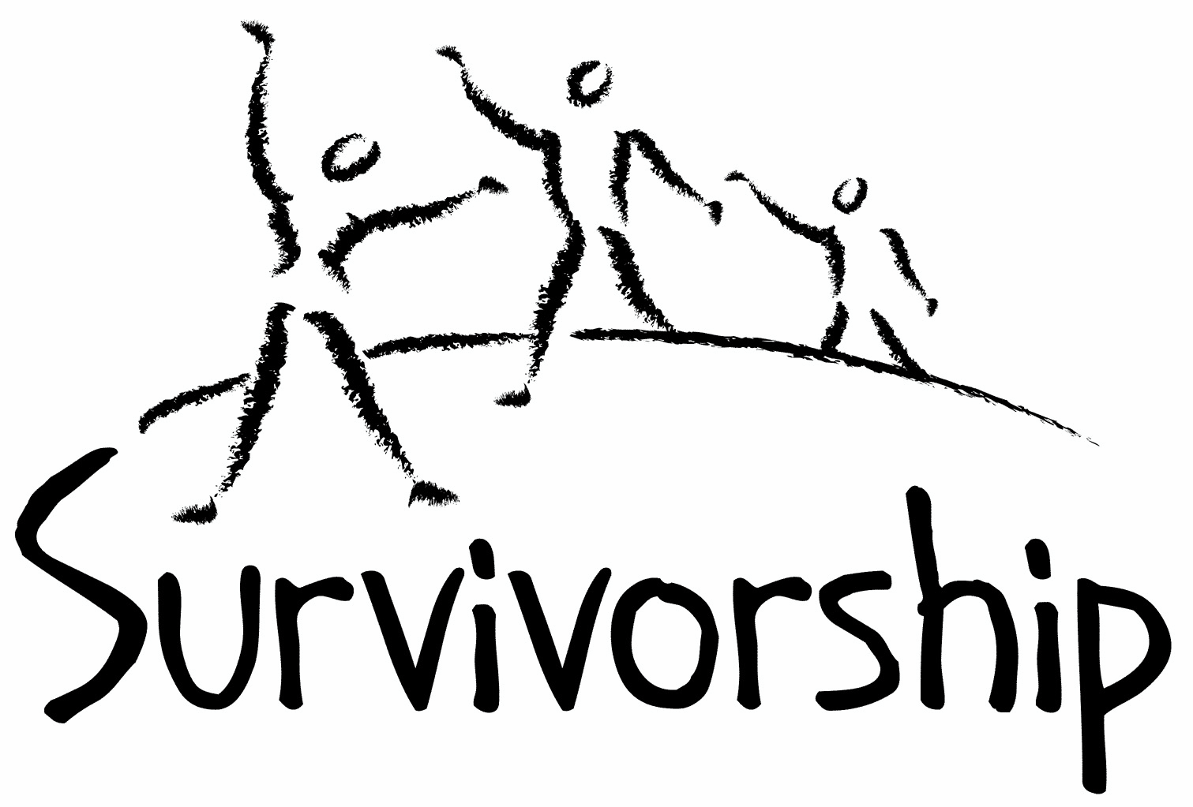
JOURNAL
For survivors of ritual abuse, mind control and torture, and pro-survivors

Copyright Information
SURVIVORSHIP JOURNAL, ISSN 046-2015, is published twice per year in Pacific Palisades, CA.
Copyright 2019 by Survivorship. All rights reserved. The entire contents of this issue are copyrighted by Survivorship and/by the individual contributors. No part of this publication may be reproduced or transmitted in any form or by any means, electronic or mechanical, including photocopying, or by any information storage and retrieval systems, without permission in writing by the copyright owners. For permission to reprint, write: Survivorship 881 Alma Real Drive Ste 311 Pacific Palisades, CA 90272 or email info@survivorship.org

Dear survivors, therapists treating surviving victims, support people and others:

In this issue we have articles by Dr. Randall Noblitt and Neil Brick and poetry by Amanda Cross.

The Survivorship Ritual Abuse and Mind Control 2019 Conference was a very successful conference this year.

Conference speakers included Alison Miller, PhD, Randy Noblitt, PhD, Eileen Aveni and Neil Brick

We co-sponsored the 2019 Annual Ritual Abuse, Secretive Organizations and Mind Control Conference on the East Coast.
Speakers included Alison Miller, Neil Brick and filmmaker Daniel Roemer

PowerPoints are available of all the presentations from our 2019 conference at: https://survivorship.org/ritual-abuse-and-mind-control-2019-conference/

Table of Contents

Page Title and Author

3 Ethics and Sensitivity to Clients' Religious Preferences
Randy Noblitt, PhD and Jessie Lowell, PsyD

5 A Survivor’s View of Recovery from Ritual Abuse
Neil Brick

9 Howl at the Moon
Amanda Cross

Ethics and Sensitivity to Clients' Religious Preferences
Randy Noblitt, PhD Jessie Lowell, PsyD
Alliant International University
Los Angeles, California

Survivors of child abuse often feel betrayed by their perpetrators, the bystanders who did not protect them, and may be perplexed about religion and spirituality. If there is a just and loving Deity how could these awful things happen to them, and to other vulnerable individuals, including children? If they believe in an all-powerful Deity, why could it not be stopped? Why did no one intervene on their behalf? The question of why bad things happen to good people, especially children, is complex, and perhaps unanswerable to the satisfaction of all. The Book of Job is one poignant telling of such a narrative in the Judeo-Christian tradition. Our point is that suffering is difficult to understand, even more so when the suffering is great, and when it harms innocents. On the other hand, many abuse survivors tell such stories while expressing a desire to be at peace with their chosen spirituality and religious faith. Some may even search for meaning for their suffering within in their spirituality practices or religious faith. How might psychotherapists respond to such clients? Further, religion and spirituality often form a foundation and set of values and practices for those that subscribe. For those in the helping professions working with these clients, if these values, beliefs, expectations, and beyond should not be neglected or dismissed.
Our suggestion is that psychotherapists should prioritize their clients’ needs without interjecting our own personal judgments and biases. Some survivors specifically want to work with therapists with particular religious or spiritual orientations, e.g., Christian, Jewish, Muslim, etc. In other instances, clients may want a secular therapist who is knowledgeable about a variety of religious traditions. I overheard one survivor tell a Christian therapist that she was hesitant to work with a Christian therapist fearing that the therapist might try to convert her. For some clients their goal is to be able to explore their own religious and spiritual thoughts and feelings freely without judgment. For others, their aim may be to integrate their own freely-chosen religious and spiritual convictions with their recovery plan. For example, some clients prefer to begin psychotherapy sessions with a prayer or an inspirational reading. We as psychotherapists can honor such preferences, making it clear that our clients’ religious and spiritual beliefs are important to us and deserve respectful treatment. Religion and spirituality is one of several aspects of diversity. For example, in Pamela Hays’s ADDRESSING model the fourth letter in the acronym stands for religion. Religion, or the absence of it, can be a critical part of a person’s core identity. Therapists need to become more knowledgeable and comfortable with this topic to best serve their clients. This may include more training in religion and spirituality as a cultural competence. Too often, psychotherapists are not comfortable discussing religious or spiritual beliefs, although understanding the importance for the client is crucial. This should be an essential part of the intake process with a client as well as infused in ongoing therapy if relevant for the client.
Reference
Hays, P. A. (2016). Addressing cultural complexities in practice: Assessment, diagnosis, and therapy (3rd ed.). Washington, DC: American Psychological Association.

A Survivor’s View of Recovery from Ritual Abuse

Neil Brick

Presented at the 2019 Annual Ritual Abuse, Secretive Organizations and Mind Control Conference on August 17 – 18, 2019 by Neil Brick (also presented at The Survivorship Ritual Abuse and Mind Control 2019 Conference).

Please note: All accusations are alleged. This presentation may be triggering for some survivors. None of the material on these pages or at the conference is meant as therapy, or to take the place of therapy.

Recovery from ritual abuse can take many years. Recovery may include working through memories, building functionality and developing more effective ways of interacting and integrating emotions. Every individual has different experiences that lead them through the recovery path. Neil Brick will discuss his long journey healing from severe abuse. This will include ways he has learned more about himself, ways he has learned to develop healthier interactions with others and ways he has helped others along the recovery path.

Neil Brick is a survivor of ritual abuse and mind control. His work continues to educate the public about child abuse, trauma and ritual abuse crimes. His child abuse and ritual abuse newsletter S.M.A.R.T. https://ritualabuse.us has been published for over 24 years. http://neilbrick.com

Defining Terms:

(These are self defined. Not necessarily meant to be definitions for others.)

What is a survivor?

A person who has survived.

What did they survive?

In my case, severe trauma. An attempt to break my will and destroy my soul. Neither of which happened.

What is recovery?

Healing from an event. In my case, a lifelong battle to uncover myself from the damage done to me and the lies fed to me.

What is Ritual Abuse?

There are many definitions. Mine is severe abuse repeated in a ritualistic manner to manipulate and hurt others.

Recovery from ritual abuse can take many years.

Working through severe trauma takes a lifetime. There is always more to learn. There are always different ways to look at trauma and see how it has effected our lives.

Recovery may include working through memories.

We have to know our past to learn where we came from, how it effected us and how we can heal from the past.

Building functionality

How do we become more functional? Does this mean we become less damaged, more able to navigate the world we live in? Does this mean being able to work, to pay bills, to take care of our basic needs?

I have always been fairly good at these things. I have survived with minimal support all of my life. I have also helped others survive.

Developing more effective ways of interacting and integrating emotions.

How do we build awareness and improve our interactions? Are our interactions chaotic? Are we emotionally all over the place or blunted? Are we causing more damage in the world by our drama or are we moving toward a place of healing and peace we can present to others?

Bring all of our emotions together into one part of ourselves is very important. Having our ideas, voices and feelings in one place in our mind is crucial to healing and being aware. This development of the natural way we would have been without trauma allows us more effective ways of living with others and our world.

Every individual has different experiences that lead them through the recovery path.

There are similarities in our paths, such as building an awareness of what happened, processing feelings about what happened and living a new way. There are differences, like following different recovery paths and using different techniques.

I will discuss my long journey healing from severe abuse. This will include ways I’ve learned more about myself, ways I’ve learned to develop healthier interactions with others and ways I’ve helped others along the recovery path.

This journey will continue and includes the present moment. Never believe someone when they say they have fully healed. To me, Nirvana is not an end point but a process where progress has been made. The rosy picture of Nirvana is meant to attract people in the earlier stages of recovery.

Sorting out and clarifying what is in my mind has been the major part of my recovery. Being able to say that something is wrong, something needs to be fixed, things need to change is living without denial. Those that deny there is grave injustice in the world, that the United States is evil and is horribly flawed, that things are getting worse in the world are unable to see what is going on.

Those that need to join a group to think, to feel, to believe are drugging themselves. These are not healthy interactions. There is no way to really help others in these situations. One is teaching spiritual and intellectual death.

We can’t help others if we haven’t helped ourselves get better. Of course, this is a process. What is considered the 12th step in recovery programs (carrying the message to others) can be done at all levels of healing, but it is more effective with deeper healing.

One cannot truly help others if one is still programmed.

Those that have not worked through their memories and the connected parts of these can’t really help others. This applies to helping professionals as well. If one is not grounded, but is uncontrollably emotionally labile, or fear driven, they are not healed and present an unhealthy model.

What works for me?

Learning – always being willing to learn, wanting to know more, reading between the lines and not taking things as present value. Like the news we are given every day. Understanding why certain stories are given to us and others are never reported.

Understanding that programming runs from media and social control to controlling human beings by ritual abuse and mind control. We aren’t thinking for ourselves if we are copying others without analyzing our motives.

How others manipulate (unethical actions).

They control information. Important data about social injustice (poverty, hunger, lack of housing or health care) or severe child abuse is hidden from most of the public.

Bullying to silence the abused. Name calling, insults, harassment, threats, creating false fear.

Ad hominem, off topic discreditation:
Instead of debating a person’s position, make fun of them or insult a point not related to their research to make them look bad

Attempt to destroy their professional status:
destroy careers, licenses, ignoring the detrimental effects this may cause.

They have developed a severely distorted view of reality, the opposite of what is going on in the world.

Damage of negative philosophies and actions.

What we do and how we do it is more important than the results. (Means vs Ends)

We have built a world where disrespect is often the norm and encouraged.

This has developed due to an unmonitored Internet with almost no repercussions, the decay of family and social systems, the continued reliance on capitalistic economic systems and the increase and development of social propaganda and mind control techniques.

George Orwell:

War is peace. Freedom is slavery. Ignorance is strength.

Who controls the past controls the future. Who controls the present controls the past.

If liberty means anything at all, it means the right to tell people what they do not want to hear.

Political language. . . is designed to make lies sound truthful and murder respectable, and to give an appearance of solidity to pure wind.

Breaking free.

Recovering and growing regardless of social decay and the development and promotion of evil philosophies.

Follow your own path. Most paths are corrupted. Some that pretend to be just and fair are the opposite. Don’t get fooled by others. See things clearly.

Refuse to give in. Do what is right. Help others. Care about others. Give all you can of yourself to make things better.

Things appear to be falling apart, at least here in America. More shootings, more roads falling apart, more homeless and lost people and more hate everywhere.

This does not stop personal growth. It can increase it and increase our awareness of how things are and what is right.

Do the right thing.

Howl at the Moon
Amanda Cross

Amanda Cross grew up in the 1970’s in rural England. She experienced severe trauma throughout her childhood. This is a collection of poems written on the long road she travelled through the darkness to daylight.

To be Alone

So many nights filled with sorrow,
Many days of despair.
Silent tears fall unbeknown,
With whispered cries of fear.
An aching heart, a dying soul,
What it is to be alone
No one knows.

Morning

To be able to see the sunrise,
A pleasure that I’m given.
To watch the world awakening,
See a new day beginning.
When the morn has broken,
I can almost feel at peace.
The pain of the night
Seems far away,
The dawn kills
The moonlight beast.

The Desolate Child

She walks alone,
Aimlessly wandering in the darkness
Of her silence.
She wonders where they are
Those who care.
They are sitting merely inches away,
Their voices she hears
Speaking of daily matters
The events that surround their world.
But their words do not penetrate the
Wall she has built around her.
She is not with them.
How she aches for them to
Hold her in their arms with the warmth and love
She knows they possess.
To reach out and touch her hand
So she knows they are there.
But they do not
They do not comfort
The Desolate Child.

No Body

I am the light that shines upon your darkness
To take away your gloom.
I am the nightmare you wake from,
The cause of all your doom.

I am the dream,
That caresses you, comforts and soothes.
The song in your heart,
Your lyrics and your tune.
I am the spirit,
To the faithless, their poetry and
Their prose.
Their torture and torment,
Their prayer and their hope.

I am the shadow,
That follows you.
The secrets that you keep,
The ghost that haunts you,
The tears that you weep.

I am your heartache, your darkness,
Your chaos and control.
Your love and your healing,
Your poison and your rose.
I am everything and nothing,
A fleeting thought, a tired song.
A distant memory, a moment in time,
The burden of what has gone.

