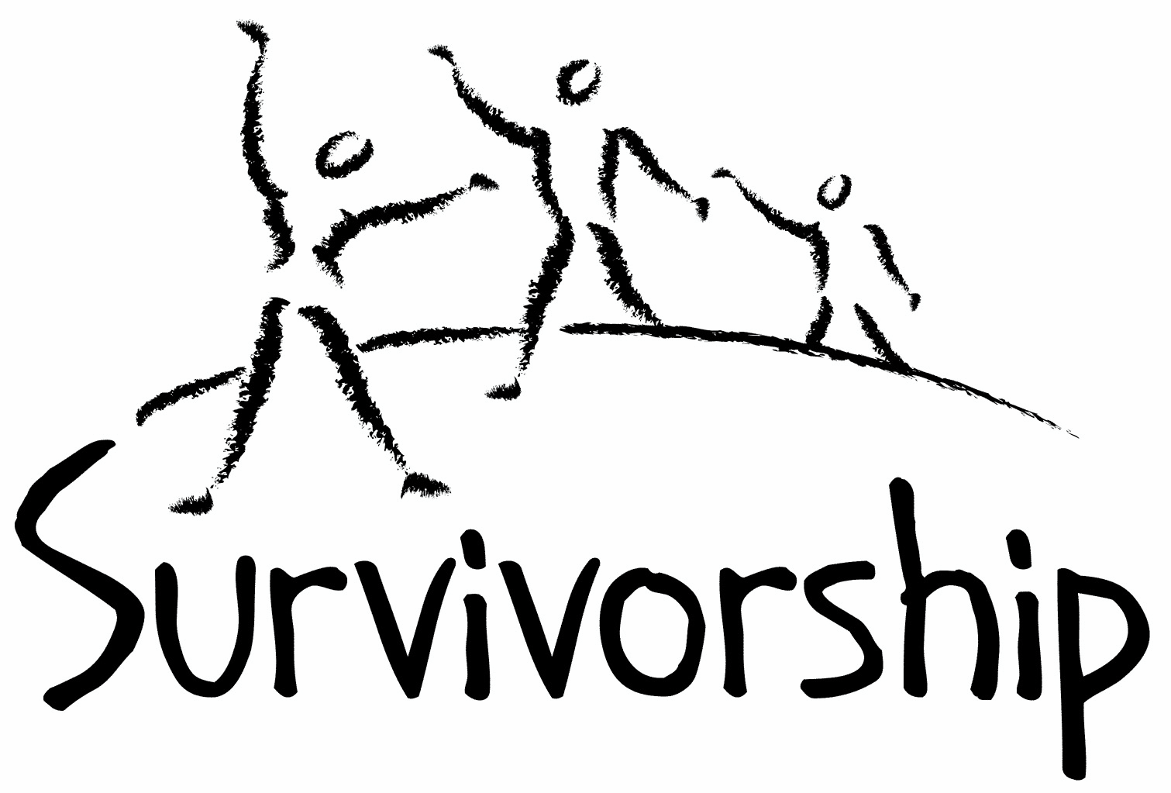

Vol. 196 No. 3 and 4
May/June 2019

The Notes, formerly called Chart Notes, ISSN 1523-275, is published bimonthly, copyright © 1999-2019 by Survivorship. All rights reserved. The entire contents of this issue are copyrighted by Survivorship and by the individual contributors. Please write Survivorship or E-mail info@survivorship.org for permission to reprint. Survivorship is a nonprofit organization.

Dear Friends,

The Survivorship Ritual Abuse and Mind Control 2019 Conference was in Long Beach California this year. Our regular conference for ritual abuse survivors and their helpers was on Saturday and Sunday May 4 - 5, 2019. Our Clinician’s Conference was opened to practitioners on Friday May 3, 2019. The conference was an excellent conference again this year, with many strong presentations.
Conference Speakers Included: Alison Miller Ph.D., Randy Noblitt, PhD, Eileen Aveni and Neil Brick
https://survivorship.org/ritual-abuse-and-mind-control-2019-conference/

An article about the conference is at https://www.einnews.com/pr_news/484335351/the-survivorship-ritual-abuse-and-mind-control-2019-conference
Survivorship has an excellent promotional video for the conference:
Survivorship Conference May 2019 - Promotional Video https://youtu.be/e-BgRG1a300

We co-sponsor the East Coast conference organized by S.M.A.R.T. (Stop Mind Control and Ritual Abuse) The 2019 Annual Ritual Abuse, Secretive Organizations and Mind Control Conference
is August 17 – 18, 2019 at the DoubleTree near Bradley International Airport in Windsor Locks, CT
Internet conference information: https://ritualabuse.us/smart-conference/
Speakers include Dr. Alison Miller, Neil Brick and movie maker Daniel Roemer. SMART will have special conference prices until June 1st and low income prices for those that need them.

Please remember to renew your membership if it is due. Information is at: https://survivorship.org/how-to-renew-your-membership/ Survivorship grows and survives with your help and support.

The Survivorship Board of Directors: Neil, Eileen, Karol and Randy
Survivorship blog https://survivorshipwp.wordpress.com
Survivorship on Twitter https://twitter.com/Survivorshiporg
Survivorship on Facebook https://www.facebook.com/SurvivorshipRitualAbusePage

We highly recommend this East Coast conference:

The 2019 Annual Ritual Abuse, Secretive Organizations and Mind Control Conference
August 17 – 18, 2019 – East Coast Conference at the DoubleTree near Bradley International Airport in Windsor Locks, CT. Prices are as low as $50 for low income survivors.

Internet conference information: http://ritualabuse.us/smart-conference/

Speaker List
These descriptions may be heavy for survivors.

Deception by Organized Abuser Groups: Helping Your Front People and Your Insiders Recognize the Lies and Tricks Which Keep You Enslaved by Alison Miller
If you are a survivor of abuse by a mind-controlling abuser group, you have parts who have been trained to obey abusers because they believe lies your abusers told you. The abusers deceived you in childhood, using drugs, acted-out scenarios, stage magic, stories and films to control your child parts and prevent you from speaking out about the abuse. Their power over you depends on your young parts believing the abusers’ lies. If you learn to recognize when your emotions and behavior are influenced by these deceptions, and to discover the ways in which you were deceived, you can increase your freedom from the abuser group. (Skype presentation)

Alison Miller, Ph.D. is a retired clinical psychologist who practised in Victoria, B.C., Canada and worked with survivors of organized abuse, including ritual abuse and mind control from 1990 to 2017. She has twice chaired the RAMCOA (ritual abuse/mind control/organized abuse) special interest group of the International Society for the Study of Trauma and Dissociation. She is the author of Healing the Unimaginable: Treating Ritual Abuse and Mind Control (for therapists), Becoming Yourself: Overcoming Mind Control and Ritual Abuse (for survivors), and co-author with survivor Wendy Hoffman of From the Trenches: A Victim and Therapist Talk about Mind Control and Ritual Abuse. She has published several other book chapters and articles, as well as being the originator of the LIFE Seminars parent education programs. https://ritualabuse.us/smart/alison-miller

A Survivor’s View of Recovery from Ritual Abuse by Neil Brick
Recovery from ritual abuse can take many years. Recovery may include working through memories, building functionality and developing more effective ways of interacting and integrating emotions. Every individual has different experiences that lead them through the recovery path. Neil Brick will discuss his long journey healing from severe abuse. This will include ways he has learned more about himself, ways he has learned to develop healthier interactions with others and ways he has helped others along the recovery path.

Neil Brick is a survivor of ritual abuse and mind control. His work continues to educate the public about child abuse, trauma and ritual abuse crimes. His child abuse and ritual abuse newsletter S.M.A.R.T. https://ritualabuse.us has been published for over 24 years. http://neilbrick.com

Daniel Roemer – Film Maker
Bio: Daniel Roemer’s unique and powerful style of directing has lead him to receive such attention as USA Film’s Top 10 Emerging Director’s list at the age of 20, two-time Project Greenlight Best Director Finalist (Ben Affleck/Matt Damon), and student Academy Award State finalist by age 22. He has been characterized as “a filmmaker with his finger on the pulse of the world’s youth,” as his short films have been distributed theatrically in over 75 countries. Partnering with Inspirational Films in Europe, colleges have packed out auditoriums with over three thousand students, as well as standing room only theaters in major European cities.

He’s screened in festivals including Sundance, AFI Fest, LA Shorts Fest, and a special senator screening in Washington DC (for selected congressmen). Daniel was also among the few who finalized for the LA Shorts Fest “DNA Award,” the festival’s top honor of a million dollar feature deal with Universal Pictures (500 contestants).

Recently Daniel was a top 50 Director Finalist (of 10,000 entrants) for Fox’s reality show “On the Lot”, produced by Steven Spielberg and Mark Burnett, showcasing filmmakers “bound for stardom”. His shooting and editing have aired on Good Morning America, Dr. Phil and Arsenio Hall’s TV series “The World’s Funniest Moments”. His behind the scenes work includes Sony Picture’s exclusive (I Love Your Work) starring Giovanni Ribisi, Jason Lee, Vince Vaughn, Christina Ricci and Elvis Costello.

His nonprofit work includes interviews and promos with John Travolta, Kelly Preston, Meryl Streep, Olivia Newton-John, John Ritter, Pierce Brosnan and Selma Blair, as well as an extensive interview with Ben Stiller for The Huckleberry Fund (nonprofit for Homeless Children). Editing credits include 15-week TV series “Beyond the Felt,” showcasing world’s top poker players, A&E reality TV show “Dumpster Diving,” feature-length documentary on Breast Cancer, starring Christina Applegate, Melissa Etheridge and Sheryl Crow (distrib. Lionsgate).

He’s filmed and edited for A&E E!, ET, Access Hollywood, TV News, and screened at national conventions for 20th Century Fox Producer, Ralph Winter (X-Men 1&2, X-Men: The Last Stand, Fantastic 4). Most recently Daniel directed a TV pilot for CW Network (Atlanta) and is in post production, as well as finishing his feature-length documentary “Red White and Blowhard” shot across the US 2012-2013. https://www.imdb.com/name/nm1281008/

Part One: Daniel Roemer will share his own story using PowerPoint, visuals and clips from his docudrama “Gray”, which digs deep into uncovering my abuse history, actual news articles from the time of the abuse, and includes interviews with prominent locals and family members, and his personal search for what went on.

Part Two: Daniel Roemer will conduct a film-making 101 class (designed for self-taping and interviewing others) – to share the story, both technical and directorial how-to’s. Clinicians would also benefit in having these skills to share their methods of work.

Everyone has a unique story, whether you are a clinician, a survivor or both. Stories, since the beginning of time, united tribes and cultures and passed along their ideals by framing LIFE as a narrative. Stories helped the listener to feel less alone in the world, feel inspired, and helped them to become all the wiser on their own journey.

As survivors, our ‘through-lines’ can get messed up, become discombobulated; our brains try to put memories back together, our emotions can flood us— it is hard. TELLING OUR STORIES can not only help “put the beads back on the string,” but it can be incredibly cathartic for both the storyteller and (if interviewing a source) the interviewee. It can also educate viewers not aware of survivor struggles, empowering them with knowledge and heightening their sensitivities, along with raising awareness. Helping others can be the most healing elixir of all. It gives meaning to suffering. Through many forms of media, we now have the ability to share our stories in ways we never could before.

A survivor or clinician wielding FILMMAKING SKILLS has the ability to ignite a long-lasting, pervasive force of influence, exposing, and becoming a voice to be reckoned with in the survivor community; as we shall not be silenced. We are a YouTube generation, and there are specific ways to utilize simple tools to share stories even as novice media-makers.

PowerPoints from the Survivorship Conference are now available at:
https://survivorship.org/ritual-abuse-and-mind-control-2019-conference/

Deception by Organized Abuser Groups: Helping Yourself and Your Clients Think Through the Issues by Alison Miller
The Use of Music and other Auditory Stimuli in Psychological Therapy with Extreme Abuse Survivors by Randy Noblitt
The Complexities of Identifying Ritual Abuse and Mind Control in Your Client by Eileen Aveni
Deception by Organized Abuser Groups: Helping Your Front People and Your Insiders Recognize the Lies and Tricks Which Keep You Enslaved by Dr. Alison Miller
A Survivor's View of Recovery from Ritual Abuse by Neil Brick
I Believe You: A Therapist Looks at 30 Years of Work with Survivors of RA/MC by Eileen Aveni

Research and Informational Pages
Video Presentations from The Survivorship Ritual Abuse and Mind Control 2017 Conference https://survivorship.org/presentations-from-the-survivorship-ritual-abuse-and-mind-control-2017-conference
Ritual Abuse Evidence https://survivorship.org/ritual-abuse-evidence
Child Abuse Wiki - Ritual Abuse
http://childabusewiki.org/index.php?title=Ritual_Abuse
The Corsini Encyclopedia of Psychology and Behavioral Science - Sadistic Ritual Abuse http://books.google.com/books?id=JQMRmyOfpJ8C&pg=PA1436&lpg=PA1436#v=onepage&
Proof That Ritual Abuse Exists https://ritualabuse.us/ritualabuse/
Large List of Ritual Abuse and Child Abuse References https://ritualabuse.us/ritualabuse/studies/satanic-ritual-abuse-evidence-with-information-on-the-mcmartin-preschool-case/
Research and Information on Dissociative Identity Disorder (formerly called Multiple Personality Disorder) https://ritualabuse.us/research/did/

News Articles
Some of these articles may describe violence and/or abuse.

Cardinal George Pell sentenced to 6 years in prison for child sex abuse
Pell is the highest-ranking Catholic cleric worldwide to be convicted of child sex abuse.
https://www.nbcnews.com/news/us-news/cardinal-george-pell-sentenced-6-years-prison-child-sex-abuse-n982331

Dr. Johnnie Barto, a sexual predator pediatrician, gets up to 158 years in prison
Dr. Johnnie Barto heads into Cambria County Courthouse in Ebensburg, Pennsylvania, on March 18, 2019, for his sentencing in the sexual assault of more than two dozen children.
https://www.nbcnews.com/news/us-news/sexual-predator-children-s-doctor-gets-158-years-prison-people-n984491

Shambhala discloses allegations of sexual assault, child abuse within Boulder-born Buddhist organization’s ranks Report by An Olive Branch includes unsubstantiated allegations, details failure to address issues
https://www.denverpost.com/2019/03/19/shambhala-an-olive-branch-abuse-report-sakyong-mipham/

Ahead Of Diocese Report, Reaction To Syracuse Abuse Compensation Program
https://www.wrvo.org/post/ahead-diocese-report-reaction-syracuse-abuse-compensation-program

Bill giving victims more time on child sex abuse lawsuits, criminal cases gets support
....The bill, HB 640, would eliminate the statute of limitations for criminal cases and extend from age 21 to age 27 the time frame during which a victim can sue over alleged abuses.
https://www.fairfieldsuntimes.com/news/state/bill-giving-victims-more-time-on-child-sex-abuse-lawsuits/article_c29b4d2a-887f-5738-8bf2-df5771d405cf.html

Member of satanic ‘Ripper Crew’ released from prison
A member of the infamous "Ripper Crew," which was linked to 18 sadistic, satanic murders in the early 1980s, has been released from prison
https://wgntv.com/2019/03/29/member-of-satanic-ripper-crew-released-from-prison/

Alleged Child Porn Lord Faces US Extradition
In 2013, the FBI exploited a zero-day vulnerability in Firefox to seize control over a Dark Web network of child pornography sites. The alleged owner of that ring – 33-year-old Freedom Hosting operator Eric Eoin Marques – was arrested in Ireland later that year on a U.S. warrant and has been in custody ever since. This week, Ireland’s Supreme Court cleared the way for Marques to be extradited to the United States. https://krebsonsecurity.com/2019/03/alleged-child-porn-lord-faces-us-extradition/

Boise priest who lived in ‘world of Satanism and pornography’ sentenced to 25 years in prison
https://www.idahostatesman.com/news/local/crime/article223358745.html

More than 12,000 Boy Scout members were victims of sexual abuse, expert says
An expert who has been working with the Boy Scouts revealed that there may have been as many as 7,819 allegedly sexually abusive troop leaders and volunteers in the storied organization, according to newly released court documents.
https://abcnews.go.com/US/12000-boy-scout-members-victims-sexual-abuse-expert/story?id=62573567

ON-GOING MEETINGS AND TRAINING OPPORTUNITIES
More information is available at https://survivorship.org/community-calendar-of-events/

Survivorship is presenting this as information only. If you choose to use one of these resources, please note that you are doing this at your own risk.

PODS - POSITIVE OUTCOMES FOR DISSOCIATIVE SURVIVORS (PODS) info@pods-online.org.uk http://www.pods-online.org.uk/events.html

ASCA (Adult Survivors of Child Abuse)
On-going meetings in CA, FL, IL, NE, NJ, NY, NC, RI, and South Africa
info@ascasupport.org www.ascasupport.org

Christina Arguello http://therapists.psychologytoday.com/rms/prof_detail.php?profid=119345&sid=1336589023.0802_18054&city=San+Francisco&county=San+Francisco&state=CA&spec=19
Intensive Trauma Therapy, Morgantown, WV.
Free Thursday morning Trauma Seminars info@traumatherapy.us http://www.traumatherapy.us

Safeguarding Children - Ongoing training North Yorkshire, UK http://www.safeguardingchildren.co.uk/lscb-training-brochure.html

Survivors of Incest Anonymous
SIA holds 12-step meetings for incest survivors. Those designated “Nothing Too Heavy to Share” meetings are designed for ritual abuse survivors. 410-282-3400 http://www.siawso.org

Trauma Center at JRI Free lecture each Thursday of the month, 12-1 p.m., Brookline, MA
moreinfo@traumacenter.org 617- 232-1303 www.traumacenter.org/training/workshops.php

Women’s Center, 46 Pleasant Street, Cambridge, MA Weekly and monthly groups for survivors of child sexual abuse, incest survivor’s interfaith quilt project, Survivors of Incest Anonymous, eating disorder support group, emotional healing group, more. info@cambridgewomenscenter.org Phone: 617-354-6394 Helpline. 617-354-8807 http://www.cambridgewomenscenter.org

Dissociation & Trauma Clinical Discussions
The Dissociation & Trauma Clinical Discussions (DissTCD) list has been created to allow for clinical discussions for all licensed mental health counselors and retired licensed mental health counselors around the world to discuss ritual abuse, mind control and other topics. If you have a related license or degree, please write for more information at DissTCD-owner@yahoogroups.com http://groups.yahoo.com/group/DissTCD

Ritual-Abuse/Mind-Control Special Interest Group
The Ritual Abuse and Mind Control Special Interest Group (RA/MC SIG) of the International Society for the Study of Trauma and Dissociation (ISSTD) was approved by ISSTD’s Executive Council in 2008. The Mission of the RA/MC SIG is to further dialogue, knowledge, research and training on the etiology, evaluation, and effective treatment of trauma and dissociation in clients reporting histories of ritual abuse or mind control. Membership in the RA/MC SIG is free to all ISSTD members as an ISSTD membership benefit. http://www.isst-d.org/default.asp?contentID=183

Call for submissions: For Survivorship's next journal, please send your essays, articles, poetry and art work for consideration for publication. We accept entries from survivors and specialists in the field. Please mail to: info@survivorship.org All entries must be in electronic form and sent by e-mail or e-mail attachment.

The Childhelp National Child Abuse Hotline 1-800-4-A-CHILD (1-800-422-4453)
HOTLINES FAMILIAR WITH RA ISSUES
* Bay Area Women Against Rape (BAWAR): 510-845-7273
* San Francisco Women Against Rape (SFWAR): 415-647-7273
* Women’s Center, Cambridge, MA: 617-354-8807

How to Renew your Membership

To find out when your membership renewal is due: if you receive our literature by mail, look at the label on your Notes or Survivorship journal. You may also write info@survivorship.org and ask. If you renew before you need to, we will just add the extra months onto your membership. Please try to keep your membership up to date.

You may renew here: https://survivorship.org/how-to-renew-your-membership/
This page has a link to paying with PayPal https://survivorship.org/membership-using-paypal/

Rates
The rates for a Survivorship membership are on a sliding scale based on ability to pay beginning from $75.00 down to what you can afford. We ask that health-care professionals contribute towards gift memberships. We regret that we are not able to provide services or include members under the age of 18.

Renewing
1. Decide if you want to read the Survivorship Journal and Notes on the web site (Internet Member) or receive the Journal by regular mail (let us know if you want to also receive the Notes by regular mail) (Regular Member).

2. Then choose how much you are able to pay. If you are a professional, we recommend that you donate $35.00 to support gift memberships for low-income survivors. We appreciate gifts so that we may offer support to survivors who are unable to work due to the after-effects of their abuse and to survivors who are imprisoned. All donations are tax deductible. We are a 501(C) corporation.

3. Decide whether you want to pay by check, money order, or PayPal. PayPal accepts charge cards. If you want to pay using PayPal, please copy and fill out the form below, email it to info@survivorship.org, and then click https://survivorship.org/membership-using-paypal/ to make your payment.

If you want to pay by check or money order, print out the form below and send it with your payment (in U.S. funds) to: Survivorship, 881 Alma Real Drive Ste 311, Pacific Palisades, CA 90272 USA

Name ________________________________________________________

Organization (if applicable) _______________________________________

City _________________________________________________________

State __________________ (Please add street address and zip code for non-internet memberships.)

E-mail _______________________________________________________

Regular Membership: $__________ or Internet Membership $___________ Donation $_____________

Total enclosed $______________________
You may also e-mail the information on this form to info@survivorship.org

