Volume 22, Issue 7 Winter 2019

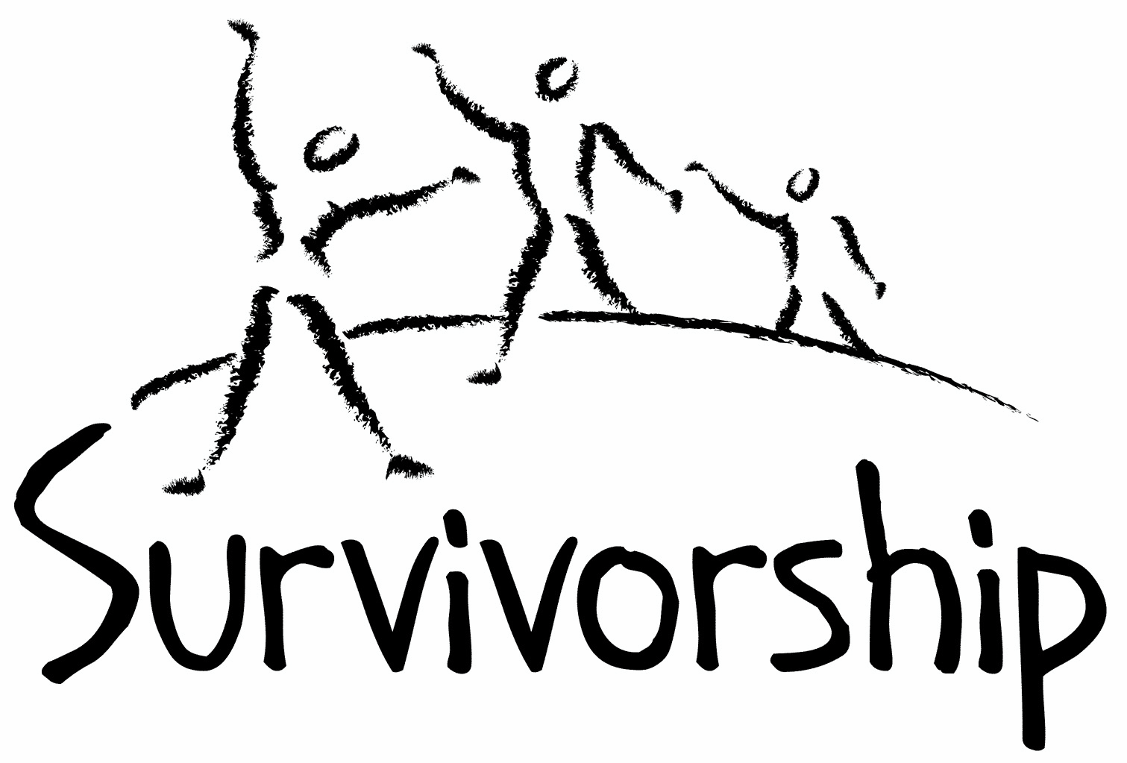
JOURNAL
For survivors of ritual abuse, mind control and torture, and pro-survivors

Copyright Information
SURVIVORSHIP JOURNAL, ISSN 046-2015, is published twice per year in Pacific Palisades, CA.
Copyright 2019 by Survivorship. All rights reserved. The entire contents of this issue are copyrighted by Survivorship and/by the individual contributors. No part of this publication may be reproduced or transmitted in any form or by any means, electronic or mechanical, including photocopying, or by any information storage and retrieval systems, without permission in writing by the copyright owners. For permission to reprint, write: Survivorship 881 Alma Real Drive Ste 311 Pacific Palisades, CA 90272 or email info@survivorship.org

Dear survivors, therapists treating surviving victims, support people and others:

In this issue we have articles by Lola Martin, Dr. Randall Noblitt, and Neil Brick

The Survivorship Ritual Abuse and Mind Control 2019 Conference will be held in Long Beach California again this year. We will have a conference for clinicians and a regular conference. The conference will be from May 3 – May 5, 2019. This conference is an excellent way for people to meet other survivors and find out more about survivor issues.

Conference speakers will include: Alison Miller, PhD, Randy Noblitt, PhD, Joseph Lumbasi, Eileen Aveni and Neil Brick

An article about the conference is at https://www.webwire.com/ViewPressRel.asp?aId=235304

We encourage those on the east coast of the US to attend The 2019 Annual Ritual Abuse, Secretive Organizations and Mind Control Conference on August 17 – 18, 2019

at the DoubleTree Hotel near Bradley International Airport in Windsor Locks, CT.
We co-sponsor this conference.

Speakers will include Dr. Alison Miller, Neil Brick and filmmaker Daniel Roemer
https://ritualabuse.us/smart-conference/

Table of Contents

Page Title and Author

3 Can we De-Pathologize Eating Disorders?
Lola Martin, M.A., M.C. and Randy Noblitt, Ph.D.

7 The Battle to Stop Ritual Abuse
Neil Brick

11 Spirit of Sun by Margie Roberts

Can We De-Pathologize Eating Disorders?
Lola Martin, M.A., M.C. and Randy Noblitt, Ph.D.
Alliant International University
Abuse survivors have a variety of increased health risks. One such category of problems is what is diagnostically known as eating disorders. The official U.S. psychiatric diagnostic manual has a chapter entitled “Feeding and Eating Disorders” that includes the diagnoses: anorexia nervosa, bulimia nervosa, and binge-eating disorder (American Psychiatric Association; APA, 2013). Anorexia nervosa refers to unhealthy eating-related and/or compensatory behaviors that result in dangerously low body weight. In bulimia nervosa the individual binges and uses compensatory behaviors such as “self-induced vomiting, misuse of laxatives, diuretics, or other medications, fasting, or excessive exercise” (APA, 2013, p. 345). On the other hand, binge-eating disorder consists of binge eating episodes without the compensatory methods of restricting caloric intake or expenditure.
These eating-related behaviors may pose serious adverse effects to one’s health and quality of life. Despite the associated risks, eating disorders are frequently characterized as treatment resistant. Researchers have proposed that difficulties in effectively treating eating disorders may be at least partially rooted in the relationship between eating disorders, trauma, and dissociation, with dissociative experiences being well-documented amongst abuse survivors as well as individuals with eating disorders.
Histories of trauma, in fact, appear to be correlated to every eating disorder classification. Clinicians working with eating disorders often note histories of childhood abuse, including neglect, physical, emotional, and sexual trauma (Schneer, 2002). Furthermore, experiences of childhood trauma and dissociative disorders are significantly more common for individuals with eating disorders than the general population (Convino, Himerson, Wolfe, Franko, & Frankel, 1994).
A history of severe or persistent transgressions in psychological, physical and/or emotional boundaries may render individuals unable to tolerate or integrate aggressive desires, traumatic reactions and dissociated parts of the self (Convino et al., 1994). Abuse may constitute too much negative stimulation and/or not enough required safety or protection (Schneer, 2002). When children have no choice but to respond to inappropriate levels of stimulation, the processing mechanisms break down (Schneer, 2002). The child experiences vulnerability, with inadequate boundaries to control what gets inside, is held inside, kept out, or removed from within, and is unable to regulate the in-and-out phenomenon (Schneer, 2002). This dimension of experience is translated to the unregulated sense of boundary maintenance and violation common to eating disordered behaviors.
The eating disorder allows the individual to replace dimensional aspects of body emotional sensations (self-with-others) with a self-body (self-object) relationship, where the body becomes the outside object that can be controlled (Gaete & Fuchs, 2016). Researchers have proposed that this rigid focus originates in the procedural memory traces of infancy or early childhood when the attachment dynamic of self-with-others is replaced by an internal focus during highly stressful circumstances (Gaete & Fuchs, 2016). In this experience, the eating disordered body becomes a concretized metaphor for traumatic disruptions in attachment. The individual experiences too much or too little stimulation from important others as happening in the body, therefore the dilemma is addressed and controlled at the level of the body (Gaete & Fuchs, 2016).
The psyche may use food to express this dilemma, although it is also often visible in other area of functioning as well. In addition to a broad range of behaviors, such as consuming too much food, consuming food too frequently, keeping food out, and forcefully removing food from their bodies, abuse survivors with eating disorders may also present with difficulties processing internal or external stimuli and difficulties deciding what to keep in or take out across various domains of their lives (Schneer, 2002). Problems of quantity are enacted with money, in relationships, worldviews, feelings about the self, and in treatment (Schneer, 2002).
Problems of quantity are enacted in treatment as well. Emotional data is displaced onto objects; therefore it becomes significant for the therapist to study how the individual with an eating disorder is taking them in, carefully noting the pace and timing of consumption (Schneer, 2002). Interventions may be interpreted as force-feedings and repetitions of abuse experiences if clinicians are not carefully attuned when working with this population. Another sign of a severe boundary enactment is when the therapist feels like they are overfeeding the individual, or that the person’s need satisfaction feels endless (Schneer, 2002). Conversely, silence on behalf of the therapist may be experienced as abandonment or emotional starvation by the individual with an eating disorder (Schneer, 2002). The therapist’s relational style can be interpreted as an expression of “too much” or “too little” stimulation. This phenomenon is particularly evident amongst individuals who have an abuse history with comorbid eating disordered behavior and can lead to the person presenting as guarded, afraid, detached, dissociated, devouring, rejecting and idealizing of the therapist (Schneer, 2002).
Therefore, if we view eating disordered behaviors as a means for expressing distress and conflict, we can begin to make better sense of the relationship between dissociation, eating disorders, and abuse histories. The eating-related behaviors give us information about the issues the individual is having internally, in relationships, and with the world around them. When we consider the impact of abuse histories on boundary development, we can better understand how maladaptive behaviors relating to food and eating parallel early experiences. Thus, expanding the individual’s capacity to symbolize in relationship with a carefully attuned other, holds hope for replacing the self-object relationship with a healthier self-with-others relationship.

‘
References

American Psychiatric Association. (2013). Diagnostic and statistical manual of mental disorders
(5th ed.). Washington, DC: Author.
Convino, N. A., Jimerson, D. C., Wolfe, B. E., Franko, D. L., & Frankel, F. H. (1994).
Hypnotizability, dissociation, and bulimia nervosa. Journal Of Abnormal
Psychology, 103(3), 455-459. doi:10.1037/0021-843X.103.3.455
Gaete, M. I., & Fuchs, T. (2016). From body image to emotional bodily experience in eating
disorders. Journal Of Phenomenological Psychology, 47(1), 17-40.
doi:10.1163/15691624-12341303
Schneer, A. (2002) Eating disorders: A disorder of in and out. Eating Disorders: The Journal of
Treatment & Prevention, 10(2), 161-176. doi:10.1080/10640260290081795

The Battle to Stop Ritual Abuse
Neil Brick

This article is adapted from Neil Brick’s conference transcript from the 2015 Annual Ritual Abuse, Secretive Organizations and Mind Control Conference.

Please use caution while reading this presentation. It may be heavy for survivors. All accusations are alleged. This transcript is educational and not intended as therapy or treatment.

For over 25 years, survivors and their advocates have worked to stop ritual abuse by educating the general public about these crimes. Through an intense struggle this research has been made public and survivors have been helped. Exposing the backlash and its true motives and how their work continues to promote social injustice will be discussed in this presentation.

Neil Brick is a survivor of ritual abuse and mind control. His work continues to educate the public about child abuse, trauma and ritual abuse crimes. His child abuse and ritual abuse newsletter S.M.A.R.T. has been published for over 23 years. http://neilbrick.com

(Please note: This article is strictly the opinion of the author and not necessarily the opinion of the SMART newsletter or Survivorship.)

The Battle to Stop Ritual Abuse

For over 25 years, survivors and their advocates have worked to stop ritual abuse by educating the general public about these crimes. Through an intense struggle this research has been made public and survivors have been helped.

A backlash continues, covering up crimes against children and protecting a hierarchical and unjust social structure that exists by propagandizing and mind controlling its members. Exposing the backlash and its true motives and how their work continues to promote social injustice will be discussed in this presentation.

For many years, we have fought to stop ritual abuse crimes and educate people about these crimes. But even today, the backlash continues, misrepresenting the research, hiding important data, harassing anti-child abuse advocates and repeating the same lies about many of the child abuse and day care cases of the past. I have covered these topics in many of my prior speeches and all of this information is available on the Internet at the website https://ritualabuse.us .

Today, I will speak about why we have been so viciously attacked and why there are repeated attempts to misrepresent and cover up our work.

Our work exposes those that attempt to control social thinking patterns. If our realities are seen as accurate by society, then this exposes the lies that our present society is built on.

Mind control and propaganda exist in every part of our society. From how people dress, to how people speak, to how people believe.

There are many lies that most in our society believe in. These lies are taught to children at an early age.

These are some of the lies people are taught:

1) We live in a democracy – The reality is the media is controlled by a few companies and the information people receive is controlled by these same companies. It is rare that people would receive any different information. All one has to do to prove this is to listen to conversations at work or at a social event. Many people will be talking about the same thing and at times quoting the ideas of the local media sources.

It is impossible to have a democracy when few think for themselves. A democracy needs a free flow of information, which does not exist in our society or most societies in the world.

Ritual abuse is a more extreme example of how the free flow of information is denied. Survivors live in families and social systems that trap them and make it difficult for them to get information about cults and mind control. A survivor may move from a cult family to a cult marriage or neighborhood or job where cult members live.

2) Religion helps people grow – The reality is that this is rare. When one chooses a religion, they give up their own freedom of thought. It is better to develop your own ideas and think for yourself than to give up your intellectual and spiritual freedom to someone else’s ideas. Often the spiritual or religious system is a system of mind control. People that are unaware of mind control techniques and that are unfamiliar of the feeling of being in a trance are prone to be victimized by a religion. Be aware of the feeling of going into a trance and leave the area you are in. One mind control technique religious leaders and other groups use are hypnotizing people by moving their hand at the bottom of a person’s visual field. Internet pages may put ads on the sides or bottoms of one’s visual field.

Ritual abuse has its own hidden spiritual system, that people believe in their cult alters. These beliefs may become more conscious in those that follow dark spiritual systems.

3) There is a god – The reality is that god is a concept that was and is used to control people. It is better to develop one’s own concept of the world than to read a book or go to a house of worship to get one’s entire spiritual system from.

Ritual abuse systems may be hidden in a variety of different religions. The Hammond, LA case is an example of a ritual abuse system being hidden in a Christian religion. Many occult and dark religions have been found to have ritual abuse systems hidden in them also.

4) Soldiers in our society – the sad reality is that soldiers are often unknowingly working to protect corporate interests in other parts of the world. They like most of society are indoctrinated into a social system that teaches them that war is okay if our government says so. They are trained to follow orders in their basic training that some have compared to mind control systems. This is not to state that soldiers are bad people. They are often good people that have been indoctrinated by our social system.

Ritual abuse victims are like soldiers in some ways. They have roles they follow due to their indoctrination. Child soldiers are an example of soldiers being indoctrinated in a cult manner to fight and kill.

5) Capitalism is a beneficial economic system – the truth is that it is impossible to have a fair and equal society in a society where the most important thing is to make money. The focus to help others is lost. As we see in our own society, over time the rich get richer and the poor suffer greatly. This system causes immense suffering and death for those unable to survive in it.

Ritual abuse victims are part of this system. They often make money for the cults as sex slaves, prostitutes or bringing in others to do this kind of work.

6) The media presents information fairly and equally – The reality is that the media often does not tell the truth and packages misinformation as the truth, repeating this as propaganda until people do not believe the truth. A good example of this is any of the mentioned points or our own topic, ritual abuse. The reality is that ritual abuse and cults exist and have existed for years. The media refuses to present our stories and the research around this, repeating the same lies about McMartin and other child abuse and day care cases. We have thousands of research articles refuting media lies, yet it is impossible to get this information into the media.

7) People believe they are not mind controlled – the reality is that everyone is, the question is how much are they mind controlled. Gender roles are a good example of mind control that almost everyone follows. TV is an example of a mind control device. People are put into a trance and become very susceptible to mind control and social programming. Religion has many mind control techniques, including certain types of prayer, fear programming and repetition. Many sales techniques are based on mind control techniques. Some car sales techniques are a good example of mind control techniques. The way churches and malls are set up are meant to disorient one and make one more susceptible to mind control.

Ritual abuse survivors, even those in recovery for years do not realize they are still mind controlled, nor do they realize when they are being accessed by others. They fall for emotional appeals. If someone asks you lots of questions about yourself when you are tired or more relaxed, they could be using mind control techniques to get more information about you.

The way to heal is to realize that anyone can be mind controlled. And those that are not familiar with mind control, social programming and propaganda techniques are being mind controlled.

Break through all programming. If you don’t, you may be susceptible to being revictimized by cult and ritual abuse mind control.

How do we break through programming?

1) Know when you are being mind controlled. If you are feeling spacey or dissociated, this means you may be susceptible to mind control. Try to get away from wherever you are. Mind control methods can include any of these media misused: TV (often misused), music, repetition, prayer, certain phrases, tone and the pacing of speech. Some religious and cult leaders know how to use these techniques and will use them. Hand movements can also be used to hypnotize people. Learn how different tones and types of music can be used to put one into a trance and avoid these.

2) A person that wants to mind control or access you will wait until you are susceptible. They know people want to connect to others. Love bombing is an overt form of mind control cults use. At a conference, people may wait until you are tired, be careful of evening and second day conversations, especially at the end of conferences when people are tired. People that want to access you will ask a lot of questions. Cult people will want specific details, like demographic and other personal information. Trust your gut. If you feel uneasy when someone is asking you something, you don’t need to tell them. You can politely say “I prefer not to discuss that.” A cult person may lead up to these questions with more general details, even divulging their own info so you give them yours. Again, go with your gut feelings around this. If you aren’t sure, you don’t have to say anything.

3) People misrepresent themselves. Rarely, will a person admit they are using mind control techniques on you. They may appear to be the nicest, friendliest or shyest person in the world. They may state they want to help you. The religious leaders now accused of raping 100s of children were often well loved charismatic people. On message boards, these people will often appear to be very helpful. When reading their messages, consider how they feel. Are they sincere or do they feel phony?

4) Don’t trust those hiding behind undefined philosophies. They may talk about how they are healing others, or ask you to listen to your inner voice. They may ask you to find the god within you or something like that. These philosophies may be new age, occult or Christian based philosophies. Mind controllers will find which philosophy or approach works best with you. Then they will use it.

5) Mind controllers will use shock techniques. These get more attention. You will especially see these often in the media. Or they may use an emotional appeal. Their writing will have strong emotional words in it that will seem overdone and out of place. Shock techniques and strong emotions make one more susceptible to mind control.

6) Repetition is another technique. The media will often repeat the same message repeatedly. The denialists of ritual abuse crimes use these techniques.

7) Be careful of those that deny they are ritual abuse survivors when it appears they are. These people may have a role in social situations, like gathering information or finding out more about people’s programming and personal information.

8) A person with less mind control or not mind controlled will feel more real. They won’t feel like part of a person with a mask. They won’t discuss how they want to save the world or heal in an undefined way. You will be able to have a real conversation with them and realize they are really there. As you work hard to recover with therapy and breaking through traumas, you will be able to notice this in others more.

Why is this all important?
Living without mind control is like living without addictions. Everything looks, feels and becomes real. The fog disappears. One’s memory improves. One can truly help others. Expect to encounter resistant. Those that are not mind controlled are not liked by cults or those that control society to profit off of others’ work. They will try to silence you. Remember “your silence will NOT protect you.” They will work to keep your message from reaching others. Don’t let this happen. Speak out and help others heal from mind control.

Remember, a free life is the best life.

Spirit of Sun
Margie Thomas

"Which path is my path? Which way will my life go?"
I have many interests. Sometimes it feels like too many.
I am trying to trust I will take the right path.
Maybe I am on it now.
But it is filled with potholes, briars and downed tree branches.
The sun filters through the dense vegetation.
However, it is not enough.
I want the full brilliance of unimpeded sun rays.
I keep stumbling forward, dealing with obstacles,
sometimes turning back to find my old familiar path
or to find someone else's supposedly smooth path.
But I have come so far.
To wade through the thicket to get back would be
more enervating than to continue forward.
Just when I think I cannot take one more step forward
because I am sick of getting my foot caught;
just when I feel too weary to continue
and want simply to lie down and give up,
that is when I feel the rising sun full on my face.
My eyes look ahead and I can scarcely believe what I see.
A wide-open, lush, grassy green field and a meadow
of beautiful blossoms ruffling in the breeze.
The sun feels blinding because I am not used to it,
but I rapidly become accustomed
as every cell in my body thirstily drinks it in.
The blossoms beckon to me like heads of miniature people,
saying, "Come play with us,
romp in the wind, soak up the sun, welcome the rain.
When the sun dips down in the horizon,
sit quietly with us as we gently fold in our petals
and breathe deeply the darkness.
If we were to resist the night
by shriveling up and burrowing deep down,
then we would be blind to the morning light
and miss out on the spirit of sun.
Yes, night will come at the end of day,
but I can now trust that bright sunlight will follow.
My own natural rhythm will develop internally,
as sure as the seasons cycle through the years.
By remaining still and present in the darkness,
I am more likely to see the coming of the light.
By shutting down or numbing myself, it may be missed.
By frantically moving, it could come and go, unnoticed.

