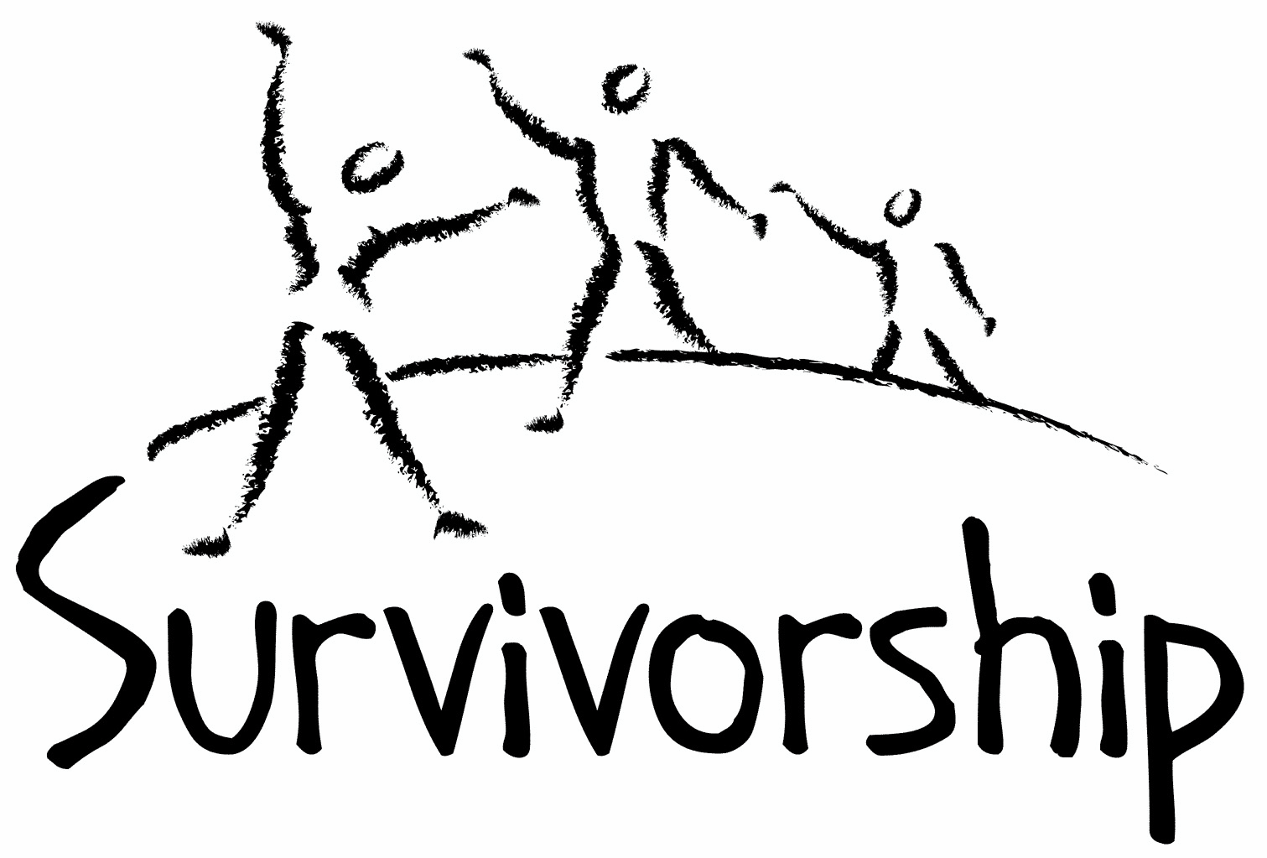

Vol. 196 No. 1 and 2
January/February 2019

The Notes, formerly called Chart Notes, ISSN 1523-275, is published bimonthly, copyright © 1999-2019 by Survivorship. All rights reserved. The entire contents of this issue are copyrighted by Survivorship and by the individual contributors. Please write Survivorship or E-mail info@survivorship.org for permission to reprint. Survivorship is a nonprofit organization.

Dear Friends,

We would like to announce the 2019 East Coast and West Coast Child and Ritual Abuse Conferences.

The Survivorship Ritual Abuse and Mind Control 2019 Conference
When:
Regular Conference - Saturday and Sunday May 4 - 5, 2019
Clinician's Conference - Friday May 3, 2019
Where:
Courtyard Marriott Long Beach Airport
Long Beach, CA
https://survivorship.org/ritual-abuse-and-mind-control-2019-conference/

We co-sponsor this conference. It is organized by S.M.A.R.T. (Stop Mind Control and Ritual Abuse)
The 2019 Annual Ritual Abuse, Secretive Organizations and Mind Control Conference
August 17 – 18, 2019
DoubleTree near
Bradley International Airport
Windsor Locks, CT
Internet conference information:
https://ritualabuse.us/smart-conference/

Please remember to renew your membership if it is due. Information is at: https://survivorship.org/how-to-renew-your-membership/ Survivorship grows and survives with your help and support.

The Survivorship Board of Directors: Neil, Eileen, Karol and Randy
Survivorship blog https://survivorshipwp.wordpress.com
Survivorship on Twitter https://twitter.com/Survivorshiporg
Survivorship on Facebook https://www.facebook.com/SurvivorshipRitualAbusePage

The Survivorship Ritual Abuse and Mind Control 2019 Conference

Clinician's Conference - Friday May 3, 2019

Deception by Organized Abuser Groups: Helping Yourself and Your Clients Think Through the Issues by Alison Miller
Sophisticated organized abuser groups use torture to deliberately split a child’s mind into different parts, train all parts to obey, and indoctrinate and train each part to do a specific job assigned by the abusers. Drugs, acted-out scenarios, stage magic, stories and films are used to deceive and control the children and prevent them from remembering or speaking out about their abuse, even in adulthood, so that the abusers can continue perpetrating this abuse without being caught. Abusers’ power over victims depends on their victims believing their lies, and that power can be diminished when victims see through the lies told to their young parts. It is important for therapists to use critical thinking to discern the deceptions, and to help their mind-controlled clients do the same.

Alison Miller, Ph.D. is a retired clinical psychologist who practised in Victoria, B.C., Canada and worked with survivors of organized abuse, including ritual abuse and mind control from 1990 to 2017. She has twice chaired the RAMCOA (ritual abuse/mind control/organized abuse) special interest group of the International Society for the Study of Trauma and Dissociation. She is the author of Healing the Unimaginable: Treating Ritual Abuse and Mind Control (for therapists), Becoming Yourself: Overcoming Mind Control and Ritual Abuse (for survivors), and co-author with survivor Wendy Hoffman of From the Trenches: A Victim and Therapist Talk about Mind Control and Ritual Abuse. She has published several other book chapters and articles, as well as being the originator of the LIFE Seminars parent education programs.

The Use of Music and other Auditory Stimuli in Psychological Therapy with Extreme Abuse Survivors by Randy Noblitt
Extreme abuse (EA) survivors often listen to music for enjoyment, relaxation, and emotion regulation. Some music and other auditory stimuli also have the capacity to trigger a variety of responses including states of adaptive containment, being shut down, identity switching, abreactive responses, trance, automatisms, and flashbacks. Although clinicians who work with survivors often hear about, or observe these phenomena, there is little discussion of them in the clinical literature. This presentation will discuss some of the uses for music and other sounds in therapy with survivors in the context of the ISSTD’s three stage treatment model for dissociative identity disorder.

Randy Noblitt, PhD, is a clinical psychologist (licensed in Texas) and professor of clinical psychology at the California School of Professional Psychology at Alliant International University, Los Angeles. In the course of his practice, Randy has treated more than 300 individuals who met the criteria for dissociative identity disorder. He is the principle author of Cult and Ritual Abuse: Its History, Anthropology and Recent Discovery in Contemporary America (Praeger, 1995. 2000), and its third edition, Cult and Ritual Abuse: Narratives, Evidence and Healing Approaches (Praeger, 2014). He is also co-editor and contributing author of the book, Ritual Abuse in the 21st Century: Psychological, Forensic, Social and Political Considerations (Robert Reed, 2008).

Regular Conference - Saturday and Sunday May 4 - 5, 2019

Deception by Organized Abuser Groups: Helping Your Front People and Your Insiders Recognize the Lies and Tricks Which Keep You Enslaved by Dr. Alison Miller
If you are a survivor of abuse by a mind-controlling abuser group, you have parts who have been trained to obey abusers because they believe lies your abusers told you. The abusers deceived you in childhood, using drugs, acted-out scenarios, stage magic, stories and films to control your child parts and prevent you from speaking out about the abuse. Their power over you depends on your young parts believing the abusers’ lies. If you learn to recognize when your emotions and behavior are influenced by these deceptions, and to discover the ways in which you were deceived, you can increase your freedom from the abuser group.

Talking About Triggers Without Being Triggering by Dr. Randall Noblitt
This presentation is an interactive discussion about triggering phenomena, with the intent of avoiding causing triggered responses in one another. Such a conversation is possible when we do not use triggers explicitly, when we use synonyms, euphemisms, or other roughly equivalent stimuli that communicate without provoking a response. Triggers can include gestures, words, music, sounds, pictures, colors, etc. Many triggers are not provocative unless they are repeated or paired with other triggers. Being able to discuss triggers without being triggering (or triggered) is one way that survivors can develop their own sense of empowerment.

Barriers encountered by RA Survivors when accessing Support in Offline Spaces (Services)
By Joseph Lumbasi
As a support organisation for RA survivors in the UK, Izzy’s Promise (SC033706) has been continuously carrying out research with its service users to identify barriers encountered and how best to overcome such barriers. Since 2002 when Izzy’s Promise was set up, they have commissioned a variety of research projects with abuse support organisations and ritual abuse (RA) survivors to identify how best to improve support services. The research projects have been conducted online using smart survey where more than 150 abuse support organisations in the UK responded to questions around barriers encountered while delivering support services to RA survivors. Similarly, the online research using smart survey where 300 RA survivors in the UK responded to questions around barriers encountered while accessing support services and suggestions on how to overcome such barriers. My intention is to analyse results from these research endeavours to produce a conference paper that I will present to delegates at the Survivors conference in May 2019 as well as publish the findings into a journal article. The findings will also be used to improve service delivery at Izzy’s Promise.

Joseph Lumbasi is a dual citizen of Kenya and Britain, educated up to postgraduate level. A graduate of Sociology, Geography, Health Research, Child and Adult Protection and currently a PhD student at the University of Dundee School of Education and Social Work. He has worked in different sectors of the economy, as a media researcher specialising on issues surrounding cultural abuse and violation of human rights e.g. female genital mutilation, trafficking of children and women locally and internationally by use of ritual oaths for purposes of prostitution and other inhuman issues. Joseph is currently the Manager of Izzy's Promise and a PhD Student at the University of Dundee undertaking a study focused on understanding the views and experiences of Ritual Abuse (RA) survivors on their use of online support as places of identity, support and empowerment. Joseph co-authored a journal article (Lumbasi, J., & Barron, I. (2016). Male Survivor Perceptions of Seeking Support: Hermeneutic Analysis of a Cluster Case Study. International Journal of Social Work, 3(1), 91.

A Survivor's View of Recovery from Ritual Abuse by Neil Brick
Recovery from ritual abuse can take many years. Recovery may include working through memories, building functionality and developing more effective ways of interacting and integrating emotions. Every individual has different experiences that lead them through the recovery path. Neil Brick will discuss his long journey healing from severe abuse. This will include ways he has learned more about himself, ways he has learned to develop healthier interactions with others and ways he has helped others along the recovery path.

Neil Brick is a survivor of ritual abuse and mind control. His work continues to educate the public about child abuse, trauma and ritual abuse crimes. His child abuse and ritual abuse newsletter S.M.A.R.T. https://ritualabuse.us has been published for over 23 years. http://neilbrick.com

News Articles
Some of these articles may describe violence and/or abuse.

Secret CIA Document Shows Plan to Test Drugs on Prisoners
https://www.aclu.org/blog/national-security/torture/secret-cia-document-shows-plan-test-drugs-prisoners

CIA considered potential truth serum for terror suspects
https://www.apnews.com/e4bc055b4fee4e0d9f47ab14adc2c173

Childhood abuse never ended for thousands of Australian adults
https://www.abc.net.au/news/2018-11-03/child-abuse-can-continue-into-adulthood/10418556

40 years later, Rep. Speier looks back on surviving Jonestown
https://www.pbs.org/newshour/show/40-years-later-rep-speier-looks-back-on-surviving-jonestown

How a future Trump Cabinet member gave a serial sex abuser the deal of a lifetime
His client, Palm Beach multimillionaire Jeffrey Epstein, 54, was accused of assembling a large, cult-like network of underage girls https://www.miamiherald.com/news/local/article220097825.html

Sex Offender Jeffrey Epstein Settles Defamation Suit, Silencing Women's Testimony
https://www.npr.org/2018/12/04/673320224/sex-offender-jeffrey-epstein-settles-defamation-suit-silencing-womens-testimony

Hundreds of sex abuse allegations found in fundamental Baptist churches across U.S.
https://www.star-telegram.com/living/religion/article222576310.html

Mind Control in China Has a Very Long History https://www.nytimes.com/2018/11/28/opinion/china-reeducation-mind-control-xinjiang.html

Woody Allen's Secret Teen Lover Speaks: Sex, Power and a Conflicted Muse Who Inspired 'Manhattan'
https://www.hollywoodreporter.com/features/woody-allens-secret-teen-lover-manhattan-muse-speaks-1169782

18 Chicago-area Jesuit priests named in new list alleging sexual abuse
https://www.chicagotribune.com/news/local/breaking/ct-met-jesuits-sex-abuse-list-20181217-story.html

Illinois AG says Catholic Church failed to disclose abuse accusations against 500 priests and clergy
https://www.cnn.com/2018/12/19/us/illinois-catholic-church-abuse-allegations/index.html

Girl, 10, dies after female genital mutilation in Sierra Leone
https://www.theguardian.com/global-development/2018/dec/20/girl-10-dies-after-female-genital-mutilation-in-sierra-leone

Truth about CIA’s illegal MKUltra mind-control experiments – using drugs, hypnosis and electronic devices- revealed in sensational new documents officials hid for decades
https://www.thesun.co.uk/news/7920010/cia-mkultra-mind-control-drugs-hypnosis-electric-documents/

Kevin Spacey Faces Felony Charge in Misconduct Case
https://www.nytimes.com/2018/12/24/movies/kevin-spacey-criminal-charges.html

Kevin Spacey scandal: A complete list of the 15 accusers
https://www.usatoday.com/story/life/2017/11/07/kevin-spacey-scandal-complete-list-13-accusers/835739001/

Harvey Weinstein judge declines to dismiss charges in rape case, sets pretrial hearing for March
https://www.cnn.com/2018/12/20/us/harvey-weinstein-court-charges/index.html

Eighth member of paedophile ring…jailed for plotting to rape baby
https://www.hulldailymail.co.uk/news/hull-east-yorkshire-news/eighth-member-paedophile-ring-including-2275623

Cardinal on trial in France's biggest church sex abuse trial
https://in.news.yahoo.com/cardinal-trial-frances-biggest-church-sex-abuse-trial-082122434.html

Woman sentenced to life as teen in killing wins clemency
A woman who says she was a victim of sex trafficking when she killed a man in 2004 was granted clemency https://apnews.com/199ec93abff34bf2a6c79b0ec385419b

The Battle to Stop Family Separation https://www.aclu.org/blog/immigrants-rights/immigrants-rights-and-detention/battle-stop-family-separation

R. Kelly under criminal investigation following Lifetime documentary series; possible victims urged to come forward https://www.nydailynews.com/entertainment/music/ny-ent-r-kelly-investigation-20190108-story.html
ON-GOING MEETINGS AND TRAINING OPPORTUNITIES
More information is available at https://survivorship.org/community-calendar-of-events/

Survivorship is presenting this as information only. If you choose to use one of these resources, please note that you are doing this at your own risk.

PODS - POSITIVE OUTCOMES FOR DISSOCIATIVE SURVIVORS (PODS)
info@pods-online.org.uk http://www.pods-online.org.uk/events.html

ASCA (Adult Survivors of Child Abuse)
On-going meetings in CA, FL, IL, NE, NJ, NY, NC, RI, and South Africa
info@ascasupport.org www.ascasupport.org

Christina Arguello http://therapists.psychologytoday.com/rms/prof_detail.php?profid=119345&sid=1336589023.0802_18054&city=San+Francisco&county=San+Francisco&state=CA&spec=19
Intensive Trauma Therapy, Morgantown, WV.
Free Thursday morning Trauma Seminars info@traumatherapy.us http://www.traumatherapy.us

Safeguarding Children - Ongoing training North Yorkshire, UK http://www.safeguardingchildren.co.uk/lscb-training-brochure.html

Survivors of Incest Anonymous
SIA holds 12-step meetings for incest survivors. Those designated “Nothing Too Heavy to Share” meetings are designed for ritual abuse survivors. 410-282-3400 http://www.siawso.org

Trauma Center at JRI Free lecture each Thursday of the month, 12-1 p.m., Brookline, MA
moreinfo@traumacenter.org 617- 232-1303 www.traumacenter.org/training/workshops.php

Women’s Center, 46 Pleasant Street, Cambridge, MA Weekly and monthly groups for survivors of child sexual abuse, incest survivor’s interfaith quilt project, Survivors of Incest Anonymous, eating disorder support group, emotional healing group, more. info@cambridgewomenscenter.org Phone: 617-354-6394 Helpline. 617-354-8807 http://www.cambridgewomenscenter.org

Dissociation & Trauma Clinical Discussions
The Dissociation & Trauma Clinical Discussions (DissTCD) list has been created to allow for clinical discussions for all licensed mental health counselors and retired licensed mental health counselors around the world to discuss ritual abuse, mind control and other topics. If you have a related license or degree, please write for more information at DissTCD-owner@yahoogroups.com http://groups.yahoo.com/group/DissTCD

Ritual-Abuse/Mind-Control Special Interest Group
The Ritual Abuse and Mind Control Special Interest Group (RA/MC SIG) of the International Society for the Study of Trauma and Dissociation (ISSTD) was approved by ISSTD’s Executive Council in 2008. The Mission of the RA/MC SIG is to further dialogue, knowledge, research and training on the etiology, evaluation, and effective treatment of trauma and dissociation in clients reporting histories of ritual abuse or mind control. Membership in the RA/MC SIG is free to all ISSTD members as an ISSTD membership benefit. http://www.isst-d.org/default.asp?contentID=183

Call for submissions: For Survivorship's next journal, please send your essays, articles, poetry and art work for consideration for publication. We accept entries from survivors and specialists in the field. Please mail to: info@survivorship.org All entries must be in electronic form and sent by e-mail or e-mail attachment.

The Childhelp National Child Abuse Hotline 1-800-4-A-CHILD (1-800-422-4453)
HOTLINES FAMILIAR WITH RA ISSUES
* Bay Area Women Against Rape (BAWAR): 510-845-7273
* San Francisco Women Against Rape (SFWAR): 415-647-7273
* Women’s Center, Cambridge, MA: 617-354-8807

How to Renew your Membership

To find out when your membership renewal is due: if you receive our literature by mail, look at the label on your Notes or Survivorship journal. You may also write info@survivorship.org and ask. If you renew before you need to, we will just add the extra months onto your membership. Please try to keep your membership up to date.

You may renew here: https://survivorship.org/how-to-renew-your-membership/
This page has a link to paying with PayPal https://survivorship.org/membership-using-paypal/

Rates
The rates for a Survivorship membership are on a sliding scale based on ability to pay beginning from $75.00 down to what you can afford. We ask that health-care professionals contribute towards gift memberships. We regret that we are not able to provide services or include members under the age of 18.

Renewing
1. Decide if you want to read the Survivorship Journal and Notes on the web site (Internet Member) or receive the Journal by regular mail (let us know if you want to also receive the Notes by regular mail) (Regular Member).

2. Then choose how much you are able to pay. If you are a professional, we recommend that you donate $35.00 to support gift memberships for low-income survivors. We appreciate gifts so that we may offer support to survivors who are unable to work due to the after-effects of their abuse and to survivors who are imprisoned. All donations are tax deductible. We are a 501(C) corporation.

3. Decide whether you want to pay by check, money order, or PayPal. PayPal accepts charge cards. If you want to pay using PayPal, please copy and fill out the form below, email it to info@survivorship.org, and then click https://survivorship.org/membership-using-paypal/ to make your payment.

If you want to pay by check or money order, print out the form below and send it with your payment (in U.S. funds) to: Survivorship, 881 Alma Real Drive Ste 311, Pacific Palisades, CA 90272 USA

Name ________________________________________________________

Organization (if applicable) _______________________________________

City _________________________________________________________

State __________________ (Please add street address and zip code for non-internet memberships.)

E-mail _______________________________________________________

Regular Membership: $__________ or Internet Membership $___________ Donation $_____________

Total enclosed $______________________
You may also e-mail the information on this form to info@survivorship.org

