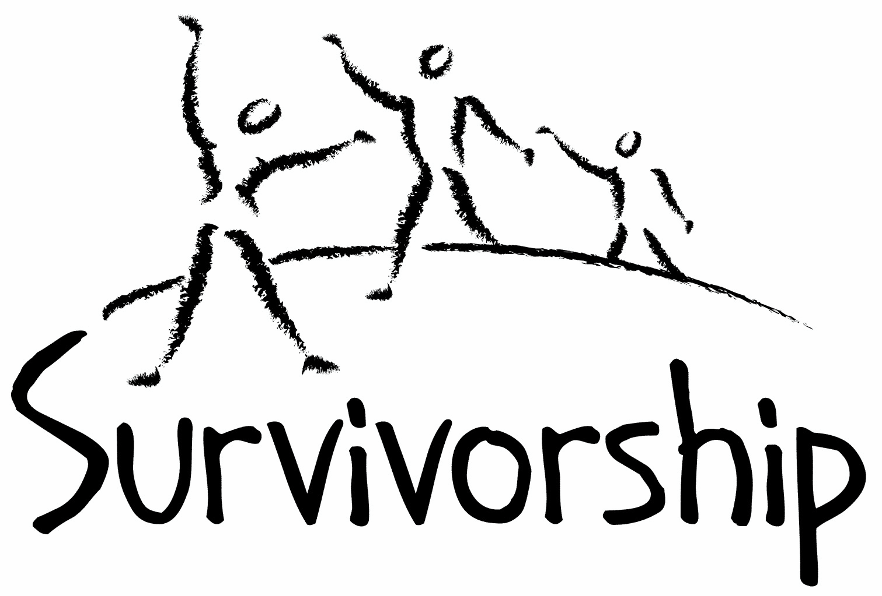

Vol. 194 No. 9 and 10
September/October 2018

The Notes, formerly called Chart Notes, ISSN 1523-275, is published bimonthly, copyright © 1999-2018 by Survivorship. All rights reserved. The entire contents of this issue are copyrighted by Survivorship and by the individual contributors. Please write Survivorship or E-mail info@survivorship.org for permission to reprint. Survivorship is a nonprofit organization.

Dear Friends,

We co-sponsored the SMART East Coast Conference this summer in August in Connecticut. https://ritualabuse.us/smart-conference/2018-conference/ Two PowerPoint presentations are online.

The Credibility of Ritual Abuse Allegations Presenter: Randy Noblitt, PhD
https://ritualabuse.us/smart-conference/2018-conference/the-credibility-of-ritual-abuse-allegations/
Synopsis: To what extent do mental health and other helping professionals believe the stories of ritual abuse survivors? This presentation systematically reviews the empirical research on the credibility of ritual abuse allegations. After presenting the findings there will be a discussion that welcomes the opinions of the attendees regarding their own conclusions including considerations of the community standard, professional ethics, related forensic questions, and advocacy for extreme abuse survivors.

Changes in Awareness of Severe Abuse and Child Abuse Crimes Over Twenty Five Years
Presenter: Neil Brick https://ritualabuse.us/smart-conference/2018-conference/changes-in-awareness-of-severe-abuse-and-child-abuse-crimes-over-twenty-five-years/ The awareness of severe abuse and child abuse crimes has changed over the last 25 years. In the early 1990s, severe abuse survivors were often believed and supported. Then a backlash started and severe abuse survivors and their supporters were harassed and attacked. The child abuse survivor movement changed and adapted. Ten years ago, research began again to help expose severe abuse crimes. This presentation will discuss the changes of the last 25 years. http://neilbrick.com/articles/neil-brick-conference-presentation-2018-changes-in-awareness-of-severe-abuse-and-child-abuse-crimes-over-twenty-five-years/

Please remember to renew your membership if it is due. Information is at: https://survivorship.org/how-to-renew-your-membership/ Survivorship grows and survives with your help and support.

The Survivorship Board of Directors: Neil, Eileen, Karol and Randy
Survivorship blog https://survivorshipwp.wordpress.com
Survivorship on Twitter https://twitter.com/Survivorshiporg
Survivorship on Facebook https://www.facebook.com/SurvivorshipRitualAbusePage

Organised Abuse in the UK Conference 2018

Wednesday 7th November 2018
Venue: Tayside Deaf Hub, The Old Mill, 23 Brown St, Dundee DD1 5EF
Time: 9:00am – 5:00pm
Book Your Place at https://www.ticketsource.co.uk/izzys-promise

Speakers

Laurie Matthew OBE - Founder and Executive Manager for Eighteen And Under, Izzy’s Promise and a host of other organisations all aimed at supporting survivors of abuse and prevention of abuse.

Sarah Nelson - Universities of Edinburgh and Dundee, has written and presented widely for decades on sexual abuse issues. Her research includes the voices of young survivors, critiques of current child protection systems, backlash theories, community prevention, and physical and mental health issues for survivors. She is author of Tackling Child Sexual Abuse: Radical Approaches (2016)

Joseph Lumbasi (PhD Student) – Manager of Izzy’s Promise.
Matt Carey (with Sarah Paton Briggs) survivor and author

Conference Topics

Empowering Survivors
The importance of listening to what survivors tell us: recent research and stories from survivors.

The Myth of the Satanic Panic
Evidence of ritual abuse was dismissed as a “satanic panic”, and this propagandistic theory remains widespread and influential today. Sarah Nelson analyses numerous flaws in the theory, as part of lies and deception in the backlash.

How Online Support Spaces are viewed and experienced by Ritual Abuse Survivors
Describing an ongoing PhD research project.

A Small Boy Smiling
A remarkable journey of healing from the trauma of child sexual abuse to spiritual awakening. In his new book, Matt Carey tells a remarkable story of survival and overcoming the trauma, guilt and shame of childhood sexual abuse, teenage alcoholism, sexual anorexia, and post-traumatic stress disorder. His lifelong search for peace, love and healing culminates in personal spiritual awakening and a desire to help other survivors of sexual abuse to discover their own healing.

Child and Ritual Abuse Conference Helps Educate Survivors and Their Helpers; Speakers included Dr. Randy Noblitt and Neil Brick https://www.webwire.com/ViewPressRel.asp?aId=227656

On Saturday and Sunday August 18 and 19, 2018, S.M.A.R.T. Ritual Abuse and Mind Control Newsletters sponsored an educational conference for survivors of ritual abuse and their helpers. Attendees report that the conference was a great success. In addition to the excellent presentations, there were opportunities for networking with other attendees and reading books and literature on the topics of severe child abuse, cults and mind control.

Dr. Randy Noblitt discussed the research surrounding examining the credibility of ritual abuse allegations. Neil Brick presented information about the progress of the child abuse movement over the last twenty-five years. A copy of his transcript is online. Jillian Jackson presented information on Cognitive Processing Therapy (CPT). Manjot Singh Khalsa presented on the topic of Radikal Healing, a holistic therapeutic approach for the healing of trauma. He presented a Kundalini Yoga experiential workshop called Be Here Now. Michael Skinner performed songs from several of his CDs. He addresses the issues of trauma, abuse and mental health concerns through public speaking and his music.

Scientific research and resources were presented during the conference, including Proof That Ritual Abuse Exists and a Large List of Ritual Abuse and Child Abuse References.

News Articles
Some of these articles may describe violence and/or abuse.

'Satanic ritual' killing: Siblings 'sacrifice elderly mum to devil'
WARNING: GRAPHIC CONTENT https://www.mirror.co.uk/news/world-news/satanic-ritual-killing-siblings-sacrifice-12939025
Perú: hijos matan a su madre en escabroso ritual satánico
http://www.cdn.com.do/2018/07/18/peru-hijos-matan-madre-escabroso-ritual-satanico/

Larry Nassar Set To Appeal Sexual Abuse Case Sentence
Attorneys for convicted sex abuser Larry Nassar filed two motions challenging the sentence he received earlier this year for sexual assault.... Nassar, a former Michigan State and USA gymnastics doctor, was sentenced up to 175 years on Michigan state charges of sexual assault, to go along with a sentence of 40 to 125 years in prison on three counts of sexual assault. He also recieved a 60–year sentence on federal child-pornography charges. https://www.si.com/olympics/2018/07/25/larry-nassar-sex-abuse-convictions-appeal

Seagram’s Liquor Heiress Charged in Nxivm Sex-Trafficking Case
Clare Bronfman, an heiress to the Seagram’s liquor fortune, pleaded not guilty on Tuesday in federal court in Brooklyn after her arrest on conspiracy and racketeering charges in connection with her role at Nxivm, a self-help group that prosecutors call a pyramid scheme and former members say is a cult.
https://www.nytimes.com/2018/07/24/nyregion/nxivm-arrest-seagram-heiress.html

Backpage.com founder and CEO face new charges A new indictment in Arizona against operators of Backpage.com alleges the classified ad site gave free ads to prostitutes and cultivated arrangements with others who worked in the sex trade to get them to post ads with the company.
A total of seven people were charged in an indictment in late March alleging the site ignored warnings to stop running prostitution ads, sometimes involving children, after the site brought in $500 million of prostitution-related revenue since its inception in 2004.
https://edmontonsun.com/news/crime/backpage-com-founder-and-ceo-face-new-charges/wcm/07104bbc-903b-4148-8701-8f6d1375315f

German mother jailed for prostituting young son online A German woman and her partner have been jailed after pimping out a boy to pedophiles they found online.
https://www.dw.com/en/german-mother-jailed-for-prostituting-young-son-online/a-44978403

Boy found at New Mexico compound died in religious ritual, officials say
http://www.ktva.com/story/38876582/boy-found-at-new-mexico-compound-died-in-religious-ritual-officials-say

Grand jury report identifies over 1,000 victims of priest abuse
More than 1,000 children — and possibly many more — were molested by hundreds of Roman Catholic priests in six Pennsylvania dioceses, while senior church officials took steps to cover it up, according to a landmark grand jury report released Tuesday....The report said more than 300 clergy committed the abuse over a period of decades.
http://www.ktva.com/story/38885579/grand-jury-report-identifies-over-1000-victims-of-priest-abuse

Ex-priest accused of sexual abuse got Disney job with help from Catholic Church, grand jury finds
https://www.cbsnews.com/news/edward-ganster-ex-priest-disney-world-job-catholic-church-pennyslvania-grand-jury-report/

'I Am a Killer' Interviews Miguel Martinez and Miguel Venegas About Their Roles in Satanic Murders https://www.aetv.com/real-crime/i-am-a-killer-miguel-martinez-miguel-venegas-texas-murders-satanic

Maryland private school investigating alleged sexual abuse A private school in Maryland has launched an investigation into allegations that a culture of sexual abuse existed in the 1970s with administrators' knowledge, a newspaper reported.
https://www.aol.com/article/news/2018/08/19/maryland-private-school-investigating-alleged-sexual-abuse/23505158/

New report lists 21 additional victims of sexual abuse at St. Paul's School 10 former faculty members named in report...St. Paul's School in Concord https://www.wmur.com/article/new-report-lists-21-additional-victims-of-sexual-abuse-at-st-pauls-school/22794264

Nuns charged in Smyllum Park child abuse investigation
Police examining claims of abuse over decades at Catholic home charge 12 people....The allegations of abuse at Smyllum Park, including unsubstantiated claims of “satanic” rituals at the home, have been at the centre of a long-running official public inquiry into child sexual abuse at children’s homes in Scotland. https://www.theguardian.com/uk-news/2018/aug/23/nuns-charged-in-investigation-into-child-abuse-at-smyllum-park

The ghosts of St. Joseph's orphanage: BuzzFeed News reveals extent of child abuse In the 1990s, Burlington Free Press journalists including Sam Hemingway reported extensively on allegations of child abuse by former residents of St. Joseph's Orphanage in Burlington. https://www.burlingtonfreepress.com/story/news/2018/08/27/buzzfeed-report-catholic-orphanages-reveals-decades-child-abuse/1108320002/

CIA Mind Control | CIA Secret Experiments National Geographic
During the Cold War, the CIA launched a highly classified program aimed at mastering the art of mind control. CIA Secret Experiments - Information on Ewen Cameron https://www.youtube.com/watch?v=NUW-frxo2X4

Ritual Calendar 2018 - Difficult Dates
Please use caution when reading this page. This page has words and dates that may remind survivors of their programming. https://survivorship.org/2018-dates/
September
9/1 Start of WWII
9/2 Krishna Janmashtami: Hindu
9/5 Labor day - US
9/5-9/7 Marriage to the Beast (Satan)
9/5-9/19 Pitr Paksha: Hindu 16-day period when spirits visit their descendant’s home
9/7 Feast of the Beast, marriage of virgins to Satan (sacrifice)
9/9 New Moon
9/9 - 9/11 Rosh Hashanah (Jewish New Year)
9/12 - 9/23 Ganesh Charurthi; Hindu: Birth of Lord Ganesha, god of wisdom, prosperity, and good fortune
9/13 Grandparents' Day
9/14 Shabbat Shuva (between Rosh Hashanah and Yom Kippur)
9/19 Yom Kippur
9/20-9/21 Midnight Host, vows, blood sacrifice from tip of finger
9/22 Fall Equinox
9/21 Rituals of the Elements and Feast of the times
9/23-10/2 Mysteries of Eleusis
9/23 - 9/30 Sukkot
9/24 Full Moon
9/25 Queen Elizabeth’s birthday (West Australia)
9/29 Michaelmas

October
10/1 - 10/2 Simchat Torah
10/2 Queen Elizabeth’s birthday (Queensland, Australia)
10/5 Opening of Mundus Ceresis
10/8 New Moon
10/8 Columbus Day – US (observed)
10/8 Thanksgiving Day in Canada
10/9 Dia de la Raza: Mexico
10/10 - 10/19 Navaratri: Hindu: Fall Festival, Worship of Durga. Lakshmi ans Saraswati
10/12 Hitler’s half birthday
10/13 Backwards Halloween
10/13-10/30 Preparation for all Hallows Eve, Samhain (Halloween). For some groups abduction, ceremonial preparation and holding of sacrificial victim for human sacrifice
10/15 Death of Goering
10/15 - 10/19 Durga Puja
10/16 Death of Rosenburg
10/19 Kali Puja
10/22-10/29 Preparation for all Hallow’s Eve
10/24 United Nations’ Day
10/24 Full Moon
10/28-10/30 Satanist High Holy Day related to Halloween (blood, human sacrifice each day)
10/31 Halloween/Samhain/All Hallow’s Eve/ Hallomas/ All Souls Day
10/31 Preparation for the Isia (ring of six: Isis, Hathor, Nepthys, Horus, Thoth, Anubis) Resurrection of Osiris
10/31 Start of the Celtic new year. Dark half of the year

ON-GOING MEETINGS AND TRAINING OPPORTUNITIES
More information is available at https://survivorship.org/community-calendar-of-events/

Survivorship is presenting this as information only. If you choose to use one of these resources, please note that you are doing this at your own risk.

PODS - POSITIVE OUTCOMES FOR DISSOCIATIVE SURVIVORS (PODS)
info@pods-online.org.uk http://www.pods-online.org.uk/events.html

ASCA (Adult Survivors of Child Abuse)
On-going meetings in CA, FL, IL, NE, NJ, NY, NC, RI, and South Africa
info@ascasupport.org www.ascasupport.org

Christina Arguello
http://therapists.psychologytoday.com/rms/prof_detail.php?profid=119345&sid=1336589023.0802_18054&city=San+Francisco&county=San+Francisco&state=CA&spec=19
Intensive Trauma Therapy, Morgantown, WV.
Free Thursday morning Trauma Seminars
info@traumatherapy.us http://www.traumatherapy.us
Safeguarding Children - Ongoing training North Yorkshire, UK http://www.safeguardingchildren.co.uk/lscb-training-brochure.html

Survivors of Incest Anonymous
SIA holds 12-step meetings for incest survivors. Those designated “Nothing Too Heavy to Share” meetings are designed for ritual abuse survivors. 410-282-3400 http://www.siawso.org
SIA Coming Home phone meeting Daily at 11:30 am and 9pm Eastern time. 1 712 432 8808 code is 742247 then press 5 once you're in.

Trauma Center at JRI Free lecture each Thursday of the month, 12-1 p.m., Brookline, MA
moreinfo@traumacenter.org 617- 232-1303 www.traumacenter.org/training/workshops.php

Women’s Center, 46 Pleasant Street, Cambridge, MA Weekly and monthly groups for survivors of child sexual abuse, incest survivor’s interfaith quilt project, Survivors of Incest Anonymous, eating disorder support group, emotional healing group, more. info@cambridgewomenscenter.org Phone: 617-354-6394 Helpline. 617-354-8807 http://www.cambridgewomenscenter.org

Dissociation & Trauma Clinical Discussions
The Dissociation & Trauma Clinical Discussions (DissTCD) list has been created to allow for clinical discussions for all licensed mental health counselors and retired licensed mental health counselors around the world to discuss ritual abuse, mind control and other topics. If you have a related license or degree, please write for more information at DissTCD-owner@yahoogroups.com http://groups.yahoo.com/group/DissTCD

Ritual-Abuse/Mind-Control Special Interest Group
The Ritual Abuse and Mind Control Special Interest Group (RA/MC SIG) of the International Society for the Study of Trauma and Dissociation (ISSTD) was approved by ISSTD’s Executive Council in 2008. The Mission of the RA/MC SIG is to further dialogue, knowledge, research and training on the etiology, evaluation, and effective treatment of trauma and dissociation in clients reporting histories of ritual abuse or mind control. Membership in the RA/MC SIG is free to all ISSTD members as an ISSTD membership benefit. http://www.isst-d.org/default.asp?contentID=183

Call for submissions: For Survivorship's next journal, please send your essays, articles, poetry and art work for consideration for publication. We accept entries from survivors and specialists in the field. Please mail to: info@survivorship.org All entries must be in electronic form and sent by e-mail or e-mail attachment.

The Childhelp National Child Abuse Hotline 1-800-4-A-CHILD (1-800-422-4453)
HOTLINES FAMILIAR WITH RA ISSUES
* Bay Area Women Against Rape (BAWAR): 510-845-7273
* San Francisco Women Against Rape (SFWAR): 415-647-7273
* Women’s Center, Cambridge, MA: 617-354-8807

How to Renew your Membership

To find out when your membership renewal is due: if you receive our literature by mail, look at the label on your Notes or Survivorship journal. You may also write info@survivorship.org and ask. If you renew before you need to, we will just add the extra months onto your membership. Please try to keep your membership up to date.

You may renew here: https://survivorship.org/how-to-renew-your-membership/
This page has a link to paying with PayPal https://survivorship.org/membership-using-paypal/

Rates
The rates for a Survivorship membership are on a sliding scale based on ability to pay beginning from $75.00 down to what you can afford. We ask that health-care professionals contribute towards gift memberships. We regret that we are not able to provide services or include members under the age of 18.

Renewing
1. Decide if you want to read the Survivorship Journal and Notes on the web site (Internet Member) or receive the Journal by regular mail (let us know if you want to also receive the Notes by regular mail) (Regular Member).

2. Then choose how much you are able to pay. If you are a professional, we recommend that you donate $35.00 to support gift memberships for low-income survivors. We appreciate gifts so that we may offer support to survivors who are unable to work due to the after-effects of their abuse and to survivors who are imprisoned. All donations are tax deductible. We are a 501(C) corporation.

3. Decide whether you want to pay by check, money order, or PayPal. PayPal accepts charge cards. If you want to pay using PayPal, please copy and fill out the form below, email it to info@survivorship.org, and then click https://survivorship.org/membership-using-paypal/ to make your payment.

If you want to pay by check or money order, print out the form below and send it with your payment (in U.S. funds) to: Survivorship, 881 Alma Real Drive Ste 311, Pacific Palisades, CA 90272 USA

Name ________________________________________________________

Organization (if applicable) _______________________________________

City _________________________________________________________

State __________________ (Please add street address and zip code for non-internet memberships.)

E-mail _______________________________________________________

Regular Membership: $__________ or Internet Membership $___________ Donation $_____________

Total enclosed $______________________
You may also e-mail the information on this form to info@survivorship.org

