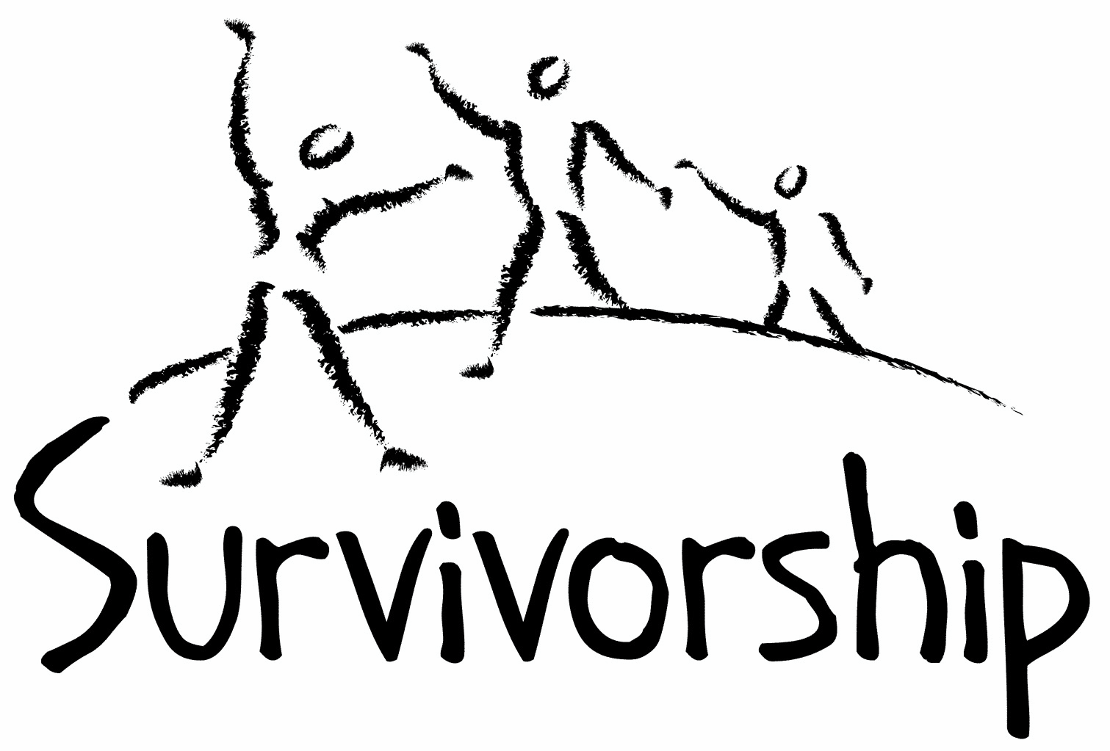

Vol. 194 No. 7 and 8
July/August 2018

The Notes, formerly called Chart Notes, ISSN 1523-275, is published bimonthly, copyright © 1999-2018 by Survivorship. All rights reserved. The entire contents of this issue are copyrighted by Survivorship and by the individual contributors. Please write Survivorship or E-mail info@survivorship.org for permission to reprint. Survivorship is a nonprofit organization.

Dear Friends,

Thank you for all of your support. We will be co-sponsoring the SMART East Coast Conference this summer in August in Connecticut. https://ritualabuse.us/smart-conference/ Please find information in this issue of our Survivorship notes.

A conference presentation of one of our board members is now online:

Changes in Awareness of Severe Abuse and Child Abuse Crimes Over Twenty Five Years
Presenter: Neil Brick
The awareness of severe abuse and child abuse crimes has changed over the last 25 years. In the early 1990s, severe abuse survivors were often believed and supported. Then a backlash started and severe abuse survivors and their supporters were harassed and attacked. The child abuse survivor movement changed and adapted. Ten years ago, research began again to help expose severe abuse crimes. More recently, first in the UK and Australia and now in the United States, a variety of child abuse, severe abuse, sexual harassment and rape cases are bringing public awareness again to the mainstream media of severe abuse crimes. This presentation will discuss the changes of the last 25 years, with an emphasis on the more recent exposures of organized child abuse crimes and social systems that have been part of the cover up of these crimes. http://neilbrick.com/articles/neil-brick-conference-presentation-2018-changes-in-awareness-of-severe-abuse-and-child-abuse-crimes-over-twenty-five-years/

Please remember to renew your membership if it is due. Information is at: https://survivorship.org/how-to-renew-your-membership/ Survivorship grows and survives with your help and support.

The Survivorship Board of Directors: Neil, Eileen, Karol and Randy
Survivorship blog https://survivorshipwp.wordpress.com
Survivorship on Twitter https://twitter.com/Survivorshiporg
Survivorship on Facebook https://www.facebook.com/SurvivorshipRitualAbusePage

The 2018 Annual Ritual Abuse, Secretive Organizations and Mind Control Conference
August 18 – 19, 2018 DoubleTree Hotel, Windsor Locks, Connecticut
https://ritualabuse.us/smart-conference/

Special conference deals until July 26, 2018:
New Low income attendees: Only $60 for two days.
New Full prices attendees: Buy one get one free, 2nd person is free.
Please write smartnews@aol.com as soon as you can if you are interested.

Conference Speakers
The Credibility of Ritual Abuse Allegations - Presenter: Randy Noblitt, PhD
Cognitive Processing Therapy (CPT) - Presenter: Jillian Jackson
Radikal Healing - Presenter: Manjot Singh Khalsa
Be Here Now - Presenter: Manjot Singh Khalsa
Changes in Awareness of Severe Abuse and Child Abuse Crimes Over Twenty Five Years
Presenter: Neil Brick
Conference Goals
– To help stop future occurrences of ritual abuse
– To help survivors of ritual abuse
– To name the groups that have participated in alleged illegal activities
– To unite those working to stop ritual abuse

Conference Presentations:

Randy Noblitt, PhD: The Credibility of Ritual Abuse Allegations

To what extent do mental health and other helping professionals believe the stories of ritual abuse survivors? This presentation systematically reviews the empirical research on the credibility of ritual abuse allegations. After presenting the findings there will be a discussion that welcomes the opinions of the attendees regarding their own conclusions including considerations of the community standard, professional ethics, related forensic questions, and advocacy for extreme abuse survivors. (Skype Presentation)

Randy Noblitt, PhD, is a clinical psychologist (licensed in Texas) and professor of clinical psychology at the California School of Professional Psychology at the California School of Professional Psychology at Alliant International University, Los Angeles. In the course of his practice, Randy has treated more than 300 individuals who met the criteria for dissociative identity disorder. He is the principle author of Cult and Ritual Abuse: Its History, Anthropology and Recent Discovery in Contemporary America (Praeger, 1995. 2000), and its third edition, Cult and Ritual Abuse: Narratives, Evidence and Healing Approaches (Praeger, 2014). He is also co-editor and contributing author of the book, Ritual Abuse in the 21st Century: Psychological, Forensic, Social and Political Considerations (Robert Reed, 2008).

Information on Randy Noblitt and His Research https://ritualabuse.us/smart/randy-noblitt/

Neil Brick, researcher and advocate: Changes in Awareness of Severe Abuse and Child Abuse Crimes Over Twenty Five Years

The awareness of severe abuse and child abuse crimes has changed over the last 25 years. In the early 1990s, severe abuse survivors were often believed and supported. Then a backlash started and severe abuse survivors and their supporters were harassed and attacked. The child abuse survivor movement changed and adapted. Ten years ago, research began again to help expose severe abuse crimes. More recently, first in the UK and Australia and now in the United States, a variety of child abuse, severe abuse, sexual harassment and rape cases are bringing public awareness again to the mainstream media of severe abuse crimes. This presentation will discuss the changes of the last 25 years, with an emphasis on the more recent exposures of organized child abuse crimes and social systems that have been part of the cover up of these crimes.

Neil Brick is a survivor of ritual abuse and mind control. His work continues to educate the public about child abuse, trauma and ritual abuse crimes. His child abuse and ritual abuse newsletter S.M.A.R.T. https://ritualabuse.us has been published for over 22 years. His research is at http://neilbrick.com

Jillian Jackson: Cognitive Processing Therapy (CPT)
CPT Cognitive Processing Therapy (CPT) is short-term, specific 12 session therapeutic intervention to help adults address specific life events associated with Post-Traumatic Stress Disorder (PTSD). It was originally designed to assist victims of rape and it has been widely used within the Veterans Administration to assist combat veterans address PTSD. Clinicians are now using this evidence-based practice to help individuals who struggle with a continuum of traumas. CPT is a derivate of the more widely known Cognitive Behavioral Therapy (CBT). Research demonstrates that CPT is effective in reducing the symptoms associated with PTSD. In this workshop, participants will learn the history of CPT, determine who is an appropriate candidate for the intervention, and how CPT is administered. The workshop will also highlight the research supporting this intervention and discuss it’s outcomes.

Jillian Jackson received a Masters of Social Work from Marywood University. Jillian provides services at the Village of Radikal Healing in Warminster and online through WeCounsel. Jillian also maintains employment at a local psychiatric hospital where her main focus is on adults with co-occurring disorders: mental health and substance abuse. Jillian’s experience includes working with a myriad of people with various life challenges and stressors and utilizes a holistic approach in assisting both adolescents and adults. Jillian offers individual, couples, and family counseling. Jillian’s experience includes grant writing, creating community-based programs and working with individuals who have extensive histories of trauma. Jillian is trained in Cognitive Processing Therapy and is certified in Reiki I.

Manjot Singh Khalsa: Radikal Healing
Radikal Healing is a holistic therapeutic approach for the healing of trauma. This workshop will provide a primer introduction to various modalities that are available and also highlight why it is vital for a process of healing and transformation to be tailored to each individual’s needs and experience.

Be Here Now
Manjot Singh Khalsa is the creator of a Kundalini Yoga and Meditation curriculum, “Be Here Now: Yoga, Meditation & Mantra for Trauma Survivors.” In today’s experiential workshop, participants will have the opportunity to stretch, breathe, strengthen and rest in a safe space. No previous yoga experience necessary. Participants will choose to sit in a chair or on the floor during this workshop.

Manjot Singh Khalsa is a psychotherapist in private practice, sacred healer, interfaith minister, teacher and co-creator of Radikal Healing. Radikal Healing is a process of life transformation utilizing a complement of modalities tailored to each client’s individual needs including psychotherapy, meditation, Kundalini yoga, Shamanic technology, energy medicine, life coaching and supervised fasting. Village of Radikal Healing in Bucks County, PA is a healing center that provides opportunities for people to embrace the Radikal Life they were meant to live.

News Articles
Some of these articles may describe violence and/or abuse.

Harvey Weinstein indicted on charges of rape, criminal sexual act https://www.cnn.com/2018/05/30/us/harvey-weinstein-indictment/index.html

Minnesota Archdiocese Reaches $210 Million Settlement With 450 Clergy Abuse Victims https://www.npr.org/sections/thetwo-way/2018/06/01/616187545/minnesota-archdiocese-reaches-210-million-settlement-with-450-clergy-abuse-victi

Vatican at crossroads in handling clergy sexual abuse cases
http://www.latimes.com/world/europe/la-fg-vatican-clergy-abuse-20180601-story.html

Bill Cosby, Harvey Weinstein cases send a Time's Up message
https://www.cnn.com/2018/05/25/entertainment/bill-cosby-harvey-weinstein-message/index.html

Archbishop Philip Wilson sentenced for concealing child sex abuse
https://www.theguardian.com/global/2018/jul/03/australian-archbishop-philip-wilson-sentenced-concealing-child-sex-abuse

Church of England downplayed extent of child abuse allegations to protect its reputation, report finds
https://www.telegraph.co.uk/news/2018/06/22/church-england-excluded-child-abuse-allegations-inquiry-downplayed/

Paedophile cults, parenting and multiple personalities: A mother who’s experienced it all
https://metro.co.uk/2018/06/22/paedophile-cults-parenting-and-multiple-personalities-a-mother-whos-experienced-it-all-7648663/

Havant sexual abuse survivor calls for more support: ‘There is life after abuse’
https://www.portsmouth.co.uk/our-region/havant/havant-sexual-abuse-survivor-calls-for-more-support-there-is-life-after-abuse-1-8547302

Judge refuses to dismiss lawsuit accusing FLDS of sexually abusing young girls under guise of religion
http://www.stgeorgeutah.com/news/archive/2018/07/03/judge-refuses-to-dismiss-lawsuit-accusing-flds-of-sexually-abusing-young-girls-under-guise-of-religion/

Dissociative Identity Disorder: What it's like to live with multiple personalities
http://www.abc.net.au/news/2018-07-01/dissociative-identity-disorder-did-multiple-personalities/9869190

Ritual Calendar 2018 - Difficult Dates
Please use caution when reading this page. This page has words and dates that may remind survivors of their programming. https://survivorship.org/2018-dates/
July
7/1 Satanic and Demon Revels (blood) – Druid sexual association with demons
7/1 Sacred Heart of Jesus
7/1 Canada Day
7/4 Independence Day in USA
7/12 New Moon
7/14 Bastille Day
7/15 St Swithun’s Day (Ireland)
7/17-7/23 Sacrifice of first born males, communion with flesh and blood
7/19-7/20 Sunfest
7/20-7/26 Abduction, ceremonial preparation and holding of sacrificial victim for Grand Climax
7/22 Parent’s Day
7/23 Beginning of Dog Days, linked to Sirius, Dog Star, Sothis, star of Set
7/24 Pioneer Day (Mormon)
7/25 St James Day/Festival of the horned god (gathering of herbs)
7/27 Grand Climax – animal and/or human sacrifice
7/27 Full Moon
7/31-8/1 Fast of Tisha B’Av
August
8/1-8/2 Lammas/Lughnasadh-corn harvest (blood)
8/3 Satanic and Demon Revels (sex)
8/11 New Moon
8/12 Feast for the First Night of the Prophet and his Bride
8/12,8/13 Diana’s day, triple goddess, moon and three moon phases
8/15 Assumption of the Blessed Virgin Mary
8/21 New Moon
8/24 Mania (opening of Netherworld Gate)
8/24 and 8/25
8/24 St Bartholomew’s Day/Great Shabbat & Fire Festival (large herb gathering)
8/26 Full Moon
8/26 Raksha Bandhan: Hindu celebrates the bond of protection between brothers, sisters, and cousins.
ON-GOING MEETINGS AND TRAINING OPPORTUNITIES
More information is available at https://survivorship.org/community-calendar-of-events/

Survivorship is presenting this as information only. If you choose to use one of these resources, please note that you are doing this at your own risk.

PODS - POSITIVE OUTCOMES FOR DISSOCIATIVE SURVIVORS (PODS)
info@pods-online.org.uk http://www.pods-online.org.uk/events.html

ASCA (Adult Survivors of Child Abuse)
On-going meetings in CA, FL, IL, NE, NJ, NY, NC, RI, and South Africa
info@ascasupport.org www.ascasupport.org

Christina Arguello
http://therapists.psychologytoday.com/rms/prof_detail.php?profid=119345&sid=1336589023.0802_18054&city=San+Francisco&county=San+Francisco&state=CA&spec=19
Intensive Trauma Therapy, Morgantown, WV.
Free Thursday morning Trauma Seminars
info@traumatherapy.us http://www.traumatherapy.us
Safeguarding Children - Ongoing training North Yorkshire, UK http://www.safeguardingchildren.co.uk/lscb-training-brochure.html

Survivors of Incest Anonymous
SIA holds 12-step meetings for incest survivors. Those designated “Nothing Too Heavy to Share” meetings are designed for ritual abuse survivors. 410-282-3400 http://www.siawso.org
SIA Coming Home phone meeting Daily at 11:30 am and 9pm Eastern time. 1 712 432 8808 code is 742247 then press 5 once you're in.

Trauma Center at JRI Free lecture each Thursday of the month, 12-1 p.m., Brookline, MA
moreinfo@traumacenter.org 617- 232-1303 www.traumacenter.org/training/workshops.php

Women’s Center, 46 Pleasant Street, Cambridge, MA Weekly and monthly groups for survivors of child sexual abuse, incest survivor’s interfaith quilt project, Survivors of Incest Anonymous, eating disorder support group, emotional healing group, more. info@cambridgewomenscenter.org Phone: 617-354-6394 Helpline. 617-354-8807 http://www.cambridgewomenscenter.org

Dissociation & Trauma Clinical Discussions
The Dissociation & Trauma Clinical Discussions (DissTCD) list has been created to allow for clinical discussions for all licensed mental health counselors and retired licensed mental health counselors around the world to discuss ritual abuse, mind control and other topics. If you have a related license or degree, please write for more information at DissTCD-owner@yahoogroups.com http://groups.yahoo.com/group/DissTCD

Ritual-Abuse/Mind-Control Special Interest Group
The Ritual Abuse and Mind Control Special Interest Group (RA/MC SIG) of the International Society for the Study of Trauma and Dissociation (ISSTD) was approved by ISSTD’s Executive Council in 2008. The Mission of the RA/MC SIG is to further dialogue, knowledge, research and training on the etiology, evaluation, and effective treatment of trauma and dissociation in clients reporting histories of ritual abuse or mind control. Membership in the RA/MC SIG is free to all ISSTD members as an ISSTD membership benefit.

Call for submissions: For Survivorship's next journal, please send your essays, articles, poetry and art work for consideration for publication. We accept entries from survivors and specialists in the field. Please mail to: info@survivorship.org All entries must be in electronic form and sent by e-mail or e-mail attachment.

The Childhelp National Child Abuse Hotline 1-800-4-A-CHILD (1-800-422-4453)
HOTLINES FAMILIAR WITH RA ISSUES
* Bay Area Women Against Rape (BAWAR): 510-845-7273
* San Francisco Women Against Rape (SFWAR): 415-647-7273
* Women’s Center, Cambridge, MA: 617-354-8807

How to Renew your Membership

To find out when your membership renewal is due: if you receive our literature by mail, look at the label on your Notes or Survivorship journal. You may also write info@survivorship.org and ask. If you renew before you need to, we will just add the extra months onto your membership. Please try to keep your membership up to date.

You may renew here: https://survivorship.org/how-to-renew-your-membership/
This page has a link to paying with PayPal https://survivorship.org/membership-using-paypal/

Rates
The rates for a Survivorship membership are on a sliding scale based on ability to pay beginning from $75.00 down to what you can afford. We ask that health-care professionals contribute towards gift memberships. We regret that we are not able to provide services or include members under the age of 18.

Renewing
1. Decide if you want to read the Survivorship Journal and Notes on the web site (Internet Member) or receive the Journal by regular mail (let us know if you want to also receive the Notes by regular mail) (Regular Member).

2. Then choose how much you are able to pay. If you are a professional, we recommend that you donate $35.00 to support gift memberships for low-income survivors. We appreciate gifts so that we may offer support to survivors who are unable to work due to the after-effects of their abuse and to survivors who are imprisoned. All donations are tax deductible. We are a 501(C) corporation.

3. Decide whether you want to pay by check, money order, or PayPal. PayPal accepts charge cards. If you want to pay using PayPal, please copy and fill out the form below, email it to info@survivorship.org, and then click https://survivorship.org/membership-using-paypal/ to make your payment.

If you want to pay by check or money order, print out the form below and send it with your payment (in U.S. funds) to: Survivorship, 881 Alma Real Drive Ste 311, Pacific Palisades, CA 90272 USA

Name ________________________________________________________

Organization (if applicable) _______________________________________

City _________________________________________________________

State __________________ (Please add street address and zip code for non-internet memberships.)

E-mail _______________________________________________________

Regular Membership: $__________ or Internet Membership $___________ Donation $_____________

Total enclosed $______________________
You may also e-mail the information on this form to info@survivorship.org

