Survivorship Notes
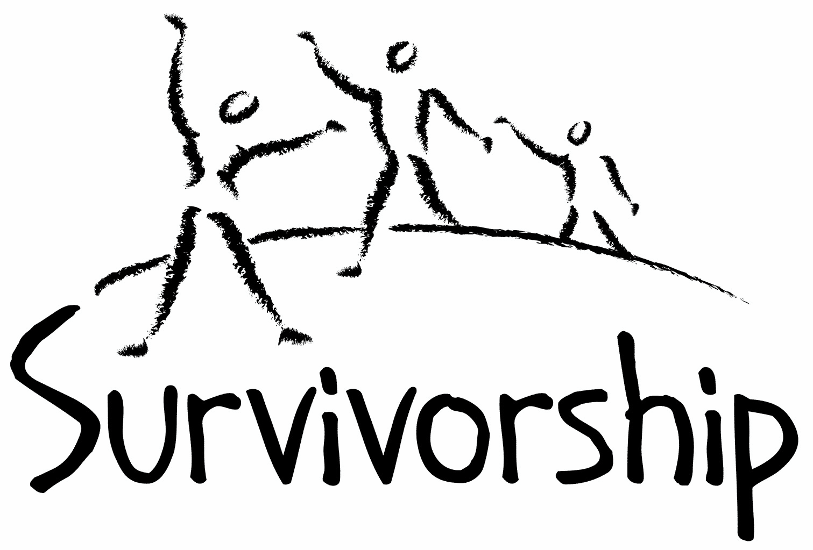

Vol. 189 No. 11 and 12
November/December, 2015

The Notes, formerly called Chart Notes, ISSN 1523-275, is published bimonthly, copyright © 1999-2015 by Survivorship, Family Justice Center, 470 27th Street, Oakland, CA 94612. All rights reserved. The entire contents of this issue are copyrighted by Survivorship and by the individual contributors. Contact Survivorship, or email info@survivorship.org for permission to reprint. Survivorship is a nonprofit organization.

Dear Survivorship Community,
Survivorship has re-opened its new and improved message board and is asking for members to re-apply for message board membership. We have worked hard to make our message board safe for survivors. To find out more about how to rejoin our message board, please write us at info@survivorship.org Our website is also faster now and easier to use. It has many sections for survivors, including past copies of our notes and journal, difficult dates and resources for survivors.
Also, if you have not renewed your membership in the last year, please renew it at https://survivorship.org/how-to-renew-your-membership or by writing us at the address above. Please renew today, as we want to make sure you will continue receiving our Survivorship notes and journal. Membership also allows you the benefits of using our website and resources.
We are planning our conference for May 2016. We will keep members updated on our conference plans for next year and let people know more in our next notes. We hope to see you there again next year.
The Survivorship Board of Directors
Micci, Neil, Alison and Wendy

Survivorship blog https://survivorshipwp.wordpress.com
Survivorship on Twitter https://twitter.com/Survivorshiporg Survivorship on Facebook https://www.facebook.com/SurvivorshipRitualAbusePage
Ritual Calendar 2015- Difficult Days
Also at https://survivorship.org/difficult-dates/

November
11/1 All Saints’ Day
11/1 Satanist High Holy Day
11/1-11/6 The Isia: six day ritual drama search for pieces of Osiris/feast of the Netherworld, parting of the astral veil/resurrection of Osiris
11/2 All Souls’ Day (in honour of the dead), Santeria, El Dia De Los Muertos
11/4 Satanic Revels
11/5 Guy Fawkes’ Day (UK)
11/7 Hilaria/Mania (Open of Mundus Cereris) rebirth of Osiris
11/9 Kristallnacht
11/11 New Moon
11/11 Kali Puja
11/11 Diwali: Hindu: Festival of Lights: The end of Lord Rama’s exile, killing of a demon by Krishna’s wife
11/11 Veteran’s Day (Armistice, 1918)
11/11 Remembrance Day ( Canada)
11/14 Sinterklaas: Feast of St Nicholas
11/25 Full Moon
11/26 US Thanksgiving
11/29 12/6 12/13 12/20 Sundays of Advent
11/30 St. Andrew’s Day
December
12/6 St. Nicholas’ Day
12/6-14 Chanukah
12/11 New Moon
12/17-12/22 Saturnalia
12/21 St. Thomas Day- Fire Festival, feast day, orgies
12/22 Yule/ Winter Solstice
12/22 Ritual of the Elements and Feast of the Times
12/22 Fast of Tevet/Holy Temple (Jewish) AM-PM
12/24 Christmas Eve/ Satanic demons revels/Da Meur/Grand High Climax
12/25 Christmas Day
12/25 Full Moon
12/26 Boxing Day ( UK, Canada, Australia, New Zealand)
12/26 St. Stephen’s Day
12/31 New Years Eve/Hogmanay

CONFERENCES, WEBINARS, WORKSHOPS, AND TRAINING

PODS - POSITIVE OUTCOMES FOR DISSOCIATIVE SURVIVORS (PODS)
Trauma and the Body: Somatisation and Dissociation
Birmingham: November 14
Rotherham: March 19, 2016
Bradford: July 2, 2016
Nottingham: July 16, 2016
London. “Working with Relational Trauma - Dealing with Disorganised Attachment” September 26
Darlington: December 5
Huntingdon: February 26, 2016
Bristol: February 27, 2016
Bristol: March 5, 2016
Brighton: April 23, 2016
London.
Trauma, Dissociation and Recovery: Working with Dissociative Identity Disorder and Complex PTSD.” November 7
Crawley: November 27
Bristol: November 28
Bristol: January 30, 2016
Darlington: February 6, 2016
London: May 7, 2016
Rotherham: May 14, 2016
Exeter: October 15, 2016
London: November 12, 2016
Brighton: November 26, 2016
info@pods-online.org.uk http://www.pods-online.org.uk/events.html

Eleos Support Network
November 14-15, 2015
“Organized Criminal Abuse of Children: Taking a Closer Look”
Carco Theater Renton, Washington
www.eleossupportnetwork.org
Presenters include Michael Salter and Alison Miller

TALOMIN BOOKS
"Treating Complex Trauma."
Presenter: Leah Giarratano
November 5 - 6, Brisbane
March 10 - 11, 2016, Singapore.
Information: https://www.talominbooks.com/html/store/training/details.asp?prodid=198

Bessel van der Kolk's complete speaking schedule is at:
http://www.traumacenter.org/about/speaking_schedule.php http://www.traumacenter.org/training/workshops.php

THE MEADOWS
Second International Conference on Sex and Love Addiction: "The Changing Architecture of Addictive Desire, Trauma and Attachment: Families, Children and Partners."
November 12 - 14, Fort Lauderdale, FL.
Presenters include: Patrick Carnes, Bessel van der Kolk, Claudia Black, Donald L. Hilton, Helen Fisher, Rob Weiss, Pat Love, Ken Adams, and Stephanie Carnes.
Information: http://www.usjt.com/Conferences/2014/2nd-Intl-Conference-On-Sex-and-Love-Addiction

Workshops for survivors, therapists, family and friends. For dates and other information, click the workshop titles at the left on http://www.themeadows.com/workshops/survivors-i-workshop
Survivors I Survivors II
Strengthening Coupleship: Working Together
Love Addiction / Love Avoidance
Family Workshop Men's Sexual Recovery
Journey Of A Woman's Heart: Finding True Intimacy
Healing Intimate Treason: For Partners of Sex Addiction
Healing Heartache: A Grief And Loss Workshop
Spirit: A Somatic Equine Workshop
Mind and Heart: A Mindful Path To Wholehearted Living

Conference on Child Abuse and Neglect
May 22 - 25, 2016
Stockholm, Sweden.
http://www.nfbo.org/web/page.aspx?sid=7799
The 2016 Annual Ritual Abuse, Secretive Organizations and Mind Control Conference August 12 – 13, 2016 at the DoubleTree Hotel - Windsor Locks, CT Internet conference information: https://ritualabuse.us/smart-conference/ For more information, write smartnews@aol.com
NEws and LInks
Three More Women Accuse Bill Cosby of Sexual Assault http://www.newsweek.com/three-more-women-accuse-bill-cosby-sexual-assault-378519
Bill Cosby sued by model over alleged sexual assault http://www.bbc.com/news/entertainment-arts-34463079
Five From Baruch College Face Murder Charges in 2013 Fraternity Hazing http://www.nytimes.com/2015/09/15/nyregion/5-from-baruch-college-face-murder-charges-in-2013-fraternity-hazing.html
U.S. Soldiers Told to Ignore Sexual Abuse of Boys by Afghan Allies http://www.nytimes.com/2015/09/21/world/asia/us-soldiers-told-to-ignore-afghan-allies-abuse-of-boys.html
Lifting the lid on Australia's child sex abuse By Marie McInerney Melbourne, Victoria Commission's work so far Confirmed 12,000 allegations of abuse relating to 3,500 religious and state institution http://www.bbc.com/news/world-australia-34355662
Jehovah's Witnesses child abuse victims 'may never see justice' http://news.stv.tv/scotland/1330094-jehovahs-witnesses-child-abuse-victims-may-never-see-justice
Controversial 'Open Secret' Reveals Hollywood Child Abuse Problem http://www.newsmax.com/Newsfront/hollywood-open-secret-documentary/2015/10/08/id/695357/
Ten of Jared Fogle's child abuse victims paid $1m total prior to sentencing Jared Fogle agreed to plead guilty to receiving child abuse images and having sex with minors. http://www.theguardian.com/us-news/2015/oct/22/jared-fogle-child-sexual-abuse-victims-restitution
E-book now available RITUAL ABUSE IN THE TWENTY-FIRST CENTURY: Psychological, Forensic, Social and Political Implications Kindle Edition by Randy Noblitt (Editor), Pamela Perskin (Editor) http://www.amazon.com/RITUAL-ABUSE-TWENTY-FIRST-CENTURY-Psychological-ebook/dp/B01134QYLK/
Ritual Abuse in the Twenty-First Century: Psychological, Forensic, Social and Political Considerations Allegations of ritual abuse are universal and mental health professionals, theologians, law enforcers, scholars, victim advocates, and others struggle to comprehend the enormity of the devastation left in the wake of these heinous acts. Ritual Abuse in the Twenty-first Century addresses the concerns that naturally evolve from any discussion of this phenomenon from the perspectives of professionals, advocates, and survivors from around the world. http://rdrpublishers.com/products/ritual-abuse-in-the-twenty-first-century-psychological-forensic-social-and-political-considerations
ACLU sues psychologists over CIA interrogation tactics http://www.aol.com/article/2015/10/13/aclu-sues-psychologists-over-cia-interrogation-tactics/21248565/
Curfew imposed in northern Liberia after ritual killings spark protests http://www.trust.org/item/20150930215054-ekn5g/
Man convicted in Satanic hotel slayings in Barrie appeals http://www.simcoe.com/news-story/5824942-man-convicted-in-satanic-hotel-slayings-in-barrie-appeals/
Dobson guilty of first-degree murder in double Satanic slaying in Barrie http://www.simcoe.com/news-story/5259471-dobson-guilty-of-first-degree-murder-in-double-satanic-slaying-in-barrie/
ON-GOING MEETINGS AND TRAINING OPPORTUNITIES
More information is available at https://survivorship.org/community-calendar-of-events/

Adult Survivors of Child Abuse-ongoing meetings/Beyond Surviving
Second Thursday of each month, 6:00-8:00 PM
Embarcadero YMCA, 169 Steuart St., San Francisco, CA
http://rachelgrantcoaching.com/

ASCA (Adult Survivors of Child Abuse)
On-going meetings in CA, FL, IL, NE, NJ, NY, NC, RI, and South Africa
info@ascasupport.org
www.ascasupport.org

Christina Arguello
http://therapists.psychologytoday.com/rms/prof_detail.php?profid=119345&sid=1336589023.0802_18054&city=San+Francisco&county=San+Francisco&state=CA&spec=19
Intensive Trauma Therapy, Morgantown, WV.
Free Thursday morning Trauma Seminars
info@traumatherapy.us
http://www.traumatherapy.us
Safeguarding Children - Ongoing training North Yorkshire, UK http://www.safeguardingchildren.co.uk/lscb-training-brochure.html

Survivors of Incest Anonymous
SIA holds 12-step meetings for incest survivors. Those designated “Nothing Too Heavy to Share” meetings are designed for ritual abuse survivors.
410-282-3400
http://www.siawso.org

SIA Coming Home phone meeting
Daily at 11:30 am and 9pm Eastern time.
1 712 432 8808 code is 742247 then press 5 once you're in.

Trauma Center at JRI
Free lecture each Thursday of the month, 12-1 p.m., Brookline, MA
moreinfo@traumacenter.org
617- 232-1303
www.traumacenter.org/training/workshops.php

Womencare Counseling Center
Weekly ongoing groups, Evanston, IL
info@womencarecounseling.com

847-475-7003
www.womencarecounseling.com

Women’s Center, 46 Pleasant Street, Cambridge, MA

Weekly and monthly groups for survivors of child sexual abuse, incest survivor’s interfaith quilt project, Survivors of Incest Anonymous, eating disorder support group, emotional healing group, more.
info@cambridgewomenscenter.org
Phone: 617-354-6394
Helpline. 617-354-8807
http://www.cambridgewomenscenter.org

Dissociation & Trauma Clinical Discussions
The Dissociation & Trauma Clinical Discussions (DissTCD) list has been created to allow for clinical discussions for all licensed mental health counselors and retired licensed mental health counselors around the world. If you have a related license or degree, please write for more information at DissTCD-owner@yahoogroups.com http://groups.yahoo.com/group/DissTCD

Ritual-Abuse/Mind-Control Special Interest Group
The Ritual Abuse and Mind Control Special Interest Group (RA/MC SIG) of the International Society for the Study of Trauma and Dissociation (ISSTD) was approved by ISSTD’s Executive Council in 2008. The Mission of the RA/MC SIG is to further dialogue, knowledge, research, and training on the etiology, evaluation, and effective treatment of trauma and dissociation in clients reporting histories of ritual abuse or mind control. Membership in the RA/MC SIG is free to all ISSTD members as an ISSTD membership benefit. To join the RA/MC SIG, please contact: Ellen Lacter: ellenlacter@earthlink.net Ann Beckett: ann_at_stgeorgestreet@yahoo.ca

Survivorship is presenting this as information and cannot guarantee your safety. If you choose to write one of these resources, please note that you are doing this at your own risk.

The Childhelp National Child Abuse Hotline 1-800-4-A-CHILD (1-800-422-4453)

HOTLINES FAMILIAR WITH RA ISSUES

* Bay Area Women Against Rape (BAWAR): 510-845-7273
* San Francisco Women Against Rape (SFWAR): 415-647-7273
* Women’s Center, Cambridge, MA: 617-354-8807

