Survivorship Notes
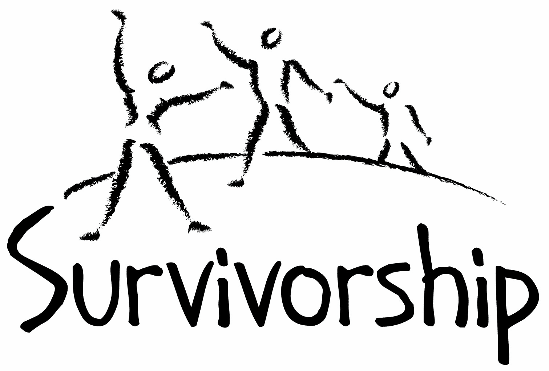

Vol. 192 No. 5 and 6
May/June 2017

The Notes, formerly called Chart Notes, ISSN 1523-275, is published bimonthly, copyright © 1999-2017 by Survivorship. All rights reserved. The entire contents of this issue are copyrighted by Survivorship and by the individual contributors. Please write Survivorship or E-mail info@survivorship.org for permission to reprint. Survivorship is a nonprofit organization.

Dear Friends,

Our May conference was a big success. We want to thank all those that attended and supported the conference.

We want to thank Dr. Randall Noblitt for joining our board of directors. Randy brings years of experience and research to our board. He is the co-author of Cult and Ritual Abuse: Narratives, Evidence, and Healing Approaches, 3rd Edition. An important chapter of his book is now online at
Empirical and Forensic Evidence of Ritual Abuse http://endritualabuse.org/evidence/evidence-of-ritual-abuse/ Information on Randy Noblitt and His Research https://ritualabuse.us/smart/randy-noblitt/

The Survivorship Board of Directors: Neil, Wendy, Eileen, Karol and Randy
Survivorship blog https://survivorshipwp.wordpress.com
Survivorship on Twitter https://twitter.com/Survivorshiporg
Survivorship on Facebook https://www.facebook.com/SurvivorshipRitualAbusePage

Please remember to renew your membership if it is due. Information is at: https://survivorship.org/how-to-renew-your-membership/ Survivorship grows and survives with your help and support.

Survivorship is proud to be one of the co-sponsors of the 2017 Annual Ritual Abuse, Secretive Organizations and Mind Control Conference. This east coast conference has been held for almost two decades.
Special low income prices and reduced rates are available before June 17, 2017.
The 2017 Annual Ritual Abuse, Secretive Organizations and Mind Control Conference
August 11 – 13, 2017 at the DoubleTree near Bradley International Airport Windsor Locks, CT

Freedom from Mind Control – Neil Brick
How to Decrease Internal System In-Fighting and Increase Respect for The Gifts of All Internal Parts – Eileen Aveni
Visual Art and Writing Workshops – Cynthia Mochowski and Pia Moorland
Mindfulness: Strive to Be in the Present – Manjot Singh Khalsa
Be Here Now – Manjot Singh Khalsa
https://ritualabuse.us/smart-conference/
E-mail smartnews@aol.com if you have any questions

CONFERENCES, WEBINARS, WORKSHOPS, AND TRAINING
PODS - POSITIVE OUTCOMES FOR DISSOCIATIVE SURVIVORS (PODS)
info@pods-online.org.uk http://www.pods-online.org.uk/events.html

Bessel van der Kolk's complete speaking schedule is at:
http://www.traumacenter.org/about/speaking_schedule.php http://www.traumacenter.org/training/workshops.php
The 2017 Annual Ritual Abuse, Secretive Organizations and Mind Control Conference
August 11 – 13, 2017 https://ritualabuse.us/smart-conference/

News and Links
Please note: Some of these articles may have descriptions of violence and abuse.

Inside the Jehovah's Witnesses: A 'perfect storm' for abuse
http://www.smh.com.au/national/inside-the-jehovahs-witnesses-a-perfect-storm-for-abuse-20170309-guukur.html

Life after a sex cult: 'If I’m not a member of this religion any more, then who am I?'
Michael Young grew up immersed in the Children of God church, which was labelled as a sect by the FBI and dogged by child abuse allegations
https://www.theguardian.com/world/2017/mar/11/children-of-god-church-sex-cult-texas-mexico-fbi

Top Movies about Cults You Can Watch on Netflix: “Holy Hell,” “Deprogrammed,” “Children of God,” “Colonia” http://www.inquisitr.com/4121094/top-movies-about-cults-you-can-watch-on-netflix-holy-hell-deprogrammed-children-of-god-and-colonia/

New Lawsuit Alleges Baylor Players Gang-Raped Women As 'Bonding Experience'
http://www.npr.org/sections/thetwo-way/2017/05/17/528804172/new-lawsuit-alleges-baylor-players-gang-raped-women-as-bonding-experience

Teen says she was forced to have sex with 1,000 men over 2 years
http://www.cbsnews.com/news/philadelphia-teen-says-she-was-forced-to-have-sex-with-1000-men-over-2-years/

2 Former Penn State Administrators Plead Guilty To Roles In Abuse Scandal
http://www.npr.org/sections/thetwo-way/2017/03/13/519996345/2-former-penn-state-administrators-plead-guilty-to-roles-in-abuse-scandal

'Evil allowed to run wild' Ex-Penn State president guilty in Sandusky case
http://www.usatoday.com/story/news/nation/2017/03/24/penn-state-graham-spanier-trial-jerry-sandusky/99595674/

Former Freemason Grand Master facing ten years in jail after being caught in sting by police as he waited to meet 14-year-old boy
http://www.dailymail.co.uk/news/article-4193914/Former-Freemason-caught-child-sex-sting-police.html

Dr Phil - March 21, 2017 - Child Trafficking Victim Comes Forward
https://www.youtube.com/watch?v=HJNrzYHE-2s

Child Abuse May Lead to Early Puberty
https://psychcentral.com/news/2017/03/29/child-abuse-may-lead-to-early-puberty/118332.html

What Is Human Trafficking? Of those exploited by individuals or enterprises, 4.5 million are victims of forced sexual exploitation.
http://www.huffingtonpost.com/entry/what-is-human-trafficking_us_58d85f7ee4b0c0980ac0e789

I AM JANE DOE - TRAILER I AM JANE DOE chronicles the epic battle that several American mothers are waging on behalf of their middle-school daughters, victims of sex trafficking on Backpage.com, the adult classifieds section that for years was part of the iconic Village Voice. IamJaneDoeFilm.com https://www.youtube.com/watch?v=Nt8jpxA_AY0

'My upbringing broke me': Disturbing insider account reveals life growing up in 'cult-like' yoga ashram where a self-styled guru sexually abused and humiliated children Satyananda Ashram
http://www.dailymail.co.uk/news/article-4379090/Woman-raised-Mangrove-Yoga-Ashram-cult-reveals-horror.html

Troubling details of life inside notorious Australian cult The Family
http://www.news.com.au/lifestyle/real-life/true-stories/troubling-details-of-life-inside-notorious-australian-cult-the-family-have-been-laid-bare/news-story/dc009f5430706ca3d3c406c158754901

Satanist’s Girlfriend Sentenced in Murders of Two Men in North Carolina
http://people.com/crime/satanists-girlfriend-sentenced-in-murders-of-two-men-in-north-carolina/

Lillelid murders still haunt East Tennessee, 20 years later
https://www.usatoday.com/story/news/crime/2017/04/02/lillelid-murders-haunt-east-tennessee-20-years-later/99876020/

Woman convicted of 1980 satanic cult murder up for parole
http://turnto10.com/news/local/woman-convicted-of-1980-satanic-cult-murder-up-for-parole

How to Avoid Being Mind Controlled at a Conference – Presentation at the 2016 Annual Ritual Abuse, Secretive Organizations and Mind Control Conference – August 2016
https://ritualabuse.us/smart-conference/2016-conference/how-to-avoid-being-mind-controlled-at-a-conference/

May be heavy for survivors
Lecture by D. Corydon Hammond, originally entitled "Hypnosis in MPD: Ritual Abuse" but now usually known as the "Greenbaum Speech" delivered at the Fourth Annual Eastern Regional Conference on Abuse and Multiple Personality, Thursday June 25, 1992, at the Radisson Plaza Hotel, Mark Center, Alexandria, Virginia, United States of America. https://www.youtube.com/watch?v=9FUersarZuo

Books on Ritual Abuse https://ritualabuse.us/ritualabuse/books/

White Witch in a Black Robe by Wendy Hoffman is a memoir about how secret high-level mind control is performed throughout victims’ lives and the ways heads of governments and religious organizations participate in this, as well as the healing process and how the mind becomes whole again.
http://us.karnacbooks.com/product/white-witch-in-a-black-robe-a-true-story-about-criminal-mind-control/37567/

The Enslaved Queen: A Memoir about Electricity and Mind Control by Wendy Hoffman, a survivor of mind control and ritual abuse who is also a therapist. This memoir exposes the existence and practices of organized criminal groups who abuse children, helps survivors of those abuses, and provides important information for professionals about the dissociative brain. http://us.karnacbooks.com/product/the-enslaved-queen-a-memoir-about-electricity-and-mind-control/35443/

Healing the Unimaginable – Treating Ritual Abuse and Mind Control by Alison Miller is a practical, task-oriented, instructional manual designed to help therapists provide effective treatment for survivors of these most extreme forms of child abuse and mental manipulation. http://us.karnacbooks.com/product/healing-the-unimaginable-treating-ritual-abuse-and-mind-control/30026

Becoming Yourself: Overcoming Mind Control and Ritual Abuse by Alison Miller In contrast to the author’s previous book, Healing the Unimaginable: Treating Ritual Abuse and Mind Control, which was for therapists, this book is designed for survivors of these abuses. It takes the survivor systematically through understanding the abuses and how his or her symptoms may be consequences of these abuses, and gives practical advice regarding how a survivor can achieve stability and manage the life issues with which he or she may have difficulty. http://us.karnacbooks.com/product/becoming-yourself-overcoming-mind-control-and-ritual-abuse/34803/

Forceps: Poems about the Birth of the Self by Wendy Hoffman
The search for my true past came in distinct waves. This collection of poems includes some from the long period when I knew something was drastically wrong but didn’t consciously know what that was and some from the breakthrough when I discovered my never-bloomed self. The poems cover the outskirts of my awakening, my plowing through and arrival in the middle of awareness. When dissociated memories and emotions exploded inside, eventually they filtered into a poem. The horror transmuted itself. These poems are that record. I have regained a real, not imposed, self. http://us.karnacbooks.com/product/forceps-poems-about-the-birth-of-the-self/38047/

Ritual Calendar 2017 - Difficult Days
Please use caution when reading this page. This page has words and dates that may remind survivors of their programming.
May
4/30-5/1 Walpurgisnacht (May eve) major festival day/Roodmas Day. Beltane (May Day) Fire festival/Celtic festival, Greatest Witches Sabbat, fertility rites/open fields. 5/1 is the Illuminati’s second most sacred holiday and may include human sacrifice.
5/2 May Day (Ireland)
5/5 Cinco de Mayo
5/8 V-E Day
5/9-5/13 Lemuria (three days Roman All Souls)
5/10 Full Moon
5/14 Mother’s Day
5/20 Armed Forces Day
5/25 Ascension Day
5/25 Lag B’Omer (birthday of Jewish Mysticism)
5/25 New Moon
5/27 Ramadan (Beginning)
5/29, 5/30 Memory day dedicated to Joan of Arc
5/29 Memorial Day
5/30-6/1 Shavuot

June
6/4 Pentecost
6/5 Queen Elizabeth’s birthday (New Zealand)
6/6 D Day (invasion of France in WW2)
6/9 Full Moon
6/12 Queen Elizabeth’s birthday (Australia except Queensland & West Australia)
6/15 Corpus Christi – feast to mock the body & blood of Christ in Christian ritual
6/17 Night of Forgiveness (Islam)
6/19 Father’s Day
6/21 First Nation’s Day - Canada
6/21 Summer Solstice (orgies, blood)
6/21 Rituals of the Elements and Feast of the Times
6/23 Midsummer’s Eve
6/23 St. John’s Eve Fire Festival
6/23 New Moon
6/24 Lighting the Midwinter Bonfires in New Zealand
6/25 Eil al-Fitr (End of Ramadan)

ON-GOING MEETINGS AND TRAINING OPPORTUNITIES
More information is available at https://survivorship.org/community-calendar-of-events/

Survivorship is presenting this as information only. If you choose to use one of these resources, please note that you are doing this at your own risk.

Adult Survivors of Child Abuse-ongoing meetings/Beyond Surviving
Second Thursday of each month, 6:00-8:00 PM
Embarcadero YMCA, 169 Stuart St., San Francisco, CA
http://rachelgrantcoaching.com/

ASCA (Adult Survivors of Child Abuse)
On-going meetings in CA, FL, IL, NE, NJ, NY, NC, RI, and South Africa
info@ascasupport.org www.ascasupport.org

Christina Arguello
http://therapists.psychologytoday.com/rms/prof_detail.php?profid=119345&sid=1336589023.0802_18054&city=San+Francisco&county=San+Francisco&state=CA&spec=19
Intensive Trauma Therapy, Morgantown, WV.
Free Thursday morning Trauma Seminars
info@traumatherapy.us http://www.traumatherapy.us
Safeguarding Children - Ongoing training North Yorkshire, UK http://www.safeguardingchildren.co.uk/lscb-training-brochure.html
Survivors of Incest Anonymous
SIA holds 12-step meetings for incest survivors. Those designated “Nothing Too Heavy to Share” meetings are designed for ritual abuse survivors. 410-282-3400 http://www.siawso.org

SIA Coming Home phone meeting
Daily at 11:30 am and 9pm Eastern time.
1 712 432 8808 code is 742247 then press 5 once you're in.

Trauma Center at JRI
Free lecture each Thursday of the month, 12-1 p.m., Brookline, MA
moreinfo@traumacenter.org 617- 232-1303 www.traumacenter.org/training/workshops.php

Womencare Counseling Center
Weekly ongoing groups, Evanston, IL info@womencarecounseling.com 847-475-7003
www.womencarecounseling.com

Women’s Center, 46 Pleasant Street, Cambridge, MA

Weekly and monthly groups for survivors of child sexual abuse, incest survivor’s interfaith quilt project, Survivors of Incest Anonymous, eating disorder support group, emotional healing group, more.
info@cambridgewomenscenter.org Phone: 617-354-6394 Helpline. 617-354-8807 http://www.cambridgewomenscenter.org

Dissociation & Trauma Clinical Discussions
The Dissociation & Trauma Clinical Discussions (DissTCD) list has been created to allow for clinical discussions for all licensed mental health counselors and retired licensed mental health counselors around the world to discuss ritual abuse, mind control and other topics. If you have a related license or degree, please write for more information at DissTCD-owner@yahoogroups.com http://groups.yahoo.com/group/DissTCD

Ritual-Abuse/Mind-Control Special Interest Group
The Ritual Abuse and Mind Control Special Interest Group (RA/MC SIG) of the International Society for the Study of Trauma and Dissociation (ISSTD) was approved by ISSTD’s Executive Council in 2008. The Mission of the RA/MC SIG is to further dialogue, knowledge, research and training on the etiology, evaluation, and effective treatment of trauma and dissociation in clients reporting histories of ritual abuse or mind control. Membership in the RA/MC SIG is free to all ISSTD members as an ISSTD membership benefit.

Call for submission: For Survivorship's next journal, please send your essays, articles, poetry and art work for consideration for publication. We accept entries from survivors and specialists in the field. Please mail to: info@survivorship.org All entries must be in electronic form and sent by e-mail or e-mail attachment.

The Childhelp National Child Abuse Hotline 1-800-4-A-CHILD (1-800-422-4453)
HOTLINES FAMILIAR WITH RA ISSUES
* Bay Area Women Against Rape (BAWAR): 510-845-7273
* San Francisco Women Against Rape (SFWAR): 415-647-7273
* Women’s Center, Cambridge, MA: 617-354-8807

How to Renew your Membership

If you receive our literature by mail, look at the label on your Notes or Survivorship journal. You may also write info@survivorship.org and ask. If you renew before you need to, we will just add the extra months onto your membership. Please try to keep your membership up to date.

You may renew here: https://survivorship.org/how-to-renew-your-membership/
This page has a link to paying with PayPal https://survivorship.org/membership-using-paypal/

Rates
The rates for a Survivorship membership are on a sliding scale based on ability to pay beginning from $75.00 down to what you can afford. We ask that health-care professionals contribute towards gift memberships. We regret that we are not able to provide services or include members under the age of 18. Thank you for helping us support the survivor community.

Renewing
1. Decide if you want to read the Survivorship Journal and Notes on the web site (Internet Member) or receive the Journal by regular mail (let us know if you want to also receive the Notes by regular mail) (Regular Member).

2. Then choose how much you are able to pay. If you are a professional, we suggest that you donate $35.00 to support gift memberships for low-income survivors. We appreciate gifts so that we may offer support to survivors who are unable to work due to the after-effects of their abuse and to survivors who are imprisoned. All donations are tax deductible. We are a 501(C) corporation.

3. Decide whether you want to pay by check, money order, or PayPal. PayPal accepts charge cards. If you want to pay using PayPal, please copy and fill out the form below, email it to info@survivorship.org, and then click https://survivorship.org/membership-using-paypal/ to make your payment.

If you want to pay by check or money order, print out the form below and send it with your payment (in U.S. funds) to: Survivorship, 881 Alma Real Drive Ste 311, Pacific Palisades, CA 90272 USA

Name ________________________________________________________

Organization (if applicable) _______________________________________

City _________________________________________________________

State __________________ (Please add street address and zip code for non-internet memberships.)

E-mail _______________________________________________________

Regular Membership: $__________ or Internet Membership $___________ Donation $_____________

Total enclosed $______________________

You may also e-mail the information on this form to info@survivorship.org

