Survivorship Notes
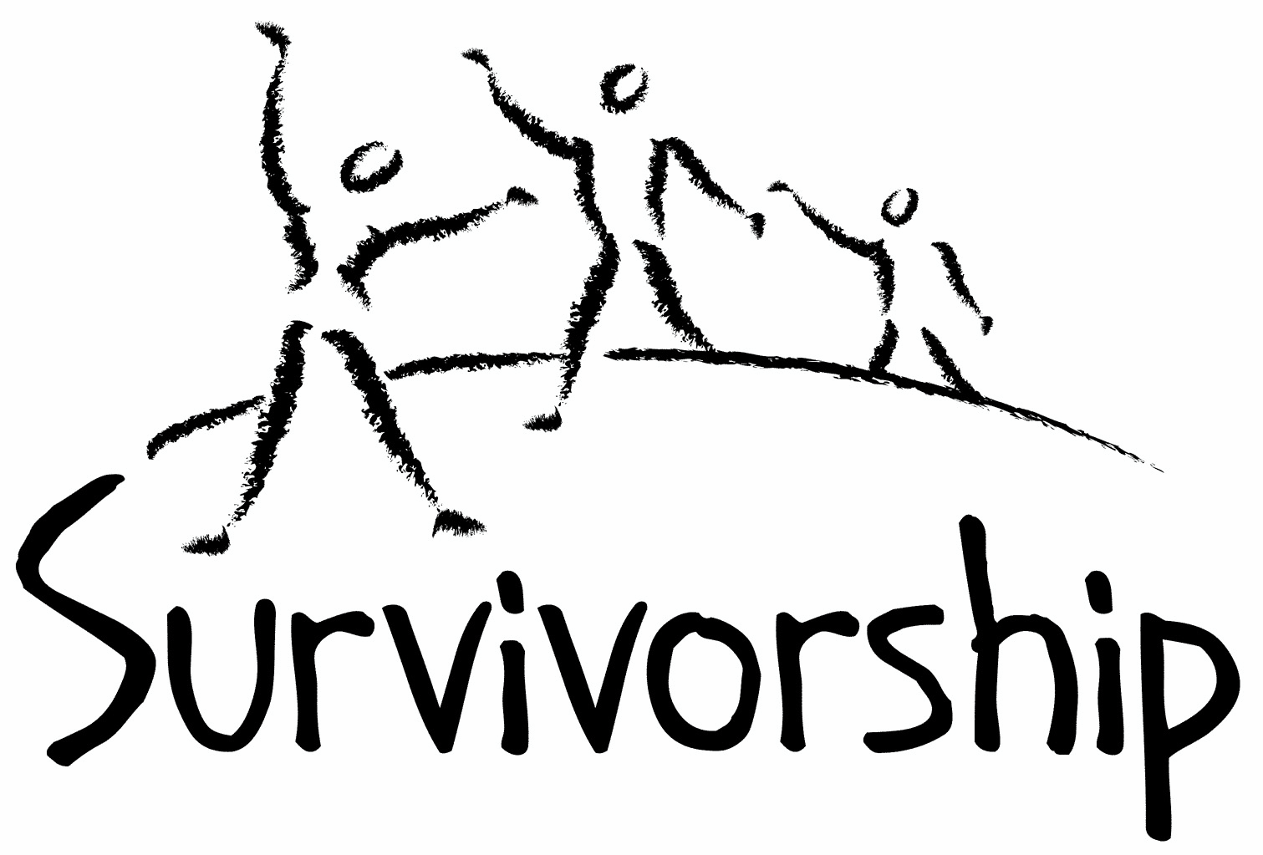

Vol. 192 No. 7 and 8
July/August 2017

The Notes, formerly called Chart Notes, ISSN 1523-275, is published bimonthly, copyright © 1999-2017 by Survivorship. All rights reserved. The entire contents of this issue are copyrighted by Survivorship and by the individual contributors. Please write Survivorship or E-mail info@survivorship.org for permission to reprint. Survivorship is a nonprofit organization.

Dear Friends,

Alison Miller has retired from our board of directors. We would like to thank Alison Miller for her years of work on the board as well as her many years of work helping survivors of ritual abuse.

Information about Alison Miller and Her Research
https://ritualabuse.us/smart/alison-miller/
Alison Miller - Survivorship Conference 2017 - Confronting the Spiritual Issues in Ritual Abuse
https://youtu.be/smVS24Fv__k
Alison Miller - Survivorship Conference 2017 - Working Through Your Traumatic Memories and Destroying the Mind Control https://youtu.be/T5CS_3GqeVU
We now have several video presentations online from our May conference: Video Presentations from the Survivorship Ritual Abuse and Mind Control 2017 Conference
https://survivorship.org/presentations-from-the-survivorship-ritual-abuse-and-mind-control-2017-conference
We are proud to co-sponsor the East Coast Child and Ritual Abuse Conference August 2017 in Connecticut. Information is at https://ritualabuse.us/smart-conference/

The Survivorship Board of Directors: Neil, Wendy, Eileen, Karol and Randy
Survivorship blog https://survivorshipwp.wordpress.com
Survivorship on Twitter https://twitter.com/Survivorshiporg
Survivorship on Facebook https://www.facebook.com/SurvivorshipRitualAbusePage
Please remember to renew your membership if it is due. Information is at: https://survivorship.org/how-to-renew-your-membership/ Survivorship grows and survives with your help and support.

Video Presentations from The Survivorship Ritual Abuse and Mind Control 2017 Conference https://survivorship.org/the-survivorship-ritual-abuse-and-child-abuse-2017-conference/
Survivorship Conference 2017 – Promo Video https://youtu.be/mgq6z3F-Wgw

Survivors may want to use caution while watching these presentations. None of these videos are meant as therapy or to take the place of therapy.
Neil Brick - Survivorship Conference 2017 - How to Avoid Being Mind Controlled at a Conference https://www.youtube.com/watch?v=GGoaYw3pEZs
Neil Brick - Survivorship Conference 2017 - Freedom from Mind Control https://youtu.be/SxBO2HU4R_M
Freedom from Mind Control Subliminal methods and mind control influence all areas of our lives. Social and cultural forms of mind control keep us from growing as human beings. These forms of control make it difficult for us to grow and learn as survivors. They make it more difficult to work through our cult control programming to free our minds and our lives. Recovery techniques will be discussed that can help survivors and others break through their mind control programs and influences.
Alison Miller - Survivorship Conference 2017 - Confronting the Spiritual Issues in Ritual Abuse https://www.youtube.com/watch?v=smVS24Fv__k Survivors of abuse by ritualistic organized perpetrator groups report numerous experiences designed to destroy their spiritual integrity and leave them believing that they are so evil that no one but the perpetrators will accept them. These experiences include simulation of religious figures such as God, Jesus, and Satan, and the afterlife including heaven and hell; designation of certain internal parts of the victim to be demons or have "demonic attachments," and most chillingly, forced childhood participation in rape and murder followed by systematic shaming of the victim as "evil."
Alison Miller - Survivorship Conference 2017 - Working Through Your Traumatic Memories and Destroying the Mind Control https://www.youtube.com/watch?v=T5CS_3GqeVU
Dr. Alison Miller has a Ph.D. from the University of British Columbia and is a semi-retired psychologist in private practice in Victoria, British Columbia, Canada. She has worked with survivors of ritual abuse and mind control since 1991.
Wendy Hoffman - Survivorship Conference 2017 - Dirty Therapy https://www.youtube.com/watch?v=Jq75igmOzXk
Wendy Hoffman Dirty Therapy We know that satanic cult perpetrator groups infiltrate the very professions and organizations that survivors turn to for help. Survivors in general often look for therapeutic assistance. Consequently, these criminal groups have set up some of their members to become therapists and to lead therapy groups. Even when we think that we are in a safe environment, what we sometimes find are people re-programming us and closing us down. There are still many safe and competent therapists working in the field of mind control. Wendy Hoffman somehow survived various forms of high level secret mind control. She tried all her life to get free and has finally succeeded. Now she wants to help and support other survivors in their quest for freedom.
Survivorship is proud to be one of the co-sponsors of the 2017 Annual Ritual Abuse, Secretive Organizations and Mind Control Conference. This east coast conference has been held for almost two decades.
Special low income prices and reduced rates are available before July 19, 2017.
The 2017 Annual Ritual Abuse, Secretive Organizations and Mind Control Conference
August 11 – 13, 2017 at the DoubleTree near Bradley International Airport Windsor Locks, CT

How to Decrease Internal System In-Fighting and Increase Respect for The Gifts of All Internal Parts – Eileen Aveni
Freedom from Mind Control – Neil Brick
Visual Art and Writing Workshops – Cynthia Mochowski and Pia Moorland
Mindfulness: Strive to Be in the Present – Manjot Singh Khalsa
Be Here Now – Manjot Singh Khalsa
https://ritualabuse.us/smart-conference/
Please e-mail mailto:smartnews@aol.com if you have any questions

CONFERENCES, WEBINARS, WORKSHOPS, AND TRAINING
PODS - POSITIVE OUTCOMES FOR DISSOCIATIVE SURVIVORS (PODS)
info@pods-online.org.uk http://www.pods-online.org.uk/events.html

Bessel van der Kolk's complete speaking schedule is at:
http://www.traumacenter.org/about/speaking_schedule.php http://www.traumacenter.org/training/workshops.php
The 2017 Annual Ritual Abuse, Secretive Organizations and Mind Control Conference
August 11 – 13, 2017 https://ritualabuse.us/smart-conference/

News and Links
Please note: Some of these articles may have descriptions of violence and abuse.

First hearings in child abuse inquiry to get under way http://www.bbc.com/news/uk-scotland-40093270

Leah Remini on Scientology's Abuse: 'It Should Be Everyone's Fight'
https://www.tvinsider.com/194985/leah-remini-interview-scientology-and-the-aftermath-season-2/

Understanding the lure and persuasiveness of cults
http://www.abc.net.au/radio/programs/nightlife/understanding-the-lure-and-persuasiveness-of-cults/8560064

Principals of Catholic schools throughout Australia have apologised for abuse
http://www.heraldsun.com.au/news/principals-of-catholic-schools-throughout-australia-have-apologised-for-abuse/news-story/6de8ec5661047097ad2cf60c8012b9d7

Bill Cosby's accuser has her dramatic, detailed day in court
http://www.latimes.com/nation/la-na-billcosby-trial-day-2-story.html
Bill Cosby trial Day 4: He's confronted with his own words and admissions https://www.usatoday.com/story/life/tv/2017/06/08/bill-cosby-trial-day-4-his-words-years-old-deposition-take-spotlight/102625900/

The Other 'Keepers': How a Priest Got Away With the Murder of a Nun for 2 Decades
http://www.insideedition.com/headlines/23706-the-other-keepers-how-a-priest-got-away-with-the-murder-of-a-nun-for

Hypnosis, grounded in science
https://www.theglobeandmail.com/life/health-and-fitness/health/science-hypnosis-change-mind-body/article35248316/

Women in Cults The Conversation Prayers and preparation for the apocalypse - two women share with their experiences of life in strict religious communities they would call cults. http://www.bbc.co.uk/programmes/p0548sbl

Cardinal George Pell charged with historical sex offences
http://www.smh.com.au/national/cardinal-george-pell-set-to-be-charged-with-serious-sex-offences-20170628-gx0v8y.html

Top adviser to Pope charged with sexual assault offenses
http://www.cnn.com/2017/06/28/asia/cardinal-pell-australia/index.html

Church Of England 'Colluded And Concealed' Bishop's Sex Abuse, Leader Says
http://www.npr.org/sections/thetwo-way/2017/06/22/533931155/church-of-england-colluded-and-concealed-bishops-sex-abuse-leader-says

Small ads sex trafficking: the battle against Backpage fury in her voice. "What if this was your daughter? How would you feel if this happened to you?"
https://www.theguardian.com/global-development/2017/jul/02/fight-for-my-daughter-battle-against-backpage-child-sex-trafficking

How to Avoid Being Mind Controlled at a Conference – Presentation at the 2016 Annual Ritual Abuse, Secretive Organizations and Mind Control Conference – August 2016
https://ritualabuse.us/smart-conference/2016-conference/how-to-avoid-being-mind-controlled-at-a-conference/

May be heavy for survivors
Lecture by D. Corydon Hammond, originally entitled "Hypnosis in MPD: Ritual Abuse" but now usually known as the "Greenbaum Speech" delivered at the Fourth Annual Eastern Regional Conference on Abuse and Multiple Personality, Thursday June 25, 1992, at the Radisson Plaza Hotel, Mark Center, Alexandria, Virginia, United States of America. https://www.youtube.com/watch?v=9FUersarZuo

Books on Ritual Abuse https://ritualabuse.us/ritualabuse/books/

White Witch in a Black Robe by Wendy Hoffman is a memoir about how secret high-level mind control is performed throughout victims’ lives and the ways heads of governments and religious organizations participate in this, as well as the healing process and how the mind becomes whole again.
http://us.karnacbooks.com/product/white-witch-in-a-black-robe-a-true-story-about-criminal-mind-control/37567/

The Enslaved Queen: A Memoir about Electricity and Mind Control by Wendy Hoffman, a survivor of mind control and ritual abuse who is also a therapist. This memoir exposes the existence and practices of organized criminal groups who abuse children, helps survivors of those abuses, and provides important information for professionals about the dissociative brain. http://us.karnacbooks.com/product/the-enslaved-queen-a-memoir-about-electricity-and-mind-control/35443/

Healing the Unimaginable – Treating Ritual Abuse and Mind Control by Alison Miller is a practical, task-oriented, instructional manual designed to help therapists provide effective treatment for survivors of these most extreme forms of child abuse and mental manipulation. http://us.karnacbooks.com/product/healing-the-unimaginable-treating-ritual-abuse-and-mind-control/30026

Becoming Yourself: Overcoming Mind Control and Ritual Abuse by Alison Miller In contrast to the author’s previous book, Healing the Unimaginable: Treating Ritual Abuse and Mind Control, which was for therapists, this book is designed for survivors of these abuses. It takes the survivor systematically through understanding the abuses and how his or her symptoms may be consequences of these abuses, and gives practical advice regarding how a survivor can achieve stability and manage the life issues with which he or she may have difficulty. http://us.karnacbooks.com/product/becoming-yourself-overcoming-mind-control-and-ritual-abuse/34803/

Forceps: Poems about the Birth of the Self by Wendy Hoffman
The search for my true past came in distinct waves. This collection of poems includes some from the long period when I knew something was drastically wrong but didn’t consciously know what that was and some from the breakthrough when I discovered my never-bloomed self. The poems cover the outskirts of my awakening, my plowing through and arrival in the middle of awareness. When dissociated memories and emotions exploded inside, eventually they filtered into a poem. The horror transmuted itself. These poems are that record. I have regained a real, not imposed, self. http://us.karnacbooks.com/product/forceps-poems-about-the-birth-of-the-self/38047/

Ritual Calendar 2017 - Difficult Days
Please use caution when reading this page. This page has words and dates that may remind survivors of their programming.
July
7/1 Satanic and Demon Revels (blood) – Druid sexual association with demons
7/1 Sacred Heart of Jesus
7/1 Canada Day
7/4 Independence Day in USA
7/9 Full Moon
7/14 Bastille Day
7/15 St Swithun’s Day (Ireland)
7/17-7/23 Sacrifice of first born males, communion with flesh and blood
7/19-7/20 Sunfest
7/20-7/26 Abduction, ceremonial preparation and holding of sacrificial victim for Grand Climax
7/23 Beginning of Dog Days, linked to Sirius, Dog Star, Sothis, star of Set
7/23 New Moon
7/24 Parent’s Day
7/25 Pioneer Day (Mormon)
7/25 St James Day/Festival of the horned god (gathering of herbs)
7/27 Grand Climax – animal and/or human sacrifice
7/31-8/1 Fast of Tisha B’Av

August
8/1-8/2 Lammas/Lughnasadh-corn harvest (blood)
8/3 Satanic and Demon Revels (sex)
8/7 Full Moon
8/7 S Partial lunar eclipse - visible in most of Europe, most of Asia, Australia, Africa, and eastern South America.
8/7 Raksha Bandhan: Hindu celebrates the bond of protection between brothers, sisters, and cousins.
8/12 Feast for the First Night of the Prophet and his Bride
8/12,8/13 Diana’s day, triple goddess, moon and three moon phases
8/15 Assumption of the Blessed Virgin Mary
8/17 Krishna Janmashtami: Hindu: Birth if Krishna
8/21 New Moon
8/21 Total Solar Eclipse (United States)
8/24 Mania (opening of Netherworld Gate)
8/24 and 8/25 Birthday celebration of Shri Krishna
8/24 St Bartholomew’s Day/Great Shabbat & Fire Festival (large herb gathering)

ON-GOING MEETINGS AND TRAINING OPPORTUNITIES
More information is available at https://survivorship.org/community-calendar-of-events/

Survivorship is presenting this as information only. If you choose to use one of these resources, please note that you are doing this at your own risk.

Adult Survivors of Child Abuse-ongoing meetings/Beyond Surviving
Second Thursday of each month, 6:00-8:00 PM
Embarcadero YMCA, 169 Stuart St., San Francisco, CA
http://rachelgrantcoaching.com/

ASCA (Adult Survivors of Child Abuse)
On-going meetings in CA, FL, IL, NE, NJ, NY, NC, RI, and South Africa
info@ascasupport.org www.ascasupport.org

Christina Arguello
http://therapists.psychologytoday.com/rms/prof_detail.php?profid=119345&sid=1336589023.0802_18054&city=San+Francisco&county=San+Francisco&state=CA&spec=19
Intensive Trauma Therapy, Morgantown, WV.
Free Thursday morning Trauma Seminars
info@traumatherapy.us http://www.traumatherapy.us
Safeguarding Children - Ongoing training North Yorkshire, UK http://www.safeguardingchildren.co.uk/lscb-training-brochure.html
Survivors of Incest Anonymous
SIA holds 12-step meetings for incest survivors. Those designated “Nothing Too Heavy to Share” meetings are designed for ritual abuse survivors. 410-282-3400 http://www.siawso.org

SIA Coming Home phone meeting
Daily at 11:30 am and 9pm Eastern time.
1 712 432 8808 code is 742247 then press 5 once you're in.

Trauma Center at JRI
Free lecture each Thursday of the month, 12-1 p.m., Brookline, MA
moreinfo@traumacenter.org 617- 232-1303 www.traumacenter.org/training/workshops.php

Womencare Counseling Center
Weekly ongoing groups, Evanston, IL info@womencarecounseling.com 847-475-7003
www.womencarecounseling.com

Women’s Center, 46 Pleasant Street, Cambridge, MA

Weekly and monthly groups for survivors of child sexual abuse, incest survivor’s interfaith quilt project, Survivors of Incest Anonymous, eating disorder support group, emotional healing group, more.
info@cambridgewomenscenter.org Phone: 617-354-6394 Helpline. 617-354-8807 http://www.cambridgewomenscenter.org

Dissociation & Trauma Clinical Discussions
The Dissociation & Trauma Clinical Discussions (DissTCD) list has been created to allow for clinical discussions for all licensed mental health counselors and retired licensed mental health counselors around the world to discuss ritual abuse, mind control and other topics. If you have a related license or degree, please write for more information at DissTCD-owner@yahoogroups.com http://groups.yahoo.com/group/DissTCD

Ritual-Abuse/Mind-Control Special Interest Group
The Ritual Abuse and Mind Control Special Interest Group (RA/MC SIG) of the International Society for the Study of Trauma and Dissociation (ISSTD) was approved by ISSTD’s Executive Council in 2008. The Mission of the RA/MC SIG is to further dialogue, knowledge, research and training on the etiology, evaluation, and effective treatment of trauma and dissociation in clients reporting histories of ritual abuse or mind control. Membership in the RA/MC SIG is free to all ISSTD members as an ISSTD membership benefit.

Call for submissions: For Survivorship's next journal, please send your essays, articles, poetry and art work for consideration for publication. We accept entries from survivors and specialists in the field. Please mail to: info@survivorship.org All entries must be in electronic form and sent by e-mail or e-mail attachment.

The Childhelp National Child Abuse Hotline 1-800-4-A-CHILD (1-800-422-4453)
HOTLINES FAMILIAR WITH RA ISSUES
* Bay Area Women Against Rape (BAWAR): 510-845-7273
* San Francisco Women Against Rape (SFWAR): 415-647-7273
* Women’s Center, Cambridge, MA: 617-354-8807

How to Renew your Membership

If you receive our literature by mail, look at the label on your Notes or Survivorship journal. You may also write info@survivorship.org and ask. If you renew before you need to, we will just add the extra months onto your membership. Please try to keep your membership up to date.

You may renew here: https://survivorship.org/how-to-renew-your-membership/
This page has a link to paying with PayPal https://survivorship.org/membership-using-paypal/

Rates
The rates for a Survivorship membership are on a sliding scale based on ability to pay beginning from $75.00 down to what you can afford. We ask that health-care professionals contribute towards gift memberships. We regret that we are not able to provide services or include members under the age of 18. Thank you for helping us support the survivor community.

Renewing
1. Decide if you want to read the Survivorship Journal and Notes on the web site (Internet Member) or receive the Journal by regular mail (let us know if you want to also receive the Notes by regular mail) (Regular Member).

2. Then choose how much you are able to pay. If you are a professional, we suggest that you donate $35.00 to support gift memberships for low-income survivors. We appreciate gifts so that we may offer support to survivors who are unable to work due to the after-effects of their abuse and to survivors who are imprisoned. All donations are tax deductible. We are a 501(C) corporation.

3. Decide whether you want to pay by check, money order, or PayPal. PayPal accepts charge cards. If you want to pay using PayPal, please copy and fill out the form below, email it to info@survivorship.org, and then click https://survivorship.org/membership-using-paypal/ to make your payment.

If you want to pay by check or money order, print out the form below and send it with your payment (in U.S. funds) to: Survivorship, 881 Alma Real Drive Ste 311, Pacific Palisades, CA 90272 USA

Name ________________________________________________________

Organization (if applicable) _______________________________________

City _________________________________________________________

State __________________ (Please add street address and zip code for non-internet memberships.)

E-mail _______________________________________________________

Regular Membership: $__________ or Internet Membership $___________ Donation $_____________

Total enclosed $______________________

You may also e-mail the information on this form to info@survivorship.org

