Volume 21, Issue 5 Winter 2018

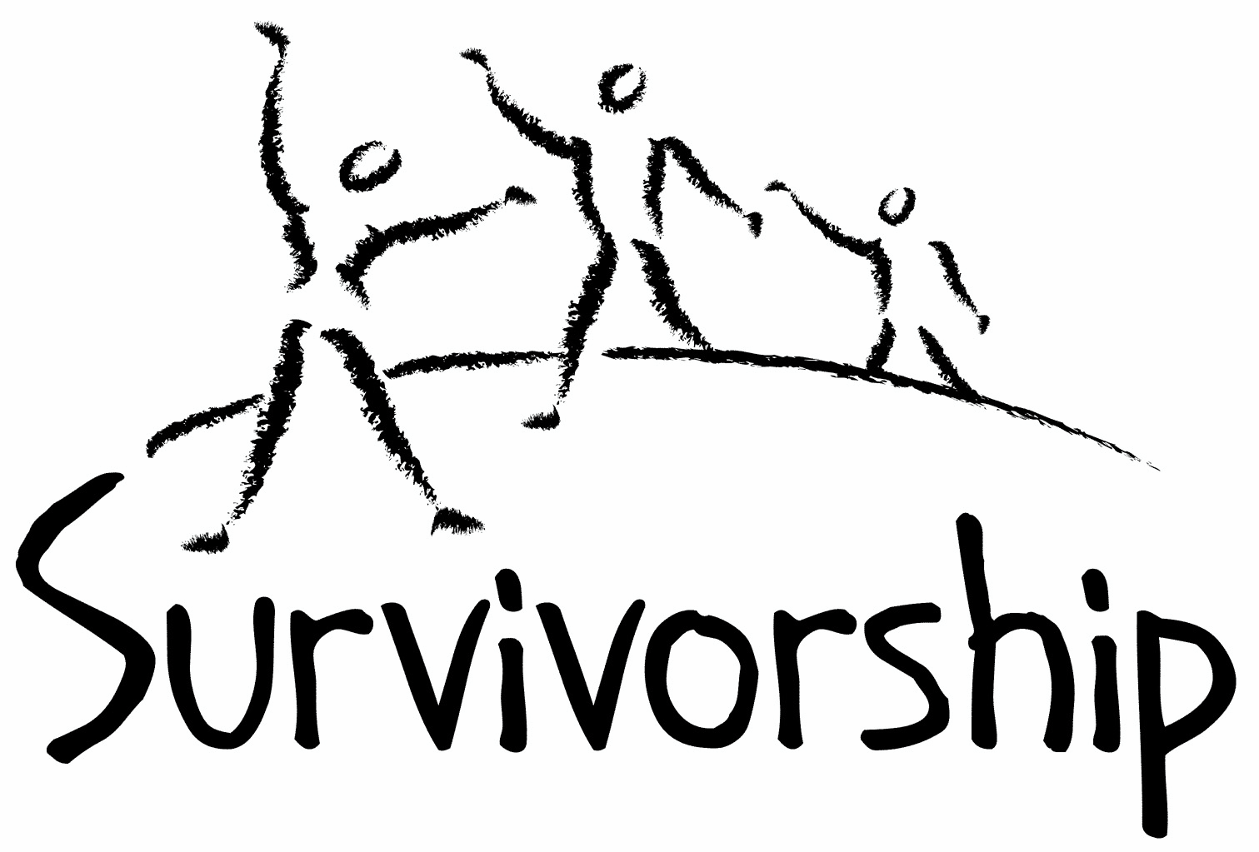
JOURNAL
For survivors of ritual abuse, mind control and torture, and pro-survivors

Copyright Information
SURVIVORSHIP JOURNAL, ISSN 046-2015, is published twice per year in Pacific Palisades, CA.
Editor: Wendy Hoffman, formatted by Neil Brick. Copyright 2017 by Survivorship. All rights reserved. The entire contents of this issue are copyrighted by Survivorship and/by the individual contributors. No part of this publication may be reproduced or transmitted in any form or by any means, electronic or mechanical, including photocopying, or by any information storage and retrieval systems, without permission in writing by the copyright owners. For permission to reprint, write: Survivorship 881 Alma Real Drive Ste 311 Pacific Palisades, CA 90272 or email info@survivorship.org

From the Editor
Wendy Hoffman
Dear survivors, therapists treating surviving victims, support people and others:

In this issue, we have the second part of Neil Brick’s article and presentation on the media and mind control, essays by two prominent therapists and writers, Alison Miller and Randy Noblitt, and some of my art work and poetry. I hope this issue is meaningful to you.

Survivorship is open to considering all submissions to this Journal. Please send us your work when you are ready.

It seems like the times are changing and survivors are becoming aware and free. It is a long, hard road but it is happening. Abused people want freedom and to become their real selves. We want to belong to ourselves and not programmers, handlers, and invisible leaders. Now some ways to achieve this independence are known. We are learning and we are capable.

Thank you for reading this issue. I hope it offers hope.

Wendy, Editor

A further note from the editor:

We are approaching a medley of holidays, which always produces stress for survivors. If you come from a generational mind control family, that is if your relatives one generation after another have been controlled by people who administer mind control and take away their victims’ will—if that is your background, then don’t go home for the holidays. If you go home, you will most likely be forced to attend rituals and will possibly be reprogrammed. You may be forced to do acts you would never ever choose to perform on your own. And you won’t even remember, most likely.

If you come from one of these longstanding criminal cult groups, and your family expects you home for the holidays, don’t think it will be because they want a cozy and loving time with you. Even if the surface looks loving and there are gestures or moments for show, the cult members will want you there to reprogram you and reset and reinstate your mind control. They expect these tune-ups. Tune-ups are necessary if your mind control is to stay intact. You do not have to comply with your perpetrators. You can resist.

If you don’t go home, expect punishment. Punishments are part of what happens when you enter recovery and try to get free. But you have to start sometime. Delaying it won’t make it go away. This may be a good time to start. For some, direct, hands-on punishment is not inevitable. Some of us who live far from our families are not always pursued in person. Instead they might telephone, email, text or communicate in some way a command to your insiders to punish you. Your insiders don’t have to obey that command. If your reporters don’t tell your family or handlers, your family will never know, you will not be punished, and you will have taken a giant step toward freedom. If you choose to spend the holidays with other people than family, think hard about whether they are safe or whether they will also abuse you. Try to find parts inside who can protect all of you from these dangers. Once all your inside parts know of one another and learn how they are triggered and summoned, then all of you may more effectively protect yourselves from being tortured and reprogrammed. As you become more conscious of who you are, you can protect yourselves. For those of you who are already integrated, you can protect yourself.

Wendy

Table of Contents

Page Title Author

3 Propaganda and Mind Control, part 2 Neil Brick

5 The Strong and the Brave Ones Alison Miller

6 Professional Ethics and Respect for Survivors Randy Noblitt

7 Portraits of my Heart, and Portraits of my
Solar Plexus, collages Wendy Hoffman

9 A Poem Wendy Hoffman

Propaganda and Mind Control, part 2

by Neil Brick
Editor’s Note: The first part of this essay appeared in the previous issue of the Survivorship Journal, summer 2017. If you haven’t already, please read that essay first.
Changing the Topic
Rather than deal with the specific topic, a group or person may try to change the topic, or discredit the other side, rather than deal with the criticisms or arguments in the debate. A variety of propaganda techniques may be used to try and do this. This technique has occasionally been used by politicians and others.
Repetition
One way of remembering something is to constantly repeat it. This is one way we learn to remember new words and songs. Rather than debating the points of the debate, a debater may simply continue calling a person a liar or crazy or a traitor, etc. (see “name calling”) without backing up their statements. How often is an idea in an argument presented without a source or logical backing. This is one place in a debate or argument where a debater may show their “true colors.”
Are they interested in debating the points of the argument or are they using propaganda and mind control techniques?
Testimonials
Individuals that are not qualified to discuss the particulars (the specific facts) of a debate or product may join the debate or ad campaign and make statements that may have little or no logical backing or factual basis. Organizations and companies may use a variety of techniques to encourage such participation.
Band Wagon
The user of propaganda may encourage people to join the cause without asking them to think about the facts and other side of the argument. This may include a kind of hero worship, including fancy clothes, high expenditures, claims of a large following, etc. I think the most important thing is to follow your instincts and recovery, not someone else. Other people may have valid and helpful things to say, but I believe our recovery has to be our own.
Logical Fallacies
These will be intentionally used by the user of propaganda to manipulate opinion.
Example: John likes apples.
Hitler liked apples.
John likes Hitler.
This can be used in politics. Equating communism to fascism because one or several communist governments may have been fascist is an example of this. A person may agree with someone on one topic and disagree with the same person on another topic. The user of propaganda may try to lump the two people or a group of people together that disagree with them, suggesting a conspiracy, when it may only be people agreeing on a certain topic.
You might hear that we can’t trust anyone if certain people aren’t safe. This is a logical fallacy and isn’t true. It may take time for the survivor to trust again, but I think we need to keep trying to trust safe people, so we can heal.
Unwarranted Extrapolation
This is another logical fallacy. A person receiving a criticism may claim that a critique of themselves or their group may cause divisiveness in society or their movement. (“Love it or leave” is an example of this.) The repetition of this idea may reinforce the idea in the reader’s mind. An alternative way of looking at this is that the same critique could also make the movement stronger, by encouraging people to think about their choices and use caution before making those choices. It may encourage all those in the movement to become healthier, making the movement even stronger.
In all logical fallacies, and in terms of propaganda in general, try to see the other possible conclusions of the argument, not simply those presented by the user of propaganda.
How to Avoid Blindly Accepting Propaganda and Being Mind Controlled
(Please note: these are only ideas. You may want to analyze each of them to see if they have any value to you and if necessary, add some of your own.)
From FactNet (about Coercive Persuasion listed under sources): “The subjects easiest to influence are usually young, trusting, gullible, and noncritical people from protective backgrounds or people who may be particularly vulnerable because of some recent unsettled transition (my note: survivors may also fit in this category)…the rejects are likely to be individuals who have easy access to accurate, critical, or counterbalancing information. Insolent, self centered, streetwise, highly critical or recalcitrant individuals are generally culled out…” Though everyone is susceptible to some degree.
1) Try to find out both sides of the story.
2) Learn about propaganda and mind control techniques and learn how to recognize them. If necessary, learn to avoid those using these techniques (this may be online or offline.) The media and advertisements may be a good place to start either learning about these techniques or avoiding them. At times, advertisements don’t even discuss the product or its attributes at all.
3) When in a potential situation where you can be MC’ed or propagandized, learn how to recognize the feelings of going into a meditative state and learn some of the techniques for getting out of these states.(Details are at “Conference trigger management and safety” http://ritualabuse.us/smart-conference/conf1999/trigger-management-and-conference-safety-presentation/) I believe that avoidance of these situations is usually the best way to keep from being MC’ed or propagandized.
4) The user of propaganda or mind control techniques may exhibit a “lack of morals,” lying and/or disregarding the rules of the debate, list, group or society. This is similar to the “us vs them” or may be justified by “the ends justify the means” arguments organizations may use, see SMART #29 (Cult Information Article. http://ritualabuse.us/2008/10/issue-29-nov-1999/ )
5) Try to use your gut feelings. If something doesn’t feel right, step back or remove yourself from the situation. I believe that a legitimate group or organization will give an individual the time and room to make their own choices (see “Emotional Manipulation” above).
I believe the following statement also applies to being MC’ed and/or fooled by propaganda. From FactNet, “No one “joins a cult.” People recruited into destructive groups think they are doing something else, something beneficial and worthwhile. Anyone can be recruited given the right sales pitch and the right conditions in one’s life. We are all potential victims.” While I believe it is necessary to learn from our mistakes, I think that feeling too much guilt doesn’t help. It may be necessary to make an amends when safe. This may be simply by getting healthy and possibly educating others.
As always, please use your own judgment and try to research everything as fully as possible. Don’t accept anything anyone says simply because they say it or claim to be an expert or whatever. Try to check it out for yourself. I am not an expert, and I am continually learning new things about myself and the above topics.
__________

The Strong and the Brave Ones (previously known as the Garbage Kids)*
By Alison Miller

I've known for a long time that that many survivors of ritual abuse and mind control have insider parts called the garbage kids (or, in the U.K., rubbish kids). They are to be found, naked and dirty and smelling of urine, in internal garbage dumps, usually with nasty things like insects and rotting flesh. These places in the inner world are copies of real-world places where these parts were dumped when they violated the abusers' rules by refusing to obey important commands. Several times I've assisted survivor clients in rescuing the garbage kids, cleaning them up, and giving them clothes and comfortable, warm internal places to live. But until now I haven't thought about the strengths of these insiders or the ways in which they can help with recovery.

Recently a client's young insiders were telling me about a group of internal girls trapped under the floorboards of the internal copy of the primary abuser's living room, put there as a punishment for disobedience. I searched for insiders who were brave enough to get them out of the room where the internal copy of the abuser was asleep in a chair. The ones I was talking with said "I'm not brave," "I'm weak," "She might catch me." I realized I needed some insiders who were strong and brave, and I thought of the garbage kids, who had been rescued (by self-created parts who lived in the trees) from an outdoor garbage dump. Like the girls under the boards, they were strong and brave. We planned to ask the garbage kids to go where the obedient ones hadn't dared to go.

Another survivor client has been struggling with a bullying supervisor at work (in the real world.) This boss intimidates her by micro-managing her work, and saying things like "Are you all right?" This brings out (just behind the front person) the little girls who feel afraid of bullies like their father, and the adult feels anxious and close to tears, although previously she was feeling all right.

The first thing we tried was enlisting the top soldiers in her now cooperative system to strengthen the front person. We were both surprised that this didn't work, and we had to figure out why. These "tough guys" were actually, like anyone in the military, trained to obey orders instantly rather than to defy authority. They (or rather, the discarded parts from whom they had been split off) had been severely punished for any assertiveness or sign of insubordination. These seemingly strong leaders were therefore very vulnerable to the bullying supervisor, trying much too hard to follow orders even when the orders made no sense. Although they had given orders in the inside world, they had always obeyed in the outside world, and even though they didn't show their emotions, they were dominated by fear.
So we thought hard about who should be present with the adult front person in the workplace. And we thought of the garbage kids. These were the ones who had stood up to authority despite the punishment. They were willing to be assertive—which was exactly what was needed. They accompanied the adult to work for the next week. She found herself able to stand up to her supervisor, make a good argument when the supervisor was wrong, and resist intimidation. The supervisor's bullying decreased as she realized the survivor wasn't going to react the way she wanted her to.

Find your garbage kids, and make good use of their strengths when you need strength.

*This essay will appear in From the Trenches, a book of essays written with Wendy Hoffman and forthcoming, Karnac Books, 2018.

Professional Ethics and Respect for Survivors
By Randy Noblitt*

Often extreme abuse survivors have self-critical thoughts and feelings. We who are psychotherapists sometimes work collaboratively with our clients toward the goal of improved and more stable self-acceptance. Sometimes our cooperative efforts are effective, but occasionally therapists may contribute to the problems rather than the solutions. We do not always spend the needed time, or show the respect that is due to our clients.

The American Psychological Association has published an ethics code that is periodically updated with amendments. The most recent version is entitled, “Ethical Principles of Psychologists and Code of Conduct including 2010 and 2016 Amendments” (2017). It entails five general principles, the last of which is respect for people's rights and dignity. This is primarily an aspirational norm, rather than a clearly enforceable standard. In some instances, it may be obvious when any particular psychologist is showing respect for others. In other cases, it may be less clear.

For psychologists and other mental health professionals we can become more mindful of our interactive style and how we come across to others. This may take a willingness to engage in self-examination. CBT therapists sometimes refer to metacognition as the process where we can think about and become aware of our own thoughts, actions, and feelings. Psychodynamically-oriented clinicians sometimes refer to mentalization as the process where we develop increased awareness and reflective capacity for our own mental processes, as well as those of others. We can ask for feedback from our clients and colleagues. Becoming better at showing appropriate respect for others can be a long-term goal in professional development as well as part of our own evolving sense of humanity as individuals. Should we consider our capacity to communicate respect as an ethical requirement for our work, and something that can be improved with effort and reflection?

Part of the problem may be related to conventional mental health thinking and attitudes. There is a common belief that therapists are experts, and a presumption that the consumers of mental health services are not. Therapists sometimes impose their preconceived ideas on their clients, rather than patiently listening to the clients’ narratives. How often do deeply-believed psychological theories become obstacles to effective listening? What if we instead focused on understanding how our clients experienced and understood their lives—at least as a first step in the therapeutic process?

Another consideration is to what extent clients should be partners in developing the treatment plan. Many therapists adopt a paternalistic attitude where they suggest, sometimes in a coercive manner, how the treatment should proceed. From a more collaborative perspective clients may be able to offer significant input in constructing and developing the treatment plan. Many clients provide valuable information about previous efforts that did or did not work for them.
My conclusion is that we have an ethical duty to be respectful of our clients. We also have an ethical responsibility to proceed in therapy with informed consent. We sometimes need to resist the temptation to direct the client’s therapy in a paternalistic manner. We should not only respect the person of the client, but also respect that individual’s autonomy. The active enlistment of the client’s views generally improves the therapeutic alliance, and at least in my experience, increases the likelihood of progress.

*American Psychological Association (2017). Ethical principles of psychologists and code of conduct including 2010 and 2016 amendments. Retrieved from http://www.apa.org/ethics/code/

PORTRAITS OF MY HEART

by Wendy Hoffman

Like the mind, the heart can be fragmented. Programmers know how to seal strong barriers between its divisions. These collages portray the manipulated heart, its release of divisions, and a more peaceful and knowledgeable state of wholeness as it becomes integrated in recovery.

PORTRAITS OF MY SOLAR PLEXUS

by Wendy Hoffman

Pools of emotions are held and preserved under the heart, in the solar plexus of victims of severe, organized, orchestrated mind control. As you heal, these feelings are discharged and the solar plexus becomes less burdened and inflamed. These collages depict that progression to health and well-being.

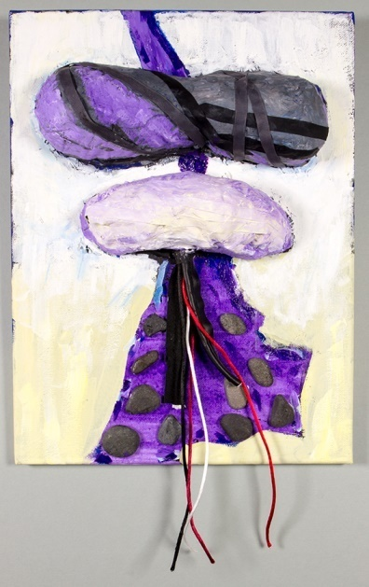 | 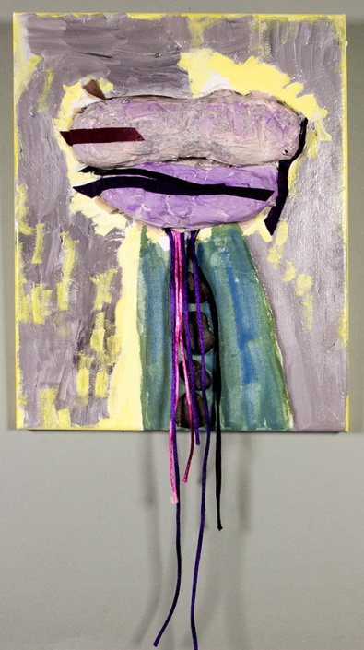

Ode to the Mind Controlled*

By Wendy Hoffman

You were born whole and lovely and good.
They divided your brain into thousands of pieces.

All through torture.

And so you became many strangers to yourself
each one living in an ice-concealed grave inside.

Hordes living in ghostly isolation,

not one knew of the others.
Clump, clump—You were not allowed to make noise.

You tiptoed through life, alone in a mobbed crowd.

I am happy that I did not stay in a shattered mind.
I followed the invisible thread back to my birth-mind.

Let the pain flood into the Red Sea.

Nothing is worth sacrificing truth for.
And freedom.

Nothing is worth not becoming yourself.

*This poem will appear in From the Trenches, written with Alison Miller and forthcoming, Karnac Books, 2018.

