Volume 21, Issue 3 Winter—December 2016

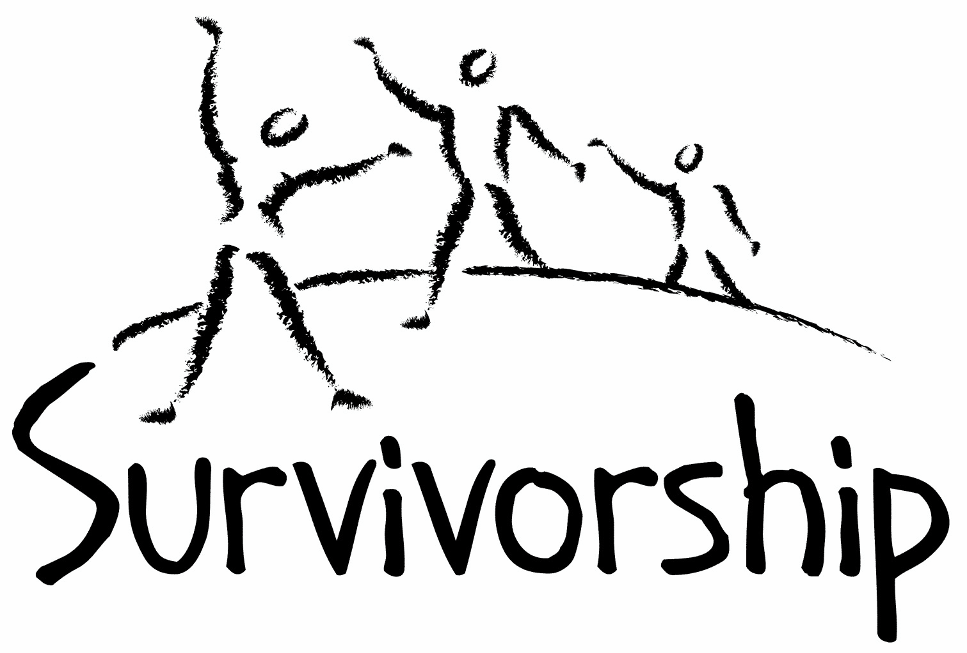
JOURNAL
For survivors of ritual abuse, mind control and torture, and pro-survivors
Copyright Information
SURVIVORSHIP JOURNAL, ISSN 046-2015, is published twice per year in Oakland, CA.
Editor: Wendy Hoffman, formatted by Alison Miller. Copyright 2016 by Survivorship. All rights reserved. The entire contents of this issue are copyrighted by Survivorship and/by the individual contributors. No part of this publication may be reproduced or transmitted in any form or by any means, electronic or mechanical, including photocopying, or by any information storage and retrieval systems, without permission in writing by the copyright owners. For permission to reprint, write: Survivorship, Family Justice Center, 470 27th St., Oakland, CA 94612 or email info@survivorship.org
From the Editor
Wendy Hoffman
Dear survivors, friends, supporters, therapists, people starting out in recovery, people in the middle:

This issue has poems, art work and essays by survivors and therapists. I hope it will help you understand what we are dealing with and give you encouragement and hope.

Please send Survivorship your work. We want to publish as much work by survivors as possible.

Please make sure there are no triggers in what you send us. We strive to make this website safe. We all deserve safety.

Please tell your therapists we have a column about what therapists have learned from working with survivors. Ask them to write an essay for us. This issue has an essay by Eileen Aveni, our newest board member.

I hope you get through these holidays safely and with a minimum of distress. My thoughts are with you.

Warmly,

Wendy, Editor

Self-care as you read: Managing Triggers
Because of the nature of extreme abuse, the material in the Journal may be upsetting or triggering for survivors. It helps to know this in advance to prepare yourself.
Here are some suggestions:
- Make yourself comfortable. Have things close by that you might need—tissues, pen and paper, art materials, food and drink, favorite toys, an object that is symbolic of healing—anything that helps you to feel secure, phone numbers of support people
- If you get upset, write about or draw your feelings
- Acknowledge your courage. Know you are choosing to read in order to further your healing
- Keep in mind that you can read at your own pace and stop at any time
- If something you read activates a specific memory or a flashback of emotions, write it down. Making sense of it can happen in your own time
- As yourself: “If I knew a child who experienced what I am remembering or feeling, what would she or he need to feel comforted?” Provide yourself with as much comfort and gentleness as you can.
Statement of Mission and Tolerance
The Survivorship Journal is for discussion and ideas. We encourage a variety of perspectives, viewpoints, and expressive forms about the topic of ritual abuse and mind control, which we define as the abuse of children and non-consenting adults in the name of an ideology or belief system. Any system of belief can be used to justify abuse. We welcome and embrace men and women who are committed to ending abuse, regardless of race, religion, political party, or sexual orientation. For survivors, no matter what religion, political party, or social movement was used to rationalize the crimes committed against you, you have a place on the ship. No matter what psychological, social, or spiritual path you are following to reclaim your life, Survivorship celebrates your healing.
Please Note: Listing of resources does not necessarily constitute our endorsement of them. They are for educational value only and some may be heavy for survivors to read. Some of the writings enclosed may not necessarily be safe for all survivors. See the info above on Managing Triggers. Survivorship recommends you take breaks as needed and have a support person available.

Table of Contents

Page Author Title
4 Ginger Freedom Two Decades Ago life story
5 Wendy Hoffman Pygmalion poem
6 Alison Miller Conversation with the Sleepers about Killing story
7 Winnie M Stranger to Myself poem
8 Eveningstar The Owl and the Moon, a Poetic Vision poem
8 Eveningstar Gathering the Alters art
9 Eileen Aveni What I Learned from Survivors essay
10 Wendy Hoffman Ode to the Unloved, Rejected and Abandoned poem
11 Neil Brick The Battle to Stop Ritual Abuse conference talk
14 Sparrow Fighting Spirit poem

Two Decades Ago

Ginger Freedom

Two decades ago I attended a Survivorship conference. My large “brown bear” that is still with me today, perched on my sewing machine, separate from the other bears, is a testament to this miraculous happening. The “host” of my system signed up because, at that time, she was having a hard time wrapping her mind around her condition, and was hungry for answers. She
began to process in her early 30s, having put religion on the shelf, and began to quest “truth” seeking answers to why her siblings were struggling, why she herself was struggling.

That little voice inside, some inner angel, some abstract nuance prompted - look to your childhood for answers to your questions. When she did, she saw how little there was in her memory bank and said, okay, I’ll go there, do that, look at that.

Not knowing such a thing as repressed trauma existed, or of the effects of trauma, the questing heart compounded with her study in dance served as a catalyst for healing/change in that the body too holds memory, and when it softens, releases, re-aligns, the power of story good/bad/ugly/ indifferent tumbles out.

She had her first flashback in a dance studio, after class, not knowing what a flashback was, and began to have flashbacks several times a day, and soon different parts were tumbling out
with different names processing horrific things, spontaneously, with no therapist initially as a guide.

It was impossible for this “host” aspect to accept the ritual abuse component of what was surfacing and journeying to the Survivorship conference was a part of the process of seeking answers.

Upon arrival, as she looked around, she realized - oh my goodness, there are people “just like me, telling the exact same stories,” and although using denial to slow the process down would last for many, many years, something in that moment died, and a confidence was born in trusting the process.

There was a speaker at the conference, I don’t remember her name, and she promised, “it gets better, it does, in the healing river. With time, the journey gets easier.” Those words became anchors for me in my darkest hours. Moments came, when I swore, if I knew what I would have to face, to process, death or insanity would have been the wiser course of action to take. On more than one occasion. I swore to myself, if I ever got to the other side of it all, I too would reach out and be a resource,
a beacon of hope, and say, yes, it does get better, because it truly does.

In 2013 I wrote two episodes of my memoir and self-published them on Amazon under the pen name of Ginger Freedom through kindle direct publishing as a step in this direction. I learned three things in this process.
One: survivors have their own journey, and telling one’s own story may not really be of interest or help to someone, but it is good for one’s own process.
Two: if there are any unprocessed layers in one’s trauma template, and one turns to memoir as a means of wrapping up a gnarly chapter in one’s life, know that writing a memoir could signal to one’s innermost selves, you’re ready, to go even deeper yet.
Three: going public with one’s story can make former abusers more pro-active in their attempt to take you down in various forms of harassing ways. Know they no longer have power over you, you can indeed keep yourself safe, one incident at a time.

The simple act of telling the story surfaced the final layer I always knew was there, and having processed and integrated some thirty-five parts and sub-parts and fragments, bunches of others surfaced to integrate, the mind control parts, and I found myself back in hell. I knew I needed to get my rump back in therapy, and in my highly dissociated flooded state I began the quest.

I found one woman highly recommended, and ten minutes into my story, she gave me my check back and said, I can’t help you, and I don’t know of anyone in this town who can. I suggest you find a somatic therapist.
I went to another therapist I found through a survivor resource and when she advised me to quit my job because what was happening was that I was being accessed by perpetrators, I just knew that to not be a good match, I needed my job because I needed the health insurance and access to care. I contacted a friend who works in the mental health system and I was given the name of a somatic therapist an hour drive away and began the schlep. I was adamant with my insurance company, and although she was out of network, they made an exception when I told them I was told that nobody in my community could help me.
She read my psychiatric files and prompted me to switch psychiatrists, and I did, and with it, an appropriate diagnosis. I learned that the field of therapy had progressed INCREDIBLY so and understood why the therapist in my home town suggested somatic therapy. I NEVER could have safely processed this final layer in the type of therapeutic talk therapy styles I had
encountered before.

Two and a half years later, in the flow of the now, I celebrate that I re-invent my system as a “multi-faceted wonder order” that is “gender and identity fluid” organizing my system in any given moment in the assemblage of me that best serves what comes up in the moment. I don’t call it integration, and it definitely isn’t a fused state, it is fluid play with gratitude at my
back and wisdom in my heart. I have been off all psychiatric medication for 7 months and manage remaining issues holistically and with herbs. Therapy sessions are more about juggling the complexity of human relationships, and parts that don’t have a space in everyday life getting a chance to work at becoming more active in life. We as me as i/I as whole as ONE question if it is possible to be fused, in that it would probably make life a tad easier, and we are open as a playful community to this idea. But as is, it doesn’t get much better than this in terms of being beyond it all. I give full expression to all of who I am. Having the courage to attend a Survivorship conference over twenty years ago gave me the courage I needed to not only survive, but process, and thrive.

Am I done yet? Fully healed? Whole? Recovered? In that the simple act of writing this short bit stirs something up, my guess is, no, not yet, but I am far enough along to say that I love life and I love my community.

With gratitude, Ginger Freedom

Pygmalion
Wendy Hoffman

Dust has gathered on ice and I am shaking it off. I begin with my unpainted fingernails and remove streamers of rage. I go on to my crushed ribs, the furrows of my troubled brow, chisel out the falling feeling and stumble across loss.
You can lose what you never had. I scrap off caked mud and realize
it’s other people’s that they put on me. I look for my skin. I keep dusting
until my chin emerges
from the melt.

Conversation with the Sleepers about Killing
Alison Miller
This is an account of a therapy session with an adult client, a survivor of organized mind control by a right-wing political group. The survivor's words (mostly coming from child parts) are in regular script; the therapist's words (my own) are in italics. The subject matter is a child being forced to kill. Only read it if you're ready to deal with this subject matter. The client does find considerable relief by the end of the session.
We all share so everybody knows that what the bad people do is not what we want to do. We're trying to get to the part where it upsets everybody if we hear a baby cry.
We're supposed to be a killer, nobody's gonna change that. It's who we are, it's in our DNA.
How old are you?
Five.
Do you know what DNA is?
No.
Is this a program?
It's a program. They have a baby over there, crying, and they bring another baby in. Every time, you see a baby crying and they bring in one that's still.
It's called embedding. We are the sleepers. They're trying to reconstruct the nature of the person by repetition, over and over. It's important to get the senses. We have to keep our eyes open so we can see for real. You don't know who you are any more. You only have so much energy.
The program is unspinning….
Somebody inside would use the memory of the baby crying, while we stabbed. The live baby initially over on the left side, the still baby by us. Then later in rituals no live baby was needed. We never know if the baby we kill is alive or dead when we kill it. Sometimes in the early stages the body got electrocuted while the baby cried.
What were the instructions?
"Whenever the ritual starts you try to hear the baby crying." The body was three and a half when they said that. You're strapped to the table, hear crying, get electrocuted. Part of it was done in the hospital, then they continued in the church. You just see the baby and think he's crying and think there'll be electricity and the baby will get killed. The electricity was in the head. The arms and legs were strapped down. Jesus (the alter involved) is the immortal one and has power over life and death. The sleepers, who are also Jesus, have to go through it too. They are told to watch so when one Jesus fails there are still the sleepers. The sleepers stay on the outside of the body and watch. They take over. It's part of their job to come into the body.
All the sleepers, all the Jesuses need to join in as we go through the memory of these trainings.
They're just saying "Killer, killer, killer, killer …." They always say the Aryan race is superior, all hail the Aryan race, heil Hitler. They chant (gibberish). They're making us killers to honour the Aryan race. That means the blond haired blue eyed ones like us. Jesus is the key, who gets raised from the dead. He has the power. Nobody can hurt Jesus because he's already dead. The Jesus that gets created is immortal.
None of you is immortal.
What is your left hand doing?
It's making a sign to make sure everybody in this memory is accounted for and present.
We have to drink the blood after, and eat the organs, because the power's in the blood that makes us have the power over life and death. And they keep making us do it till we don't flinch or get sick. "You're the killer, you don't think. We have the power, we can take your life." It's all for the purpose to make the ultimate killer.
When the body became ten they let go of the arm and it kept moving, it got caught up in the motion. "You're the killer. All hail the Aryan race." We wished the arm had kept moving and cut us up instead.
The boy's going to be killed anyways, and it'll be slower or worse if they do it than if we do it.
Who in you decided to let the arm keep moving and kill the boy without anyone's hand on yours?
Essence (the core spiritual essence of us) decided. Essence always knows the truth. It was a choice you should never have to make.
They always blamed us, and said we would go to hell. All these years we've been going crazy because of it.
Essence chose what would make the boy suffer least. You didn't choose that he would die, you only chose how he would die, the least painful way.
So we're not evil! It was really a kind thing that we did. That's weird. We showed mercy. We thought we were going to eternal damnation.
We never thought we'd get this relief.

Stranger to myself
Winnie M.

I am a stranger to myself
I ride the wispy backs of air currents at night, walk closely shoulder to shoulder with myself
I see her in the early morning hours sleeping, her legs tremor sometimes when she is afraid
I am a stranger on the afternoon bus, preparing for home preparing to leave again
I am a stranger in class, answering questions to topics I don’t know and acting numb
Meanwhile, a tiny ocean of emotion capsizes the internal container my family made

I am a stranger to myself, born into a life that is embarrassing and hidden: The elusive underbelly bought in Hollywood, but denied in the corners where it crawls and thrives

I am a stranger to myself
She has seen so much; I have worked so hard
Together we can teach each other how to heal from what
our world does not seem ready to listen to
I am a stranger, but someday I will know myself. Someday I will know my history
When I was little, I had no control, no voice, no choice but to survive
I am a stranger to myself but I will hold on to her
I will hold myself and listen to my experience

The Owl & the Moon,

a Poetic Vision
by Eveningstar

When I was just a small child,
I repeatedly dreamed of the moon.
There was an Owl upon it,
Not (the dish ran away with the spoon.)
At night I could see the Blue Moon,
I could see the colors that swirled on Earth.
I was so young, and so very scared,
The Grade I was in was the First.
I don't know why I dreamed it,
But I dreamed it every night.
The Owl & the Moon were motionless,
And there was not a chance of flight.
I was determined to be an Artist,
As through the years I grew,
I made that dream a picture,
And with a Pen I Drew.
I learned the lines I drew with,
Could make Art, and maybe a poem.
They must have somehow soothed me,
As I prayed to be safe in my bed at home.

Gathering the Alters
by Eveningstar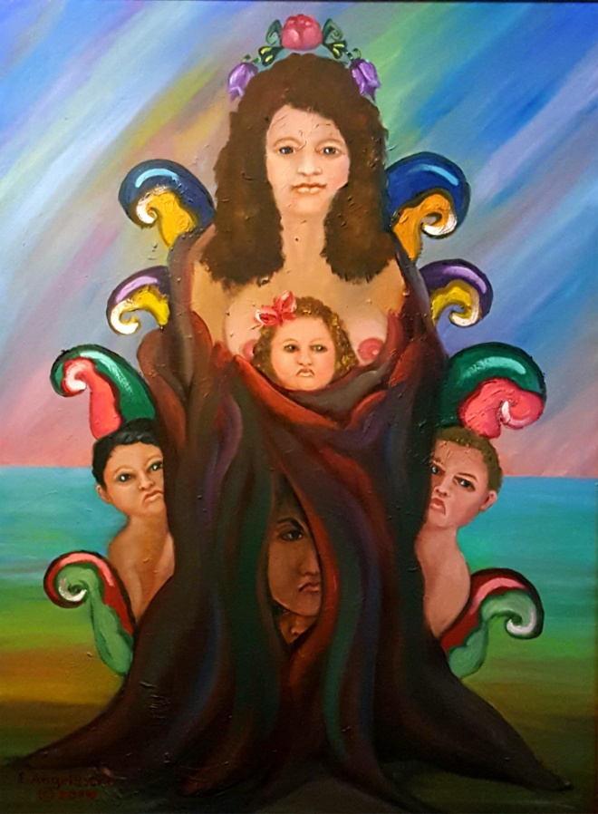

What I Learned from Survivors
Eileen Aveni
Eileen Aveni is the newest member of the Board of Directors of Survivorship.
I am a therapist and a professional musician. Sometimes I wonder which came first. I did not come from an abusive background but I had an uncle who came home from the war with a major case of PTSD. But we didn’t know that term back then. We loved him but my parents never knew what to do with him. As a child we saw his children become really messed up because of his bad choices. I also watched as a younger cousin from another part of the family was clearly being victimized, and my parents had her over at times to get her away from my uncle and aunt (this was before child abuse laws came in to effect). I saw her cower in the corner in fear and not be able to play with us. My parents explained that we had to be patient and nice to her and try to engage her. In those times my absolute fascination with psychology was born. I saw my parents model love and patience. As I grew, my parents explained more about those situations. So I began to understand that the world wasn’t a good place for some children. I also knew that if I could figure out how to help them, that maybe they would have a better life.
At the same time, I was a natural musician, always playing something to make music. I fell in love with the piano and singing. I was shy. But music brought me out. I could get on stage and communicate. So I majored in music and loved it. But – somehow I couldn’t get psychology out of my head.
So I took two Bachelor of Music degrees, one in music and one in music therapy from two different colleges - somehow trying to combine both of my loves. One of my internships took me to the University of Michigan Child Psychiatric Hospital where I worked with a four year old child who acted much like my little cousin. My childhood experiences were beginning to make sense as I could tell I understood this child.
After working in music therapy for awhile I finally realized that my love of psychology was winning, so I started graduate work in clinical social work. One of my internships was at the Center for Forensic Psychiatry where I met pedophiles and mass murderers – those who were accused of incredibly heinous crimes. I saw into the mind of the truly deranged, evil-ridden person. Another internship was in Child Protective Services in an inner city ghetto. I learned to inspect children’s bodies and how to question them for abuse and look into the faces of their abusers – usually their parents who often wanted to do better but felt that they couldn’t help themselves. The need to really learn how to help people became fierce in me. I knew if I could just learn enough, that maybe I could save some of these kids. From that point on, I have never stopped learning. I found that once I mastered some area of clinical work I would have to move on to something more complex.
My first real therapist job was in neuro-surgical intensive care and oncology – where I took every case of dying patients. Listening to people’s hearts as they faced death was jarring and soul-searching for me. I was drawn to it. I knew there was something they could teach me. It carved out a deep space inside of me to hold their pain while trying to help - yet I had to learn how to give it over once they passed away. It was a most remarkable time to grow to prepare for the next steps in my life.
I continued on into bereavement work while starting a practice. One day someone in grief surfaced memories of sexual abuse. Their memories evolved into ritual abuse. I did not recognize it at the time. I just knew this was different.
Six years later I realized that four of the people I had been treating over those years were ritual abuse survivors. Word got out among colleagues that ‘Eileen must know how to work with these clients’. Suddenly the local psych ERs and others were referring to me. I had no idea what I was getting in to. But I knew that this could never be as challenging as death and dying so I figured I could handle it and learn from them. After all, these people had survived.
Before the end of 1991 I had ten ritual abuse clients. I was nearly sinking. I was desperate to learn but few local colleagues knew anything at the time. So I started my quest – to learn from anyone who would teach me. I called book authors, traveled to meet specialists in this field, talked to police, went to crime scenes, helped craft RA laws, ran a safe house, and joined a national RA advocacy group where suddenly I was pushed onto the national scene. I met, learned from, and taught along with the best clinicians in the field. We learned together, through the False Memory wars and ever since. They are some of my best friends because we met in combat, in the trenches.
I realized how I was prepared all along for this calling. I’m still a professional musician. But my natural, driven ability to solve the most scrambled puzzle is also part of my makeup. To sit with child alters and learn from them, to hear the near death stories, to hear the nuances of their voices with my trained musical ear as they switch, as they tried to get through the most incredible emotional and physical pain at the hands of their abusers – I have learned that these people are truly heroes. They make my day – everyday! Sometimes I just want to kneel at their feet and cry because I feel so humbled that they would trust me to help them walk through their pain. We are all the same. But some of us have faced evil squarely in the face, and have not only come through it but now know what good really is. It could have broken them. But instead they chose good. They have no doubts. Evil can make us or break us. I pray that I will be able to finish the race strong like they have.

Ode to the Unloved, Rejected

and Abandoned

Wendy Hoffman

It wasn’t your fault.
It may not have been anyone’s fault.
Right from the start, we were emptied out
and raw hatred inserted.
They trained our mothers to turn their backs on us,
our fathers to be brutal.
Your grandfather may be your father.
How could your mother overcome that?
That is our heritage.
It is your mission now to love yourself.
You are as lovable as
anyone else on earth.
You deserve to be cherished.
You are not to blame.

The Battle to Stop Ritual Abuse
This is Neil Brick’s conference transcript from the 2015 Annual Ritual Abuse, Secretive Organizations and Mind Control Conference
Please use caution while reading this presentation. It may be triggering. All accusations are alleged. The conference and this transcript are educational and not intended as therapy or treatment.
For over twenty-five years, survivors and their advocates have worked to stop ritual abuse by educating the general public about these crimes. Through an intense struggle this research has been made public and survivors have been helped. Exposing the backlash and its true motives and how their work continues to promote social injustice will be discussed in this presentation.
Neil Brick is a survivor of ritual abuse and mind control. His work continues to educate the public about child abuse, trauma and ritual abuse crimes. His child abuse and ritual abuse newsletter S.M.A.R.T. has been published for over twenty years. http://neilbrick.com
(Please note: This article is strictly the opinion of the author and not necessarily the opinion of the SMART newsletter or the webmaster.)
The Battle to Stop Ritual Abuse
For over twenty-five years, survivors and their advocates have worked to stop ritual abuse by educating the general public about these crimes. Through an intense struggle this research has been made public and survivors have been helped.
A backlash continues, covering up crimes against children and protecting a hierarchical and unjust social structure that exists by propagandizing and mind controlling its members. Exposing the backlash and its true motives and how their work continues to promote social injustice will be discussed in this presentation.
For many years, we have fought to stop ritual abuse crimes and educate people about these crimes. But even today, the backlash continues, misrepresenting the research, hiding important data, harassing anti-child abuse advocates and repeating the same lies about many of the child abuse and day care cases of the past. I have covered these topics in many of my prior speeches and all of this information is available on the Internet at this website.
Today, I will be speaking about why we have been so viciously attacked and why there are repeated attempts to misrepresent and cover up our work.
Our work exposes those that attempt to control social thinking patterns. If our realities are seen as accurate by society, then this exposes the lies that our present society is built on.
Mind control and propaganda exist in every part of our society. From how people dress, to how people speak, to how people believe.
There are many lies that most in our society believe in. These lies are taught to children at an early age.
These are some of the lies people are taught:
1) We live in a democracy – The reality is the media is controlled by a few companies and the information people receive is controlled by these same companies. It is rare that people would receive any different information. All one has to do to prove this is to listen to conversations at work or at a social event. Many people will be talking about the same thing and at times quoting the ideas of the local media sources.
It is impossible to have a democracy when few think for themselves. A democracy needs a free flow of information, which does not exist in our society or most societies in the world.
Ritual abuse is a more extreme example of how the free flow of information is denied. Survivors live in families and social systems that trap them and make it difficult for them to get information about cults and mind control. A survivor may move from a cult family to a cult marriage or neighborhood or job where cult members live.
2) Religion helps people grow – The reality is that this is rare. When one chooses a religion, they give up their own freedom of thought. It is better to develop your own ideas and think for yourself than to give up your intellectual and spiritual freedom to someone else’s ideas. Often the spiritual or religious system is a system of mind control. People that are unaware of mind control techniques and that are unfamiliar of the feeling of being in a trance are prone to be victimized by a religion. Be aware of the feeling of going into a trance and leave the area you are in. One mind control technique religious leaders and other groups use are hypnotizing people by moving their hand at the bottom of a person’s visual field. Internet pages may put ads on the sides or bottoms of one’s visual field.
Ritual abuse has its own hidden spiritual system, that people believe in their cult alters. These beliefs may become more conscious in those that follow dark spiritual systems.
3) There is a god – The reality is that god is a concept that was and is used to control people.
It is better to develop one’s own concept of the world than to read a book or go to a house of worship to get one’s entire spiritual system from.
Ritual abuse systems may be hidden in a variety of different religions. Hammond, LA is an example of a ritual abuse system being hidden in a Christian religion. Many occult and dark religions have been found to have ritual abuse systems hidden in them also.
4) Soldiers in our society – The sad reality is that soldiers are often unknowingly working to protect corporate interests in other parts of the world. They like most of society are indoctrinated into a social system that teaches them that war is okay if our government says so. They are trained to follow orders in their basic training that some have compared to mind control systems. This is not to state that soldiers are bad people. They are often good people that have been indoctrinated by our social system.
Ritual abuse victims are like soldiers in some ways. They have roles they follow due to their indoctrination. Child soldiers are an example of soldiers being indoctrinated in a cult manner to fight and kill.
5) Capitalism is a beneficial economic system – The truth is that it is impossible to have a fair and equal society in a society where the most important thing is to make money. The focus to help others is lost. As we see in our own society, over time the rich get richer and the poor suffer greatly. This system causes immense suffering and death for those unable to survive in it.
Ritual abuse victims are part of this system. They often make money for the cults as sex slaves, prostitutes or bringing in others to do this kind of work.
6) The media presents information fairly and equally – The reality is that the media often does not tell the truth and packages misinformation as the truth, repeating this as propaganda until people do not believe the truth. A good example of this is any of the mentioned points or our own topic, ritual abuse. The reality is that ritual abuse and cults exist and have existed for years. The media refuses to present our stories and the research around this, repeating the same lies about McMartin and other child abuse and day care cases. We have thousands of research articles refuting media lies, yet it is impossible to get this information into the media.
7) People believe they are not mind controlled – The reality is that everyone is, the question is how much are they mind controlled. Gender roles are a good example of mind control that almost everyone follows. TV is an example of a mind control device. People are put into a trance and become very susceptible to mind control and social programming. Religion has many mind control techniques, including certain types of prayer, fear programming and repetition. Many sales techniques are based on mind control techniques. Car sales techniques are a good example of mind control techniques. The way churches and malls are set up are meant to disorient one and make one more susceptible to mind control.
Ritual abuse survivors, even those in recovery for years do not realize they are still mind controlled, nor do they realize when they are being accessed by others. They fall for emotional appeals. If someone asks you lots of questions about yourself when you are tired or more relaxed, they could be using mind control techniques to get more information about you.
The way to heal is to realize that anyone can be mind controlled. And those that are not familiar with mind control, social programming and propaganda techniques are being mind controlled.
Break through all programming. If you don’t, you may be susceptible to being revictimized by cult and ritual abuse mind control.
How do we break through programming?
1) Know when you are being mind controlled. If you are feeling spacey or dissociated, this means you may be susceptible to mind control. Try to get away from wherever you are. Mind control methods can include any of these media misused : TV (often misused), music, repetition, prayer, certain phrases, tone and the pacing of speech. Some religious and cult leaders know how to use these techniques and will use them. Hand movements can also be used to hypnotize people. Learn how different tones and types of music can be used to put one into a trance and avoid these.
2) A person that wants to mind control or access you will wait until you are susceptible. They know people want to connect to others. Love bombing is an overt form of mind control cults use. At a conference, people may wait until you are tired, be careful of evening and second day conversations, especially the end of conferences when people are tired. People that want to access you will ask a lot of questions. Cult people will want specific details, like demographic and other personal information. Trust your gut. If you feel uneasy when someone is asking you something, you don’t need to tell them. You can politely say “I prefer not to discuss that.” A cult person may lead up to these questions with more general details, even divulging their own info so you give them yours. Again, go with your gut feelings around this. If you aren’t sure, you don’t have to say anything.
3) People misrepresent themselves. Rarely, will a person admit they are using mind control techniques on you. They may appear to be the nicest, friendliest or shyest person in the world. They may state they want to help you. The religious leaders now accused of raping hundreds of children were often well loved charismatic people. On message boards, these people will often appear to be very helpful. When reading their messages, consider how they feel. Are they sincere or do they feel phony.
4) Don’t trust those hiding behind undefined philosophies. They may talk about how they are healing others, or ask you to listen to your inner voice. They may ask you to find the god within you or something like that. These philosophies may be new age, occult or Christian based philosophies. Mind controllers will find which philosophy or approach works best with you. Then they will use it.
5) Mind controllers will use shock techniques. These get more attention. You will especially see these often in the media. Or they may use an emotional appeal. Their writing will have strong emotional words in it, that will seem overdone and out of place. Shock techniques and strong emotions make one more susceptible to mind control.
6) Repetition is another technique. The media will often repeat the same message repeatedly. The denialists of ritual abuse crimes use these techniques.
7) Be careful of those that deny they are ritual abuse survivors when it appears they are. These people may have a role in social situations, like gathering information or finding out more about people’s programming and personal information.
8) A person with less mind control or not mind controlled will feel more real. They won’t feel like part of a person with a mask. They won’t discuss how they want to save the world or heal in an undefined way. You will be able to have a real conversation with them and realize they are really there. As you work hard to recover with therapy and breaking through traumas, you will be able to notice this in others more.
Why is this all important?
Living without mind control is like living without addictions. Everything looks, feels and becomes real. The fog disappears. One’s memory improves. One can truly help others. Expect to encounter resistant. Those that are not mind controlled are not liked by cults or those that control society to profit off of others’ work. They will try to silence you. Remember “your silence will NOT protect you.” They will work to keep your message from reaching others. Don’t let this happen. Speak out and help others heal from mind control.
Remember, a free life is the best life.

Fighting Spirit
Sparrow

Self-destruct is your desire
’cause your brain’s been trained to be a liar.
It tells you you’re worthless
It tells you you’re small –
undeserving of love – any love at all

Daddy took you to the CIA
The soldiers there had games to play
They wanted to see if they could find
a way to erase and reprogram your mind

Tortured into outer space
you left your body without a trace
A swastika soldier, wearing a grin,
opened your mind and climbed right in

Electrocuted into believing their lies
that your only value is between your thighs
A porno plaything for the perverts lust
They broke your heart and destroyed your trust
silenced your voice and taught you to obey
then hid the memory of it all away.

But there’s a fire in you they couldn’t control
An oasis of strength called your soul
A place of power in your heart and brain
their perverted science can’t contain.
A fighting spirit –
A recognizer of truth
A knowing within
Their lies can’t pollute
the truth that you’re precious, powerful and wise
and stronger than all of their swastika lies.

