Volume 19, Issue 1 March 2014

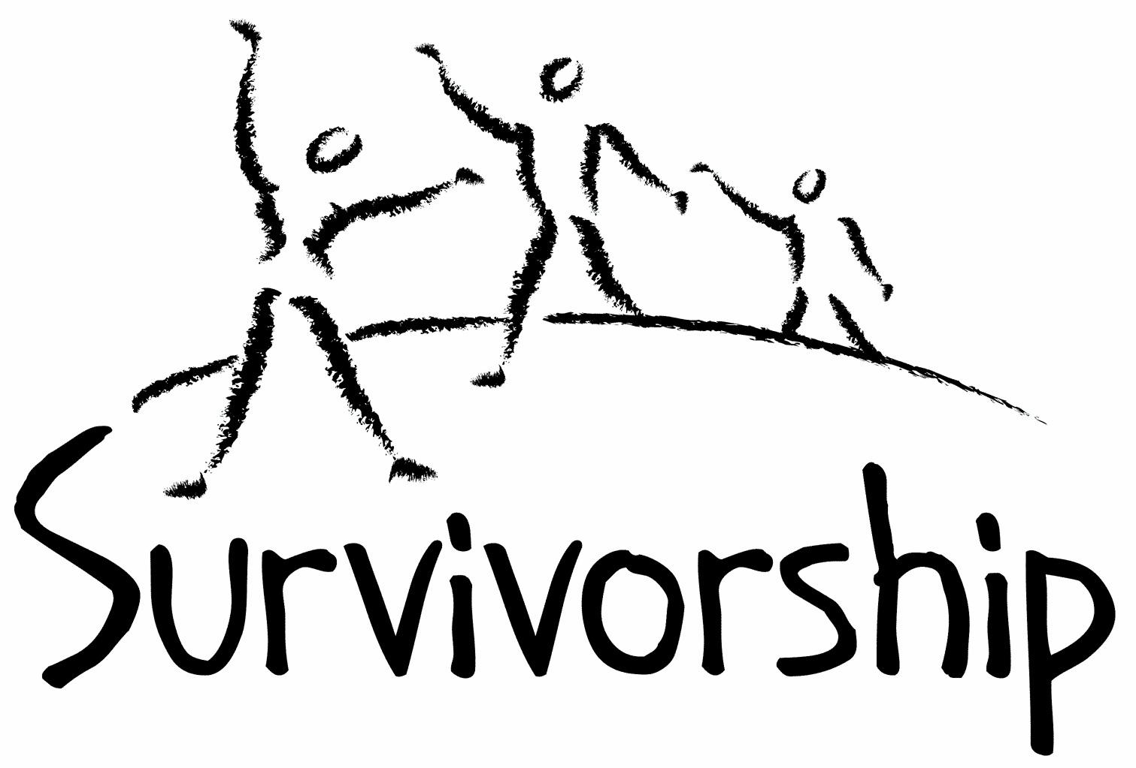

JOURNAL

For survivors of ritual abuse, mind control and torture, and pro-survivors

SPRING EDITION

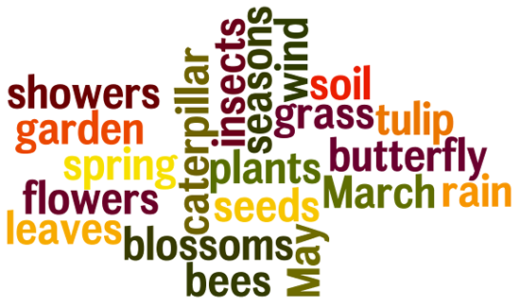

Self-care as you read: Managing Triggers

Because of the nature of extreme abuse, any or all of the material in the Journal may be upsetting or triggering for survivors. It helps to know this in advance and to prepare your self.

Here are some suggestions:

- Make yourself comfortable. Have things close by that you might need—tissues, pen and paper, art materials, food and drink, favourite toys, an object that is symbolic of healing—anything that helps you to feel secure, phone numbers of support people
- If you get upset, write about or draw your feelings
- Acknowledge your courage. Know you are choosing to read in order to further your healing
- Keep in mind that you can read at your own pace and stop at any time
- If something you read activates a specific memory or a flashback of emotions, write it down. Making sense of it can happen in your own time
- As yourself: “If I knew a child who experienced what I am remembering or feeling, what would she or he need to feel comforted?” Provide yourself with as much comfort and gentleness as you can

Statement of Mission and Tolerance

The Survivorship Journal is a medium for open discussion and voicing of ideas. We encourage a variety of perspectives, viewpoints, and expressive forms in approaching the topic of extreme abuse, including ritual abuse, which we define as the abuse of children and non-consenting adults in the name of an ideology or belief system. Any system of belief can be used to justify abuse. We are committed to fighting abuse, not ideologies. We welcome and embrace men and women who are committed to ending abuse, regardless of race, religion, political party, or sexual orientation. For survivors, no matter what religion, political party, or social movement was used to rationalize the crimes committed against you, you have a place on the ship. No matter what psychological, social, or spiritual path you are following to reclaim your life, Survivorship celebrates your healing.

Please Note

Listing of resources does not necessarily constitute our endorsement of them. They are for educational value only and some may be heavy for survivors to read. Some of the writings enclosed may not necessarily be safe for all survivors. See the info above on Managing Triggers. Survivorship recommends you take breaks as needed and have a support person nearby or on call.

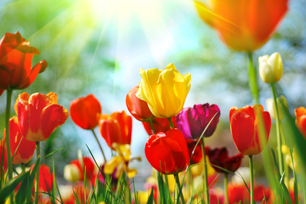

From the Desk of the Editor

There are times when we wonder where we are, and where we have come from. Since Spring is a time of rejuvenation, and of life coming forward, I like to think of it as a time for celebrating our healing journey. The winter cold has moved forward and the flowers are returning, adding a rich colourful environment that remind us of laughter and things that bring us joy.

Of course, Spring also brings us reminders that we are human, and that life isn’t always as clear and bright as a ‘Spring day’. We wade through our memories, hoping to reach a point where we can catch our breath, and learn to live in the moment. We hope our lives can become fruitful, and our friendships bountiful.

Just like this Spring Journal, may we learn to triumph over adversity, and to face challenges with determination, fortitude, and love. For love is truly all there is.

I ask for the readers’ indulgence and understanding, since I am just a ‘step in editor’. If you feel the inclination to step forward to take ownership as a new editor, I welcome you.

A journal is only as good as its readers. If I hold your interest, then I have done my job. If you reach an ‘aha’ moment and learn something new, then I congratulate your perception and purpose, and welcome your comments, artwork, poetry, and prose. I welcome all of you to become involved in Survivorship, at whatever level you are able to. I welcome you, and I welcome SPRING!

Shamai Currim 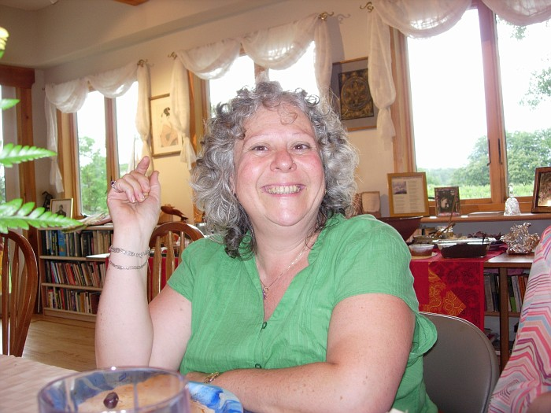

Letters to the Editor are always welcome.
Email: editor@survivorship.org
The creek
The light continues to change so fast it is hard to keep up with the shadows cast. The day is finally becoming warmer. I imagine it is around 12:30. I am sitting by what's left of a creek as November is soon to arrive with its replenishment.
There is a breeze off and on as the Earth warms up. I've been sitting on this log for over an hour, not being able to sense what to do, and then I realize that I am just fine. I don't need to do or be anything here.
The warning sounds of Jays and Squirrels are gone. The Crow and Raven have moved on.
With every change of light, flies and bees surround me, enjoying the pools of sunlight warming their wings.
Off over my left shoulder I hear branches snapping, rustling, nature's spirits may be coming to visit this quiet creek.
There are orange, brown and white butterflies around me, forming a ring, and I am finally warm, like they are becoming.
The creek water giggles under a log and the light sparkles off the lit pools.
There are now 4 orange, black and white butterflies sitting next to me in the sun, fanning their wings for the warmth of the sun. Now there are 6! Now 7, all in a circle around me in the only sunlight. Now 9! Now 11. Now 13! I dare not move, even though my butt aches. It's been about 15 minutes since this began.
They are following the sun pools from my right, then in front, then to my left, as the heat crosses over me. They are only inches away at times. The orange looks more like shimmering gold.
"Sometimes you have to wait", Great Spirit tells me.
They are going now. Maybe that's what Spirit wanted me to hear. Sometimes you have to wait. Be patient, kind and compassionate to myself while the healing of Spirit finds me here, quiet, listening to the music and messages of the Earth.
Only 3 left. The sounds of the creek and the drone and the buzzing of the flies and bees returns to my hearing. This space next to the creek will soon be without my butterfly sisters. I am growing hot too.
The giggle and trickle of the creek can once again be heard rolling over and over round, flat stones, and underneath log damns that try, but can't stop the tiny creek. Only 2 left now as the sun pool moves left and I am on the edge of shade. One more butterfly sits next to me. I see its tongue sipping whatever water it can from a fallen leaf. True happiness and peace, and divine grace have no names. They are, and here they are also me.

Still feasting, the butterfly is covered in shade and flies another few inches into the sun pool. I watch her search. Over in the sun pool there are now 4. The branch that looked like an alligator sticking it's nose out of the water is gone into shade. In the sun, the creek's ripples move faster. Is that possible? It's about light, it's about my light, which they didn't get, no matter how hard they tried, You have always been here with me, and always will be.
A large cone falls loudly, splashing into the creek, plunk. A brown, rarely seen, nuthatch comes down to the edge of the creek and pecks along. So it begins again. "Be mindful. Watch and be calm, silent, still. You are safely held here in my hands. As is the all that is, so are you".

By Micci


Where In the Darkness, There is Light Act 1

On this side we wander, unafraid, filled with a wondrous imagination. The source,
The grace, the light, fits nicely on these branches, rough and tender.
A piece of this and a piece of that, goes round and round; we plunder what we can.

It is not static here; it’s more fluid than the kaleidoscope of atoms bouncing
Here and there in relative order. Take my hand as I stand here waiting,
For you; I take shelter from the sound, waiting for you to walk away.

The time has come; don’t look so sad, the hurting is spread before us on the wings
Of these angels running to chase the moon. We walk on ceilings here, so to speak,
The kind brushed ever so nicely upon the sky. Are you ready? Let’s go.

Two steps in, there’s an up and there’s a down, you can jump to the depths, or not.
In equal portions of black and white. If we skip past the surface, in our weightlessness,
We can see what’s been planted so long ago; balanced upon its perch.

Take a breath deep into your soul now take another, up we go.
Take my hand; this place of wonder can get you lost. Without a compass
You may fall to the surface; break apart in the muck.

We glide above the trees alongside the hawks, the wind rustling by
Messing our hair, cool to the touch. We are flying with our legs dangling
Down like two flamingos; the beauty in awkwardness.

I look down and spot the house of mirrors, black, with a door blood red
Trepidation fills me like the great Hindenburg, destined. I hold on tight and kick my legs.
Away from the black! Away from the shock! Away!

Circles here, circles there, a dance of the butterflies; they are connected
By colorful highways, flares bursting into existence then gone – impermanent.
We are looking down, breathe, out!

The Lord of the Land smoking; thick brown pricks signal his presence behind
Blackened red eyes. “Open wide my child as I defile your corpse with mine”
Unknowingly, I come to you, enslaved by your fruitless, maniacal hands upon my skin.
Have your child? Surely you jest; I will leave my crayons behind.

Do not look so sad, the hurting is spread before us on the wings of these angels,
Running to chase the moon. Equal portions of black and white; balanced.
In our weightlessness, we can see what’s been planted so long ago
below the sparkling snow upon the ground.

Above the trees, past the Sun, beyond what is left is my hope, alive
As if encased, embraced; kept safe in the expanse of the “out there”,
Where in the darkness, there is light. Let’s go.

Written by: Ana Fonseca -2013
Healing with art

This image is the result of an intuitive collaging process which begins with setting intention to heal, integrate, and find what serves my own highest good and that of all life. Around this figure, on a larger sheet of paper, I wrote affirmations, laid down colored tissue paper in loose configurations, then cut and tore an old image that conveyed pain and fear, glued those down, creating an undersea garden where all could come to peace. After returning to it several times, photographing and writing about the shifts I found happening, I released all that was around the figure and kept the smaller area to remind me of what has developed and changed, that my transitioning continues, and that it's good to come to center and breathe… let it all go, feel peace.

For more information on this process, contact
Adriane Kelly
InterPlay
Creative Wellness Practice
adrianekelly@yahoo.com
“Walk as if you are kissing the Earth with your feet.”
― Thích Nhất Hạnh, Peace Is Every Step: The Path of Mindfulness in Everyday Life

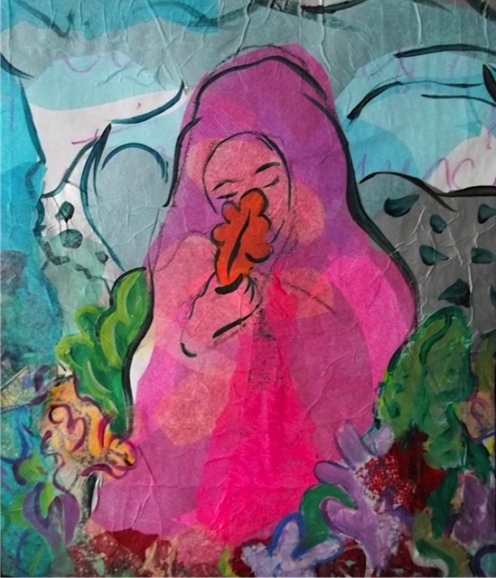
Discovering a part

The following is an accurate description of my experience as I discovered a part of me a few days ago and tried to integrate it. It is not fiction.

It was a Monday morning when somehow little Evie allowed me to see more of her. She is in a state of panic. She has blood trickling down her legs and is screaming... My heart aches as I see her in this state. She stomps her feet hard and with elbows bent she moves her wrists up and down in the air in a frenzy... I am aching... What can I do to relieve the pain of my child? Encouraged by my loving therapist, I approach her. Her limbs hang on to her body as if from a very fine thread. One rough movement and the limbs will fall off. Her soul is raped and bruised everywhere. She smells terribly and there is fresh blood and old, dried blood between her legs. I can't even give her a shower... She might fall apart in my arms...

I pray for courage to hold her near, to embrace her and move beyond the stench... Courage is granted. Thank you my Higher Power.... Never alone... Never. I put a blanket over her, a blanket for children. I gently bring her on my lap and hold her there. I have nothing to say. What could I possibly say to the massacred child I hold in my arms? I see her locks of hair, her tiny fingers... Oh my child.... Oh my darling... Compassion floods my soul...

The look of terror and frenzy slowly gives way to calm which in turn gives way to an emptiness in her look... She has that empty, void look that an insane patient has. I get scared! I am scared! Now it is my turn to cry and scream: BASTARDS!!!!!!!!!!!!! What have you done to her!!!!!!!!!!!! BASTARDS!!!!!!!!!!!! COWARDS!!!!!!!!!!! I HATE YOU!!!!!!!!! I loathe the day you were born!!!! And I weep, I weep with my tears falling down on her cheeks....

To no avail though.... She is gone, in another land, far away from me... My child, my little Evie is gone far away. She does not hear me, she does not feel me. I take her to our secret place. That place is safe. My Higher Power is there. No bastards are allowed. No fucking bastards can break through the protection of my Higher Power. He has a name, the bastards know it and they tremble in fear... BASTARDS!

I leave her there in a safe room. My Higher Power is not allowed to approach her. She knows He is there and she knows I do not allow Him to approach her. He is a guard and He also cooks for her. As I leave her in the room, I see my Higher Power. I feel affection and safety close to Him. I want to hug Him, stay in His arms and cry my pain, feel His comfort. He is all I have....

On my way to approach Him, I hear giggles.... Giggles? There is NO ONE else here. I know that. The place is top secret. Who is it then? I see a little girl coming. She looks familiar... Same locks of hair, same olive complexion, same language... She is happy and care free... I freeze. Oh my goodness me!! She is little Evie. But another one. She does not know about the abuse and torture. I turn to look at my Higher Power, panic in my eyes: “Who is she?! How much pain is she going to cause? How much resistance is she going to come up with? How many more decades of work to integrate her?! Where was she all these years?”.... I feel dizzy, afraid that once again the earth is falling under my feet.

My Higher Power smiles, calms me down, doesn't say much. He doesn't have to. He simply lets me take a look at little Evie the twin, as I quickly name her. She is nourished, loved, celebrated, protected. She is loving and welcoming. No resistance. This kid loves.

I run to little Evie's room. She knows. She needs to tell me. What happened? Who is she out there? I see tears running down. Her empty, insane look is melting away. Tears that were frozen for years well up. How many years? Around 31. Without any words, she explains to me:

There was too much blood, too much semen, too much torture. Too many rituals, too many sacrifices, too much porn, too many drugs, too many beatings. They took everything away. But little Evie, my precious, little Evie found a way. She committed the ultimate sacrifice. She tore a part away... Slowly, painfully she held her soul in her little fingers and one day at a time, one sacrifice at a time, one ritual at a time, one beating at a time she would tear a little bit more. Like a piece of thick garment that you need to apply force to tear it and you need to do it carefully so it tears as evenly as possibly, she tore her soul. With each tearing sound, she mourned the loss of what she thought would never ever be retrieved. Still, she preferred to say good bye to her innocence and her happiness, risking that she might never ever find it again, than keep it there and have it defiled.

Oh, the pain of that... Doubled in half from my pain, I cry with her. I cry with tears and I cry without tears, those invisible ones that are still waiting for more safety before they materialize... My precious, little Evie, my child, my innocent found a way.... Oh, how much was asked of her! At an age that she was supposed to chase butterflies and dress like a fairy, she instead had to perform the ultimate sacrifice.

My little Evie is immersed in loss.... She has been hoping and waiting that her twin might appear one day. My little Evie used to pray to her Higher Power to keep her twin safe, but she despaired in the midst of the darkness that surrounded her and gave up. For the most part she eventually believed that Evie the twin was gone... for ever....

But her Higher Power was faithful...He tore alongside her..., mourned and bled as she did and he kept Evie the twin safe. He nourished and loved her for every minute that they were apart. No minute was wasted. No part of this separation was minimized. Every tick of the clock was carefully considered. His eyes were on the clock every hour, every minute, every second...

In my part of the world, spring has come. The almond trees blossom like brides on their way to their beloved. Birds put their orchestra together and spoil us with their songs... I cannot help but stand under the trees and listen to them. Nature is celebrating and creation is being re birthed. And my Higher Power knows that it is in spring time that I get comforted, when I see the bare tree branches bud with life... I am a bare tree branch...

Like the compassionate father, brother and friend that He is, He brings the two of them together in the background of such beauty...

I slowly lead Evie the twin to the little Evie. Oh my goodness.... They know each other. They close their eyes and fall in each other's embrace... They are twins. They belong to each other. I leave the room. The moment is sacred. I leave them to heal in each other' s embrace.

My Higher Power guards the place. No predators allowed. No bastards can approach. DID YOU HEAR THAT, BASTARDS!!!!????

I go on line and I find a video on You tube that I would often watch. Now it all makes sense. It is a video of two twins being carefully and innocently bathed by a professional carer. I watch the video again. Now I get a feeling of how my twins feel in each other' s embrace....

Written by Evdokia (Evie) A., SRA survivor


There's a Hole in a Wall

There's a hole in the wall,
Where the strength of her will found its last fall.
Where bright days turned grey and she knew to accept what was to come; may,
Turn her dreams to fears and her smile to tears.
How much would she give to know what she lived, that for the lies of a man she gave her last stand.
Her child they took and the pendant that was the hook; to use again in exchange for a paper and pen;
To write a note, a time and a day, a number and come what may.
He sits on his throne and his actions are a measure of his tone; cold and hard, dark and grey;
The World turns to greet another day.
There's a hole in the wall and it matches them all.

by Sonja Hollisunne

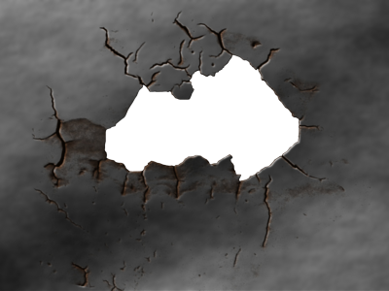
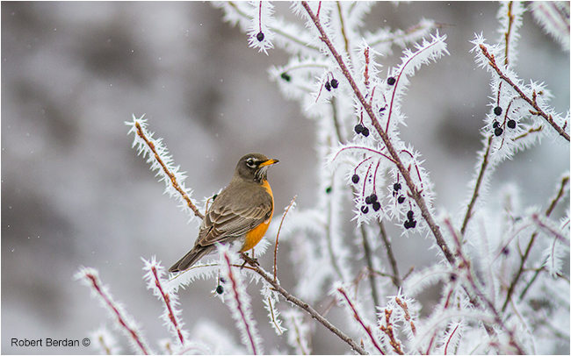 It is snowing fire in the eyes of passersby, the leopards of my mind are camouflaged on a balcony for hire, the ghosts of the homeless retain that hunted haunted look-they join me but don't feel the cold as we pass coffee houses, the ghosts empty their rucksacks of moons, drivers don't see moons crossing or the homeless either.

In Pearson Park Zachariah jumps down from his podium-he will only talk to the isolated and dispossessed and asks me how long I have been without a home. Pearson offers me a place on his monument then tells me he doesn't believe in ghosts. Who is genuinely homeless I enquire? - as he pulls someone out of the pond who looks exactly like me. In Pearson's eyes I am airborne, gliding on feathers of fire, erasing memories of crying homeless charades; geese arrive
hymning the faculty of flight. I have to exit my nocturnal epiphanies. Walking through spring bank cemetery a ghost uses me as his sleeping bag-I can see his dream as he passes through endless doors and corridors and our dream, collide when he enters a house I am building in which I am in several places at once as the bricklayer, carpenter and roofer. I am disturbed by my friend the ghost, his past selves are pursuing him, he hides in an empty room. I have had dreams in which nothing happens, slept in the doorways of empty shops and dreamt all night.

The cold is preserved within me. After sitting in the park conservatory for an hour, I must resemble a flask. Sleeping in the tunnel on the track between Goddard avenue and Chanterlands avenue is as precarious as a seagull clinging to driftwood. The tunnel stores echoes of fire engines and ambulances-the sirens resemble the rhythms of speech. Did anyone die in here alone? Indifferently?

To the government the homeless are like the sphinx, remote, immovable and inscrutable, but they have not seen the sphinx's sinuous breath stroking the sands, incarnating sages, raising stages, releasing caged perceptions. Sleeping in the back of the deep, the moons hands are gloved as it steals painful dreams without leaving fingerprints. I wake to a flash of driftwood in the waters plus a hint of kindness from a stranger who gives me a pound coin, Perhaps I could persuade the river to walk with me or invite the estate agents to talk. As the shutters rise, the coin in my pocket seems to get heavier. I pass two of my homeless friends. They are like two flaming keys on either side of a door. They do not possess the inner scaffolding I have constructed.

Does anyone else feel the pull of a pendulum as geese fly between East Park and Pearson park? The homeless are scattered numbers from a shattered clock. I hope the winds shake the clock face. Why don't the authorities trace the movements of the missing? People pass me walking dogs. I have an angel on a lead, Heaven is heaving with demolitionists debricking Hell, sealing up wishing wells and walling up eyes. I pass a charity shop and see a figure in a snow globe standing outside a house. In the city centre a busker sings silent night, but people don't seem to notice. He seems alarmed at the lack of fire in fellow citizens.

If only winter would lend me its fur coat as I sleep on a field with horses, on a field near first lane. The police helicopter wakes me. A rook shakes a worm. One last dreaming horse refuses to wake. A robins red breast burns in the frost-winter. Our frugal host has hidden its harvest and raised its costs. I had a dream about the ghost of a butterfly hovering over a glass case attempting to trace its earthly form.

I pass a house I used to occupy-it is empty still. By Barry Carter

Quotes About Spring
http://www.goodreads.com/quotes/tag/spring

 “In the spring, at the end of the day, you should smell like dirt.”
― Margaret Atwood, Bluebeard's Egg

 “Spring passes and one remembers one's innocence.
Summer passes and one remembers one's exuberance.
Autumn passes and one remembers one's reverence.
Winter passes and one remembers one's perseverance.”
― Yoko Ono

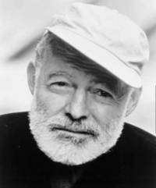 “When spring came, even the false spring, there were no problems except where to be happiest. The only thing that could spoil a day was people and if you could keep from making engagements, each day had no limits. People were always the limiters of happiness except for the very few that were as good as spring itself.”
― Ernest Hemingway, A Moveable Feast

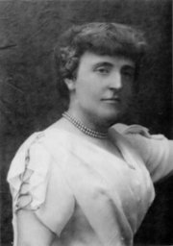 “Is the spring coming?" he said. "What is it like?"...
"It is the sun shining on the rain and the rain falling on the sunshine...”
― Frances Hodgson Burnett, The Secret Garden

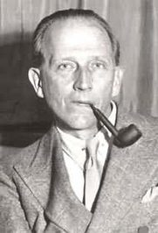 “She turned to the sunlight
And shook her yellow head,
And whispered to her neighbor:
"Winter is dead.”
― A.A. Milne, When We Were Very Young

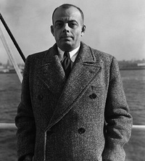 “Of course I’ll hurt you. Of course you’ll hurt me. Of course we will hurt each other. But this is the very condition of existence. To become spring, means accepting the risk of winter. To become presence, means accepting the risk of absence.”
― Antoine de Saint-Exupéry, The Little Prince

The chrysalis 

Like a chrysalis
I still hold the promise of life.
A cocoon around me
that has been cemented,
cursing me into a life of
endless struggling and groaning,
making sure all the while
that it will not crack,
it will not give in,
mocking my thirst for life.

And yet! Transcendence
takes me by surprise:
There are cracks in the cement!
There is healing after all...
Will my tender wings survive?
One rough touch and
the promise is gone.
The odds are all against me.
After all, the curses
have my name written under them.

But yes!
My wings are unfolding and
I am beginning to
feel the gentle breeze...
Oh, the paradox of it all:
The more I take a look into
my ever-reminding body of a caterpillar,
the more I feel my loss, my shame, my grief,
the more my rice-paper wings stretch
and I get itchy for a fly.
Look:
I am.... flying!

Today I am alive
and against the odds
I will stay alive and cherished
in the eyes of the One
who made me and named me:
evdokia*.

*the one you take delight in.

written by Evdokia (Evie), SRA survivor

Survivorship Ritual Abuse and Child Abuse 2014 Conference

Survivors Supporting Survivors
Two days of survivor and professional workshops, a safe room, great price, good food, safe environment, a chance to mingle with others who share your experience. Join together in this unique opportunity to bring the movement forward.
On May 17 – 18, 2014 Survivorship will hold a conference at the Executive Inn & Suite – 1755 Embaracadero – Oakland, CA 94606.

http://survivorship.org/survivorship-ritual-abuse-and-child-abuse-2014-conference/
This year’s keynote speaker will be Dr. Jennifer J. Freyd, PhD
Her topic will be: What We Have Learned About Interpersonal and Institutional Betrayal Trauma
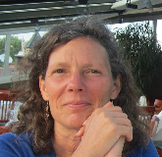Jennifer J. Freyd, PhD, is Professor of Psychology at the University of Oregon. She received her BA in Anthropology from the University of Pennsylvania and her Ph.D in Psychology from Stanford University. Professor Freyd directs a laboratory investigating the impact of interpersonal and institutional trauma on mental and physical health, behavior, and society. She has published over 150 articles and she is author of the award-winning Harvard Press book Betrayal Trauma: The Logic of Forgetting Childhood Abuse and she co-edited with Anne DePrince the volume, Trauma & Cognitive Science. Her new co-authored book Blind to Betrayal was published in English by John Wiley & Sons in March 2013. It has been translated into Traditional Chinese and Portuguese. Additional translations of her Blind to Betrayal into Simple Chinese, Russian, and Korean are in process. Freyd has received numerous honors including the Award for Outstanding Contributions to Science in Trauma Psychology from the American Psychological Associations’s Trauma Division. She is a Fellow of the American Psychological Association, the American Psychological Society, and the American Association for the Advancement of Science. She currently serves as the Editor of the Journal of Trauma & Dissociation.
For those interested in registering for the conference, please write:conference2014reg@survivorship.org
Board of directors 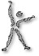
Featuring/Interview with:
Micci Martinez
Micci, what brings you back to the Board of Directors of Survivorship?
I was originally on the Board of Directors for 6 years. I came back because I love this organization. The Board members, other volunteers and our members are amazing, brave, creative and committed people. The Ship helped me through incredibly difficult times. I started coming to Survivorship workshops and Conferences in the late 80's. I have integrated now. I also came back to the Board because I wanted to give back the kind of kindness, compassion and fellow ship I was so freely given.
What is your focus now that you're back on the Board?
I wanted to bring back our incredibly important Conferences. I wanted to bring them back because they were a huge part of my healing, and made it possible for me to know I wasn't alone. I was able to make friends and contacts that I still count on today. I remember how profoundly impacted I was by Caryn Stardancer and others. I'm really excited that I am involved with making this year’s momentous 25 year anniversary Conference happen. Another focus I have is fundraising. I am looking into creative ways to raise more money for Survivorship. I have done extensive fundraising with other non-profit organizations, and look forward to seeing how they can be used for us.
Do you have a message for members of Survivorship?
You are all wonderful people. You never have to be alone and isolated. One or many more of us will understand and believe whatever your truth is. Please become more involved, as you can, with Survivorship. Give your time, your gifts and skills, your money and help Survivorship reach more of us. There are people all around the world who are part of this amazing organization. Thank you all for your participation in Survivorship. We wouldn't be here without all of you.
What else would you like our members to know?
You are never alone. Isolation and silence can keep us apart, and that gives those with power and those who have hurt us what they want. As much as you can do, and nothing is too small, helps to break them. Use your voice and truth when you are ready to bring the truths to light. We will win.
Become a Member

Membership in Our Organization Brings You . . .

Survivorship Journal – articles on healing – personal narratives – articles on therapeutic, social, and political issues – poetry – book, TV, and movie reviews - artwork

Survivorship Notes – short articles – organizational
updates – opportunities for activism – announcements and resources – national and international conference dates

Web Page: http://www.survivorship.org – articles and links – calendar of events – difficult dates – reprints and back issues – items for sale by survivors – member’s section with the Journal, newsletters, and members-only message boards and chat room
Webinars each month by survivors and therapists – recordings of past webinars

Conferences yearly with the possibility of meeting other survivors and learning from those willing to share their stories and expertise

Help keep Survivorship alive and strong. Your membership dues and donations allow us to offer gift memberships to those who cannot afford dues and to support our day-do-day activities.

Membership Categories
Every member with Internet access gets a username and password to enter the Members’ only section

$35 to $75 Regular Member (receives the Journal by regular mail and the Notes by e-mail)
$25 to $50 Internet Member (reads the Journal and Notes on the website)

If you are a professional or a for-profit agency, we suggest that you donate an additional $35.00 toward gift memberships. Special donations help with special events such as support groups, workshops, trainings, webinars, and conferences.

Gifts
$35 to $100 Donor
$100 to $500 Sustaining Donor
$500 and over Benefactor
Every donation, no matter how small, makes a difference and is deeply appreciated.

Survivorship is a grassroots organization supported by membership fees and donations. We accept no federal or state grant monies. We are run for and by survivors.

Many ritual abuse survivors find they “fall apart”—especially right after they begin to remember—and cannot work as they used to. We ask for donations for gift memberships so that we may offer vitally needed support at this critical time. We offer gift memberships to those on long-term disability or in prison. Gifts are also needed to reach out to survivors who may not know of our resources and to educate the public and professionals working with survivors. All donations are tax deductible.

To pay dues or donate online using PayPal, go to Survivorship.org

Mail membership fees and donations to:
Survivorship, Family Justice Center, 470 27th St., Oakland, CA 94612

Name___________ _____________________________________________

Username I would like to use _______________________________________

Organization (if applicable)________________________________________

City ________________________________ State__________ Zip___________________

E-Mail _____________________________________Amount enclosed______________

Volunteer for Survivorship
By helping Survivorship, you challenge your programming, develop confidence and new skills, and support our community.

There are many different ways to volunteer:
* Make a commitment to serve on the Board of Directors.
* Publish your articles, poems, and artwork in the Journal. Copy-edit or proof read. Or become a Guest Editor for one issue of the Journal. It’s fun!
* Research conferences and resources for the Notes. Write a short article.
* Give a Webinar.
* Help maintain and update our web site.
* Give a training on ritual abuse to a hotline, school of social work, nursing or psychology, rape crisis center, or battered women’s shelter.
* Organize a fund raising event.
* Be creative and think of other ways you might help out!

Next step: write or email info@survivorship.org and tell us what you would like to do.

Please know how grateful we are to you for reaching out to isolated survivors and helping educate the public about ritual abuse. If our community doesn’t do it, nobody will.

Copyright Information
SURVIVORHSIP JOURNAL, ISSN 046-2015, is published three times per membership year in San Francisco, CA.
Editor: Shamai Currim PhD Copyright 2014 by Survivorship. All rights reserved. The entire contents of this issue are copyrighted by Survivorship and/by the individual contributors. No part of this publication may be reproduced or transmitted in any form or by any means, electronic or mechanical, including photocopying, or by any information storage and retrieval systems, without permission in writing by the copyright owners. For permission to reprint, contact: Survivorship, Family Justice Center, 470 27th St., Oakland, CA 94612 or email info@survivorship.org

